
TECHNICAL REPORT ON THE STUDENT INDUSTRIAL WORK EXPERIENCE
SCHEME (SIWES)

HELD AT
GARISHO GLOBAL SERVICE LIMITED LICENSE ELECTRICAL CONTRACTOR.
General Electrical Works, Services, Supply, Installation & Contracts.
BY
LUKUMAN ABDULFATIHI OLUWASHINA
ND/23/EEE/PT/0171

SUBMITTED TO
THE DEPAERTMENT OF ELECTRICAL/ELECTRONICS ENGINEERING,
INSTITUTION OF TECHNOLOGY (IOT) KWARA STATE POLYTECHNIC, PMB 1375 ILORIN KWARA STATE.
IN PARTIAL FULFILMENT OF THE REQUIREMENT FOR THE AWARD OF NATIONAL DIPLOMA (ND) CERTIFICATE

AUGUST – NOVEMBER, 2024
DEDICATION
Firstly, I want to dedicate this work to Almighty Allah who shows me through the period of internship, gracing me with wisdom strength, knowledge, understanding and unending cost of great things
Also dedicated this report to my parents Mr and Mrs LUKUMAN for their love, care and support since the time I was born till this moment. I say a big thanks to my parents.
I am also grateful to my family and friends who has always been there for me in terms of needs and supports, Thanks to you all.

ACKNOWLEDEMENT
I extend my gratitude to Garisho Global Service Limited for the opportunity and support during my training. I also appreciate my supervisors and colleagues for their guidance and mentorship.
My Appreciation is incomplete, if I failed to thank my industry based supervisor, in person of ALHAJI ABDULGANIYU AREMU for his guidance, patience and untiring effort to the completion of my SIWES program, May Allah continue to bestow his mercies on him.

PREFACE
This contain a written report of the work done by me during the four month Industrial attachment GARISHO GLOBAL SERVICE LIMITED LICENSE ELECTRICAL CONTRACTOR. This work goes further to share the experience I had in the organization. This summarizes all the things I learn and the problems encountered by me and my recommendations and conclusion of all my work.

REPORT OVERVIEW
This is an industrial attachment report for the students industrial work experience (SIWES) programme carried out at GARISHO GLOBAL SERVICE LIMITED LICENSE ELECTRICAL CONTRACTOR. Within the period of Four months from August - November, 2024.
The report comprises the background of SIWES, the description of the organization, its aims and objectives, the experience gained as an industrial training student and the summary, conclusion and recommendations.
It has a total of 5 chapters with sub-chapter. It also has the preliminary pages, such as the tile page, report overview and table of contents and recommendations on the improvement of scheme.

CHAPTER ONE
INTRODUCTION
  - BACKGROUND OF SIWES

The Student Industrial Work Experience Scheme (SIWES) was established by the Industrial Training Fund (ITF) to bridge the gap between theoretical knowledge acquired in classrooms and practical work experience in industries. It is a mandatory program for students in technical and engineering fields to gain hands-on training in their respective disciplines.
It is a programme required to be undertaken by all students of tertiary institutions in Nigeria pursuing courses in“specialized engineering, technical, business, applied sciences and applied arts and Mass Communication".
The Federal Government on 8th October 1971 established the industrial training (ITF) to acquaint the students on the industrial work method. The SIWES which is a subsidiary formed in 1973 was initiated to improve the students technical abilities to expose them to industrial cuLture thereby getting the acquainted with the role to play towards the technological advancement of the nation.
It creates an avenue on environment in which the students are exposed to areas of their various disciplines to enhance their mental and creative minds in the aspects of Practical.
It is therefore a practical aspect of the academic work; which students may not have opportunity to carry out throughout their stay in the higher institutions.
  - OBJECTIVES OF SIWES
The main objectives of SIWES include:
- Exposing students to real-life industrial work settings.
- Enhancing students’ technical knowledge and skills.
- Bridging the gap between theory and practice.
- Preparing students for employment in their respective fields.
  - IMPORTANCE OF THE INDUSTRIAL TRAINING
The Students Industrial Work Experience Scheme (SIWES) is the accepted skills training programme, which forms part of the approved Minimum Academic Standards in the various degree programmes for all the Nigerian universities.
It is an effort to bridge the gap existing between theory and practice of engineering and technology, science, agriculture, medial, management and other professional educational and Mass Communications programmes in the Nigerian tertiary institutions.
It is aimed at exposing students to machines and equipment, professional work methods and ways of safe-guarding the work area s and workers in industries and other organization.
Industrial training is essential as it helps students:
- Understand workplace ethics and professionalism.
- Gain confidence in handling real-life tasks.
- Develop problem-solving and decision-making skills.

CHAPTER TWO
COMPANY OVERVIEW
2.1 INTRODUCTION TO GARISHO GLOBAL SERVICE LIMITED
Garisho Global Service Limited is a licensed electrical contractor specializing in electrical installations, maintenance, and consultancy services. The company provides solutions for industrial, commercial, and residential electrical systems.
Garisho Global Service Limited also established with a commitment to delivering high-quality electrical solutions, the company has built a reputation for reliability and excellence in the electrical industry. The firm serves residential, commercial, and industrial clients, ensuring compliance with safety and regulatory standards.
2.2 SERVICES OFFERED
- Electrical wiring and installation.
- Maintenance and repair of electrical systems.
- Power distribution and transformer installation.
- Solar energy solutions and alternative power sources.
- Electrical consultancy and project management.
- Electrical Wiring and Installation
Electrical wiring and installation involve setting up electrical systems in residential, commercial, and industrial buildings. This includes laying out electrical cables, installing switches, sockets, lighting fixtures, and circuit breakers, ensuring proper connectivity and adherence to safety standards. Proper wiring prevents electrical hazards such as short circuits and fire outbreaks.

- Maintenance and Repair of Electrical Systems
Regular maintenance and repair of electrical systems help in detecting faults early and preventing system failures. This includes inspecting electrical panels, repairing faulty wiring, replacing damaged components, and ensuring electrical appliances function efficiently. Maintenance enhances safety, improves energy efficiency, and prolongs the lifespan of electrical equipment.
- Power Distribution and Transformer Installation
Power distribution involves transmitting electricity from power plants to homes and businesses through transformers and electrical grids. Transformer installation is critical for stepping up or stepping down voltage levels to ensure safe and efficient electricity distribution. Proper installation and maintenance of transformers prevent power surges, losses, and equipment damage.
- Solar Energy Solutions and Alternative Power Sources
Solar energy solutions involve harnessing solar power through photovoltaic (PV) panels to generate electricity. Alternative power sources, such as wind turbines, inverters, and generators, provide backup or renewable energy solutions. These solutions are eco-friendly, reduce dependency on fossil fuels, and offer sustainable energy options for homes and industries.
- Electrical Consultancy and Project Management
Electrical consultancy involves providing expert advice on electrical system design, safety compliance, and energy efficiency. Project management in electrical engineering ensures the successful execution of electrical projects by planning, budgeting, and supervising installations. Consultants and project managers help in optimizing resources, ensuring regulatory compliance, and delivering quality electrical solutions.

2.3 ORGANIZATIONAL STRUCTURE
The company is structured into various departments, including:
- Electrical Engineering Department
- Project Management Team
- Safety and Compliance Unit
- Administrative and Finance Department
- Electrical Engineering Department
This department is responsible for the design, installation, and maintenance of electrical systems. Engineers and technicians within this department ensure that electrical works meet industry standards and safety regulations.
- Project Management Team
This team oversees the planning, execution, and completion of electrical projects. They coordinate with clients, suppliers, and internal teams to ensure projects are completed on time, within budget, and according to specifications.
- Safety and Compliance Unit
The safety and compliance unit ensures that all electrical works adhere to national and international safety standards. They conduct risk assessments, implement safety procedures, and train staff on workplace safety practices.
- Administrative and Finance Department
This department manages the company’s financial records, procurement, and overall administrative functions. They ensure smooth operations by handling budgeting, payroll, and logistics support.

2.4 COMPANY MISSION AND VISION
- MISSION
To provide top-notch electrical contracting services with a focus on safety, efficiency, and innovation.
- VISION
To be a leading electrical contracting firm known for its expertise and commitment to quality service delivery.

CHAPTER THREE
INDUSTRIAL TRAINING EXPERIENCE
3.1 WORK SCHEDULES AND RESPONSIBILITIES
During my SIWES training at Garisho Global Service Limited, I was assigned the following tasks:
- Assisting in electrical wiring and installation in residential and commercial buildings.
- Conducting routine maintenance of electrical panels and circuit breakers.
- Troubleshooting and repairing faulty electrical connections.
- Learning how to read electrical schematics and blueprints.
- Adhering to safety protocols and industry best practices.
3.2 TOOLS AND EQUIPMENT USED
- Multimeter
- Insulation resistance tester
- Circuit breaker analyzer
- Soldering iron
- Power drills and hand tools
- MULTIMETER
A multimeter is an essential electrical testing device used to measure voltage, current, and resistance. It can be analog or digital and is commonly used for troubleshooting electrical circuits.
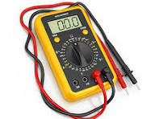

Multimeter

2. INSULATION RESISTANCE TESTER
This device is used to measure the resistance of electrical insulation in wires, transformers, and electrical equipment. It ensures that electrical components are safe and prevents leakage currents. 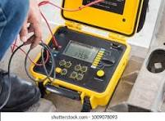
Insulation Resistance Tester

3. CIRCUIT BREAKER ANALYZER
A circuit breaker analyzer is used to test the performance of circuit breakers by evaluating their timing, contact resistance, and insulation resistance. It ensures the reliability of breakers in electrical systems.
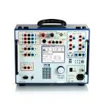

Circuit Breaker Analyzer

4. SOLDERING IRON
A soldering iron is a hand tool used for melting solder to join two electrical components together. It is commonly used in circuit board repairs and electronic assembly.

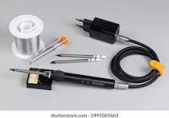 Soldering Iron

5. POWER DRILLS AND HAND TOOLS
Power drills are used for drilling holes and driving screws in electrical installations. Hand tools, including pliers, screwdrivers, and wire strippers, are essential for electrical work and wiring.
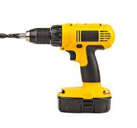

Power Drills and Hand Tools
3.3 PROJECT HANDLES
Some of the projects I participated in include:
- Wiring of a newly constructed office complex.
- Installation of solar panels for a small-scale business.
- Replacement of faulty transformers in an industrial plant.

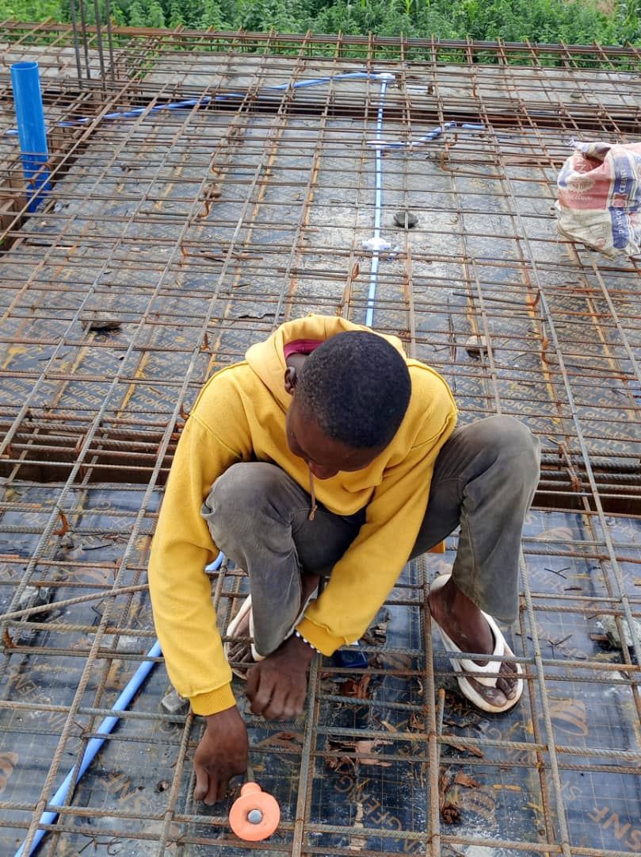

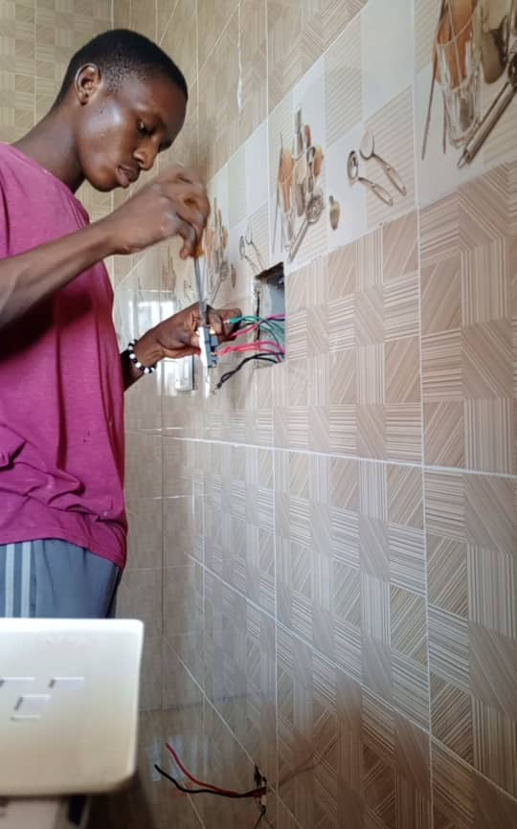

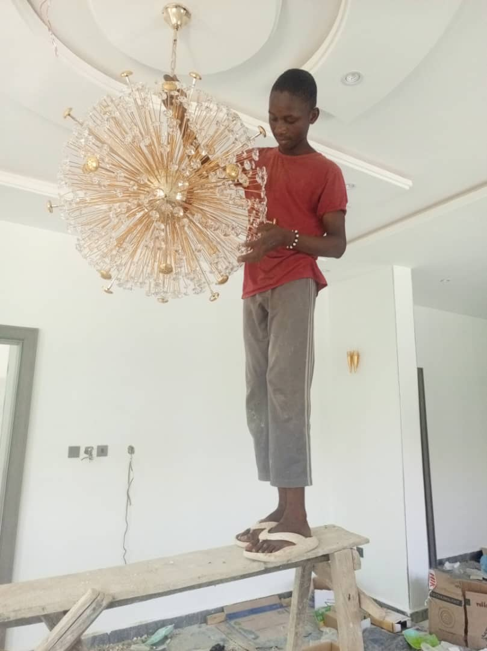

CHAPTER FOUR
CHALLENGES AND SOLUTIONS
4.1 CHALLENGES FACES
- Difficulty in understanding complex electrical schematics.
- Exposure to hazardous working conditions.
- Limited hands-on experience before training.
- Power outages affecting project execution.
4.2 SOLUTIONS IMPLEMENTED
- Attending extra training sessions with senior engineers.
- Strict adherence to safety measures and use of personal protective equipment (PPE).
- Active participation in troubleshooting and repair tasks.
- Learning alternative power backup solutions for smooth operations.

CHAPTER FIVE
CONCLUSION AND RECOMMENDATIONS
5.1 CONCLUTION
The SIWES program at Garisho Global Service Limited was a valuable experience that enhanced my practical knowledge of electrical engineering. It provided exposure to real-world electrical system installations, maintenance, and safety protocols. The experience has significantly improved my technical skills and confidence in handling electrical tasks.
5.2 RECOMEMDATIONS
- The company should provide structured training sessions for interns before assigning field tasks.
- More safety drills and hands-on workshops should be organized.
- Institutions should collaborate with industries to improve the transition from theoretical learning to practical application.
- Internship duration should be extended to allow students to gain in-depth knowledge of industrial operations.
- Companies should introduce mentorship programs where experienced engineers guide interns through real-world challenges.
- Students should be encouraged to work on mini-projects to enhance their understanding of electrical systems.

