

A TECHNICAL REPORT
STUDENT INDUSTRIAL WORKING EXPERIENCE SCHEME
(SIWES)

Held at
INTEGRATED DATA SERVICES

Prepared by:
ODESILE QUREEB OLANREWAJU
ND/23/BAM/PT/01753

SUBMITTED TO

DEPARTMENT OF BUSINESS ADMINISTRATION
INSTITUTE OF FINANCE AND MANAGEMENT STUDIES
KWARA STATE POLYTECHNIC, ILORIN

IN PARTIAL FULFILLMENT OF THE AWARD OF THE REQUIREMENT OF THE AWARD OF NATIONAL DIPLOMA IN BUSINESS ADMINISTRATION

OCTOBER - NOVEMBER.2024
DEDICATION
I dedicate this technical report to the Almighty Allah, the giver of knowledge, wisdom and understanding.

ACKNOWLEDGEMENT
I am grateful to Almighty Allah, who granted me the grace, strength and knowledge to go through my period of Industrial attachment successfully. My sincere appreciation and heartfelt gratitude goes to my parents MR and MRS ODESILE.

ABSTRACTS
The Students Industrial Work Experience Scheme (SIWES) is an accepted skills acquisition programme which forms part of the approved academic standard in the degree programme for Nigeria University. In 1974, the federal government of Nigeria introduced the national policy on industrial training, called the Students Industrial Work Experience Scheme (SIWES).This programmes is under the umbrella of the ministry of education through the industrial training fund (ITF), was designed to help students acquire the necessary practical education/experience in their field of study and other related professions. This is an effort which was created on order to bridge the existing gap between the theory taught in the classroom and practice of science, agriculture, medicine, engineering, technology and other professional programmes in the Nigeria tertiary institution. The programme was established basically to impact elaborate practical understanding to students with respect to their various disciplines. This report is a summary of the experience I acquired during my Students' Industrial Work Experience Scheme (SIWES) in NTA. I served as an intern in the News Department of the organization.

TABLE OF CONTENT
TITLE PAGE I
DEDICATION II
ACKNOWLEDGEMENTS III
ABSTRACT IV
TABLE OF CONTENT V
TABLE OF CONTENTS
CHAPTER ONE
  - INTRODUCTION TO SIWES 1
  - HISTORY OF SIWES 1
  - OBJECTIVES OF THE PROGRAMME 1-2
1.4 OBJECTIVES OF ESTABL ISHMENT 2
CHAPTER TWO
2.1 ORGANIZATIONAL CHART 3
2.2 INTRODUCTION TO PRODUCTION SECTOR 3-4
2.3 MANUFACTURING PRODUCTS 4-5
2.4 HOW TO KEEP RECORD OF STAFF EVERYWEEK 4-6
CHAPTER THREE
3.1 HOW TO HANDLE CUSTOMER INQUIRIES AND COMPLAINTS 7-8
3.2 LOGISTICS AND SUPPLY CHAIN 8-9
3.3 HOW TO ARRANGE RAW MATERIALS DELIVERY AND PRODUCT SHIPMENTS
9-10
3.4. INTRODUCTION TO MAINTENANCE AND ENGINEERING DEPARTMENT 10-11
3.5. HOW TO DEVELOP NEW PRODUCT AND IMPROVING THE EXISTING ONES
11-12
CHAPTER FOUR
4.1 INTRODUCTION TO MANAGEMENT AND STRATEGY 13-14
4.2 HOW TO RECORD PRODUCTION AND SALES DATA 14-15
4.3 HOW TO ENSURE ADHERENCE TO REGULATIONS 15-16
4.4 SIX SIGMA 16
CHAPTER FIVE
5.1 CONCLUSION 17
5.2 RECOMMENDATION 17

CHAPTER ONE
  - INTRODUCTION TO SIWES
Students Industrial Work Experience Scheme (SIWES) is a Skills Training Program designed to prepare and expose Students of Universities, Polytechnics, Colleges of Technology, Colleges of Agriculture and Colleges of Education for the Industrial Work situation they are likely to meet after graduation. The Scheme affords Students the opportunity of familiarizing and exposing themselves handling equipment and machinery that are usually not available in their institutions.

1.2 HISTORY OF SIWES
The Students’ Industrial Work Experience Scheme (SIWES) was initiated in 1973 by the Federal Government of Nigeria under the Industrial Training Fund (ITF) to bridge the gap between theory and practice among products of our tertiary Institutions. It was designed to provide practical training that will expose and prepare students of Universities, Polytechnics, and Colleges of Education for work situation they are likely to meet after graduation.
Before the establishment of the scheme, there was a growing concern among the industrialists that graduates of institutions of higher learning lacked adequate practical background studies preparatory for employment in industries. Thus the employers were of the opinion that the theoretical education going on in higher institutions was not responsive to the needs of the employers of labour.
As a result of the increasing number of students’ enrolment in higher institutions of learning, the administration of this function of funding the scheme became enormous, hence ITF withdrew from the scheme in 1978 and was taken over by the Federal Government and handed to National Universities commission (NUC), National Board for Technical Education (NBTE) and National Commission for Colleges of Education (NCCE). In 1984, the Federal Government reverted back to ITF which took over the scheme officially in 1985 with funding provided by the Federal Government.

1.3 OBJECTIVES OF THE PROGRAMME
The specific objectives of SIWES are to:
- Provide placements in industries for students of higher institutions of learning approved by relevant regulatory authorities (NUC, NBTE, NCCE) to acquire work experience and skills relevant to their course of study
- Prepare students for real work situation they will meet after graduation.
- Expose students to work methods and techniques in the handling of equipment and machinery that may not be available in schools.
- Make transition from school to the labour market smooth and enhance students’ conduct for later job placement
- Provide students with the opportunity to apply their knowledge in real life work situation thereby bridging the gap between theory and practice
- Strengthen employer involvement in the entire educational process and prepare students for employment in industry
Promote the desired technological knowhow required for the advancement of the nation.
1.4 OBJECTIVES OF ESTABLISHMENT
- To provide innovative and effective solutions
- To deliver exceptional customer service
- To drive business growth and expansion
- To build a strong brand reputation
- To develop and maintain a skilled workforce
- To promote a culture of innovation and continuous improvement
- To maintain high-quality standards and best practices
- To foster strategic partnerships and collaborations

CHAPTER TWO
2.1 ORGANIZATIONAL CHART
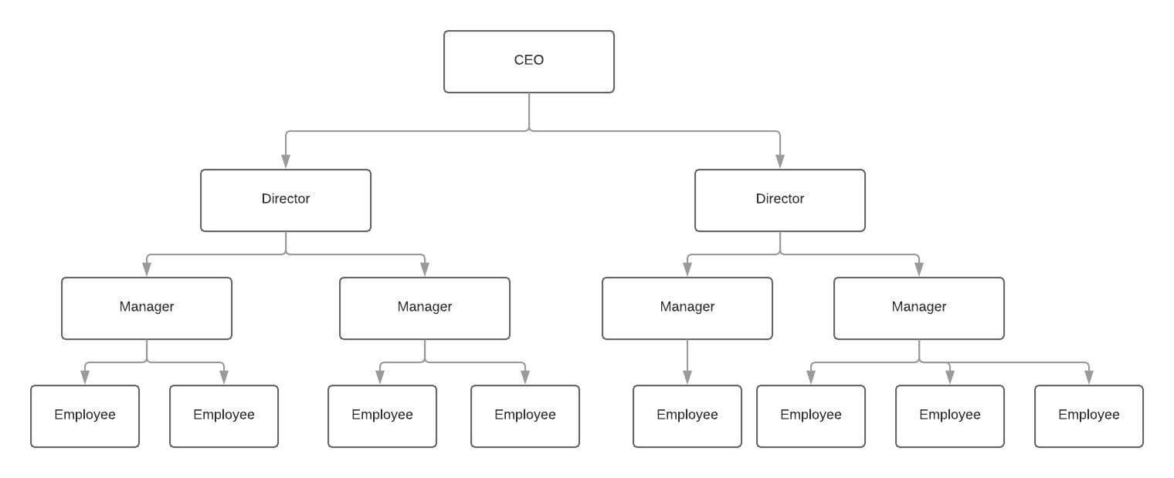
2.2 INTRODUCTION TO PRODUCTION SECTOR
The production sector refers to the part of an economy that focuses on creating goods and services by transforming raw materials and inputs into finished products, essentially encompassing all businesses involved in manufacturing, agriculture, and extraction of natural resources, where the primary function is to produce tangible outputs for consumption or further processing; it is considered a key component of a nation's economic activity, contributing significantly to GDP and employment opportunities.

Key points about the production sector:
- Inputs and Outputs:
The production process involves combining various inputs like labor, capital (machinery), land (natural resources), and raw materials to generate outputs in the form of finished goods or services.
- Types of Production:
  - Primary Production: Extraction of raw materials from nature, including agriculture, mining, fishing, and forestry.
  - Secondary Production: Manufacturing and processing of raw materials into finished goods, like car assembly, textile production, and food processing.
  - Tertiary Production: Provision of services like transportation, retail, healthcare, and finance.

HOW TO SCHEDULE PRODUCTION AND ALLOCATING RESOURCES
- Demand forecasting:
Analyze historical sales data and market trends to predict future product demand, which forms the basis for your production plan.
- Capacity planning:
Evaluate your existing production capabilities, including machinery, labor, and materials, to determine if you can meet forecasted demand.
- Production breakdown:
Divide the production process into smaller, manageable tasks, considering the sequence of operations required.
- Resource identification:
Inventory all available resources like machinery, personnel, and raw materials, including their specific skills and limitations.
- Resource allocation:
Assign resources to each task based on factors like:
  - Skill level: Match the required expertise to the task.
  - Availability: Ensure resources are available at the necessary time.
  - Cost efficiency: Allocate resources to minimize production costs.
- Scheduling tools: Utilize scheduling software or Gantt charts to visualize the production timeline, including start and end dates for each task and resource allocation.
- Load balancing: Distribute workload evenly across resources to avoid bottlenecks and maximize utilization.
- Monitoring and adjustments: Regularly track progress against the schedule, identify potential issues, and make necessary adjustments to resource allocation as needed.

2.3 MANUFACTURING PRODUCTS
Manufacturing products involves using raw materials to create finished goods. This process involves processing, refining, and shaping the materials using tools, equipment, and other processes.

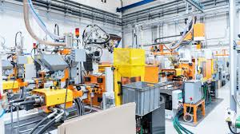

Steps of manufacturing
- Develop an idea
- Research the market
- Design the product
- Prototype and finalize the design
- Test the prototype
- Manufacture the product
- Monitor the process

2.4 HOW TO MANAGE PAYROLL
To manage payroll effectively, you need to: establish clear payroll policies, automate processes wherever possible, gather accurate employee data, calculate wages and deductions correctly, comply with tax laws, maintain detailed records, and regularly review your payroll system for efficiency and accuracy; consider using payroll software or outsourcing payroll services depending on your business size and needs.

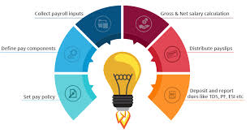

Key steps in payroll management:
- Set up payroll policies:
Define pay periods, compensation structure, overtime rules, deductions (taxes, benefits, etc.), and other relevant policies.
- Gather employee data:
Collect necessary information like name, address, Social Security number, bank details, and tax withholding information for each employee.
- Time and attendance tracking:
Implement a system to accurately record employee hours worked, including overtime and leave.

- Calculate gross pay:
Determine the total earnings for each employee based on their hourly rate, salary, or commission.
- Calculate deductions:
Withhold federal and state income taxes, Social Security and Medicare taxes, health insurance premiums, retirement contributions, and any other applicable deductions.
- Generate paychecks:
Issue paychecks to employees on the designated payday, ensuring accurate amounts are paid.
- File payroll taxes:
Comply with federal and state tax regulations by submitting required payroll tax forms to the appropriate agencies on time.
- Maintain payroll records:
Keep detailed records of employee earnings, deductions, and tax withholdings for audit purposes.
- Consider payroll software:
Utilize payroll software to automate calculations, generate paystubs, and streamline the payroll process.
- Regularly review and update:
Periodically assess your payroll processes to identify potential errors, compliance issues, and areas for improvement.

CHAPTER THREE
3.1 HOW TO HANDLE CUSTOMER INQUIRIES AND COMPLAINTS
Steps to handle customer inquiries and complaints:
- Listen attentively:
Pay full attention to the customer's concerns, ask clarifying questions to fully understand the issue, and avoid interrupting.
- Acknowledge the complaint:
Express understanding and validate their feelings by saying something like, "I understand your frustration regarding this issue."
- Apologize when appropriate:
Even if the issue isn't entirely your fault, a sincere apology can go a long way in de-escalating the situation.
- Gather information:
Ask necessary questions to gather details about the problem, including dates, times, and relevant product information.
- Investigate the issue:
Look into the problem to determine the root cause and possible solutions.
- Offer a solution:
Present a clear and feasible solution that addresses the customer's concerns, explaining the steps involved.
- Communicate clearly:
Explain the solution in simple terms and confirm the customer understands.
- Follow up:
Reach out to the customer after implementing the solution to ensure their satisfaction and address any remaining concerns.
Important considerations:
- Be timely:
Respond to customer inquiries and complaints promptly.
- Maintain professionalism:
Use polite language, avoid getting defensive, and remain calm even when dealing with an upset customer.
- Emphasize empathy:
Try to see the situation from the customer's perspective and show that you care about their experience.
- Document complaints:
Keep a record of all complaints to identify trends and areas for improvement.
- Escalate when necessary:
If you cannot resolve a complaint on your own, know when to involve a manager or higher-level support.

3.2 LOGISTICS AND SUPPLY CHAIN
What is Logistics?
Logistics refers to the planning, coordination, and execution of the movement and storage of goods, products, and resources from one place to another. It involves managing the flow of goods, information, and resources to meet customer demands.
What is Supply Chain Management?
Supply Chain Management (SCM) is the management of the flow of goods, services, and information from raw materials to end customers. It involves coordinating and integrating all activities, functions, and stakeholders involved in the production and delivery of a product or service.



Components of Logistics and Supply Chain Management:
1. Supply Chain: Network of organizations, people, activities, and resources involved in producing and delivering a product or service.
2. Logistics: Planning, coordination, and execution of the movement and storage of goods, products, and resources.
3. Transportation: Movement of goods, products, and resources from one place to another.
4. Inventory Management: Management of inventory levels, including storage, handling, and tracking.
5. Warehousing: Storage and handling of goods, products, and resources in a warehouse or distribution center.
6. Distribution: Delivery of goods, products, and resources to customers.
7. Supply Chain Visibility: Ability to track and trace the movement of goods, products, and resources throughout the supply chain.
3.3 HOW TO ARRANGE RAW MATERIALS DELIVERY AND PRODUCT SHIPMENTS
To effectively arrange raw materials delivery and product shipments, you need to carefully plan production schedules, coordinate with suppliers on delivery timings, utilize inventory management systems to track stock levels, and optimize transportation logistics to ensure timely deliveries and minimize costs; this includes considering factors like lead times, demand forecasting, storage capacity, and shipment distances.

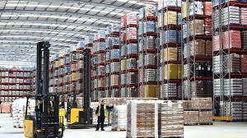

Key steps to follow:
Demand Forecasting:
  - Analyze historical sales data to predict future product demand accurately.
  - Use this information to plan raw material orders and production schedules accordingly.
Supplier Management:
  - Establish strong relationships with reliable suppliers who can consistently deliver quality raw materials on time.
  - Negotiate delivery terms, including lead times, minimum order quantities, and pricing.
  - Communicate production schedules and demand fluctuations to suppliers to optimize deliveries.
Inventory Management:
  - Implement a robust inventory management system to monitor raw material stock levels.
  - Set reorder points to ensure sufficient raw materials are available for production without overstocking.
  - Utilize Just-In-Time (JIT) inventory strategies where possible to minimize storage costs.
Production Scheduling:
  - Align production schedules with anticipated raw material deliveries to avoid disruptions.
  - Consider production lead times and batch sizes when planning schedules.
  - Factor in potential delays and buffer stock to mitigate production disruptions.
Transportation Logistics:
  - Choose appropriate transportation modes (truck, rail, air) based on product type, delivery distance, and urgency.
  - Negotiate favorable shipping rates with carriers.
  - Optimize delivery routes to minimize transportation costs.
Communication and Coordination:
  - Maintain clear communication with suppliers, production teams, and customers regarding delivery timelines and any potential changes.
  - Utilize technology like order management systems to track shipments and update stakeholders on delivery status.
Important considerations:
- Storage Capacity:
Ensure adequate storage space for raw materials and finished products to avoid stock issues.
- Quality Control:
Implement quality checks throughout the process, including on incoming raw materials and finished goods.
- Sustainability:
Evaluate transportation options with lower environmental impact.
- Emergency Contingency Plans:
Develop strategies to address unexpected disruptions like supplier delays or production setbacks.

3.4 INTRODUCTION TO MAINTENANCE AND ENGINEERING DEPARTMENT
A maintenance and engineering department within a company is responsible for the planning, execution, and oversight of all activities related to maintaining and repairing machinery, equipment, and facilities, utilizing engineering principles to optimize asset reliability, minimize downtime, and ensure smooth operational efficiency across the organization; essentially, their primary goal is to keep everything running smoothly by proactively preventing breakdowns and addressing issues when they arise through scheduled maintenance and repairs.

Steps in Regular Maintenance and Repair
- Develop a maintenance plan: Identify critical equipment, set maintenance intervals based on usage or time, and create a checklist of tasks to be performed regularly.
- Visual inspections: Regularly examine equipment for signs of wear like cracks, corrosion, loose parts, or unusual noises.
- Cleaning: Keep equipment clean by removing dust, debris, and contaminants to prevent damage and corrosion.
- Fluid checks: Monitor fluid levels in engines, hydraulic systems, and other components, ensuring they are within the proper range.
- Lubrication: Regularly lubricate moving parts to reduce friction and wear.
- Filter replacements: Replace air filters, oil filters, and other filters according to the manufacturer's recommendations.
- Battery maintenance: Check battery terminals for corrosion and ensure proper charging.
- Calibration checks: Calibrate instruments and gauges as needed to maintain accuracy.
- Part replacement: Replace worn-out parts like belts, hoses, and seals before they fail completely.
- Record keeping: Maintain detailed records of maintenance activities, including dates, tasks performed, and any issues observed.



3.5 HOW TO DEVELOP NEW PRODUCT AND IMPROVING THE EXISTING ONES
The stages of new product development: A step-by-step process
- Idea generation. Idea generation involves brainstorming for new product ideas or ways to improve an existing product
- Idea screening
- Concept development and testing
- Marketing strategy and business analysis
- Product development
- Test marketing
- Product launch

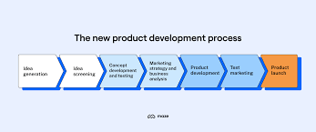
How to Improve an Existing Product
To improve an existing product, gather customer feedback to identify pain points, analyze user behavior, and then implement changes by adding new features, enhancing usability, adapting to changing needs, and conducting thorough testing to validate improvements; essentially, listen to your customers, understand their frustrations, and make targeted adjustments to address them while keeping market trends in mind.

CHAPTER FOUR
4.1 INTRODUCTION TO MANAGEMENT AND STRATEGY
Management and strategy" refers to the practice of planning, organizing, leading, and controlling an organization's activities to achieve its goals, by developing and implementing strategic plans that position the company favorably within its market, considering internal strengths and weaknesses alongside external opportunities and threats to gain a competitive advantage; essentially, it's about making informed decisions to navigate the business landscape and reach desired outcomes.

Key aspects of management and strategy:
- Strategic Planning:
Analyzing the current situation through SWOT analysis (Strengths, Weaknesses, Opportunities, Threats) to develop a long-term vision and set clear objectives for the organization.
- Strategy Formulation:
Creating a roadmap to achieve the goals by identifying the best course of action, including market positioning, product development, resource allocation, and competitive strategies.
- Implementation:
Putting the chosen strategy into action by assigning tasks, mobilizing teams, and managing resources effectively.
- Evaluation and Control:
Regularly monitoring performance against strategic goals, identifying deviations, and making necessary adjustments to stay on track.

How to Set Company Goals and Objectives
- Establish a clear vision and mission:
Understand the long-term direction of the company and what you want to achieve to guide goal setting.
- Perform a SWOT analysis:
Assess your company's internal strengths and weaknesses, along with external opportunities and threats, to inform goal setting.
- Use the SMART framework:
Ensure your goals are Specific, Measurable, Achievable, Relevant, and Time-bound.
- Identify key areas for focus:
Determine the most important aspects of your business to prioritize goals in areas like sales, market share, customer satisfaction, or operational efficiency.
- Break down large goals into smaller objectives:
Divide major goals into manageable steps with clear deadlines to track progress.
- Involve stakeholders:
Get input from different departments and levels within the company to ensure alignment and buy-in.
- Prioritize objectives:
Decide which goals are most critical and allocate resources accordingly.
- Develop action plans:
Create detailed plans with specific actions and responsible individuals for each objective.
- Communicate goals clearly:
Ensure all employees understand the company goals, their individual roles, and the expected outcomes.
- Regularly review and adjust:
Monitor progress towards goals, identify areas needing improvement, and make adjustments as needed.
Example of a SMART goal:
- Goal: Increase market share in the local region.
- SMART objective: "Increase market share by 10% in the next fiscal year by launching a targeted marketing campaign focused on new customer acquisition."

4.2 HOW TO RECORD PRODUCTION AND SALES DATA
Steps for recording production data
- Identify relevant metrics:
Determine which production details are critical to track, such as raw materials used, labor hours, machine downtime, units produced, and defects.
- Data collection method:
Choose a method to capture data, like manual entry on a production log sheet, using a dedicated production data collection terminal, or integrating with machinery to automatically record data.
- Record details consistently:
For each production run, log the date, time, product code, quantity produced, materials used, labor hours, any quality issues, and machine performance.
Key steps for recording sales data:
- Utilize POS system:
If applicable, use a POS system to automatically record sales transactions, including product details, quantity sold, price, customer information, and payment method.
- Manual recording:
If not using a POS, maintain a sales log to record each sale, including product details, customer information, price, and payment method.
- Sales channel tracking:
Differentiate sales based on sales channels like online store, physical store, or wholesale accounts.

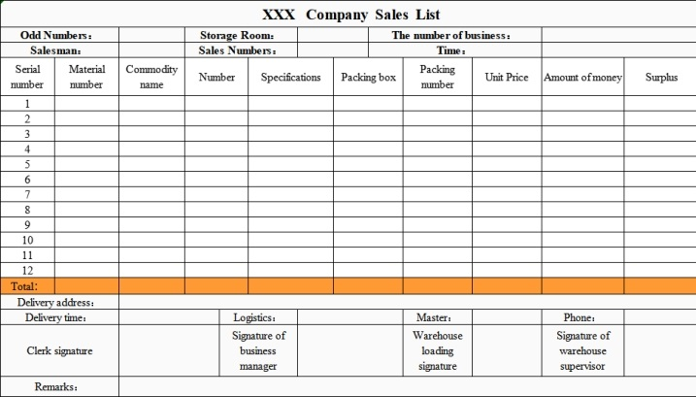

4.3 HOW TO ENSURE ADHERENCE TO REGULATIONS
To ensure adherence to regulations, an organization should: implement comprehensive compliance programs, regularly review policies, conduct internal and regulatory audits, provide ongoing employee training, and utilize compliance management software to monitor adherence and take corrective action when necessary; essentially fostering a culture of compliance within the company by keeping everyone informed and accountable for following regulations.

Steps to achieve regulatory adherence:
- Stay informed:
Regularly monitor changes in relevant regulations and industry standards to stay updated.
- Develop clear policies:
Create detailed policies and procedures that outline compliance requirements and expectations for all employees.
- Employee training:
Provide regular training sessions to educate employees on relevant regulations, company policies, and potential compliance risks.
- Risk assessment:
Conduct periodic risk assessments to identify potential compliance issues and prioritize mitigation strategies.
- Internal audits:
Perform regular internal audits to verify compliance with policies and regulations.
- Compliance monitoring:
Implement systems to monitor ongoing compliance with regulations and identify areas needing improvement.
- Reporting and corrective action:
Establish procedures to report non-compliance issues and take prompt corrective actions when necessary.
- Leadership commitment:
Ensure leadership actively promotes a culture of compliance and holds employees accountable for adherence.
- Utilize compliance software:
Consider using specialized software to streamline compliance management tasks, such as tracking policy updates, managing training records, and reporting on compliance metrics.

4.4 SIX SIGMA
Six Sigma is a quality management process that aims to reduce defects and improve the production of products and services. It's a statistical measurement of how far a process is from perfection.

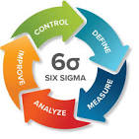

How it works
- Motorola developed Six Sigma in the 1980s.
- It's used in many industries, including manufacturing, healthcare, finance, and service.
- Six Sigma uses a step-by-step approach called DMAIC, which stands for define, measure, analyze, improve, and control.
- Lean Six Sigma combines Lean manufacturing principles with Six Sigma techniques.

Benefits
- Six Sigma can help improve customer satisfaction, reduce costs, and increase profits.
- It can help eliminate inefficiencies in a company's process flow.
- It can help identify the causes of waste or redundancy and develop solutions to address them.

Certifications
- Six Sigma Black Belt Certification provides knowledge of Six Sigma philosophies and principles.
- Six Sigma Green Belt Certification provides problem-solving skills, with an emphasis on the DMAIC model.

CHAPTER FIVE
5.1 CONCLUSION
The student industrial work experience scheme (SIWES) helps students to expand their knowledge and experience in their field of study. It will also help student whenever they come across it in future career.

5.2 RECOMMENDATION
The following are the suggested recommendation for the program
- The company should remain friendly and accommodating to future IT student.
- The SIWES coordinator and school should where organized enlightenment program for IT student in order to know the important of SIWES.
- The school (Polytechnics) should consider the four months mandatory SIWES while drafting the calendar for a successive session in a way that will affect the returning IT Student.

