

A TECHNICAL REPORT ON

STUDENT INDUSTRIAL WORK EXPERIENCE SCHEME (SIWES)
HELD AT

KWARA STATE BROADCASTING CORPORATION, RADIO KWARA,
2, POLICE ROAD, GRA, ILORIN KWARA STATE

BY

OMOTOYE DAMILOLA RACHEAL ND/23/MAC/PT/0159

SUBMITTED TO THE DEPARTMENT OF MASS COMMUNICATION
INSTITUTE OF INFORMATION COMMUNICATION TECHNOLOGY
KWARA STATE POLYTECHNIC, ILORIN KWARA STATE IN PARTIAL FUFILMENT OF THE REQUIREMENTS FOR THE AWARD OF NATIONAL DIPLOMA IN MASS COMMUNICATION

AUG - NOV, 2024

DEDICATION
This report is dedicated to my loving parent, Mr. and Mrs. Omotoye, my supporter, helper, adviser and also for their care before, during after the program. I will be forever be grateful to you daddy and mummy.

ACKNOWLEDGEMENT
I thank God Almighty for his mercy and grace that kept me all through my Industrial Training period.
I am greatly indebted to my parents, Mr. and Mrs. Omotoye for their financial and moral support during the course of the programme and also ensuring that my industrial training was worthwhile and fulfilling one.
I also want to thank everyone that contributed to the success of my industrial training, my industrial supervisor, Mrs Aremu Olubukola, my colleagues and co-workers.

TABLE OF CONTENTS
Cover Page Dedication Acknowledgement Table of contents Chapter One
Aims and objectives of SIWES Origin of SIWES
History of Radio Kwara Introduction
Chapter Two
What is news? Elements of news story Types of news story Organization chart
News written and interview on the effect of indiscriminate refuse dumping on water ways
Chapter Three
Problem faced during SIWES Types of Headlines
Front page of a newspaper
Arrangement and paragraph of news story Terminology used in journalism
Chapter Four
Quality of a good news story Important of headline in news story
Grammatical rules in writing headlines
Chapter Five Conclusion Summary

CHAPTER ONE AIMS AND OBJECTIVES OF SIWES
- To provide an avenue for students in Institutions of higher learning
to acquire industrial skills and experiences in their course of study.
- To provide students with an opportunity to apply their knowledge in real work and actual practice.
- To make the transition from school to the world of work easier and
to enhance students contacts for later job placement.
- Prepare students for industrial work situation they are likely to meet after graduation.
- Expose students to work methods and techniques in handling
equipment and machinery that may not be available in their institution.

ORIGIN OF SIWES
The Students Industrial Work Experience Scheme (SIWES) was initiated in 1973 by the Industrial training Fund (ITF). It is a tripartite programme involving the students, the Universities and industries. It is founded by the Federal Government of Nigeria and jointly coordinated by the ITF and the National Universities Commission (NUC).
It is a skill training programme designed to expose and prepare students of Tertiary Institution for the Industrial Work situation they are likely to meet after graduation. The scheme also exposing themselves to the needed experience in handling equipment and machinery.

HISTORY OF RADIO KWARA
In 1974, construction work started on the modern studio house, the 10kw short wave, and 20kw medium wave transmitting station sites.
These facilities were put in use as from 19th December, 1976. However, following the directive of the federal government, the short wave transmitter was closed down in 1978.
Kwara state Broadcasting corporation (Radio Kwara) as constituted today came into being the enactment of the kwara Edit No.3 of 1979, but

with retrospective effect from April 1st 1978. This was one of the beneficial by products of the first state creation in Nigeria.
On the creation of state in 1976, a master plan was drawn and approved for the country as to the number and capacity of transmitter and made of transmission to be sited in each location.
Owing to the topography of Kwara state, it was decided that it should be covered with both medium and short wave transmitters.
On 1st April, 1978. In compliance with federal Government’s objective which transferred all radio Nigeria stations in the state to their respective hosts states, the formal handling over of the station by the Nigeria Broadcasting Corporation (NBC) to the Kwara state government was performed by Horation Agedeh of the Federal Radio Corporation (FBC), Lagos on 5th September, 1978.
All the existing staff then was given the option of either staying with the corporation or going to the Federal Radio Corporation (FRC). Those who opted to stay were retained. Rolling to renovate the station with award of contract for the provision of modern studio equipment and additional 50kw Harris transmitter for the transmission, totaling over #300,000,000.
This singular development has made Radio Kwara not just one of few radio stations with installed digital studio in Nigeria, but one of the first stations in Nigeria to comply with the global directive on conversion from analogue broadcast to digital broadcast.
The general manager who by the edit of the corporation is a member of the board heads the management.
He is also to offer general advises to the board and management on statutory requirement and policy decisions of the board among others. Both are appointed by the executive governor, as may be delegated in the case of the corporation secretary. Usually, the corporation is split into six
(6) directorates (departments) of equals.

This is made up of administration which is the service department that looks after and keeps custody of records all staff and is in charge of correspondence.
Its specific function include; Implementation of policy decision, interpretation of staff regulations and government circulars and in-charge of general staff.
The other five are professional departments whose names are suggestive of their functions, V.I.O, Engineering, News and current affairs, programme, finance and marketing.
At the time of taking over by the state government, this station had a broadcasting house situated at the present premises and transmitting station located at Apata yakuba, along Jebba road, Ilorin.
It then had two 10kilowatts medium wave transmitter at Apata yakuba situation. The two inherited 10KW transmitters were very old. In fact, only one of them was working satisfactorily at the time of takeover in 1978.
In 1984, the federal government boosted the transmitting capacity of Radio Kwara through the kwara state government. The station that had two 50KW medium wave transmitter at Budo Efo, with this development, the state government approved the recommendation of the corporation to install the four (4) imported 10KW medium wave transmitters in the fringe areas of the Kwara state for effective coverage.
Two of them installed at Egbe, one at Otibe near Okene (both not Kogi state) and the fourth at Koro in New-Bussa (now in Niger state). All the three booster stations were completed.
In spite of the giant stride, in 1999, the transmitting station at Budo Efo witnessed serious set-back when the 840 feet tower mast was struck and destroyed by thunder storm.

This problem became a serious challenge to contend with, bearing in mind that transmitting station then became an integral part of Radio Kwara and a dendable in the performance of its statutory responsibility.
However, the government of Dr. Abubakar Bukola Saraki, on assumption of office in May 2003, set the ball for the purpose of achieving its objectives, the corporation is vertically structured to assure overall management efficiency and effectiveness, high degree of specialization, optimum span of control and clear lines of authority and responsibility.
The overall administrative machinery of the corporation is headed by the general manager who is the chief executive and is responsible for the effective implementation of the statutory responsibilities of the corporation and the decisions of the board and management.
Each of the department is further divided into divisions, braches and units. The overall objective of these divisions and sub-divisions is to ensure delegation of power and optimal efficiency.

DEPARTMENTAL STUCTURE OF RADIO KWARA
Generally, the corporation is divide into six directorates (Departments) of equal status. The Administration through the corporation secretary.
It organize co-ordinates, plans and personal to resources for the accomplishment of the objectives of the corporation.
News And Current Department: This gives information Of all governments activities at the federal, state and local level.
Programme Department: this is responsible for producing programmed and scheduling for broadcast as well as the audio visual library.
Sale And Marketing Department: This department is taking care of generating revenue for the station, through sales of airtime and other broadcast product.
Engineering Department: This is responsible for the controlling of technical input of the organization and ensures that they are in a good condition for effective passing across of message to the audience.
Financial Department: This is responsible for keeping of financial records of the organization, especially bank statement e.t.c INTRODUCTION
Training is a key factor in enhancing the efficiency and expertise of the workforce. The Students Industrial Work Experience Scheme (SIWES) programme prepares students for labour markets.

It has become an innovative phenomenon in human resources development and training in Nigeria. The media profession, like other professions is dynamic. This dynamism is in response to Information and Communication Technology (ICT).

CHALLENGES OF SIWES TO STUDENT
Problem I encountered during the programme was the problem of transportation. It is difficult for student that lives in far place to get to the organization every working days.

WHAT IS NEWS?
CHAPTER TWO NEWS

News is the account of event been gather and written to the reading pleasure or listen pleasure of the target audience.

ELEMENT OF NEWS STORY
Proximity: We can define it as someone that is closer to you or nearer to you, for example, if a air flight crashes and there are three Nigerians involves in the crash found dead and two hundred Americans dead in the crash, the people closer to you are the Nigerians. If you are ask to report the incident in your Newspaper company. The headline will be NIGERIA INFLATION RATE DROPPED BY 5% IN THE FIRST QUARTER OF 2024
Prominence: This is the act of been important among other, e.g. if the president of Federal Republic of Nigeria visited the Rector Kwara State Polytechnic while commissioning the academic conference centre of the Institution. The most important at the academic conference centre is the president because he is the number 1 citizen of the country.
Timeliness or immediacy: something that is happening now. News is what is new. An afternoon raid on a rock cocaine house may warrant a live ENG report during the 6p.m News. However, tomorrow, unless there are major new developments, the same story will probably not be important enough to mention.
Oddity: Whatever that is strange or unusual.

TYPES OF NEWS STORY
- Feature Story: This story is all about research, for radio or television you interview someone the source of the news story.
- Interpretative or indebt report: It is a story whereby you explain everything in detail account with a background story.
- Promotional Story: It is a story that is meant for promoting a particular person, organization or body.
- Factual Story: It is based on what happen directly telling us what happen or occur in an event.

NEWS WRITING AND INTERVIEW INTERVIEW
Interview: This is an act of getting news from the source and disseminating it to the audience.

SERIES OF INTERVIEW
One on one interview Complex interview Event interview

THINGS YOU HAVE IN MIND BEFORE CONDUCTING AN INTERVIEW
- Background information
- Bold enough to face any interviewee
- You must know what you want to ask about
- You must be very neat
- Serving the interviewee a notice
- You must allow the interviewee to explain in details
- You must have a recorder (midget)

CHAPTER THREE TYPES OF HEADLINES
- Rider Headline: This can be bold and tiny, it has sub-headline
under it.
- Kicker Headline: It kick start the news directly and is not allowed in newspaper, rather use comma.
- Pan left or right Headline: They are arranged in either left side or right side of the Newspaper.
- Banner Headline:A large Newspaper headline, especially one across the top of the front page.

FRONT PAGE OF A NEWSPAPER
- Most head or name plate
- Name of the Newspaper
- Date
- Amount
- Online address
- Number
- Email
The date, amount, online addresses, numbers, e-mail on the front page of newspaper are called folio.

ARRANGEMENT AND PARAGRAPH OF A NEWS STORY
- The headline
- The byline
- The lead
- The body
- The conclusion
The first paragraph is called the head, the second paragraph must entails the whole 5ws and H, the third paragraph must entails the full story of the lead and the last part of the news is the conclusion.

TERMINOLOGY USED IN JOURNALISM
Alleged, Debunked, Commission, Inaugurate, Displeasure, Expressed, Blasted, Played, Protest, Stressed, Noted, Said.

CHAPTER FOUR QUALITIES OF A GOOD NEWS STORY
Accuracy: It must be very accurate, free from error
Balance: Every part that is involved may say something
Truthful or objective: It must be factual; the story must be truthful exactly what happen
Recent or timeliness Straight to the point

IMPORTANCE OF HEADLINE IN A NEWS STORY
It must be attract the reader
It makes readers to decide whether to move further It makes a Newspaper better sale

GRAMMATICAL RULES IN WRITING HEADLINES
- You must make use of present simple tense. For example STATE GOVERNMENT CONFOUNDS BURSARY AWARD TO STUDENT
- Always do away with auxiliary verb, for example, if a new policy has been decided by the new parliament.
- Always use infinitive for future event, for example WILL in the headline change to- TO, and in the body it will change to would.
- Leave out article in any news headlines, for example GUN MEN KIDNAPS MAN ASK FOR RANSOME
- Always replace conjunction with punctuation marks, e.g. APC OFFICE INVASION: DSS SHUNS COURT ORDER

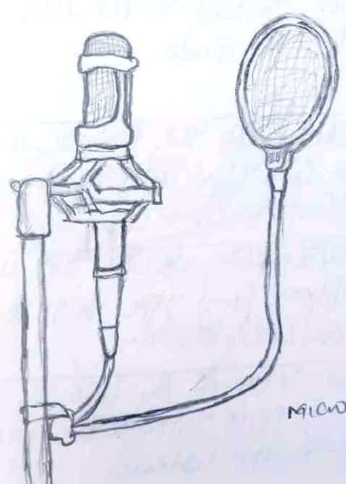
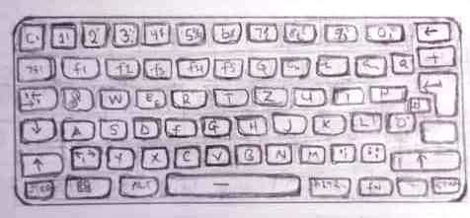
STUDIO EQUIPMENTS
MICROPHONE KEYBOARD
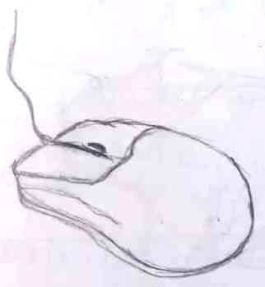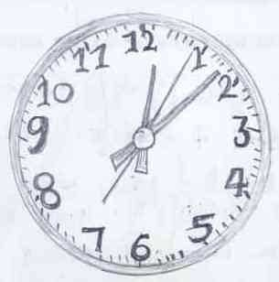
MOUSE CLOCK
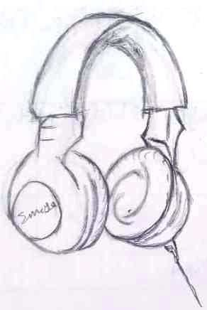
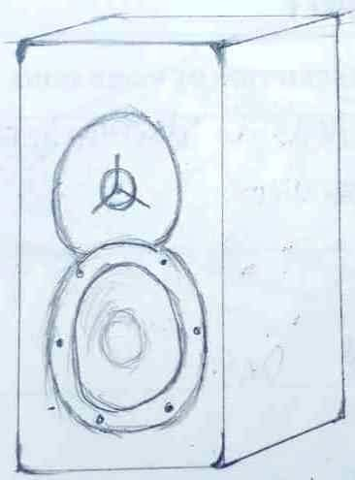
HEADSET SPEAKER

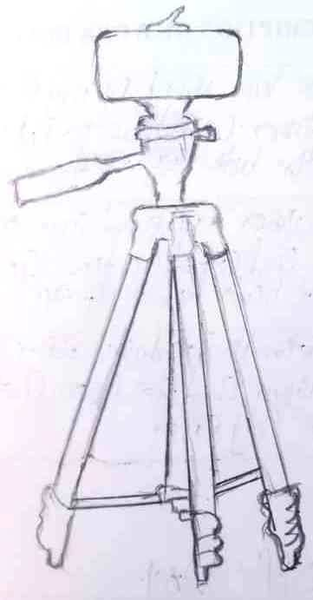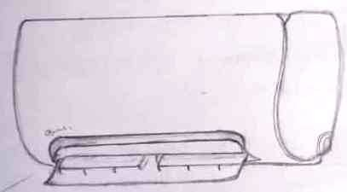
CAMERA AIR CONDITIONER
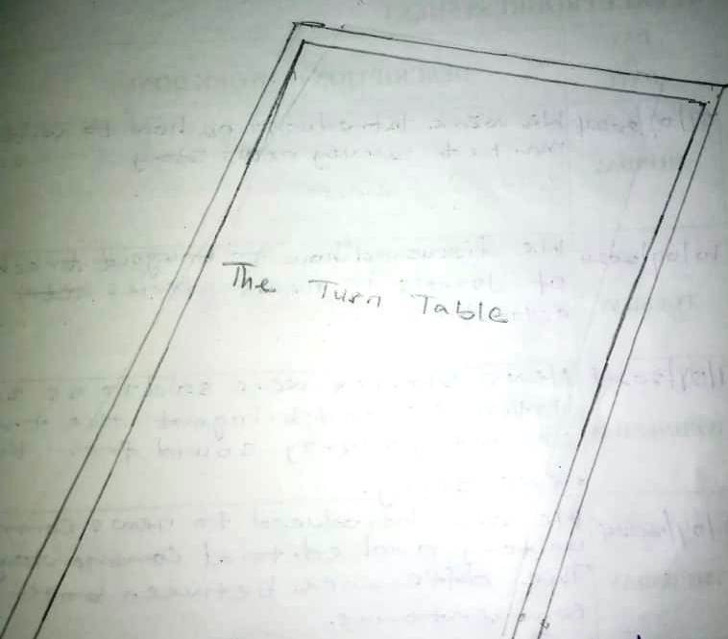
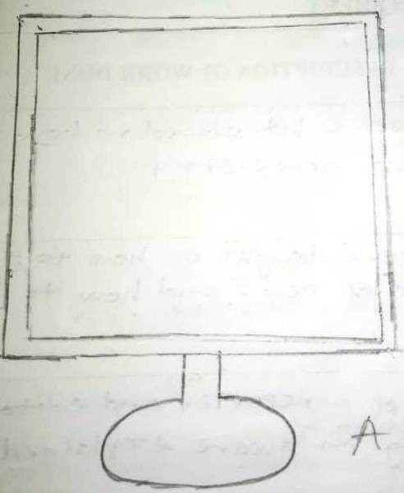
TURN TABLE MONITOR
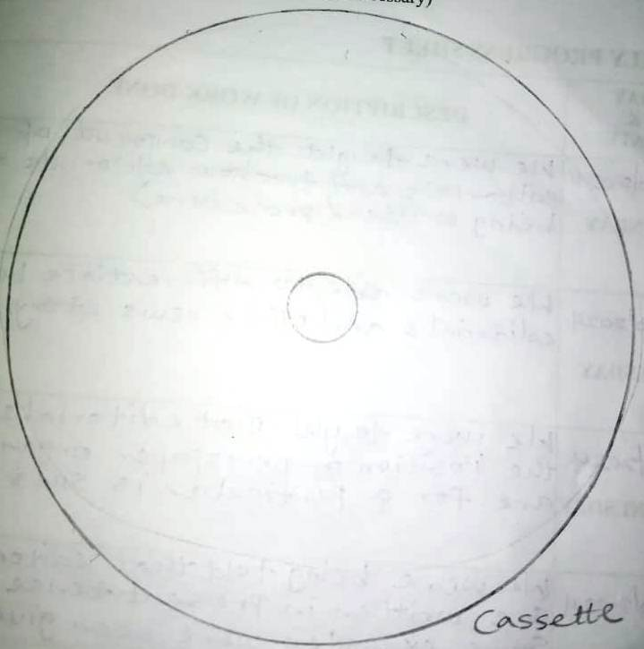

DISC

CHAPTER FIVE SUMMARY
The Student Industrial Work Experience Scheme (SIWES) has been a pivotal platform for honing my skills in information processing, management, preservation, and documentation. This practical experience has seamlessly complemented my academic knowledge, providing me with invaluable insights into real-world applications. The hands-on training offered during SIWES has been instrumental in bridging the theoretical gap, offering me a firsthand understanding of industry practices. Consequently, SIWES has played a crucial role in my professional development, equipping me with practical skills essential for success in my field.

CONCLUSION
The evaluation conducted thus far reveals a significant gap between the intended objectives of the Students Industrial Work Experience Scheme (SIWES) and its actual implementation. It is concerning to observe that a lack of proper coordination and supervision has hindered the full realization of SIWES objectives. This highlights the critical need for collaborative efforts from all stakeholders to ensure that students are adequately equipped with the skills and knowledge required for workplace efficiency. The Federal Government, along with the Industrial Training Fund and other relevant agencies overseeing the SIWES program, must take proactive steps to address the existing shortcomings in the system. By doing so, they can mitigate the challenges faced by students during their industrial training and enhance the overall effectiveness of the SIWES program. It is imperative that all parties involved work together to strengthen the implementation of SIWES and provide students with valuable learning experiences that align with the program's objectives.

