

TECHNICAL REPORT ON STUDENT INDUSTRIAL WORK EXPERIENCE SCHEME (SIWES)

UNDERTAKEN AT
FORESCRAFT NIGERIA LIMITED & KASHAMADUPE FARM SERVICE
KM 5, Ajala Street, Off Atiku Abubakar Road, Ilorin

PRESENTED BY
AHMOD MUBARAK ALADE
ND/23/AGT/PT/0025

SUBMITTED TO:
THE DEPARTMENT OF AGRICULTURAL TECHNOLOGY, INSTITUTE OF APPLIED SCIENCES, KWARA STATE POLYTECHNIC, ILORIN.

IN PARTIAL FULFILLMENT FOR THE REQUIREMENT OF THE AWARD OF NATIONAL DIPLOMA IN
AGRICULTURAL TECHNOLOGY

AUGUST TO NOVEMBER, 2024

ACKNOWLEDGEMENT
I wish to register my profound gratitude to Allah Almighty for the guidance and grace throughout my life.
My appreciation goes to the entire staff of FORESCRAFT NIGERIA LIMITED & KASHAMDUPE FARM SERVICE for making industrial training interesting educative and worthwhile. My appreciation also goes to my industrial based supervisor ALHAJI ABDULWAHAB KAMALDEEN O., whose accessibility. Unitary effort, patient and guidance and suggestion fabulously contribution to the completion of this report, may God continue to guide and protect them and their family.

TABLE OF CONTENT
Title page
Acknowledgement
Table of content
CHAPTER ONE
1.0 Introduction of SIWES
1.1 Aims of SIWES
1.2 Objectives of SIWES
CHAPTER TWO
2.0 Background History of the Establishment
2.1 History of Forescraft Nigeria Limited
2.2 Transition into Hatchery Operation
2.3 Expansion into Breeding
2.4 Impact and Growth
2.5 Locational Plan
2.6 Organogram
CHAPTER THREE
3.1 Technical Training Experience
3.2 Fishery Unit
CHAPTER FOUR
4.1 Poultry Unit
4.2 Brooding of day old Chick
4.3 Medication and Vaccination
4.4 Daily Routine Management
4.5 Feeds and Feeding of Birds (DOC)
CHAPTER FIVE
5.0 Recommendation and Conclusion
5.1 Recommendation
5.2 Conclusion
CHAPTER ONE
1.0 INTRODUCTION OF SIWES
SIWES simply refer to students industry work experience scheme, is a skill training programme deigned to expose and prepare students of universities, polytechnics, college of technology, colleges of agriculture and colleges of education for the industrial work experience they are likely to meet after graduation. The pogramme also affords student the opportunity of familiarizing and exposing themselves to the needed experience in handling equipment and machinery that are usually not available in their institutions.
Before the establishment of the scheme, there was a growing concern among industrialist that graduates of tertiary institution lacked adequate practical background preparatory for employment in industries. That is, the employers were of the opinion that the theoretical education going on in institutions for initiating and designing the scheme by the fund during it’s formative years 19673 – 94 was introduced to acquaint student with skill of handling employers and machinery.
1.1 AIMS OF SIWES
- To expose students of higher place of learning to the practical aspects of what they are being taught in school and prepare them for future work related experiences.
1.2 OBJECTIVES OF SIWES
- To prepare for the industrial work experience they are to undergo after graduation
- To expose student to work method and techniques in handling equipment and machinery that may not available in their institution.
- To provide student opportunity to see the world of theirs.
CHAPTER TWO
2.0 BACKGROUND HISTORY OF THE ESTABLISHMENT
2.1 HISTORY OF FORESCRAFT NIGERIA LIMITED
Forescraft Nigeria Limited is a fish farming business located on Ajala Street, Off Atiku Abubakar Road, Ilorin.
The company was established in 2009 with the goal of producing high quality fish for commercial purpose. Since its inception, it has grown into a reputable agriculture enterprise, specializing in fish breeding, juvenile production and hatchery operations.
The company started its operations in 2009 by constructing a fish pond for rearing fish under Alh. Abdulwahab Kamaldeen O. Initially, the founder started with just a few concrete pounds focusing on juvenile production. At suppliers, which took approximately two months before they reached a marketable size. This reliance on external sources posed challenges including inconsistent supply and varying quality of juveniles.
2.2 TRANSITION INTO HATCHERY OPERATION
Determined to improve efficiency and reduce dependency on external suppliers, the founder decided to venture into hatchery operations. In 2014, he took the initiative to learn the process of fish hatching himself. This marked significant milestone in the company’s history, and it allowed for better control over the quality of juvenile fish and ensured to steady supply for production. Since then, Forescraft Nigeria Limited has continued to progress in fish farming, incorporating modern techniques to improve its output.

2.3 EXPANSION INTO BREEDING
By 2023, the company has expanded its operations by creating breeding ponds specifically for hatching fish eggs.
This development enabled for founder to fully transition into independent fish breeding with the ability to produce between 50,000 and 100,000 juvenile fish at a time, the hatchery operations, which previously required sourcing form other suppliers, were now handled entirely in – house the breeding cycle typically takes between three to ten days, allowing for faster and more efficient production.
2.4 IMPACT AND GROWTH
Over the years, Forescraft Nigeria Limited has made notable contributions to the aquaculture industry by producing high – quality fish stock for local markets. The company’s ability to hatch and breed fish independently has positioned it as a key player in the fish farming section through continuous learning, innovation and expansion, the business has remained sustainable and profitable.
The journey of Forescraft Nigeria Limited highlights the importance of adaptation and self – sufficiency in agribusiness from starting with a small concrete pond to establishing a full-fledged hatchery and breeding system, the company’s growth reflected its commitment to excellence in fish farming.
With a solid foundation in aquaculture, Forescraft Nigeria Limited is well – positioned for further expansion and long – term
Division/Units => Fishery and Poultry Production (Layers)
Division/Unit
Fishery
Poultry

2.5 LOCATIONAL PLAN
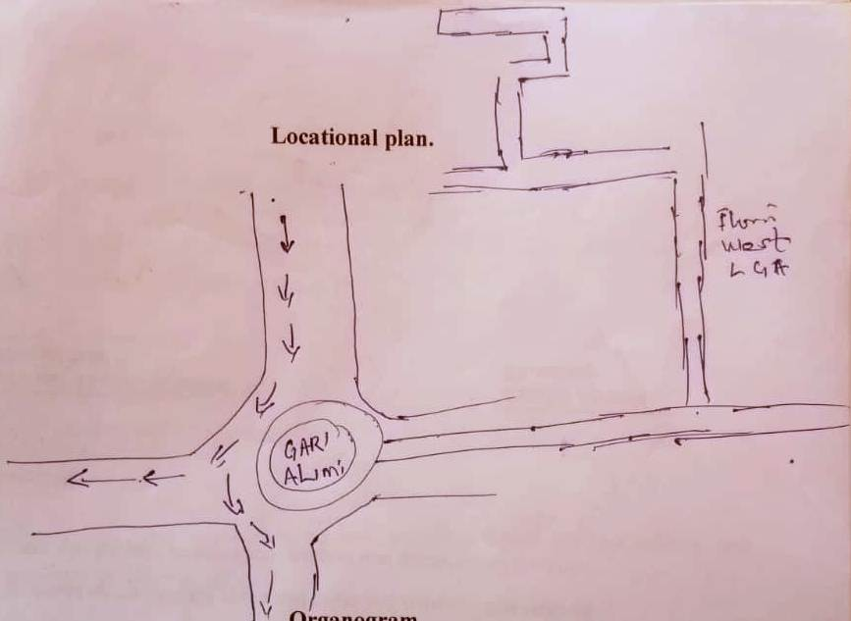

2.6 ORGANOGRAM
Director (Owner)
MANAGER
Supervisor Fish Section
Supervisor Poultry Section
Workers
Workers
Workers
Workers
Workers
Workers

CHAPTER THREE
3.1 TECHNICAL TRAINING EXPERIENCE
At my SIWES placement Forescraft Phase I and II there were two major division/unit as their area of specialization
Division / unit/ section
- Fishery unit / section
- Poultry unit / section
3.2 FISHERY UNIT
At fishery unit were exposed to various technical aspect of fish rearing and management as follows:
- Fish and fishes types
- Feed, types feeding of fishes
- Water and water management of fish
- Pond, pond types and ponds management
- Fish breeding
- Spawning
- Identification of male and female fishes
- Fish life – stages
- Aquarium and preparation of aquarium of hatchery
- Stimulating reproduction hormones ovulars /ovaporum
- Fish: is an aquatic animals that fed phytoplant zooplanton and artificial for cultured aquatic animals (fish).
Fishery: is the art and sciences of fish rearing and their management of modern day aquatic animals culturing (fish).
Aquaculture: the sciences of rearing fishes under a difference water bodies i.e. concrete pond, plastic panel vert. earthen pond etc.
At my SIWES farm we were introduced and exposed to majorly African cat fish or mudfish also called clarias garipons. Though we were informed that there were other fishes that can be cultured in Kwara Stat i.e. Tilapia.
Feed Types And Feeding Of Fish
We were introduced to different feeds and feed types based on the fish sizes, this led us to we the farm supervisor called fish life – stages.
Feed
- Pelleted fish
- Powder fish feed
- Pelleted or pellet fish feed was made out of the following feed ingredients.
- Maize
- Soya bean
- G.N.C Ground nut cake
- Starch
- Lysin
- e.t.c.
- Powder fish feed was also made out of the above ingredient but they are majorly imported i.e. (Artemia).
Fish life – stages of their Feeds
Fish => fry Fingerlins Juvenine Table size

Feed => Artemia Pellet Pellet Pellet

Feeding of fishes
We were introduced to feeding of fish techniques and we practiced the feeding based on roster and time to feed.
When and how to feed fish
We feed fishes in the morning and examine the supervisor said we are to follow the trend since they are under artificial management.
Morning within the hours of 7:30 – 8:30am
Evening within the hour of 4:30 – 5:30pm
Application was by broadcasting at a targeted point.
Water water source and water management
Water is liquid oxygen and the supervisor informed us the fish is water and water is fish once there is no water nobody can plan or thinks of rearing fishes. With this to set-up fish farm there must be reliable and constraint water source and supply.
Reliable Water source of fish rearing
- Stream / river water following => 100% oxygen level
- Well water => 85 – 75% oxygen level
- Borehole water = 50 – 45% oxygen level
- Stagnate water is not advisable.

Pond Water Management
The best water management apart from getting the water from reliable source, the pond water must be change when observed the algae in water hail seven loose in water like particle and perceiving differently odour in the water bodies.
Pond Pond types and Pond Management
Pond simply refer to housing for fishes and its can be of different types based on types, structure and material used.
Pond types
- Earthen pond
- Concrete pond
- Plastic pond
- Vert or Thapoly framework
At my SIWES place no were majorly exposed to Earthen and concrete pond and maintenance.
Pond Management
The farm supervisor transformed us that we should make some that the following management practices.
- Pond should left to total dryness for mouth
- Any dirty water in nay pond must drained off
- For any earthen pond, it’s must cleared and re-excavated yearly.
Breeding /Hatchery
Breeding is an art and science of reproduces anther young fishes of it’s kind of the parent stock.
Breeding can also be refer to as hatching for any artificial breeding or hatchery, as should be artificial stimulating hormones known a outlines or overporim.
When we were to carried out breeding or hatching we carried out fish selections based on
- Gender, males and females
- Maturity in males – pink tips of penis
- Maturity in female – golden brown egg
- Dose of administer of hormones
Stage II, we were taught preparation of housing or space to hatch or breed out fertilized egg in known as aquarium
Stage III, we filled the aquarium with water and we sett in the west called Kabar.
Stage IV, the supervisor carried out the injection of the females fish with ovulin to stimulate the released of the egg in the next 16 – 18 hours.
Stage V, spawning follows, spawning is the gentle press on the belly of the female fish for the release on the egg of fertilization.

CHAPTER FOUR
4.1 POULTRY UNIT
We were taught and identified that poultry are birds of any difference kinds and they are classified as mongrastric animals i.e. local cock, hen hybrid birds ranges from cocokrel, boiler layers noiler, ducks, geese, ostreg, etc.
At poultry units we were taught and had a technical training on the following.
4.2 BROODING OF DAY OLD CHICKS (DO)
With the help of industrial based supervisor we purchased day old chicks for brood and brooding management
We made used of the following materials for brood and brooding management
      - Brooding pen or cage
- Dislufecent; for dislufect pen or cage against any diseases
- Heat source: be it electiciites heat generating bulbs, charcoal coolpot
- Brightness source: bulb, lanta dry cell battery touch light
- Drinks, feeders, drugs, feeds, vaccine
- Needle and syringe.
4.3 MEDICATION AND VACCINATION
We were showed difference poultry drugs and how to medicate poultry birds at day old likewise at adult example drugs used are Embaz in forth, anacinlin antibiotic maltivitamines oxtetracylin power and injectable.
Vaccine and vaccination
Vaccine and hormones instored on luingorgansim to prevent deadly infestion that can calm poultry birds to death.
TYPES OF AVAILABLE VACCINE
Lasto ta vaccine
Gomboro vaccine
Fow pox vaccine
Kamorov vaccine
Vaccination programme we were exposed to during SIWES for broiler day old birds
Days | Vaccine | How we administer
Before 10days old | Lastoal | Oral, inside water through mouth
Before 14days | 1st gomboro | Oral, inside water through mouth
Before 21days | 2nd lastoa | Oral, inside water through mouth
Before 28days | 2nd Gomboro | Oral, inside water through mouth

3.4 DAILY ROUTINE MANAGEMENT
Everything we cleaned the pen/cage, washed their drinker for another fresh water or if there was need to applied drugs or medicant for medication.
NB We were taught that we should be giving preventives antibiotic at every two to three weeks for three to five days to prevent infection that those birds might picked along with feed or with water or on the floor.
Also any applied drugs that lapse 24hours most be discard and washed the drink or with ordinary water or water solution provided the materials to washed should not be metalics.

4.5 FEEDS AND FEEDING OF BIRDS (DOC)
During the SIWES we were exposed to difference feeds and the feed ingredients constituent in feed type.
Chick starter or broiler starter from day one till 4weeks
Broiler finisher 4weeks till 8 to 12weeks
Grower mash 6weeks till table size for cocreals and 10% egg drop for layers.
Layers mash After 10% egg dropped till spent or old layers
Some Available feeds ingredient of different proposition
Maize
GNC (Ground-nut cake)
Soya beans
Fish
PKC (Palm Kernel Cake)
Bone meal
Micro nutrient
Lysine
Methionine
Premix
Salt

CHAPTER FIVE
RECOMMENDATION AND CONCLUSION
RECOMMENDATION
SIWES Programe is an interested practical and working experience which facilitate familiarity with working act, tools and machinery handling for student such graduate and under graduate with these view. It is highly recommend that federal governments should fund the programme for more better efficiency.
CONCLUSION
In conclusion SIWES programme it’s what of continuity with strong monitoring by the (ITF) officers and various higher places of learning to make sure that their students are fully participate in the programme for better working experience for great better nation ahead.

