

A TECHNICAL REPORT
STUDENT INDUSTRIAL WORKING EXPERIENCE SCHEME
(SIWES)

HELD AT:
MICTORY FARM ALONG EYENKORIN GAA ODATA ILORIN, KWARA STATE

PREPARED BY:
OLASUPO OMOTOLANI BOLUWAJI
ND/23/BAM/PT/0558

SUBMITTED TO:

DEPARTMENT OF BUSINESS ADMINISTRATION AND MANAGEMENT
KWARA STATE POLYTECHNIC, ILORIN

IN PARTIAL FULFILLMENT OF THE REQUIREMENTS FOR THE AWARD OF NATIONAL DIPLOMA (ND) IN BUSINESS ADMINISTRATION AND MANAGEMENT

Sept., – Nov., 2024
DEDICATION
I dedicate this technical report to the Almighty GOD, the giver of knowledge, wisdom and who is rich in mercy.

ACKNOWLEDGEMENT
I take this opportunity to express my profound gratitude and deep regards to the creator of heaven and earth, the one who knows the beginning and the end, the alpha and the omega. my sincere gratitude also goes to my guidance MR. & MRS. OLASUPO for their financial support and word of encouragement during my SIWES Programme and also to those who stood by me during my SIWES programme, thank you all. I also take this opportunity to express a deep sense of gratitude to compliment my supervisor at my place of attachment for taking her time for my practical knowledge and for her cordially support, valuable information and guidance which helped me in completing my SIWES through various stages may Almighty God bless you abundantly.
TABLE OF CONTENT
Dedication
Acknowledgement
CHAPTER ONE
  - Introduction to SIWES
  - History of SIWES
  - Objectives of the Programme
  - Objectives of Establishment
CHAPTER TWO
2.1 Activities of place of Attachment
2.2. Precaution Taken in the Place of Attachment
2.3 Organizational Product and Benefits
CHAPTER THREE
Reporting on Work Carried Out
3.1 Reporting on Daily Work Carried Out
CHAPTER FOUR
Challenges Encounter In Place of Attachment
CHAPTER FIVE
Summary, Conclusion and Recommendations
5.1 Summary
5.2 Conclusion
5.3 Recommendations
CHAPTER ONE
  - INTRODUCTION TO SIWES
Students Industrial Work Experience Scheme (SIWES) is a Skills Training Program designed to prepare and expose Students of Universities, Polytechnics, Colleges of Technology, Colleges of Agriculture and Colleges of Education for the Industrial Work situation they are likely to meet after graduation. The Scheme affords Students the opportunity of familiarizing and exposing themselves handling equipment and machinery that are usually not available in their institutions.

1.2 HISTORY OF SIWES
The Students’ Industrial Work Experience Scheme (SIWES) was initiated in 1973 by the Federal Government of Nigeria under the Industrial Training Fund (ITF) to bridge the gap between theory and practice among products of our tertiary Institutions. It was designed to provide practical training that will expose and prepare students of Universities, Polytechnics, and Colleges of Education for work situation they are likely to meet after graduation.
Before the establishment of the scheme, there was a growing concern among the industrialists that graduates of institutions of higher learning lacked adequate practical background studies preparatory for employment in industries. Thus the employers were of the opinion that the theoretical education going on in higher institutions was not responsive to the needs of the employers of labour.
As a result of the increasing number of students’ enrolment in higher institutions of learning, the administration of this function of funding the scheme became enormous, hence ITF withdrew from the scheme in 1978 and was taken over by the Federal Government and handed to National Universities commission (NUC), National Board for Technical Education (NBTE) and National Commission for Colleges of Education (NCCE). In 1984, the Federal Government reverted back to ITF which took over the scheme officially in 1985 with funding provided by the Federal Government.
1.3 OBJECTIVES OF THE PROGRAMME
The specific objectives of SIWES are to:
- Provide placements in industries for students of higher institutions of learning approved by relevant regulatory authorities (NUC, NBTE, NCCE) to acquire work experience and skills relevant to their course of study
- Prepare students for real work situation they will meet after graduation.
- Expose students to work methods and techniques in the handling of equipment and machinery that may not be available in schools.
- Make transition from school to the labour market smooth and enhance students’ conduct for later job placement
- Provide students with the opportunity to apply their knowledge in real life work situation thereby bridging the gap between theory and practice
- Strengthen employer involvement in the entire educational process and prepare students for employment in industry
- Promote the desired technological knowhow required for the advancement of the nation.
1.4 OBJECTIVES OF ESTABLISHMENT
The specific objectives of establishment are to:
- Ensure the health and well-being of livestock through proper care, housing, and nutrition.
- Implement environmentally sustainable farming practices to minimize ecological impact and promote biodiversity.
- Achieve financial success by maximizing production efficiency and optimizing market strategies.
- Produce high-quality meat, milk, and other animal products that meet or exceed market standards.
- Explore new markets and expand distribution channels to increase sales and brand presence.
- Adopt new technologies and practices to improve productivity, animal health, and product quality.
- Foster good relationships with local communities and stakeholders, contributing to social and economic development.
- Adhere to all relevant regulations and standards in livestock management and animal health.
- Invest in research to enhance breeding programs, disease management, and overall livestock genetics.
- Provide training for employees and stakeholders to ensure best practices in livestock management and care.
CHAPTER TWO
2.1 ACTIVITIES OF PLACE OF ATTACHMENT
The experience, knowledge, skills and exposure acquired during the period of attachment in the industrial exercise cannot be over emphasized. I was exposed to certain areas in my course of study, such as:
- Chick Production
- Breoder Management
- Disease Management and Bio security
- Nutrition and Feeding Strategies
- Feed Cost Control
- Layer Management and Egg Production
- Feed Fermulation
- Livestock Nutrition
- Turkey Management
- Farm Policy
- Nutritional Impact
- Feed Storage and Handling
- Sales Strategies and Techniques
- Nutrition Planning
- Pig and Goat Managent

2.2. PRECAUTION TAKEN IN THE PLACE OF ATTACHMENT
- Implement strict biosecurity protocols to prevent the introduction and spread of diseases.
- Control access to farms and maintain hygiene practices.:
- Conduct routine veterinary inspections and vaccinations for livestock.
- Monitor animals for signs of illness and respond promptly.
- Ensure adequate shelter and space for animals to prevent overcrowding.
- Maintain clean and well-ventilated living conditions to reduce stress and disease risk.
- Provide balanced diets tailored to the specific needs of different livestock species.
- Ensure access to clean water at all times.
- Train employees on safe handling practices and emergency procedures.
- Use appropriate personal protective equipment (PPE) when working with animals and machinery.
- Implement waste management systems to handle manure and other by-products responsibly.
- Monitor and manage the impact of farming practices on local ecosystems.
- Develop emergency plans for natural disasters, disease outbreaks, or other crises.
- Equip facilities with necessary tools and resources for quick response.
- Maintain accurate records of animal health, breeding, and vaccinations.
- Track feed and medication usage to ensure compliance with regulations.

2.3 ORGANIZATIONAL PRODUCT AND ITS NUTRITIONAL BENEFIT

EGG
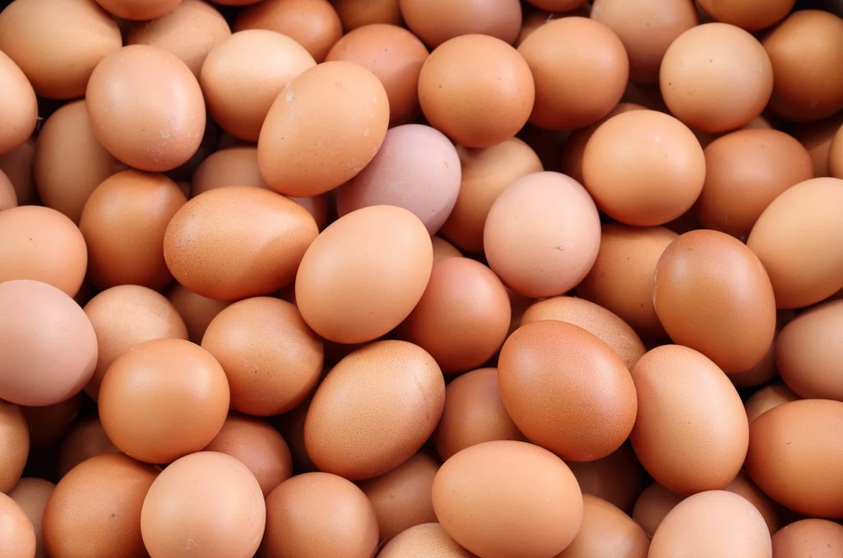

Nutritional Benefits:
Protein: Excellent source of high-quality protein.
Vitamins: Rich in vitamins A, D, E, and B12, along with choline, important for brain health.
Healthy Fats: Contains omega-3 fatty acids (if enriched) which benefit heart health.

LEATHER AND HIDES


Nutritional Benefits:
While not directly consumed, leather products are derived from livestock and provide durable materials for clothing and accessories.
Collagen from hides can be beneficial for joint health when used in supplements.

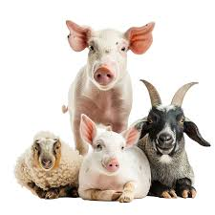
MEAT

Types: Beef, Pork, Lamb, Chicken, Turkey, etc.
Nutritional Benefits:
Protein: High-quality protein source essential for muscle growth and repair.
Vitamins: Rich in B vitamins (B12, niacin, riboflavin) that support energy metabolism.
Minerals: Good source of iron (heme iron), zinc, and selenium, which are vital for immune function and overall health.

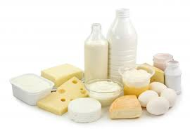
MILK AND DAIRY PRODUCTS

Types: Whole milk, skim milk, cheese, yogurt, butter, etc.
Nutritional Benefits:
Calcium: Important for bone health and development.
Protein: Provides casein and whey proteins essential for muscle maintenance.
Vitamins: Contains vitamin D, which aids in calcium absorption, and vitamin B12.

ANIMAL FEED AND SUPPLEMENTS

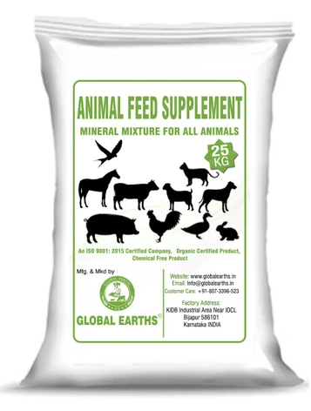
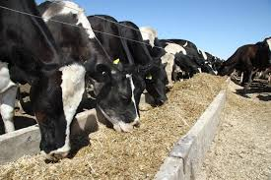

Nutritional Benefits:
While not directly a consumer product, high-quality animal feed contributes to the health of livestock, leading to better quality meat and dairy products for consumers.

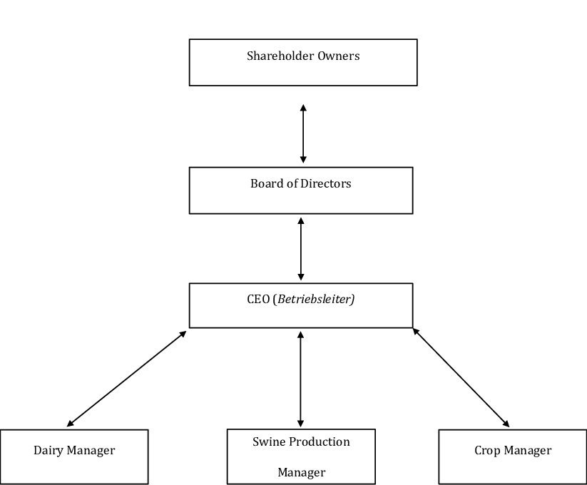
ORGANIZATION STRUCTURE/ORGANOGRAM

CHAPTER THREE
REPORTING ON WORK CARRIED OUT
3.1 Reporting on Daily Work Carried Out
WEEK 1: I was introduced to all member in the organization and I was given rules and regulation of the organization
WEEK 2: I learnt about breoder management and chick production
WEEK 3: I learnt about disease management and biosecurity for disease precaution
WEEK 4: I learnt about nutrition and feeding strategies for nutritional planning
WEEK 5: I learnt about layer management and egg production
WEEK 6: I learnt about feed formulation and production for layers and understanding nutritional requirements
WEEK 7: I learnt about pig and goat management and how to do feed formulation for effective production
WEEK 8 : I learnt about feed storage and handling, also, I learnt about marketing sales strategies
WEEK 9: I learnt about feed cost control and budgeting for cost reduction
CHAPTER FOUR
CHALLENGES AND GAIN ENCOUNTER IN PLACE OF ATTACHMENT

GAINS
- Practical exposure to livestock management, animal care, and farm operations enhances learning.
- Acquisition of technical skills related to animal husbandry, veterinary practices, and farm management.
- Building relationships with industry professionals as lead to future job opportunities.
- Insight into best practices and regulatory requirements within the livestock industry.
- Learning to address real-world challenges and make decisions in a dynamic environment.
- Exposure to various roles within the livestock sector helps clarify career interests and goals.
- Opportunities to contribute positively to animal care and welfare initiatives.

CHALLENGES
- Working with livestock can be physically demanding, requiring strength and stamina.
- Exposure to animals cause health risks, including zoonotic diseases. Proper safety measures are essential.
- Dealing with sick or injured animals as been emotionally challenging.
- Balancing practical work with academic responsibilities as been difficult.
- The work environment is noisy, dirty, and require adaptation to unpleasant odors.
- Understanding and adhering to industry regulations as been a complex and overwhelming.

CHAPTER FIVE
SUMMARY, CONCLUSION AND RECOMMENDATIONS
5.1 SUMMARY
Livestock company offers numerous opportunities, including access to a growing market, potential for innovation, and the chance to engage with well-established brands. Dedicated and knowledgeable professional with experience in livestock management and animal husbandry. Skilled in overseeing animal care, nutrition, and health, ensuring compliance with industry standards and regulations. Proven ability to manage breeding programs, monitor herd health, and implement sustainable farming practices. Strong communication and teamwork skills, with a commitment to enhancing productivity and welfare in livestock operations.
5.2 CONCLUSION
Working in a livestock company requires a strong understanding of animal husbandry, market dynamics, and sustainable practices. The industry plays a vital role in food production and contributes significantly to the economy. Professionals in this field must be adaptable, knowledgeable about animal welfare, and committed to improving practices to enhance efficiency and sustainability.
5.3 RECOMMENDATIONS
- SIWES supervisors should make sure they visit the students in their place of attachment for proper monitoring, improvement and progress for the benefit of the societies as a whole.
- Employees should seek ongoing training and education to stay updated on industry trends and technological advancements.
- Regularly update your knowledge of industry trends, consumer preferences, and regulatory changes to stay ahead of the competition.
- Focusing on eco-friendly practices and sustainable materials can enhance the company’s brand image and appeal to environmentally conscious consumers.
- Engage in ongoing training and workshops to stay updated on best practices, regulations, and innovations in livestock management.
- Implement and promote sustainable farming practices that reduce environmental impact and enhance resource efficiency.
- Build relationships with other professionals in the industry to share knowledge and collaborate on common challenges.

