

STUDENTS’ INDUSTRIAL WORK EXPERIENCE SCHEME (SIWES)

HELD AT
AUTOMATIC NIGERIA LTD, ILUPEJU BYPASS, ILUPEJU,
LAGOS STATE

BY
ABOLAJI BABAJIDE
ND/23/MEC/FT/0029

SUBMITTED TO THE DEPARTMENT OF MECHANICAL ENGINEERING, INSTITUTE OF TECHNOLOGY, KWARA STATE POLYTECHNIC, ILORIN, KWARA STATE

SEPTEMBER-DECEMBER, 2024

DEDICATION
This report is dedicated to Almighty for the successful completion of this SIWES work

ACKNOWLEDGEMENTS
I give thanks to Almighty God for the successful completion of this SIWES programme. Special thanks to the management of Automatic Nigeria Ltd for the time been spent with them.
Lastly, my appreciation goes to all those who were supportive in one way or the other during the course of this programme.

OUTLINES
Chapter One
Introduction 1
Objectives of the SIWEC Program 2
About Organization 2
Chapter Two
Activities undertaken during the Program 5
Skills and Knowledge Acquired 6
Chapter Three
Challenges Faced 8
Chapter Four
Conclusion 10
Recommendations 10

CHAPTER ONE
INTRODUCTION
The Student Industrial Work Experience Scheme (SIWES) was established in 1973 by the Industrial Training Fund (ITF) under the federal government of Nigeria. This initiative was introduced during the administration of General Yakubu Gowon, as a response to the increasing gap between theoretical knowledge acquired in academic institutions and the practical skills required in the workforce. Recorgnizing the challenges faced by students in gaining hands-on experience, SIWES was created to bridge this gap by providing students with a platform to acquired practical skills relevant to their fields of study.
Initially targeted at students in science, technology, engineering and related disciplines, the scheme has since expanded to accommodate students from other fields, such as business administration mass communication and social sciences. The primary aim of SIWES is to expose students to industrial work settings, allowing them to gain practical knowledge, develop technical skills and understand workspace dynamics before graduation. This ensures that students are better equipped to meet the demands to their professions upon entering the labor market.
The implementation of SIWES involves a tripartite collaboration between the federal government, educational institutions and participating organizations. Students are assigned to organizations relevant to their academic disciplines, where they are required to work for a specified period. This hands-on experience helps to consolidate classroom learning by exposing students to real-life applications of theoretical concepts. Through this approach, SIWES serves as a vital tool for producing competent and industry-ready graduates.
Over the years, SIWES has proven to be highly beneficial to Nigerian students. It has provided a platform for students to acquire invaluable work experience, develop problem-solving skills and build professional networks that could be instrumental in their career growth. Additionally, the program has enabled students to identify and strengthen their areas of interest, which enhances their confidence and adaptability in the workplace.
Moreover, SIWES has contributed significantly to national development by producing a workforce that meets industry standards and addresses skill gaps in various sectors. It has fostered a culture of innovation, hard work and professionalism among Nigerian students, thereby improving their employability and reducing the level of unemployment in the country.
In summary, SIWES remains a cornerstone to practical education in Nigeria, equipping students with the skills and exposure needed to thrive in an ever-evolving job market. The program’s relevance and impact continue to grow, reflecting its critical role in shaping the future of the Nigerian workforce.
OBJECTIVES OF THE SIWES PROGRAM
The objectives of the SIWES programme are:
- To expose students to various mechanical engineering techniques, tools and equipment used in the industry, allowing them to develop and refine their technical competence
- To enable students to gain firsthand experience in the workplace, helping them build essential professional skills such as communication, teamwork, and problem-solving in an engineering context.
- To provide a platform for students to experience the actual working conditions in mechanical engineering firms, ensuring a smoother transition from academic learning to professional practice.
- To provide students with an opportunity to apply the theoretical knowledge acquired in the classroom to real-world industrial settings, improving their practical skills in mechanical engineering.
- To inspire students to think critically and creatively while solving real engineering problems, fostering a mindset of innovation and continuous improvement in the field of mechanical engineering.
ABOUT ORGANIZATION
Automatic Nigeria Ltd, founded in 2006, is a reputable company specializing in high-quality mechanical services, particularly in the automotive sector. The firm is located at Ilupeju Bypass, Lagos State, and has become well-known for its expert vehicle repairs, diagnostics, and maintenance solutions. With years of experience, Automatic Nigeria Ltd has built a strong reputation for reliability, customer satisfaction, and its commitment to using advanced technologies in the repair and maintenance of vehicles.
Since its inception in 2006, Automatic Nigeria Ltd has been focused on providing exceptional automotive services. The company has developed a reputation for excellence, offering a wide range of services, from routine maintenance to complex engine overhauls. Its team of skilled technicians is trained to handle various mechanical and electrical issues in automobiles, ensuring that all clients’ needs are met with precision and care.
One of the key aspects that set Automatic Nigeria Ltd apart is its dedication to customer care. Located in Ilupeju Bypass, Lagos, the company offers personalized services tailored to each customer’s unique needs. The firm’s philosophy is centered around transparency and clear communication, ensuring that customers are fully informed about the work being done on their vehicles. This customer-first approach has helped Automatic Nigeria Ltd build trust and establish long-term relationships with its clientele.
A hallmark of the firm’s success is its use of modern diagnostic tools and technologies. Automatic Nigeria Ltd employs state-of-the-art equipment to diagnose and repair vehicles efficiently. The use of computerized diagnostic scanners, for example, enables the team to quickly identify engine issues and read error codes from the Engine Control Unit (ECU), which helps pinpoint the root causes of problems. This level of precision ensures that repairs are both accurate and timely.
The facility at Ilupej Bypass is fully equipped with the latest tools and machines necessary to provide comprehensive automotive services. The workshop is spacious, well-organized, and adheres to the highest safety standards. This environment allows the team to work effectively, ensuring that each job is completed with the utmost attention to detail. The workshop’s clean and well-maintained conditions also reflect the firm’s commitment to quality and professionalism.
In addition to its core repair and maintenance services, Automatic Nigeria Ltd also offers valuable consultations to clients. The company frequently advises customers on how to maintain their vehicles to prevent future issues, helping them avoid costly repairs. This customer-focused service extends to businesses as well, as the firm provides fleet maintenance services, ensuring that commercial vehicles are always in optimal condition.
Looking ahead, Automatic Nigeria Ltd is focused on expanding its operations and services. The company continues to invest in training and development, ensuring that its technicians are up-to-date with the latest automotive technologies. This commitment to growth and professional development helps maintain the high standards the firm is known for and positions it for continued success in the automotive repair industry
ORGANOGRAM OF THE ORGANIZATION
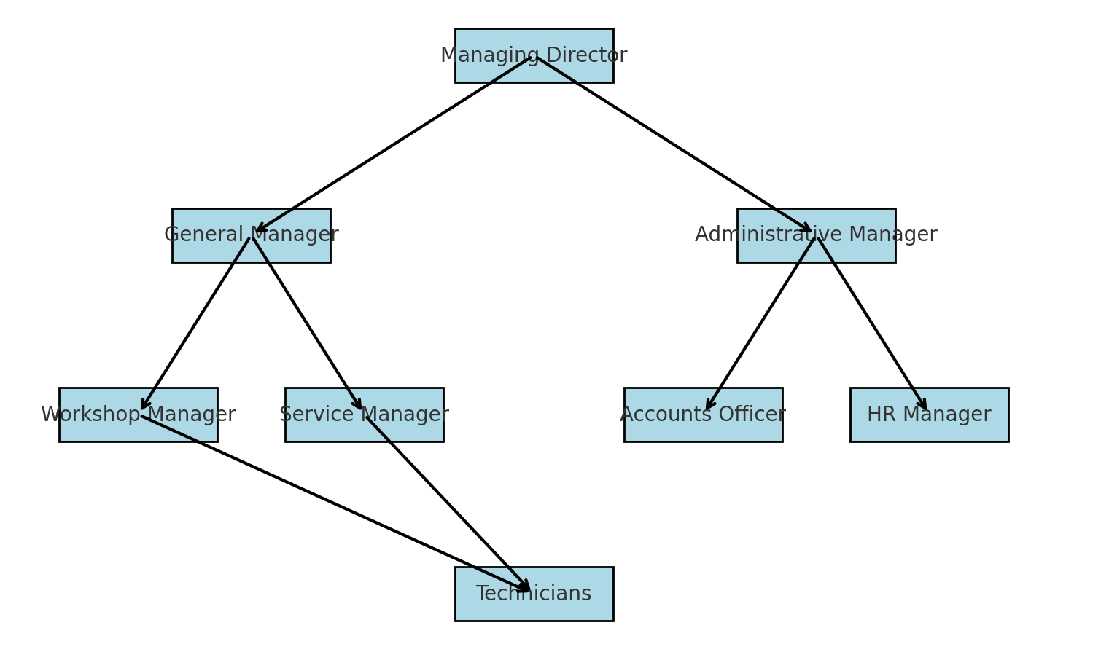

CHAPTER TWO
ACTIVITIES UNDERTAKEN DURING THE PROGRAM
During my SIWES program at Automatic Nigeria Ltd, I had the opportunity to engage in various activities that significantly enhanced my practical knowledge and technical skills in mechanical engineering. One of the primary tasks involved identifying engine parts and understanding their functions. I learned to recognize components such as the crankshaft, camshaft, pistons, valves, and cylinder heads, as well as their roles in ensuring the smooth operation of an engine. This foundational knowledge was essential in building a comprehensive understanding of engine mechanics.
I actively participated in the servicing of car engines, which included routine maintenance tasks like changing engine oil, replacing oil filters, inspecting air filters, and checking spark plugs. This experience allowed me to appreciate the importance of regular engine servicing in enhancing performance and extending the lifespan of vehicles. Working alongside skilled technicians provided me with the practical insights needed to carry out these tasks with precision.
Another key activity was learning how to read and interpret error codes using diagnostic scanners. I had the chance to operate a computerized diagnostic scanner on a Lexus RX 350 to identify faults within the Engine Control Unit (ECU). By interpreting the error codes, I contributed to diagnosing and resolving vehicle issues effectively. This exposure to modern diagnostic tools highlighted the critical role of technology in streamlining fault detection and repair processes.
During the program, I was also involved in the replacement of a worn crankshaft. This task required carefully removing the damaged component and installing a new one, ensuring proper alignment and torque specifications. Similarly, I assisted in replacing piston rings, which involved disassembling the engine, cleaning the piston grooves, and correctly installing the new rings. These activities deepened my understanding of the importance of precision and attention to detail in mechanical installations.
In addition to these technical tasks, I contributed to maintaining a clean and organized workshop environment. This involved proper storage of tools and equipment, as well as adhering to safety protocols to prevent accidents. These responsibilities reinforced the importance of workplace organization and safety in achieving efficiency and productivity.
Overall, the SIWES program provided me with invaluable hands-on training and practical exposure, bridging the gap between theoretical knowledge and real-world application. Working on various tasks under the guidance of experienced technicians not only enhanced my technical skills but also improved my problem-solving abilities, teamwork, and communication. This experience has significantly prepared me for future challenges in the field of mechanical engineering.
SKILLS AND KNOWLEDGE ACQUIRED
During the SIWES program at Automatic Nigeria Ltd, I acquired a range of skills and knowledge that have significantly enhanced my capabilities in mechanical engineering.
One of the most critical skills I developed was the ability to identify engine components and understand their functions. This foundational knowledge is essential for diagnosing and repairing engine-related issues. Additionally, I gained practical expertise in performing routine engine maintenance tasks such as oil changes, filter replacements and spark plug inspections, which are for ensuring the optimal performance of vehicles.
The program also introduced me to the use of modern diagnostic tools, particularly in reading and interpreting error codes using a computerized diagnostic scanner. This experience improved my ability to identify faults accurately and resolve them efficiently, which is an indispensable skill in today’s technology-driven automotive industry.
Furthermore, I acquired hands-on experience in replacing critical engine parts, such as worn crankshafts and piston rings. These tasks required precision, patience and adherence to technical specifications, all of which I honed during the program.
In addition to technical skills, I developed an understanding of workshop safety protocols and the importance of maintaining an organized and clean working environment. These practices not only prevent accidents but also enhance efficiency and productivity in the workplace.
The program also provided me with valuable teamwork and communication skills. Collaborating with experienced technicians on various projects taught me the importance of effective communication and coordination in achieving successful outcomes.
Overall, the SIWES program significantly broadened my technical knowledge and equipped me with practical skills that are crucial for a successful career in mechanical engineering.

TOOLS I WORKED WITH IN THE ORGANIZATION
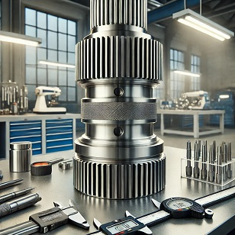

Fig 1: Image of Shaft
During my SIWES program, I actively engaged with industrial shafts, focusing on their inspection, maintenance, and alignment processes. My tasks included measuring shaft dimensions using precision tools like calipers and micrometers to ensure adherence to design specifications. I assisted in the installation and alignment of shafts within machinery, ensuring they operated efficiently and without excessive wear. Furthermore, I was involved in monitoring for faults such as misalignment or surface damage, and I contributed to minor repairs and lubrication to extend their operational lifespan. This experience significantly enhanced my practical understanding of rotational machinery and mechanical systems.

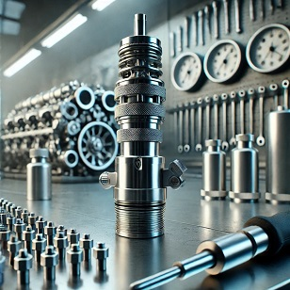

Fig 2: Injector Nozzle
During my SIWES program, I gained hands-on experience with injector nozzles, primarily in their inspection, cleaning, and calibration processes. My role involved dismantling the nozzles from engine systems for thorough cleaning to remove carbon deposits and debris that could affect performance. I used specialized tools to measure and adjust the nozzles for accurate fuel delivery, ensuring optimal engine efficiency. Additionally, I learned to identify common faults such as clogging or leakage and assisted in replacing worn components. This practical exposure enhanced my understanding of fuel injection systems and their critical role in engine performance and efficiency.
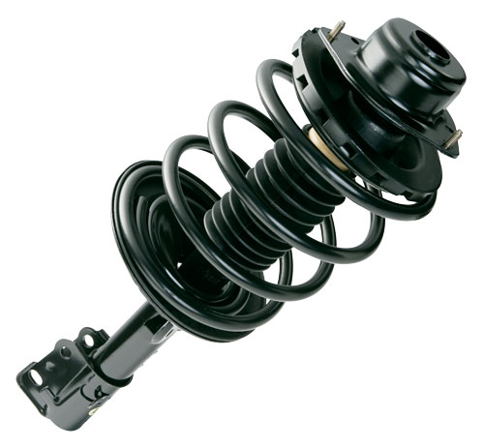
Fig 3: Shock Absorber
A shock absorber is a crucial component in mechanical systems, especially in vehicles, designed to dampen and absorb shocks and vibrations from uneven surfaces, ensuring a smooth ride and protecting other components from excessive wear. During my SIWES program, I had the opportunity to work with shock absorbers extensively, particularly in their maintenance and performance evaluation. My role involved inspecting the piston and cylinder assembly for wear, testing the damping capabilities, and assisting in the reassembly process after repairs. This hands-on experience enhanced my understanding of how shock absorbers contribute to overall mechanical efficiency and safety.
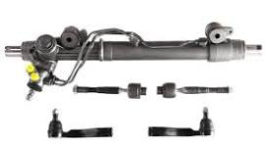
Fig 4: Steering Rack
A steering rack is a vital component in a vehicle's steering system, responsible for converting the rotational motion of the steering wheel into linear motion to turn the wheels. It provides precise control and stability during driving. During my SIWES program, I gained hands-on experience working with steering racks, which involved inspecting for wear and tear, diagnosing issues like leaks or stiffness, and assisting in the replacement of worn-out components.

CHAPTER THREE
CHALLENGES FACED
During my SIWES program at Automatic Nigeria Ltd, I encountered several challenges that tested my adaptability and problem-solving skills. One of the significant challenges was the steep learning curve associated with identifying and understanding the functions of numerous engine components. As a novice, grasping the intricacies of complex systems required extra effort and close attention to details.
Another difficulty was handling advanced diagnostic tools. Although the experience of using a computerized diagnostic scanner to read error codes was invaluable, understanding and interpreting these codes accurately required substantial guidance and repeated practice. Familiarizing myself with the technology and applying it effectively was initially overwhelming. The physical demands of the tasks posed another challenge. Activities such as replacing a worn crankshaft and piston rings required significant manual labor and precision. Working for extended hours in the workshop environment was tiring, and adapting to the physically intensive nature of the job took time.
Time management was also a challenge, as there was a need to balance observing experienced technicians with participating actively in hands-on tasks. This required a careful approach to ensure I gained adequate exposure while completing assigned duties efficiently.
Adhering to strict safety protocols presented its own challenges, particularly in understanding the importance of every safety measure and ensuring compliance under all circumstances. At times, multitasking while maintaining safety standards proved difficult but necessary for avoiding accidents.
Communication and teamwork occasionally posed hurdles, especially when coordinating with senior technicians who hand their own methods and pace of work. Understanding their instructions and aligning with their expectations required patience and active listening.
Despite these challenges, each obstacle provided an opportunity for growth. Over time, I adapted to the demands of the program, improved my skills and became more confident in handling the tasks assigned to me. These experiences were instrumental in building my resilience and enhancing my technical competence.

CHAPTER FOUR
CONCLUSION
In conclusion, my SIWES program at Automatic Nigeria Ltd was a transformative experience that bridge the gap between theoretical knowledge and practical application in the field of mechanical engineering. The hands-on exposure to identifying engine components, performing maintenance tasks, using diagnostic tools and replacing critical engine parts significantly enhanced my technical skills and understanding of automotive systems.
The challenges I faced during the program, including mastering complex systems, adapting to physically demanding tasks, and navigating communication within a team, fostered my resilence, problem-solving abilities, and teamwork skills. These experiences have equipped me with the confidence and competence to tackle real-world engineering problems effectively.
Overall, the SIWES program not only deepened my knowledge of mechanical engineering but also prepared me for future professional endeavors by instilling a strong work ethic, attention to detail and a commitment to safety and excellence. I am confident that the skills and insights gained during this program will serve as a solid foundation for my career in mechanical engineering.
RECOMMENDATIONS
The below recommendations are made to industrial board and other government agencies in charge of educational needs of Nigerian students:
- Improved orientation of SIWES students: Organizations should provide a comprehensive orientation at the start of the program to help students better understand their roles, responsibilities and workplace expectations.
- Enhanced supervision and Mentorship: Supervisors should dedicate more time to mentoring SIWES students, ensuring they receive adequate guidance and support throughout the program
- Provision of Adequate tools and Resources: Employers should ensure that SIWES students have access to the tools, equipment and materials necessary to perform their tasks effectively.
- Encouragement of Feedback and Interaction: Organizations should encourage open communication and regular feedback sessions to address the concerns of SIWES students and improve their learning experience.
- Focus on Task Rotation: To broaden students’ exposure, organizations should implement task rotation, allowing students to gain experience in different departments and develop a wider range of skills.

