

TECHNICAL REPORT ON STUDENT INDUSTRIAL WORK EXPERIENCE SCHEME

HELD AT:
CHALLENGE SAVANAH COMPLEX BESIDE UBA, ILORIN KWARA STATE

BY

ADETUNJI SOLIU MUHAMMED
MATRIC NO: ND/23/EEE/PT/0047

SUBMITTED TO:

DEPARTMENT OF ELECTRICAL/ELECTRONIC ENGINEERING DEPARTMENT (I.O.T) ILORIN, KWARA STATE

IN PARTIAL FULFILLMENT OF THE REQUIREMENTS FOR THE AWARD OF NATIONAL DIPLOMA (ND) IN ELECTRICAL/ELECTRONIC ENGINEERING

AUGUST 2024 TO NOVEMBER, 2024
DEDICATION
This report is humbly dedicated to Almighty Allah, the omniscience, the omnipotent, the beginning and the end, the door of all things, who spare my life before adaptor the completion of this programme (SIWES). Also to my lovely parent Mr. and Mrs. ADETUNJI for their support in all my endeavours.

ACKNOWLEDGMENT
First and foremost, I give all adoration to Almighty Allah for making this programme (SIWES) of four (4) month a success for me and for spearing my life comes to an end by His grace.
My special thanks goes to my lovely parents for their support and not forgetting the entire CHALLENGE SAVANAH COMPLEX BESIDE UBA, ILORIN KWARA STATE for the immeasurable knowledge ported to me, may God reward you as you play the role of brothers and sisters.

PREFACE
This booklet contain the details of activities and experience during my SIWES which was held at CHALLENGE SAVANAH COMPLEX BESIDE UBA, ILORIN KWARA STATE. The experience and knowledge acquired during the programme was written in the report which is basically on Electrical Installation, which is also essential for the fulfillment of National Certificate.
It has exposed me to the use of various tools whose operation techniques work only but theoretical explained in the lecture room. I thank the National Board of Technical Education for the Introduction of the student industrial work Experience scheme (SIWES) programmed to the school of learning.

ABSTRACT
This report cover the systems of electrical installation the types of electrical installation system, such as surface wiring system and conduit wiring system, the tools and instruments used and their uses, various types of materials used in electrical installation including the cable to be use and various things to consider before the electrical installation of a building installation.

TABLE OF CONTENTS
Title i
Dedication ii
Acknowledgment iii
Preface iv
Abstract v
CHAPTER ONE
1.0 Introduction 1
1.1 Definition of SIWES 1
1.2 Specific Aims of SIWES 1
1.3 Objective 2
1.4 Rule and Regulation 3
CHAPTER TWO
2.0 Brief History of the organization 3
2.1 Organization chart 3
CHAPTER THREE
3.0 Electrical Tools and Instruments 4
3.1 Uses of the above tools and instruments 4
3.2 Maintenance of the tools 6
3.3 Some safety precaution in the electrical installation 7
3.4 Wiring system 7
3.5 Material needed in electrical installation 8
Materials used in electrical installation 11
3.6 Types of wiring system 12
3.7 surface wiring system 12
Block diagram for connection of lighting point and switch for
Surface wiring 13
3.8 Conduit wiring system 14
3.9 Types of conduit wiring system 14
3.9.1 Half conduit system wiring 14
3.9.2 Full conduit system wiring 14
3.10 Laying of conduit pipe 14
3.11 Earth leakage circuit breaker (ELCB) 16
3.12 Purpose of ELCB 16
3.13 Types of ELCB 17
3.14 ELECTRICAL SYMBOLS AND COLOUR CODE
CHAPTER FOUR
4.0 Relevance of the experience gained at students field of study 19
CHAPTER FIVE
5.0 Conclusion and Recommendation 20
5.1 Conclusion 20
5.2 Recommendation 20

CHAPTER ONE
1.0 INTRODUCTION
Student industrial work experience scheme (SIWES) is designed to take care of the practical aspect of learning in science and engineering profession of is important that student are allowed to go out and learning how to put-into practice of all what they have learnt in lecture room while in course of study that is why engineering student of Kwara State Polytechnic are mandated to take part in training program.
The training is applied for the student industrial work experience scheme (S.I.W.E.S) the student were compulsory to go for a training after vocation of year 1 and the other student training and program
1.1 DEFINITION OF SIWES
SIWES, means student industrial training work experience scheme, it is a course by which student are expose to practical training in their respective field of study. SIWES is the acceptable skill training program set up as the requirement for the award of national diploma ( N. D ) certification for studying engineering and applied science. Its efforts is to bridge the gap existing between theory and practical aspect of engineering and some applied science.
1.2 SPECIFIC AIMS OF SIWES.
- It enable the industrial to be able to recruit graduates to the post appropriate to their background, training and the orientation during the change over from student to work status.
- To be introduced to as wide a range of industrial skills as much as possible.
- To enable trainee student become familiar with the organization and control of the industries similar to where they are likely to work after graduation.
- To introduce trainee to the industrial atmosphere and discipline.
- To provide opportunity for the trainee student to apply knowledge obtained in form of lecture and practical to industrial reality.
- To provide an opportunity for the trainee student to assess their own suitability for carriers.
1.2 OBJECTIVES
Specifically, the objectives of the students industrial Work Experience Scheme are to provide an avenue for students in Nigeria Tertiary Institutions to acquire industrial skills and experience in their course of study.
- Siwes programs provide student with a lot of experience what will enable the professional after graduation.
- It also enhance constant for future employment.
1.3 Rule and Regulation of the organization
* No fighting and No stealing if any body court by fighting or steal it will face the panel of judgment.
* All trainers must come to work shop in the time given to everybody.
* According to the rule and regulation of the organization each tools must be return into the tools box after uses of it.
* Finally the organization rule and regulation also teach that the trianer must clean all environment before they go home.

CHAPTER TWO
2.0 BRIEF HISTORY OF THE ORGANIZATION
CHALLENGE SAVANAH COMPLEX BESIDE UBA ILORIN, KWARA STATE was established in year 1962byENGR. MURITALA ADETUNJIand it is compose of the highly technical and electrical works.
The chairman of the company has experience in electricalwiring installation ofhouse and company, he has works in many company.
2.1 ORGANIZATION CHART

Managing Director

Asst. Managing Director
Supervisors

Student Workers Apprentice

CHAPTER THREE
3.0 ELECTRICAL TOOLS AND INSTRUMENTS
Electrical Engineering makes use of different instrument in performing different operations.
Some of the instruments used are listed below:
- Screw driver
- Bending spring
- Gloves
- Pliers
- Hammer
- NeonTester
- Fixing tape
- Hack saw
- Centre punch
- Bench vice
- Spanner
- Soldering iron
- Safety belt
- Raw plug drill
- Cutting pliers
- Multi meter

  - USES OF THE ABOVE TOOLS AND INTRUMENTS
- Center Punch – it is used for making point in metal or concrete blocks before drilling.
- Spanner – for tightening and losing hexagonal headed bolt and nuts.
- Soldering Iron – for soldering cable conductor joints.
- Safety Belt – for prevention and holding the body when climbing concrete poles.
- Cutting Pliers – for cutting conductors
- Raw plug Drill – for forming holes inside the block or concrete.
- Volt meter – is use for measuring the amount of voltage that passes through a cable or which a load posses.
- Multi Meter – is an instrument designed to measure electric current, voltage and usually resistance, typically over several ranges of value.
- Screw Driver - it is used for loosing and tightening screw.
- Bending Spring – it is made up of spring, it is used in bending PVC pipe when working on conduit wiring system. It’s of two sizes, 20mm and 25mm
- Gloves –it is used for from electric current flowing through a wire in order to avoid self harm.
- Pliers – it is used for cutting, disconnecting or removing installation material like rubber from a conductor. It is also used to hold material firmly.
- Hammer – it is used for clipping cable to a surface and breaking of wall during conduit wiring.
- Tester – it is used to check whether a conductor is live. It is also used to detect the flow of current in a conductor.
- Fixing Tape – it is used in passing wire into PVC pipe when working on conduit system wiring.
- Hacksaw – it is used for cutting metal and PVC pipe when working on conduit wiring system.

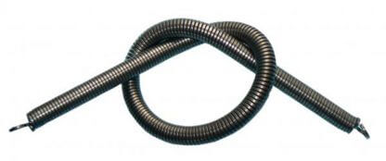

DIAGRAMS ARE SHOWN BELOW
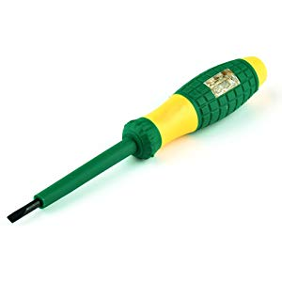

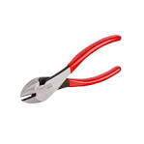
Nose plier
Combination Plier
Cutting Plier
Neo Tester
Bending Spring
Multi Meter
Hack Saw
Clipping Hammer
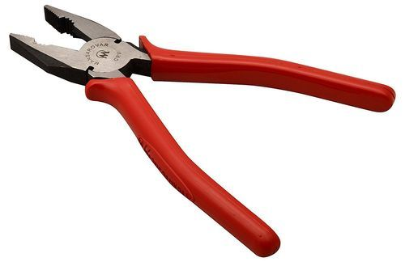





3.2 MAINTENANCE OF THE TOOLS.
The maintenance are listed below.
- Keep the tools in cool and dry place.
- It should be check regularly.
- It should be kept away from rain.
- It should be clean after use

3.3 SOME SAFETY PRECAUTION IN ELECTRICAL INSTALATION.
- Right materials should be use for its main job
- Always put on your overall when in workshop or any place of work.
- Always remove the fuse when carrying out installation on live cable.
- Test the conductor polarity by means of tester not by touching it ordinarily.
- It is dangerous to operate electrical machine you are not familiars with.
- Spark from switch cause serious burns.
- Always use correct tools for all jobs. Since incorrect tools used can result in accident.
- When using ladder, ensured that it is placed properly to avoid it from falling down.
- When working on concrete pole with ladder, ensure safety belt is used to hold the body when working.
3.4 WIRING SYSTEM.
When choosing a system of wiring from a building, the following point must be put into consideration:
- Neatness of the finished jobs:-To see if a particular wiring system if choosing a for a building will not be eyes sure.
- Time required to complete the wiring:- That is, if therefore length of time that is allocated for the completion will not fail, particularly urgent jobs being allocated by government .
- The durability of the installation:- If a particular wiring chosen withstanding the hazard condition of usage or will last long as expected of the installation. For Example, a surface PVC. Sheathed wiring will prove hazardous to a metal workshop.
- Future Extension and Alteration:- One must ensure that a system of wiring will give room for future addition. For Example, a concealed conduct wiring will not be suitable for factory installation which is often subjected to extension.
- Drainage to the fabric of the building by cut away:- For Example, it will be better to wire a completed multi-storey building in surface wiring than concealed conduct which may weaken the wall and pillars when chiseled to form channel.
- Special consideration like dampness:- Flammable in a situation which is either permanently damp or intentionally damb, damp proof fitting and wiring materials must be used to prevent ingress of moisture to the wiring and if flammable situation all accessories and apparatus to be used must be of flame proof type.
- Cost of installation:- Cost is one of the important aspect to be considered when deciding on a system of because a client may want to wire his or her building in fill conduit, because of the neat appearance but by the time he or she sees the estimated cost of the wiring he or she may not be able to afford the cost.
3.5 MATERIAL NEEDED IN ELECTRICAL INSTALLATION
- Cable:- A Length of insulated single conductor (Solid or stranded), or of two or more such conductor, each provided with its own insulation, which are laid up together.
- PVC Sheathed Cable:-A Cable of which the conductor insulation and mechanical protection is of polyving-chloride.
- Cable Trunking:-A cast for cables, constructed of metal sheet, wood or insulating materials and may be of rectangular or square cross section of which one side is removable or binged for the whole of its length for the purpose of laying cable therein.
- Circuit Breakers:- A mechanical device for making and breaking a circuit both under normal and abnormal condition, such as those of a short circuit being broken automatically.
- Consumers Control Unit:- It is a distribution board incorporation a main switch or main circuit breaker within its unit.
- Distribution Board:-This is an assemblage of parts including one or more fuses or miniature circuit breaker, arrange for the purpose of distribution of Electrical energy to final sub-circuit and to other distribution boards.
- Earth Continuity Conductor:-This is the earth wire that connect the earthen terminal on a apparatus to the earthing rod.
- Earth Electrode:-A metal rod or rods metal plate or mat having effectual connection with the general mass of the earth.
- Fuse:- It is a device for opening a circuit by means of a conductor designed to melt when an excessive current flows. Its consists of two parts, the base and the bridge.
- Installation of Conductor:-It is a suitable non-conductor material enclosing surrounding or supporting a conductor.
- Junction Box:-A box connecting two or more length of conductor or trunking appliance.
- Lighting Fitting:-A device for containing a lamp or lamps together with any holder, shade or reflector for Example, (wall Bracket fittings) Lamp holder, & fluorescent fittings.
- Switch:- A device other than a fuse or circuit breaker for closing and opening a circuit.
- Switch Fuse:- A device consisting of a switch and one or more fuse, so that the fuse is not being carried by the moving part of the switch.
- Switch –1 Way:- This is Switch meant to control a lamp or set of lamp in one position.
- Switch 2-Way:- This Switch meant to control a lamp or set of lamp in two way position only.
- Switch Intermediate:- This is the Switch that meant for controlling a lamp or set of lamp in three or more position.
- Switch Fuse-switch:- A switch that a moving part of which carried one or more fuses for heavy current control.
- Switch Board:-An assembly of switch gear with or without instrument but excluding local switches in final sub-circuit.
- Switch Gear:- It is a device for controlling the distribution of electrical energy or for controlling electrical circuit, machine and current using appliances.
- Lamp holder: - a fixture for an electric light bulb
- Socket: - A socket is one endpoint of a two-way communication link between two programs running on the network.
Lamp holder
13A Flush Socket
13A Double socket
Conductor Cable
Lamp holder and Bulb
3-Gang switch
2-Gang switch
1-Gang switch
Cables and Socket
ELCB
MATERIALS USED IN ELECTRICAL INSTALLATION
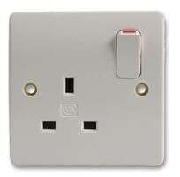
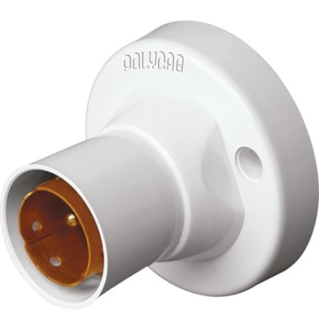
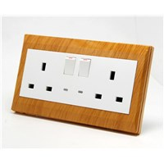
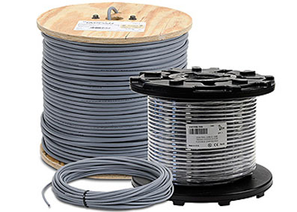

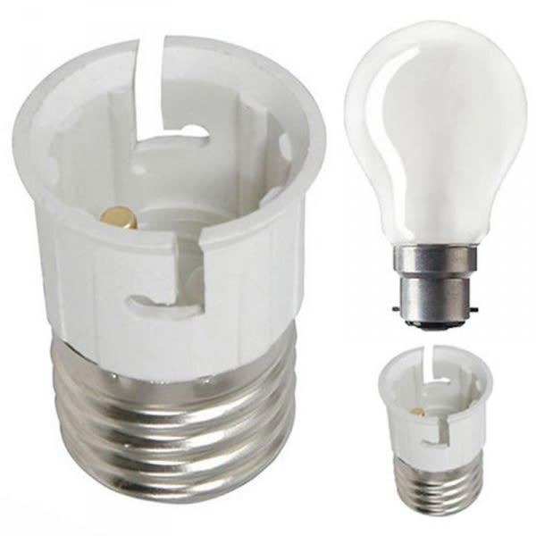
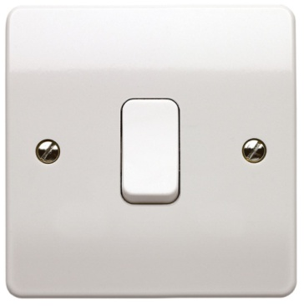
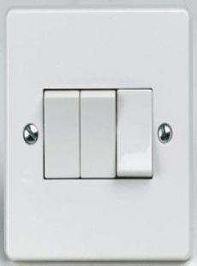
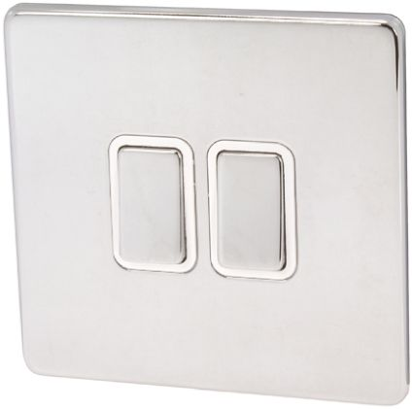

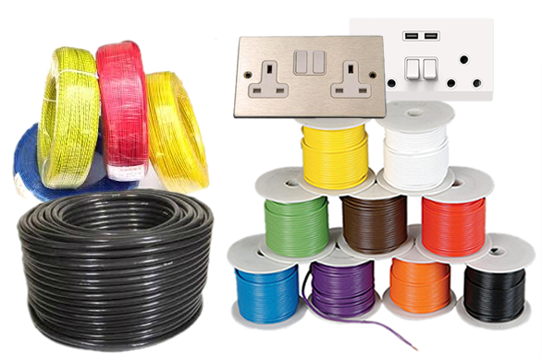
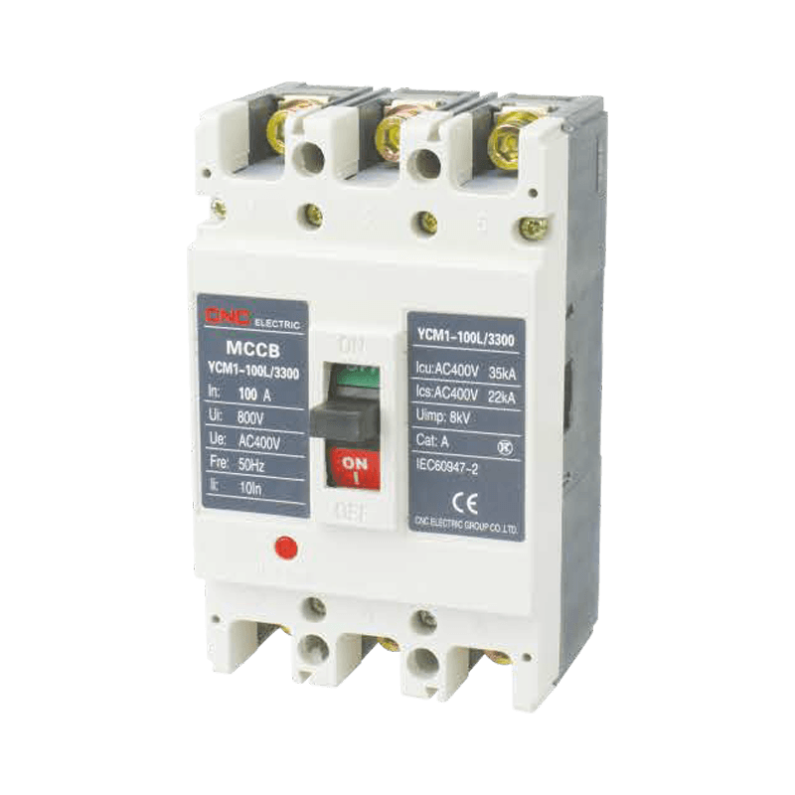

3.6 TYPES OF WIRING SYSTEM
- Surface wiring system
- Trunking wiring system
- Full conduit wiring system
- Half conduit wiring system
3.7 SURFACE WIRING SYSTEM
This is the system of wiring by which is called PVC sheathed wiring on surface, this involve the use of PVC insulated laid up in flat formation with a close covering of thought PVC as mechanical protection since there is no metal sheat. A bare conductor as in twin and earth cable will be enclosed in PVC sheat to serve as the earth continuity conductor.
SOME OF THE MATERIALS USED FOR SURFACE WIRING SYSTEM
- plastic box (3x3, 3x6)
- junctionbox
- Ceiling rose
- Lamp holder
- Cable
- Clips and nails

BLOCK DIAGRAM FOR CONNECTION OF ONE LIGHTEN POINT AND SWITCH FOR SURFACE WIRING

Lighting bulb
Supply cable
Switch
Junction box
N
L

N
L

COM
L1

3.8 CONDUIT WIRING SYSTEM
It is the laying of PVC pipe inside the blocks for passing cables for conduit wiring.
SOME OF THE MATERIALS USED FOR CONDUIT WIRING SYSTEM
- 1mm wire, 2.5, 6mm.
- Iron box (3x3, 3x6)
- Pipe (20mm, 25mm)
- Wall bracket box(“U” way, “end” way, and “four” way)
3.9 TYPES OF CONDUIT WIRING SYSTEM.
- Half conduit system wiring.
- Full conduit system wiring.
3.9.1 HALF CONDUIT SYSTEM WIRING
This system of wiring it require laying for PVC pipe inside the block and on the ground, it require less cost and less materials.
3.9.2 FULL CONDUIT SYSTEM WIRING.
This is the system of wiring by which it require laying of PVC pipe inside concrete blocks, on the ground and including the inside of the ceiling such as that there won’t be a space for cable to be showing or to be seen outside. It require more cost than the half conduit system of wiring, it is require more materials than the half conduit, its more well presentable for the well wise customers.
3.10 LAYING OF CONDUIT PIPE
Good conduit work can only be achieved when there is good PVC pipe laying.
The following points will assist Electricians in this field.
- PLANING THE LAYOUT:-The following point should be considered before starting the actual layout.
- The Building should be studied property (e.g if it is bungalow).Draw your layout.
- Make sure the consumer has a requirement clearly before started in the architects drawing.
- MARKING OUT:-During the marking out, the following procedure should be taking.
- Position of the boxes for Switches, Sockets, Cooker, etc. should be clearly marked.
- Position of the Distribution Board.
The laying cannot be done by using chalk to make marks and lines as following.
- Channeling and cutting bricks or concrete: After the marking out of the building, the next thing is to use chisel or hammer to cut or channel the bricks in order to put conduit pipes inside the bricks.
- Preparing the conduit:- Conduit comes in length, length should be cut to size with hacksaw having a fine tooth blade. It should be cut in a pipe vice. Preparing the conduit will also involve bending of the conduit depending on the type of conduit being installed which may heavy or light gauge conduit, full or half pvc pipe laying system.
- Piping of the channeled Bricks:- After the cutting and bending of conduit to desire length, the next thing is to put the conduit pipe inside the channeled bricks, floor or concrete.
- Gumming and Dressing of the Channeled Bricks:- After the piping of the channeled brick and dress it to it normal position.

Size and Cable Used in an Electrical Installation:

S/N | SIZE OF CABLE | USES
i. | 1.5mm | For lighting
ii. | 2.5mm | For Socket of 13Amps and 15A
iii. | 4mm | For AC and Cooker Control unit
iv. | 6mm | For Cooker Unit
v. | 10mm | For meter and distribution board
vi. | 16mm | For Servicing Building
TYPE OF SWITCH THAT WE HAVE:-
We have different types of switch as follow:
- One Gang Switch.
- Two Gang Switch.
- Three Gang Switch.
- Four Gang Switch.
TYPES OF SOCKET THAT WE HAVE:
- 13A (3X3 for one way, 3x6 for two way socket)
- 15A (3X3 for one way, 3x6 for two way socket)
3.11 EARTH LEAKAGE CIRCUIT BREAKER (ELCB)
It is a safer devices used in electrical installation with high earth impedance to prevent shock, it detects small stray voltages on the metal enclosures of electrical equipment and interrupts the circuit if a dangerous voltage is detected
3.12.1 PURPOSE OF ELCB
- The main purposes of earth leakages circuit breaker is to prevent injury to humans and animal due to electric shock
- To detect faults currents from life to the earth ground wire within the installation.
3.13 TYPES OF ELCB
There are two types of ELCB which are
- Voltage operated
- Current operated
Voltage operated: These devices sense a voltage to decide the earth leakage. A single phase voltage ELCB will have six terminals. Which are:
- Line in
- Line out
- Neutral in
- Neutral out
- Earth
- Fault
Current operated: It is a device which consists of 3 winding transformer which has 2 primary windings and one secondary winding.
The two primary winding are:
- Neutral wires
- Two wires.
And the secondary winding is a wire wound coil. The current through the secondary the secondary winding is zero at the balanced condition
3.14 ELECTRICAL INSTALLATION SYMBOLS.
Electrical installation Symbols; it used to represent electrical devices used in electrical works.

3.15 SOME SYMBOLS THAT CAN BE SEE IN ELECTRICAL WORK
NAME SYMBOLS
Live L
Neutral N
Earth
Fan Regulator
15 AMP SK
AMP SK
Distribution Board
Change over
Cooker control unit
Air conditioner
1 way switch
2 way switch
Security light

  - SOME COLOUR CODE IN ELECTRICAL
COLOUR CODE
Yellow earth
Green earth
Blue neutral
Red live
Brown live

CHAPTER FOUR
4.0 RELEVANCE OF THE EXPERIENCE GAINED AT STUDENTS FIELD OF STUDY
During the student industrial work experience scheme (SIWES) period I was deeply exposed to electrical engineering aspect unlike before. I am unable to recognized I can now work with most of instrument being mention. Some of the electrical work that I don’t know before but during my SIWES training I was shown with this little experience being gained in the organization especially the electrical installation I can now work successfully on my own.
Involvement at the section/unit with respect to the industrial training (ITF) program. I have acquired more knowledge and view on the diverse engineering. Field in which I have learnt more about the practical application of electrical engineering. While I was in the organization I was working with the stuff of the organization involved in the electrical installation.

CHAPTER FIVE
- CONCLUSION AND RECOMMENDATION
The period of industrial training attachment at CHALLENGE SAVANAH COMPLEX BESIDE UBA, ILORIN KWARA STATEhas given me the opportunity inlearning about electrical work and maintenance with the engineer and also fellows SIWES student from other institution from which I had acquired and received more knowledge from them.
5.1 CONCLUSION
Based on my industrial work experience the following can be drawing:
- It is very important to be in the right place for industrial attachment.
- Learning outside the school enriches knowledge of understanding in the field of study.
5.2 RECOMMENDATION
CHALLENGE SAVANAH COMPLEX BESIDE UBA, ILORIN KWARA STATE is a very nice and interesting place, in fact the company is curious about its safety to all including the non-staff but it has some lapses when it comes to provision of student applied which can be used to reduce staff during working site.
The company needs to extends theirbranches to some other State so that number of staff and the trainer will increase and also add to the level of experience of the staff and trainer.

