

TECHNICAL REPORT ON STUDENT INDUSTRIAL WORK EXPERIENCE SCHEME

HELD AT:
ZMARKABLE NIGERIA ENTERPRISE

BY

ZUBAIR RIDWANULLAH AYOMIDE
ND/23/EEE/PT/0143

SUBMITTED TO:
DEPARTMENT OF ELECTRICAL/ELECTRONIC ENGINEERING DEPARTMENT (I.O.T) ILORIN, KWARA STATE

IN PARTIAL FULFILLMENT OF THE REQUIREMENTS FOR THE AWARD OF NATIONAL DIPLOMA (ND) IN ELECTRICAL/ELECTRONIC ENGINEERING

AUGUST-DECEMBER, 2024

PREFACE
This is a report of four month industrial training which is part of the certificate which was embarked upon by the Engineering students after their first year stay in school.
This is done to enable the student exposed to the practical aspect of his course of study and however, document what he or she gained during the working Experience scheme training.
The programme is aimed at correcting in competency in the school leaving Scientific technical graduate in the country.

ACKNOWLEDGEMENT
All thanks and glorification is due to ALMIGHTY ALLAH for sparing my life and seeing me through during the SIWES program all praise and adoration on to your name forever.
My profound gratitude goes to my dearest parents for their financial, spiritual and morally support they have given me since my childhood to this level that I am today; during my first year program SIWES I love you two so much, I am so proud to be your son.
I also express my gratitude towards my family, friends, and lovers of progress who have all participated in putting me up one way or the other; I am so indebt to you all.

TABLE OF CONTENT
Preface i
Acknowledgement ii
Table of Content iii
CHAPTER ONE
1.0 Introduction 1
1.1 Definition of SIWES 1
1.2 Objectives of the SIWES 2
1.3 Place of Attachment of the SIWES 3
CHAPTER TWO
2.0 Report on the Training Program 5
2.1 Steps in troubleshooting in electrical installation 6
CHAPTER THREE
3.0 Conduit wiring and installation in building 8
3.1 Advantages of conduit wiring 11
3.2 Disadvantages of conduit wiring 12
3.3 Concealed wiring 13
3.4 Advantages of Concealed wiring 14
3.5 Disadvantages of concealed wiring 14
3.6 Wiring Accessories
CHAPTER FOUR
4.0 Relevance Of The Experience Gained At The Students Field Of Experience 16
CHAPTER FIVE
5.0 Recommendation 19
Conclusion 19

CHAPTER ONE
1.0 INTRODUCTION
Student Industrial Working Experience Scheme (SIWES) is implemented to carry out the practical aspect of learning in science and engineering profession. It is important that students are permitted to go and acquire more practical skills that can complement their theoretical knowledge of the lecture room at Kwara State Polytechnic which are of various facet mandated in different training programmes.
This is only meant for student under Industrial Working Experience Scheme (SIWES)
1.1 DEFINITION OF SIWES
Student Industrial Working Experience Scheme (SIWES) can simply be defined as the practical experience of student in order to have a qualified control and satisfactory performance in the field.
The meaning and definition of SIWES is referred to as 'student Industrial Working Experience Scheme'. This is a programme introduced by the Federal Government of Nigeria, supervised by the Industrial Training Fund (ITF) under the National Board for Technical Education (N.B.T.E) in order to compulsorily permit Students of various Disciplines to acquire basic Technical skills from various organizations related to their field of studies.
Student Industrial Working Experience Scheme was established by ITF (Industrial Training Fund) in 1973 to solve the problem of lack of adequate practical skill preparatory for employment industries by Nigerian graduates of tertiary institutions.
1.2 OBJECTIVES OF THE SIWES.
(i) It exposes students to practical environment that are not available in lecture rooms.
(ii) It exposes learners to a wholistic industrial environment.
(iii) It gives students the opportunity to put into practice some of the skills already acquired.
(iv) It enables students to gain more practical skills.
(v) It exposes students to work methods.
(vi) It exposes learners to safety precautions in industries.
(vii) SIWES exposes trainees to handling of equipment and machinery.
(viii) Students are exposed to the practice of division of labour in production setting.
(ix) It protects the students in the all important call of do-it-yourself principles.
(x) It exposes students to employment opportunities and possiblities after graduating.
(xi) The exposure is capable of stirring the students up to think of what to do personally.
(xii) SIWES is a promoter of a cardinal objective in the National Policy on Education.
1.3 PLACE OF ATTACHMENT OF THE SIWES.
The OLTIMA Electrical Company is strategically located in No 124 Basin Road, Ilorin Kwara State

CHAPTER TWO
2.0 REPORT ON TRAINING PROGRAM
During the industrial training I was exposed to some areas of electrical and electronics engineering which I found very interesting. During my first month of the training program, I was introduced to various electrical component and installation materials like the multi strands wire, , cable trunk, fishing tape; Different type of wire sizes like : 2mm, 1.5mm 4mm 10mm, 16mm 70mm; Safety precautions when carrying out an electrical installation or maintenance.
During the industrial training I learnt how to troubleshoot a working electrical installation as well as a faulty electrical installation to know which part of the installation is damaged so as to replace or repair the affected components to restore the system back to a perfect working state for effective functionality. it is the process of analyzing the behavior or operation of a faulty circuit to determine what is wrong with the circuit. It then involves identifying the defective component(s) and repairing the circuit. Depending on the type of equipment, troubleshooting can be a very challenging task. Finally, troubleshooting requires confirmation that the solution restores the computer process to its working state.
2.1 STEPS IN TROUBLESHOOTING IN ELECTRICAL INSTALLATION
- Gather information
- Identify the problem
- Establish a reason or a probable cause
- Test probable cause theory to determine the source of the problem
- fix or repair the problem
- Verify the repair
- Document the problem and process
The most common issue I encountered during my SIWES program is the low voltage in shop owners suite which is mainly caused by a faulty neutral wire. It can be fixed by replacing the incomer neutral I.e neutral(black) connecting the meter box to the breaker panel.
During this industrial training, I learnt how to install some easy-to-fix accessories like sockets(15Amps and 13Amps), breakers, bulbs, switchs, to complex ones like three-phase meter box single phase meter box, Distribution box, HBC (High Breaking Capacity ) fuse, control box for pumping machine, down light LEDs and

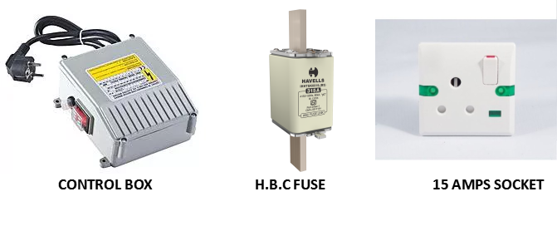

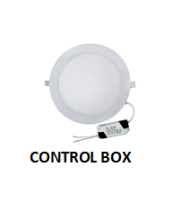
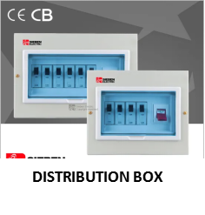

CHAPTER THREE
3.0 CONDUIT WIRING AND INSTALLATION METHODS
Conduit wiring is a system of wiring using tubes (pipes) either steel or PVC, to provide good mechanical protection for its conductors drawn inside the tubes. It also gives high degree of protection from fire hazards to its conductors. Conduit pipes will be installed on the surface of walls or roofs by means of saddles or hooks or concealed inside the wall or roof or floor.
Modern building construction adopts conduit wiring (PVC conduit or GI conduit both in various mechanical strength depending on site requirement and project specification) and found mainly in two types:
1) Surface or Open type conduit installation,
2) Recessed or Concealed type conduit installation.
3.1 Advantages of conduit wiring
- Safe
- Better appearance
- No risk of fire
- No risk of damage of cable insulation
- Safe from humidity, smoke, steam, etc.
- No risk of shock
- Long lasting
Disadvantages of conduit wiring
- Expensive
- Installation is not easy
- Not easily customisable for future use
- Hard to detect faults
Concealed Wiring
It is laborious to install this wiring. The layout of this wiring is done under the plaster of the wall of the building.
Advantages of concealed wiring
- Safe
- Better appearance
- No risk of fire
- No risk of damage of cable insulation
- Safe from humidity, smoke, steam, etc.
- No risk of shock
- Long lasting
Disadvantages of concealed wiring
- Expensive
- Installation not easy
- Not easily customisable for future use
- Hard to detect faults
Wiring Accessories
Wiring accessories are used for connecting appliances (Fig. 3.4). (a) Switch A switch is used to make or break an electrical circuit. It is used to switch ‘on’ or ‘off’ the supply of electricity to an appliance.
- Switch: A switch is used to make or break an electrical circuit. It is used to switch ‘on’ or ‘off ’ the supply of electricity to an appliance.


- Lamp Holder: Lamp holders are mechanical devices that support lamps and connect them to electrical circuits. They hold light bulbs and make electrical contact to provide a bulb with power.
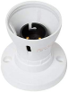

- Ceiling rose: It is used to provide a tapping to the pendant lamp–holder through the flexible wire or a connection to a fluorescent tube


- Socket outlet/plug: A socket is a device or point in a wall where you can connect electrical equipment to the power supply.
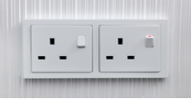

- Main switch: To control the electrical circuit a main switch is used. Through the main switch, the power in a building is controlled completely.

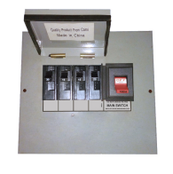

CHAPTER FOUR
4.0 RELEVANCE OF THE EXPERIENCE GAINED AT THE STUDENTS FIELD OF EXPERIENCE.
In the field of engineering, excursions, experience, practicals, are all mandatory factors for the make up and the edification of a good engineering student, most companies, always ask for experience before employing anyone into their company because the they know how crucial it is in order to get the right man for the job, practicals and getting experience is not one a student can get from the school or from a book because most institution based their learning on theories mostly.
One of the major relevance that the SIWES offered to us students, is experience, most of us do not know what a 'lightning arrestor is not until the experience we got from the SIWES. From what we learnt from the SIWES we were able to see that which we have heard and also put them into practical use.
Secondly, the SIWES offered us the opportunity to socialize with our senior engineers who have worked with various companies. During the course of our socialization, we were also taught how to answer questions on an interview during the quest of seeking for jobs as engineers. The socialization with engineers are things most of us never had before, during the course we were offered the opportunity to do just that, and for those of us that never had that, we very much appreciated it.
CHAPTER FIVE
5.0 RECOMMENDATION
I recommend that the SIWES should be sustained and mandatory for every student most especially engineering students who want to have real life applications of engineering knowledge gained over the years in class and to become more inquisitive in the aspect of choosing field.
5.1 CONCLUSIONS
The SIWES Programme is an eye opener that paves way for most especially an engineering student who dreams of becoming an engineer after academics studies. The experience gained, cannot be under estimated for the privileged to have the practical applications of the theoretical knowledge gathered in class which as brothering my knowledge and understanding in Engineering world.

