Chapter Two:

Literature Review

2.1 Introduction
Urban traffic management in Nigeria faces several challenges, including high vehicular volumes, inadequate infrastructure, and poor compliance with traffic regulations. Roundabouts, widely used as a traffic control mechanism, are critical for managing intersections in busy urban centers. According to Raji and Okunola (2018), roundabouts improve traffic flow by reducing conflict points, facilitating smooth vehicular movement, and enhancing safety. However, the performance of these facilities is contingent on proper geometric design, capacity management, and user compliance.

2.2 Junctions and Roundabouts
A junction is an intersection where two or more roads meet, providing a crossing or merging area for vehicular and pedestrian traffic (Olanrewaju & Adebayo, 2021). Junctions play a critical role in urban mobility by facilitating the distribution of traffic across networks. Roundabouts, a specific type of junction, channelize traffic flow into a one-way circular movement around a central island. Unlike conventional intersections controlled by signals or stop signs, roundabouts rely on yield control and vehicular priority to circulating traffic, minimizing delays and enhancing capacity (Adeleke & Akinyele, 2020). . Evaluation of junction capacity is very important since it is directly related to delay, level of service, accident, operation cost, and environmental issues. For more than three decades modern roundabouts have been used successfully throughout the world as a junction control device. Basic Concepts of Roundabouts and Definition of A roundabout is a channelized intersection at which all traffic moves anticlockwise around a central traffic island. (AACRA Geometric Design Manual, 2003). This definition can be used for traffic circles also because it doesn't mention priority. Roundabouts are intersections of two or more roads that are made up of a one way-circulating roadway that has priority over approaching traffic. Yield signs control the approaching traffic and the driver can only make a right turn onto the circulating roadway. The only decision the entering motorist needs to make once they reach the yield line is whether or not a gap in the circulating traffic is large enough for them to enter. The vehicles then exit the circulating roadway by making a right turn toward their destination (FHWA-RD-00-067, 2000).
Roundabouts differ from other types of junctions due to their operational characteristics, which include deflection angles that slow vehicles, circulating lanes that prioritize flow, and simplified decision points for entering traffic. According to Ogunbanjo (2019), these features make roundabouts ideal for managing intersections with moderate traffic volumes. However, their efficiency diminishes under uneven traffic distribution or high congestion levels, necessitating careful design and periodic evaluation. Roundabouts are often confused with traffic circles or rotaries and it is important to be able to distinguish between them. According to FHWA-2000 information guide, roundabouts have 5 or 7 main characteristics that identify them when compared to traffic circles:
- Traffic control: Yield control is used on all entries at roundabouts. The circulatory roadway has no control.
- ii. Priority to circulating vehicles: Circulating vehicles have the right of way in roundabouts. Some traffic circles require circulating traffic to yield to entering traffic.
- iii. Pedestrian access: Pedestrian access is allowed only across the legs of the roundabout, behind the yield line. Some traffic circles allow pedestrian access to the central island.
- iv. Parking: No parking is allowed within the circulatory roadway or at the entries. Some traffic circles allow parking within the circulating roadway.
- Direction of Circulation: All vehicles circulate counter-clockwise and pass to the right of the central island of the roundabout. Some neighborhood traffic circles allow left-turning vehicles to pass to the left of the central island. Besides to those five mentioned above, Thaweesak (1998) included additional features of roundabout, which distinguish them from other traffic circles.
- Approach Flare: Most roundabout approaches flare out at the entries and allow more vehicles to enter the circulating roadway at a more obtuse angle. This improves capacity, and allows entering vehicles to enter at similar speeds as the circulating vehicles unless a queue has developed at the entry. The size and angle of the flare is generally controlled by a raised traffic island that separates the entering and exiting traffic at an approach. This island also gives pedestrians a safe location to cross the approach in two stages. This is the old English principle and gives high capacity, but low safety due to high speed in some countries.
- Deflection: This characteristic is the geometry of the facility that requires vehicles to slow down as they maneuver through the roundabout. The size of the Center Island and angle of approach determine the deflection and potential speeds of entering and circulating vehicles. Generally, the effect of the roundabout is that traffic is required to slow down to negotiate the curve around the central island, but unlike full stop and signal controlled intersections, vehicles entering a roundabout are not required to stop completely. This makes the facility more efficient under a wide range of traffic volumes, as motorists only need to find an acceptable gap for entrance.

2.3 Geometric Design of Roundabouts
The geometric design of a roundabout significantly influences its operational efficiency and safety. Poorly designed roundabouts can lead to increased conflicts, delays, and even accidents. Key design elements include:
- Entry and Exit Widths: These determine the volume of vehicles that can enter or leave the roundabout without excessive delays. Wide entry and exit lanes accommodate higher volumes but must be balanced with safety considerations (Ogunbanjo, 2019).
- Inscribed Circle Diameter: This affects the deflection angle and speed at which vehicles navigate the roundabout. Smaller diameters increase deflection and slow vehicles, enhancing safety but potentially reducing capacity (Adeyemi et al., 2022).
- Weaving Section: The length and width of the weaving section are critical for accommodating merging and diverging traffic without excessive conflicts. Adequate weaving lengths reduce the likelihood of abrupt lane changes and collisions.
Design standards recommend entry widths of 6.5m to 7m for urban roads and inscribed circle diameters that balance deflection and capacity. The relationship between geometric design and traffic flow underscores the need for site-specific adaptations to optimize roundabout performance.

2.4 Capacity and Level of Service (LOS)
The capacity of a roundabout is defined as the maximum number of vehicles it can accommodate under prevailing traffic and road conditions. Capacity directly affects performance metrics such as delays, queue lengths, and stop rates. In Nigerian cities, roundabouts often operate near or above their capacity during peak hours, resulting in significant inefficiencies (Abubakar & Bello, 2017).
The Level of Service (LOS) categorizes operational efficiency into six grades, from A (free-flow conditions) to F (oversaturated conditions). LOS provides a qualitative measure of traffic performance based on delays, speed, and flow rates. Studies by Adeleke and Akinyele (2020) reveal that most urban roundabouts in Nigeria operate at LOS D or worse, indicating high delays and reduced efficiency. This highlights the importance of periodic capacity evaluations and targeted interventions.
Two primary methods are used to evaluate roundabout capacity:
- Empirical Models: These models use observed traffic data and geometric characteristics to estimate capacity and delays. They are widely used due to their simplicity and reliability.
- Analytical Models: These rely on gap-acceptance theory to estimate entry and circulating flows. Analytical models are particularly useful for assessing the impact of geometric modifications on performance.
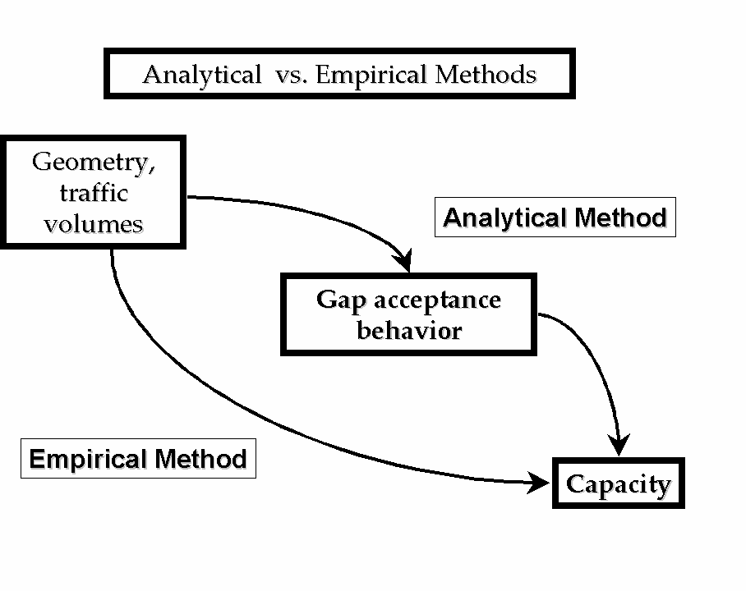
Figure 2-2 Analytical Verses Empirical methods
Table 2.1 summarizes typical LOS categories and their implications for traffic performance.
LOS Category | Delay (Seconds/Vehicle) | Traffic Conditions
A | 0-10 | Free-flowing traffic
B | 10-20 | Stable flow with minor delays
C | 20-35 | Noticeable delays during peak hours
D | 35-55 | High delays and reduced efficiency
E | 55-80 | Approaching capacity limits
F | >80 | Over-saturated conditions

2.2.1 TRAFFIC OPERATION in a ROUNDABOUT
The traffic operations at roundabout are three; diverging, merging, weaving. All the other conflicts are converted into these three less severe conflicts.
- Diverging: it is a traffic operation when the vehicles moving in one direction is separated into different streams according to their destinations
- Merging: merging is the opposite of diverging. Merging is referred to as the process of joining the traffic coming from different approaches and going to a common destination into a single stream.
- Weaving: weaving is the combine movement of both merging and diverging movements in the same direction.
2.3 Design of Element of a Roundabout
The design elements include design speed, radius at entry, exit and the central island, weaving length and width, entry and exit widths. A typical roundabout and the important design elements are shown in Figure 2.1.
2.3.1 Design Speed
All the vehicles are required to reduce their speed at a roundabout. Therefore, the design speed of a roundabout will be much lower than the roads leading to it. The normal practice is to keep the design speed as 30 and 40kmph for urban and rural areas respectively.

2.3.2 Entry, Exit and Island Radius
The radius at the entry depends on various factors like design speed, super elevation, and coefficient of friction. The entry to the roundabout is not straight, but a small curvature is introduced.
The exit radius should be higher than the entry radius and the radius of the roundabout island so that the vehicles will discharge from the rotary at a higher rate. A general practice is to keep the exit radius as 1.5 to 2 times the entry curve.
2.3.3 Weaving Length
The weaving length determines the ease with which the vehicle can maneuver through the weaving section and thus determines the capacity of the rotary. The weaving length is decided on the basis of the factor, such as, the width of the weaving section, average width of entry, total traffic and proportion of weaving traffic in it. It is desirable to prevent direct cuts and this can be achieved by making the ratio of weaving length to weaving width large enough. A ratio 4:1 is regarded as minimum. The minimum values of weaving lengths as recommended by IRC are given in Table 2.1
Design Speed (kmph) | Minimum Length of Weaving (m)
40 | 45
30 | 30
Table 2.1 Suggestions for Weaving Length

2.3.4 Width of The Roundabout
The entry width and exit width of the rotary is governed by the roundabout is governed by the traffic entering and leaving the intersection and width of the approaching road. The width of the carriageway at the entry and exit will be lower than the width of the carriageway at the approaches to enable reduction of speed. IRC suggests that a two lane road of 7m width should be kept as 7m for urban roads and 6.5m for rural roads. Further, a three lane of 10.5m is to be reduced to 7m and 7.5m respectively for urban and rural roads.
The width of the weaving section should be higher than the width at entry and exit. Normally, this will be one lane more than the average entry and exit width. Thus weaving width is given as,
W = $\frac{e_{1}+e_{2}}{2}$+ 3.5
where e₁ is the width of the carriageway at the entry and e₂ is the carriageway width at exit.
Weaving length determines how smoothly the traffic can merge and diverge. It is decided based on many factors such as weaving width, proportion of weaving traffic to the non-weaving traffic etc. This can be best achieved by making the ratio of weaving length to the weaving width very high. A ratio of 4 is the minimum value suggested by IRC. Very large weaving length is also dangerous, as it may encourage over-speeding.
2.3.5 Practical Capacity
The capacity of a roundabout is directly determined by the capacity of each weaving section, and by the geometrical layout. The Transport and Road Research Laboratory (U.K) which has pioneered research on this aspect, recommends the formula and that is modification of the well-known Wardrop”s formula.
$${Q_{P=} }_{\frac{\text{280W}\left(\text{1+}\frac{\text{e}}{\text{W}}\right)\left(\text{1+}\frac{\text{P}}{\text{3}}\right)}{\text{1+}\frac{\text{W}}{\text{L}}}}$$
Where,
Q_{P} = practical capacity of the weaving section in pcu per hour.
W = width of weaving section (6 to 18m)
W = $\frac{e_{1}+e_{2}}{2}+3.5$
e = average width of entry e₁ and width of non weaving section e₂
e = $\frac{e_{1}+ e_{2}}{2}$
e₁ = width of weaving section at entrance in meter
e₂ = width of weaving section at exit in meter
L = length of weaving section between the ends of channelizing island in m
L = 4 x W
P = proportion of weaving traffic given by
P = $\frac{b+c}{a+b+c+d}$
a = left turning traffic moving along left extreme lane
d = right turning traffic moving along right extreme lane
b = crossing/weaving traffic turning toward right while entering the roundabout
c = crossing/weaving traffic turning toward left while leaving the roundabout

2.5 Factors Affecting Traffic Flow at Roundabouts
Several factors influence traffic flow and operational efficiency at roundabouts, including:
2.5.1 Traffic Composition
The mix of cars, motorcycles, buses, and trucks affects flow rates and delays. Larger vehicles require more space and time for maneuvering, reducing overall capacity. Ogunbanjo (2019) notes that high proportions of heavy vehicles exacerbate congestion, particularly during peak hours.
2.5.2 Geometric Design
Improperly designed entry angles, flare lengths, and weaving sections lead to increased conflicts and delays. Adeyemi et al. (2022) emphasize that roundabouts with inadequate geometric features often experience operational inefficiencies and higher accident rates.
2.5.3 Driver Behavior
Non-compliance with yield rules, aggressive driving, and poor lane discipline are common in Nigerian cities, exacerbating congestion. Studies by Abubakar and Bello (2017) highlight the role of public awareness campaigns in mitigating these issues.
2.5.4 Pedestrian Activity
High pedestrian volumes crossing roundabouts disrupt vehicular flow, especially in commercial areas like Offa Garage. Pedestrian crossings should be strategically placed to minimize their impact on traffic (Raji & Okunola, 2018).

2.6 Traffic Delay at Roundabouts
Delays at roundabouts result from conflicts at entry points, pedestrian crossings, and insufficient capacity. Traffic delays are categorized into fixed delays, caused by traffic control devices, and operational delays, stemming from vehicle interactions. These delays are significant performance indicators and can be measured using methods such as manual counts and path-tracing techniques (Babatunde et al., 2022).
Fixed delays are typically unavoidable and result from infrastructural limitations or signal timings. Operational delays, however, can often be mitigated through design improvements and better traffic management practices.

2.5 Traffic Volume Study
Traffic volume is used as a quantity measure of flow which is of importance to traffic engineers and is essentially a counting process referring to the number of vehicles crossing a section of a road or transportation facility per unit time at any selected period (Khana et al, 2013).
A complete traffic volume study may include the classified volume study by recording the volume of various types and classes of traffic, the distribution by
direction and turning movements and the distribution by direction on different lanes per unit time.
Here are the few purposes of traffic volume study;
i. To establish relative importance of any route or road facility.
ii. To decide the priority for improvement and expansion of a road and to allot the funds accordingly.
iii. To plan and design the existing and new facilities of traffic operations on the road.
iv. To make analysis of traffic pattern and trends on the road.
V. To carry out the structural design of pavements and geometrically design of roads by classified traffic volume study.
vi. To plan one-way street and other regulatory measures by volume distribution study.
vii. To design road intersections, planning signal timings and channelization by turning movement study.
viii. To help in planning of sidewalks, cross walks and pedestrian signals by pedestrian volume study.
ix. To perform economic studies after estimating the highway user's revenue.
There are three methods of collection traffic volume namely: Manual counting,
Automatic recorders and Moving car method (Sharma, 2013)
2.5.1 Mechanical Counters
In this method, a field team of enumerators (traffic persons) is deputed to record traffic volume on the prescribed record sheets in a specified period. A sample of the field sheet which is used for traffic counts.
The main advantage of this method is that the field team can record the type and direction of vehicles. However, it is not practicable to do manual counting for all
For this project, manual count method was considered feasible. The aim of counting using this method is to get the vehicle composition, turning movements and pedestrian traffic.

2.5.3 Moving Car Method
In this method, the number of vehicles met, overtaken and the time taken to travel are noted by the observer moving in a car once against the traffic and second time along with the traffic.
2.6 Delay at Intersections
Delay is a temporary or slow movement along the highway or at a road intersection due to traffic congestion and obstruction. Highway system performance can be expressed in terms of vehicle delay and vehicle travel time; these studies are usually conducted during both peak and non-peak periods (Balke, 2005).
Delay studies are of considerable value to the highway planner since they enable him to pinpoint locations where conditions are unsatisfactory as well as determining the reasons for and extent of the delays. This information can be used to indicate the urgency of need for improvement and the extent to which the improvement should be carried out (O'Flaherty, 2001).
The results of delay studies can be used to determine route efficiency, levels of service and input into transportation. Delay and street parking are also described as major causes of traffic congestion particularly in the peak hours and these have an impact on the environment especially to people who live and work in urban areas with the noise and air pollution associated with traffic (Balke, 2005)
2.6.1 Types of Delay
Studies into the causes and extent of delays on highways must take into account the major types of delay that occur along routes. According to O'Flaherty (2001), there are two major types of delay. They are:
i. Fixed delay: This type of delay occurs mostly at roadway intersections. It is literally the result of some fixed roadway conditions and hence it can occur irrespective of whether the highway is crowded or not. Typical highway fixtures causing this type of delay are traffic signals, railway crossing, roundabouts and stop signs.
ii. Operational delay: This is primarily a reflection of the interacting effects on the highway or street. Operational delays can be caused by parking and un-parking vehicles, by pedestrians, crossing and turning vehicles at uncontrolled intersection, as well as by vehicles stalling in the middle of the traffic stream.
2.6.4 Methods of Determining Delay at Intersections
Various types of delays occur at different types of intersection (at grade and grade separated). Consequently, various methods of measurements should be adopted for accuracy of results. General methods of measurement of delays at grade intersection are
(i) Manual count method
(ii) Trace path method
(iii)Stopped delay per approach method
i. Manual Count Method
This is the most common method of delay count in this part of the world. It involves the counting vehicles stopped in the intersection approach at successive intervals. A typical duration of these intervals is 15 seconds, although other values can be selected. However, if the traffic at the intersection is controlled by a fixed time signal, the sampling interval should be selected so that repetitive counting of stopped vehicles does not occur in the same portions of the signal cycle.
ii.Trace Path Method
In Trace-Path Method, the delay estimated corresponds to the total delay that an average vehicle experiences directly or indirectly due to the intersection. The trace-path method tracks individual vehicles while noting their actions. The use of test cars as in travel time studies is a type of path trace.
iii.Stopped Delay Per Vehicle Method Stopped
delay per vehicle results directly from the field study. Highway capacity manual (1985-1994) used "stopped delay" as measure of effectiveness (MOE) for the performance of signalized intersections. This was due to perception that "stopped delay", in time, a vehicle was physically stopped on the intersection is an easier performance measure for a driver to perceive and for traffic personal to survey

