Chapter One:

Introduction

1.1 Introduction
Roundabouts are integral components of urban road networks, designed to manage traffic flow efficiently and enhance road safety. A roundabout is a type of circular intersection where vehicles travel counter clockwise around a central island, yielding upon entry to circulating traffic. This design minimizes conflict points and reduces the likelihood of high-speed collisions, leading to smoother and safer traffic movement (Raji & Okunola, 2018). Globally, roundabouts have proven effective in reducing delays and enhancing the capacity of intersections when properly designed.
Roundabout Is a type of circular intersection designed to improve traffic flow and enhance safety by requiring vehicles to yield upon entry and circulate counter clockwise around a central island (Rafferty et al. 2015). This design reduces conflict points, particularly those associated with head-on and high-speed collisions, and encourages a smoother and more predictable traffic movement. (Rafferty et al. 2015)
The first use of the word ‘roundabout’ appeared in the UK Ministry of Transport and Planning Institute Circular No.302 in 1929 as cited by (Abubakar and Ndoke, 2013).
Ilorin is the Capital of Kwara state, Nigeria and has witnessed tremendous development in recent years and thereby faces huge traffic rushes during the peak hours of the day. Effectively managing vehicular traffic flow is an important challenge for current-day societies, traffic means considerable costs for the populace and a great deal of effort is devoted in every big city to minimize the trouble caused by extreme numbers of vehicles (Mubasher and Qounain, 2015).
The difficulties of a traffic mode (such as, accidents, queues and pollutant emissions) are considerable at intersections. The intersection being the target of conflict in vehicular movements sometimes needs to be signalized. Signalized intersections are time- sharing, the different states of lights (green, amber or red) indicating the permission to go towards the intersection (green) or the need to stop before the junction (red) are used. Roundabout contrastingly is a space sharing that gives major priority to the rotational flow (Demir and Demir 2020).
Roundabouts have been used across the globe and are being the most used lately in Nigeria, as an element of urban areas for several past years but not every intersection and under all circumstances are roundabouts the perfect intersection control (Murat et al., 2021). There are situations under which roundabouts are not at all feasible, and certain times when they need to be considered with caution these are at times when intersection traffic flow is severely unbalanced which was observed at the Offa Garage roundabout
The Offa Garage Roundabout, located in Ilorin, Kwara State, is one of the city's busiest junctions, connecting several arterial roads that serve as conduits for commercial, residential, and transit traffic. As Ilorin continues to experience rapid urbanization and population growth, the volume of vehicles using this roundabout has surged, often exceeding its designed capacity. Consequently, issues such as prolonged delays, congestion, and frequent accidents have become prevalent, highlighting the need for a comprehensive evaluation of its traffic flow.
This study seeks to assess the traffic operations at the Offa Garage Roundabout, examining its geometric features, capacity, and level of service (LOS). The findings will provide actionable insights for improving traffic management and ensuring sustainable mobility in Ilorin.

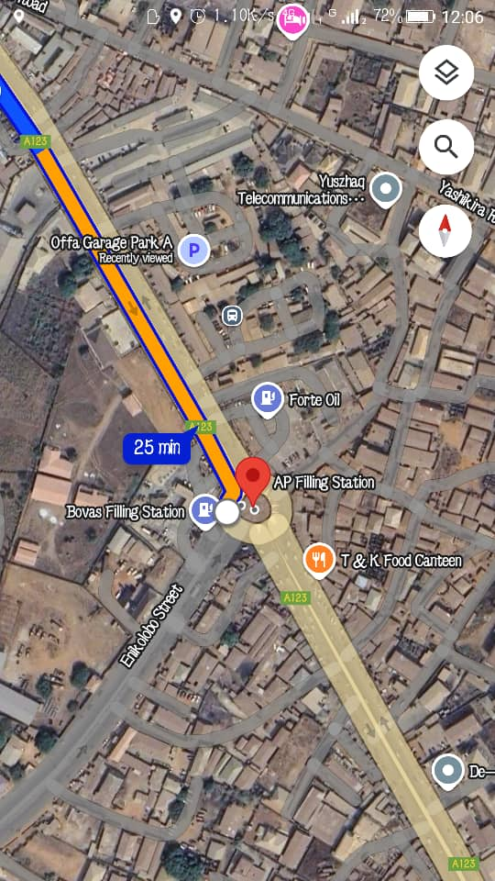
Figure 1 illustrates the location and layout of the Offa Garage Roundabout within the Ilorin urban network.

1.2 Aim and Objectives
The aim of this research is to evaluate the traffic flow of the Offa Garage Roundabout in Ilorin, Kwara State.

The objectives are as follows:
- Determine the geometric features of the Offa Garage Roundabout
- Evaluate the traffic capacity of the roundabout
- Analyse the level of service (LOS)
1.3 Problem Statement
Intersections, especially roundabouts, are critical points in urban transportation networks where conflicts and delays are most pronounced. The Offa Garage Roundabout experiences significant traffic congestion during peak hours, with frequent conflicts between entering and circulating vehicles. Factors such as uneven traffic distribution, non-compliance with traffic rules, and inadequate geometric design exacerbate these issues.
The congestion at this roundabout results in increased travel times, higher fuel consumption, and elevated levels of environmental pollution. Additionally, the inefficiencies at the intersection hinder economic activities, as delays affect the movement of goods and services. Despite its importance to Ilorin’s transportation network, limited studies have evaluated the roundabout’s performance comprehensively. This research aims to fill this gap by providing data-driven insights into its operational challenges and potential solutions.

1.4 Scope of Study
This study focuses on evaluating the traffic operations at the Offa Garage Roundabout in Ilorin, Kwara State. It involves:
- Conducting a reconnaissance survey to observe traffic patterns and identify critical issues.
- Collecting field data on vehicular volume, delays, and geometric features of the roundabout.
- Analyzing the data using tools such as the Highway Capacity Manual (HCM) and traffic simulation software.
- Proposing improvement strategies based on the findings.
The analysis will cover both weekday and weekend traffic conditions to capture variations in traffic flow. While the study’s primary focus is on vehicular traffic, pedestrian movements and their impact on the roundabout’s performance will also be considered.

1.5 Justification
Efficient traffic management is crucial for the socio-economic development of urban centers. The Offa Garage Roundabout, a vital intersection in Ilorin, facilitates mobility for commuters, traders, and other road users; however, its current inefficiencies marked by prolonged delays, increased fuel consumption, and elevated accident risks pose serious challenges to the city's transportation network. Evaluating the performance of this roundabout is essential, as it enables the identification and mitigation of traffic bottlenecks, which in turn can improve overall traffic flow. Optimized traffic operations reduce travel time and lower transportation costs, thereby benefiting both businesses and individual commuters. Moreover, by reducing congestion, fuel consumption and harmful emissions are decreased, contributing to a healthier urban environment. Finally, targeted improvements can significantly lower accident risks, ensuring safer travel for all road users. Together, these factors underscore the critical need for a comprehensive performance evaluation and subsequent redesign of the Offa Garage Roundabout to promote sustainable urban mobility in Ilorin

