

TECHNICAL REPORT ON
STUDENTS INDUSTRIAL WORKS EXPERIENCE SCHEMES (SIWES)

HELD AT

MSN CELLULAR VENTURE
NO 16 ABU COURT EPETEDO LAGOS ISLAND, LAGOS STATE

PRESENTED BY:

ALABI MEMUNAT OMOLARA
ND/23/BAM/PT/0298
SUBMITTED TO:

THE DEPARTMENT OF BUSINESS ADMINISTRATION, INSTITUTE OF FINANCE AND MANAGEMENT STUDIES, KWARA STATE POLYTECHNIC, ILORIN.
IN PARTIAL FULFILMENT OF THE REQUIREMENT FOR THE
AWARD OF NATIONAL DIPLOMA (ND) IN BUSINESS ADMINISTRATION.

AUGUST - NOVERMBER 2024

DEDICATION
I am delight to dedicate this report to Almighty God who gave me the grace and opportunity to complete this programme.

ACKNOWLEDGEMENT
I thank God Almighty for his mercy and grace that kept me all through my SIWES period.
I am greatly indebted to my parents, Mr. & Mrs. ALABI for their morally, spiritually and financially, word of encouragement and prayer given to me, who make my SIWES programme successful and also my relatives and siblings.
I also want to thank my friend and everyone that contributed to the success of my SIWES program my Industrial supervisors, my colleagues and co-workers for the tremendous moral assistance throughout the period of my attachment.

REPORT OVERVIEW
The report comprises the background of SIWES, the description of the organization, its aims and objectives, the experiences gained as an industrial training student and the summary, conclusions and recommendations.
It has a total of 5 chapters with sub-chapters. It also has the preliminary pages, such as the title page, report overview and table of contents and recommendations on the improvement of scheme.

TABLE OF CONTENT
Title Page
Dedication
Acknowledgement
Report Overview
Table of Contents
CHAPTER ONE
- Background of Siwes
1.1 Defination of Siwes
1.2 Purpose of Siwes
1.3 Objectives of the Training
CHAPTER TWO
- History and background of organization
2.1 Mission and Visions
2.2 Organizational Structure
CHAPTER THREE
3.0 Overview of POS Operations
3.1 Activities Performed During Training
3.2 Challenges Faced
3.3 Solutions to Challenges
CHAPTER FOUR
4.0 Observations
4.1 Recommendations
CHAPTER FIVE
Conclusion

CHAPTER ONE: INTRODUCTION
1.0 Background of SIWES
SIWES program was established in year 1973 by the federal Government of Nigeria through the industrial Training Fund (ITF) under the National Board of Technical Education (N.B.T.E) and it has its head quarters in Jos, plateau state.
There are other reasons behind the establishment of SIWES program, but the major reason is to learn the practical aspect of their field of study while still in course of study, which will help to face the future challenges in their respective field of study.
1.1 DEFINITION OF SIWES
Student Industrial Work Experience Scheme (SIWES) can simply be defined as a course by which student are exposed to practical training in their respective field of study. Its aim is to expose students to work practically in their respective disciplines. However, the scheme therefore was introduce to enable students match theoretical classroom knowledge with related practical knowledge in the industrial
1.2 Purpose of the Training
The main objective of this SIWES training was to expose me to the operations of a Point of Sale (POS) business and its role in the financial sector. The training provided insights into customer service, cash handling, transaction processing, and business management.
1.3 Objectives of the Training
The specific objectives of the training include:
- To gain practical experience in POS operations and business transactions.
- To understand how financial transactions are conducted using POS terminals.
- To develop customer service and problem-solving skills in a business setting.
- To learn how to manage cash flow and prevent fraud in POS transactions.
- To understand the challenges associated with POS businesses and how to overcome them.

CHAPTER TWO: COMPANY PROFILE
2.0 History and Background of the Organization
MSN CELLULAR VENTURE is a financial service provider offering Point of Sale (POS) transactions to customers. The company was established in 2016 and located in NO 16 ABU COURT EPETEDO LAGOS ISLAND, LAGOS STATE
It serves as an intermediary between banks and customers by providing easy access to cash withdrawals, deposits, and money transfers.

2.1 Mission and Visions
- Mission: To provide fast, secure, and efficient financial services to customers through POS transactions.
- Vision: To be the most reliable and customer-friendly POS service provider in the community.

2.2 Organizational Structure
The organization operates with a simple structure, including:
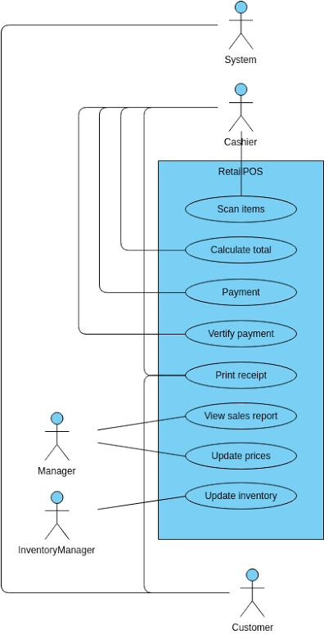
CHAPTER THREE: SIWES ACTIVITIES
3.0 Overview of POS Operations
A Point of Sale (POS) system is an electronic payment system that allows customers to perform financial transactions without visiting a bank. POS machines enable customers to withdraw money, deposit funds, transfer money, and make payments using their debit or credit cards.
POS businesses have grown rapidly due to the need for financial inclusion and the convenience they offer to customers, especially in areas with limited banking facilities.
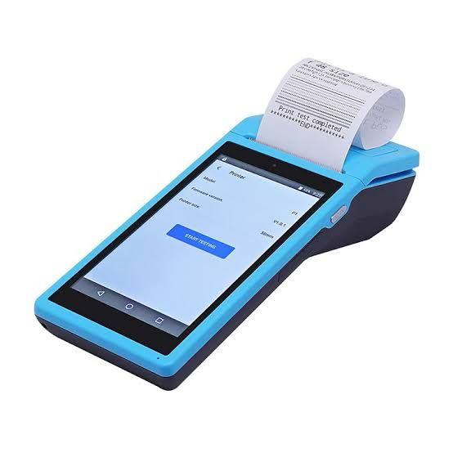
3.1 Activities Performed During Training
During my SIWES training, I was actively involved in various activities related to POS operations, including:
- Customer Service – I assisted customers in carrying out transactions and answered their inquiries regarding charges, transaction limits, and network issues.
- Transaction Processing – I processed withdrawals, deposits, and fund transfers using POS machines.
- Cash Management – I handled cash transactions, ensured proper record-keeping, and managed cash flow.
- Transaction Reconciliation – I balanced daily transactions, ensuring that cash in hand matched system records.
- Fraud Prevention – I learned how to detect and prevent fraudulent activities such as fake alerts and unauthorized card usage.
- POS Troubleshooting – I assisted in resolving minor technical issues related to network failures and machine malfunctions.

3.2 Challenges Faced
During my training, I encountered several challenges, including:
- Network Issues: Delays in transaction processing due to poor network connectivity.
- Cash Shortages: Insufficient cash to meet customer withdrawal demands.
- Fraudulent Transactions: Cases of fake alerts and fraudulent card usage.
- Customer Complaints: Complaints about transaction failures and delays in bank reversals.
3.3 Solutions to Challenges
To address these challenges, the following measures were taken:
- Alternative Network Providers: Multiple network providers were used to reduce transaction failures.
- Proper Cash Planning: Adequate cash management strategies were adopted to avoid shortages.
- Fraud Prevention Measures: Customer identity verification and fraud detection tools were implemented

CHAPTER FOUR: OBSERVATIONS AND RECOMMENDATIONS
4.0 Observations
Based on my SIWES experience, I observed the following:
- POS businesses are growing rapidly due to the increasing demand for financial services.
- Customer service is crucial in retaining customers and building trust.
- Network issues remain a major challenge in POS operations.
- Fraudulent transactions pose a significant risk to POS businesses.
4.1 Recommendations
- To improve POS business operations, I recommend the following:
- Improved Network Infrastructure: Banks and service providers should enhance network stability to ensure seamless transactions.
- Strict Security Measures: POS operators should adopt security measures to prevent fraud and unauthorized transactions.
- Adequate Cash Management: Proper cash planning should be implemented to prevent shortages.
- Customer Education: Customers should be educated on how to protect their ATM cards and avoid fraud.
- Diversification of Services: POS businesses should offer additional services such as bill payments and airtime recharge to increase revenue.

CHAPTER FIVE: CONCLUSION
My SIWES experience at MSN VENTURE was highly educational and beneficial. I gained practical knowledge in POS operations, customer service, cash handling, and fraud prevention. The training also enhanced my problem-solving skills and understanding of business management.
The knowledge and experience acquired during this training will be valuable in my future career in business administration. I am grateful for the opportunity to participate in SIWES, as it has broadened my understanding of real-world business operations.

