
REPORT ON
STUDENT INDUSTRIAL WORK EXPERIENCE SCHEME (SIWES)

HELD AT;
ADO-ODO/OTA LOCAL GOVERNMENT AREA , OTA, SANGO OTA OGUN STATE.

BY
ABUBAKAR SOFIYAT ANIKEADE
ND/23/STA/FT/0032

SUBMITED TO
DEPARTMENT OF STATISTICS,
INSTITUTE OF APPLIED SCIENCES,
KWARA STATE POLYTECHNIC, ILORIN.

IN PARTIAL FULFILMENT OF THE REQUIREMENTS
FOR THE AWARD OF NATIONAL DIPLOMA (ND) IN STATISTICS.

DEDICATION
This report is dedicated to almighty God, the Supreme Being, the beneficent, the merciful, and the foundation of wisdom, knowledge and understanding to the prudent.

OUTLINE
Title Page 1
Dedication 2
Outline 3
Introduction to SIWES 4
Definition of SIWES 4
Aim and Objectives of SIWES 5
Introduction of Industrial Placement 5
Organogram of Industrial placement 6
Departments and their function 6
Statistical Work Done 7
Experiences Gained in the Industrial Place 9
Conclusion 10
Recommendation 11

INTRODUCTION TO SIWES
Student industrial work experience scheme (SIWES) was established by Industrial Training Fund (ITF) in 1973/1974 to solve the problem of lack of adequate practical skills preparatory for employment in industries by Nigerian graduate of tertiary institutions.
Prior to the establishment of the schemes, there was a concern among our institution of higher learning lacked practical background studies preparation for employment in the industries.
The student industrial work experience scheme (SIWES) is a skill training program designed to expose and prepare student of agriculture technology, environmental science, medical science and pure & applied science for the industrial work situation one is likely to meet after graduation.
The program was established with various coordinating agencies respect to each tertiary institution in the country. These agencies are:
- NBTE (National Broad for Technical Education)
- NUC (National University Commission) for University
- NCCE (National Commission of College of Education) for colleges of education.
DEFINITION OF SIWES
Student industrial work experience which is a program established by I.T.F (Industrial Training Fund) in 1976 to bridge the gap between theory and practical aspect of learning in a tertiary institutions in Nigeria.
SIWES was established in Nigeria to help student develop on their practical aspect of learning expose them to various techniques in the industry and also help them to know the ways of handling equipment and machineries.
AIM AND OBJECTIVES OF SIWES
The aim and objectives of SIWES are as follows;
- Provide an avenue for students in institution of higher learning to acquire industrial skills and experience in their approved courses of study.
- Prepare students for the industrial work situation which they are likely to meet after graduation.
- Expose students to work methods and techniques in handling equipment and machinery not available in their institution.
- Provide students which they are likely to meet after graduation.
- Expose students to work methods and techniques in handling equipment and machinery not available in their various institutions.
INTRODUCTION OF INDUSTRIAL PLACEMENT
The Ado-Odo/Ota Local Government Area is one of the 19 Local Government Areas of Ogun State, Nigeria. It came into existence on 19 May 1989, following the merging of Ota, part of the defunct Ifo/Ota Local Government with Ado-Odo/Igbesa Areas of the Yewa South Local Government. Ado-Odo/Ota borders on metropolitan Lagos. The Local Government Area is the second largest in Ogun State and it is headquartered at Ota (or Otta) at 6°41′00″N 3°41′00″E to the north of the Area. Other towns and cities include Araromi-Alade, Ado-Odo, Agbara, Igbesa, Iju-Ota, Itele, Kooko Ebiye Town, Owode, and Sango Ota.
Their Official website https://adoodootalg.org.ng/
There are currently eleven Traditional Obaship institutions in the Local Government Area namely: Olofin of Ado-Odo, Olota of Ota, Onilogbo of Ilogbo, Oloja Ekun of Igbesa, Onikooko of Kooko Ebiye, Onitele of Itele, Amiro of Ilamiro, Onitekun of Itekun, Olodan of Odan Abuja Sule, Alagbara of Agbara, Onigun of Odan-Abuja, Onikogbo of Ikogbo, Olu of Owode Ota, Olu of Atan Ota, Olu of Ijoko Ota and Olu of Tigbo Ilu .
The postal code of the area is 112.

ORGANOGRAM OF INDUSTRIAL PLACEMENT
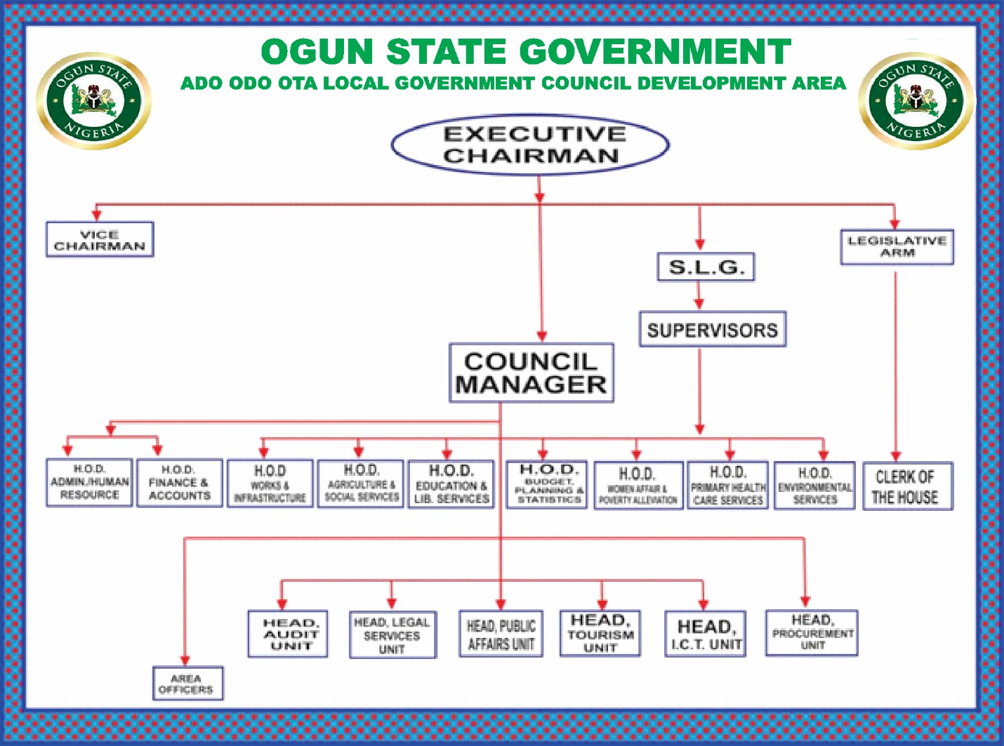

DEPARTMENT IN THE PLACEMENT AND THEIR FUNCTION
- CHAIRMAN: To chair meetings of the LGA Board (the Board of Directors of the LGA company), General Assembly, Executive Advisory Board and the Councilors’ Forum, ensuring that they operates in accordance with the Articles of Association and Governance Framework of the Association and the requirements of the Companies Acts where appropriate.
- VICE CHAIRMAN: The vice chair of a council is second in command at the council level. He or she should strive to maintain a relatively high profile in the council, be on friendly terms with all members and generally provide support and assistance to the chair.
- COUNCIL MANAGER: The manager prepares a budget for the council's consideration; recruits, hires, terminates, and supervises government staff; serves as the council's chief advisor; and carries out the council's policies.
- LEGISLATIVE ARM: The legislative arm of the Local Government Council is composed of the leader of the Council and other Councilor’s. Generally, it is involved in policy-making, promulgation or enactment of bye-laws and making of rules and regulations governing the running of the affairs of the local government.
- SUPERVISORS: Monitoring and supervising the execution of capital and other projects in the Local Government Area, especially those in their respective Wards. Mobilizing their respective communities to participate in community development projects. To serve as members of any committee established by the Council or the Chairman.
- AREA OFFICERS: ensure that practical decisions and actions related to local government policies and procedures – made by local councillors – are enacted. Their other main role is to ensure that local public service provision and delivery is efficient and cost-effective.
STATISTICAL WORK-DONE
Statistics can be said to be about collecting, organizing, summarizing, presenting and analysis of data and there are various method or techniques in which data can be analyze to make a valid and valid conclusion or interpretation of the analyzed data. During my stay at Local Government, I was placed in the records department in which I input the daily record in the system using SPSS and MS Excel, and I was able to carry-out some statistical work using statistical technique known as Descriptive Statistics to analysis the data recorded.
Some of the work done.
Citizen ID | Age | Gender | Household size
1001 | 34 | Male | 5
1002 | 27 | Female | 3
1003 | 56 | Male | 7
1004 | 41 | Male | 4
1005 | 23 | Female | 2
1006 | 65 | Female | 6
1007 | 38 | Male | 5
1008 | 50 | Female | 4
1009 | 29 | Female | 3
1010 | 45 | Male | 6

Average age of resident
Average = $\frac{Total sum of ages}{number of individuals}$
= $\frac{34+27+56+41+23+65+38+50+29+45}{10}$ = $\frac{408}{10}$ = 40.8, appro 41.
Thus, the average age of the recorded citizen is 41 years.
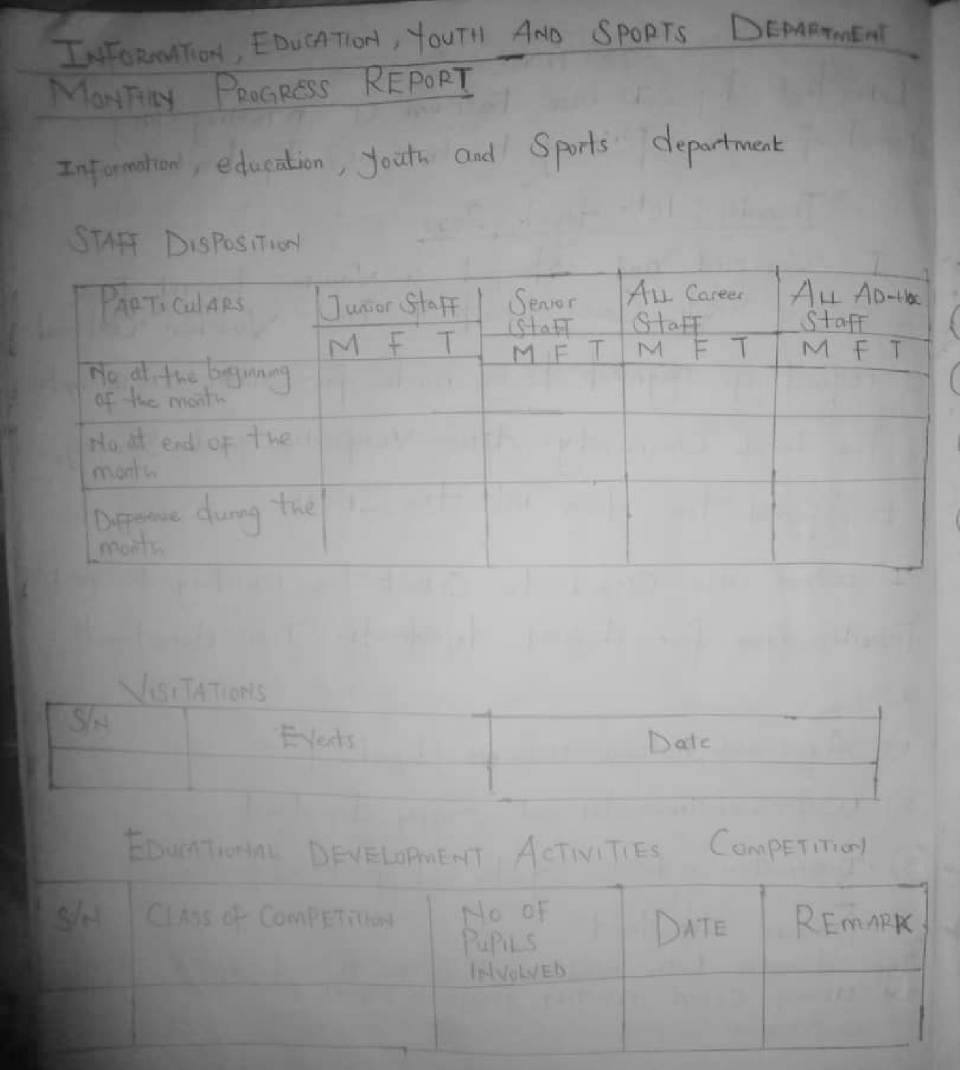
FIG. 1 SAMPLE OF A MONTHLY REPORT TEMPLATE

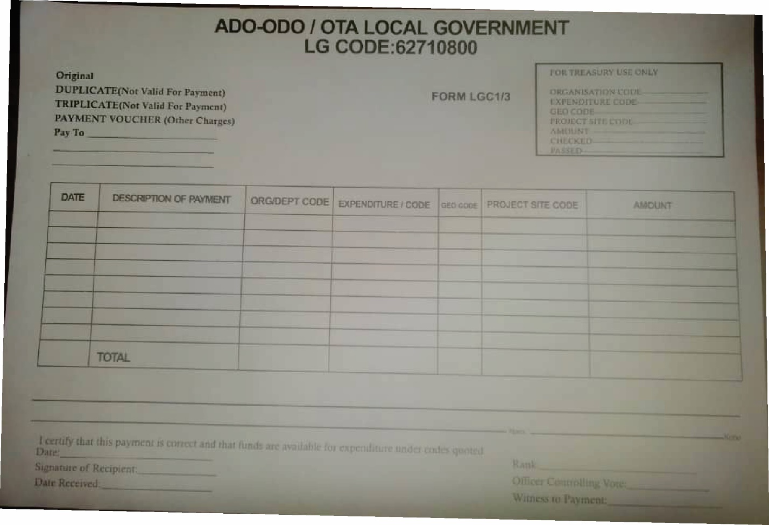
FIG. 2 VOUCHER SAMPLE

EXPERIENCE GAINED IN SIWES PLACEMENT
During my SIWES at Ado/Odo Ota Local Government Council, the following knowledge was acquired;
- Throughout my work experience, I gained valuable insights into financial management practices, departmental coordination, and the importance of accuracy and accountability in financial transactions. I had the privilege of contributing to the smooth operation of the organization's financial processes.
- I was exposed to how to use the theoretical knowledge gained in school to solve real life problem.
- I was taught good working ethics and etiquettes.
- Documentation of plans, report and relevant records.
- I was taught how to make data analysis using SPSS and Ms Excel.
- I was informed on the essentiality of graphical representation.
- I was taught how to calculate monthly expenditures.
- I was taught how to work on Voucher management
- I was taught how to send out Call Circular for budget proposal to the Head of Local Government Admin (HOLGA)
- I was taught how to analyze monthly progress reports.

CONCLUSION
After my stay at the SIWES placement, which I was placed in the records department in which I input the daily record in the system, and I was able to carry-out some statistical work by practical, I understand that solving the problem of skill acquisition by graduates of Nigerian technical / vocational education is a reason for the establishment of SIWES. It was planned to be a bridge between educational institutions and industrial employers with the latter providing general and specific occupational skills and knowledge. If the scheme is not adequately implemented it becomes difficult for graduates of the system to secure proper understanding of their choice of study and implementing into occupations or make smooth transition to the labor market world.
Incompetence in workplace is related to the kind or quality of training in the school. To improve on the scheme’s implementation students should be placed in industries relevant to their field s of study. There is need for greater cooperation between industries and educational institutions on how best to implement SIWES programme. It can thus be concluded that SIWES offers the students learning experiences which cannot be directly gained in the class room.

RECOMMENDATION
- All the institutions involved should be organizing orientation courses in collaboration with the ITF for their students prior to their attachment with the attendance made mandatory for the students accepted for SIWES and ITF staff.
- ITF should ensure the regular visitation of the ITF officers to supervising Agencies institutions, employers and students on attachment.
- ITF should be providing insurance cover to students on attachment and improve on paying students and supervisors allowances for motivation.
- The Banks should speed up their action at clearing of cheque issued to avoid unnecessary delay.

