
A TECHNICAL REPORT
ON
STUDENT INDUSTRIAL WORK EXPERIENCE SCHEME I (SIWES I)

UNDERTAKEN AT
SUNNY AUTOMECH LTD, IKEJA LAGOS STATE.
BY
OWOLABI KAMALDEEN AYOMIDE
MATRIC NO: ND/23/MEC/FT/0016

SUBMITTED TO THE DEPARTMENT OF MECHANICAL ENGINEERING, FACULTY OF INSTITUTE OF TECHNOLOGY, KWARA STATE POLYTECHNIC P. M.B 1375, ILORIN, KWARA STATE.

IN PARTIAL FULFILLMENT OF THE REQUIREMENTS FOR THE AWARD OF NATIONAL DIPLOMA(ND) DEGREE IN MECHANICAL ENGINEERING
5th August, 2024 TO, 5th December, 2024.

CERTIFICATION

This is to certify that I Owolabi Kamaldeen Ayomide with matriculation number ND/23/MEC/FT/0016 compiled this report based on my five months Student Industrial Work Experience Scheme at SUNNY AUTOMECH LTD Workshop from August, 2024 to December, 2024.

…………………….. ………………………

Student’s Name Student’s Signature

…………………………. ………………………….

School based supervisor Supervisor’s Signature

DEDICATION
This report is dedicated to the Almighty God, whose unwavering guidance and blessings have been the foundation of my success throughout this transformative journey. I also dedicate this work to my parents, Mr. and Mrs. Owolabi, whose unwavering support and encouragement have been instrumental in my personal and professional development, as well as to the esteemed faculty members of the Faculty of Technology, whose expertise and dedication have equipped me with the knowledge and skills necessary to thrive in this industry.

ACKNOWLEDGEMENT
I express my heartfelt gratitude to the Almighty God for His steadfast provision and mercy throughout the duration of my industrial training program. I extend my sincere appreciation to the dedicated staff of the Sunny Automech LTD Workshop, who welcomed me with open arms and imparted invaluable knowledge and practical skills during my time there. I am also deeply grateful to the lecturers of the Faculty of Technology, who have selflessly shared their expertise and equipped me with the foundational understanding necessary to excel in this field. Furthermore, I am indebted to my parents, Mr. and Mrs. Owolabi, for their unwavering financial support and accommodation during this pivotal phase of my academic and professional journey.

ABSTRACT
The Student Industrial Work Experience Scheme is a program established by the Federal Government of Nigeria with the primary objective of exposing students in higher institutions to practical experience and industrial skills within their respective fields of study. This report documents my five-month internship at the Sunny Automech LTD Workshop, where I had the opportunity to apply the theoretical knowledge gained in the classroom to real-world automotive maintenance and repair scenarios. During the course of my internship, I was involved in a variety of tasks, including engine diagnostics, transmission repair, and electrical system troubleshooting.
Through this comprehensive experience, I have not only deepened my understanding of automotive engineering principles but have also developed a robust set of hands-on skills and problem-solving abilities that will undoubtedly serve me well as I transition into the industry.
Exploring the synergies between academia and industry, this report provides a detailed account of my journey, the knowledge and skills acquired, and the insights gained through this invaluable Student Industrial Work Experience Scheme.

TABLE OF CONTENTS

CHAPTER ONE
1.1 CERTIFICATION
1.2 DEDICATION
1.3 ACKNOWLEDGEMENT
1.4 ABSTRACT
1.5 BRIEF HISTORY OF THE SUNNY AUTOMECH LTD WORKSHOP
1.6 ACTIVITIES AND RESPONSIBILITIES DURING THE INTERNSHIP
CHAPTER TWO
2.1 JAPANESE AUTOMOBILE SYSTEM
2.2 BRAKE SYSTEM
2.3 SUSPENSION SYSTEM
2.4 TRANSMISSION SYSTEM
2.5 ENGINE SYSTEM
2.6 IGNITION SYSTEM
2.7 EXHAUST SYSTEM
CHAPTER THREE
3.1 ACTIVITIES CARRIED OUT DURING THE INTERNSHIP
3.1 ENGINE SERVICE (CHANGE OF OIL)
3.2 CHANGING OF BRAKE PAD
3.3 CHANGING OF GEARBOX
3.4 TROUBLESHOOTING AND DIAGNOSIS
3.5 CHANGING OF SHOCK ABSORBER
3.6 CHANGING OF BRAKE DISC

CHAPTER FOUR
4.1 CHALLENGES ENCOUNTERED
4.2 SUMMARY OF ATTACHMENT ACTIVITIES
4.3 RECOMMENDATION
4.4 CONCLUSION
4.5 REFERENCES

CHAPTER ONE
1.5 BRIEF HISTORY OF THE SUNNY AUTOMECH LTD WORKSHOP

The Sunny Automech LTD Workshop is a renowned automotive
maintenance and repair facility located in the heart of Lagos, Nigeria.
Established in 1999, the workshop has gained a reputation for its
expertise in servicing and repairing a wide range of Japanese
automobile models, including Toyota, Honda, Nissan, and Mitsubishi, among others.

1.6 ACTIVITIES AND RESPONSIBILITIES DURING THE INTERNSHIP
During the course of my five-month internship at the Sunny Automech LTD Workshop, I was
involved in a diverse range of activities and responsibilities, including engine diagnostics, brake system
maintenance, suspension system repair, transmission system overhaul, ignition system troubleshooting, and exhaust system replacement.
Through these hands-on experiences, I was able to apply the theoretical
knowledge gained in the classroom to real-world automotive engineering challenges, developing a more comprehensive understanding of the intricacies involved in the maintenance and repair of Japanese automobiles.

CHAPTER TWO

2.1 JAPANESE AUTOMOBILE SYSTEM
Japanese automobiles are renowned for their reliability, fuel efficiency, and advanced technological features. The key systems that underpin the
performance and functionality of these vehicles include the brake system, suspension system, transmission system, ignition system, and exhaust system.

2.2 BRAKE SYSTEM
The brake system in Japanese automobiles is designed to provide efficient and reliable stopping power, ensuring the safety of both the driver and passengers. The Japanese automotive industry has consistently demonstrated a commitment to engineering excellence, particularly in the design and performance of the brake systems found in their vehicles.

COMPONENTS OF THE BRAKE SYSTEM
- Brake Pads: Responsible for creating friction to slow or stop the vehicle.
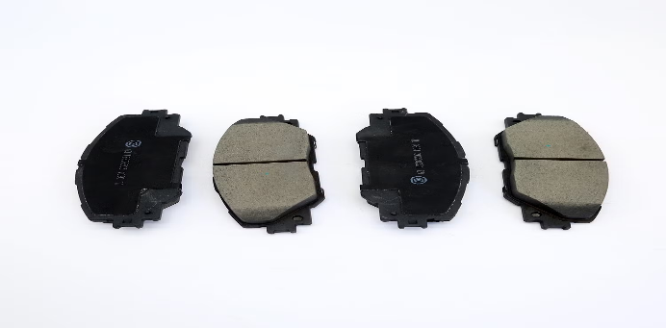
- Brake Discs: Integral to the braking process, these discs convert the kinetic energy of the moving vehicle into thermal energy, which is then dissipated.
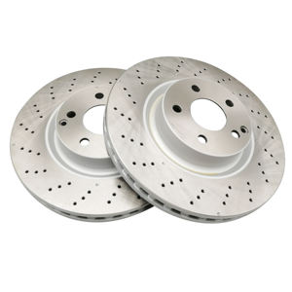
- Brake Callipers: These hydraulic components apply pressure to the brake pads, causing them to grip the brake discs and slow or stop the vehicle.
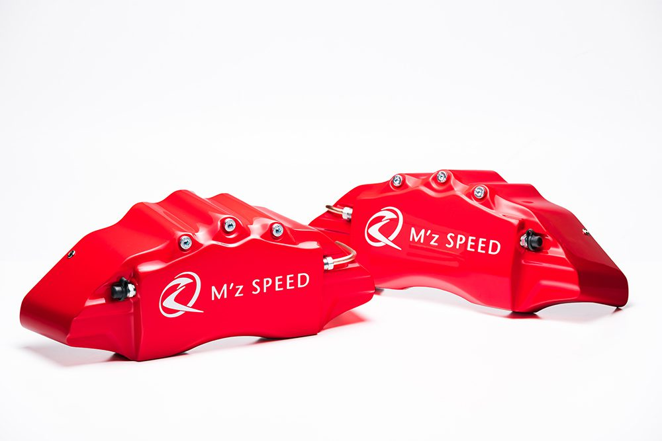
- Brake Pedals: The interface between the driver and the brake system, the pedal transmits the driver's input to the hydraulic system.
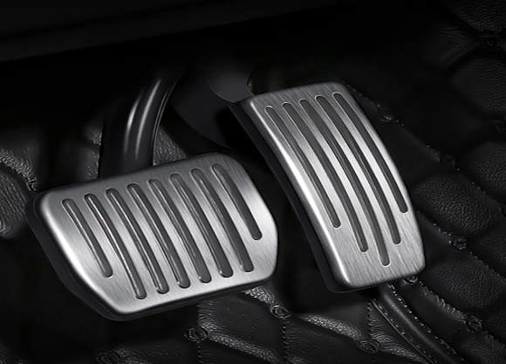
- Master cylinder: This component converts the driver's force on the brake pedal into hydraulic pressure, which is then distributed to the brake callipers.
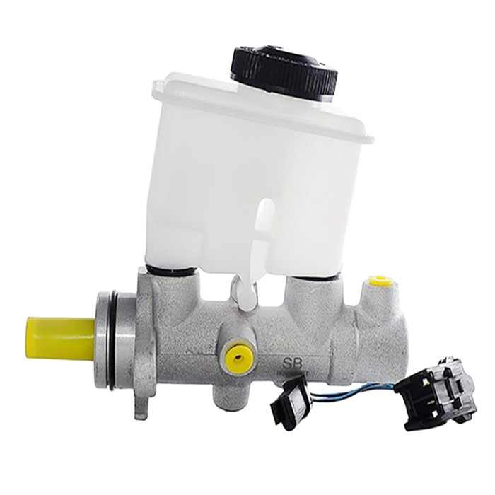
- Brake Fluid: The incompressible fluid that transmits the hydraulic pressure from the master cylinder to the brake callipers.
- Brake lines: The conduits that carry the brake fluid from the master cylinder to the brake callipers.
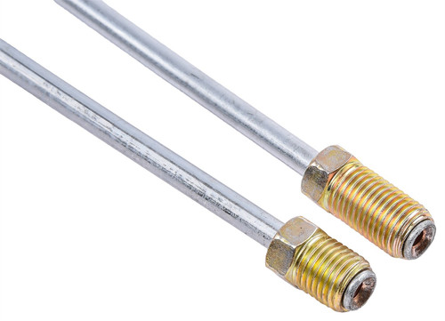
The efficient and reliable performance of these components is crucial for ensuring the safe operation of Japanese automobiles.

2.3 SUSPENSION SYSTEM
The suspension system in Japanese automobiles plays a critical role in providing a smooth and comfortable ride, as well as maintaining the vehicle's stability and handling characteristics. Types of suspension systems commonly found in Japanese vehicles include:
- Macpherson Strut Suspension: A widely used independent suspension system that combines a strut with a control arm.
- Coil Spring Suspension: A suspension system that uses coil springs to absorb the impact of road irregularities.
- Torsion Beam Suspension: A semi-independent suspension system that uses a torsion beam to connect the rear wheels.
- Double Wishbone Suspension: An independent suspension system that utilizes two wishbone-shaped control arms to provide superior handling and ride quality.
- The suspension system components, such as shock absorbers, springs, and control arms, work together to enhance the vehicle's overall ride quality, handling, and stability.

- COMPONENTS OF THE SUSPENSION SYSTEM
- Shock Absorbers: These components dampen the vertical movement of the vehicle's wheels, reducing the impact of bumps and uneven road surfaces.
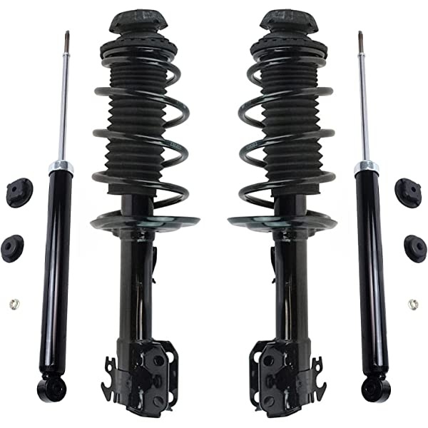
- Coil Springs: These energy-absorbing components store and release kinetic energy helping to smooth out the ride.
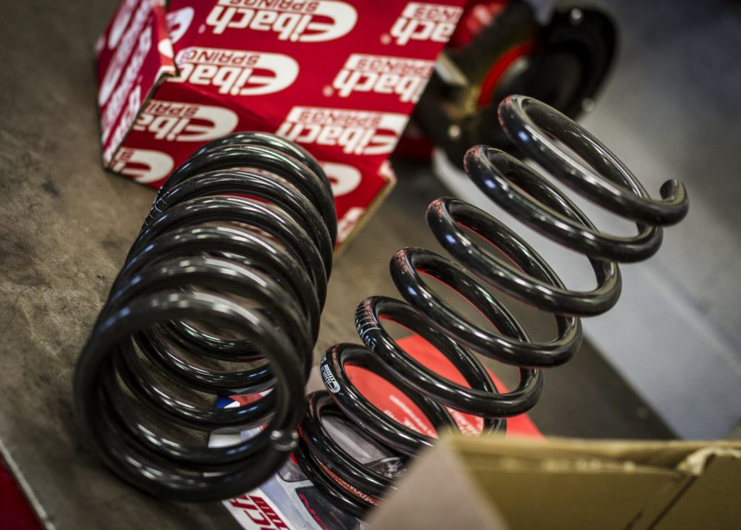

- Control Arms: The linkages that connect the wheels to the vehicle's frame, allowing for controlled suspension movement.
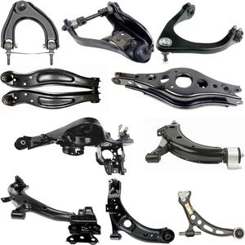
- Bushings: Flexible components that isolate the suspension parts from the vehicle's frame, reducing vibration and noise.
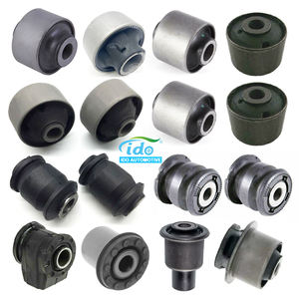

- Stabilizer Bar: This component helps to reduce body roll during cornering, improving the vehicle's overall handling and stability.
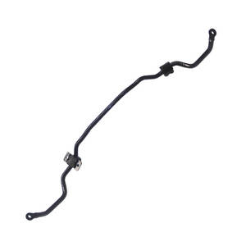
- Stabilizer Linkage: The linkage that connects the stabilizer bar to the suspension components.
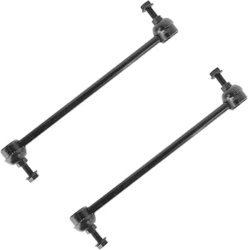
The precise engineering and tuning of these suspension system components is a hallmark of Japanese automotive design, contributing to the renowned handling and ride quality of these vehicles.
2.4 TRANSMISSION SYSTEM
The transmission system in Japanese automobiles is responsible for transmitting the engine's power to the wheels, allowing for efficient and seamless acceleration and deceleration. types of transmission systems found in Japanese vehicles include:
- Manual Transmissions: These transmissions require the driver to manually shift between gears using a clutch pedal and gear shifter.
- Automatic Transmissions: These transmissions automatically shift between gears, providing a more convenient driving experience.
- Continuously Variable Transmissions: A type of automatic transmission that uses a belt or chain to provide an infinite number of gear ratios, offering improved fuel efficiency and a smoother driving experience.

COMPONENTS OF THE TRANSMISSION SYSTEM
Torque Converter: This component in automatic transmissions converts the engine's rotational force into hydraulic pressure, which then drives the transmission.
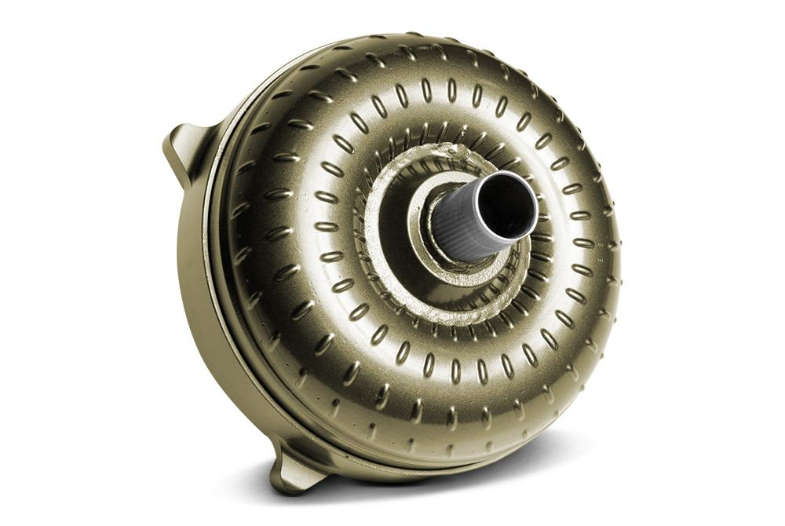

Clutch: In manual transmissions, the clutch disengages the engine from the transmission, allowing the driver to shift gears.
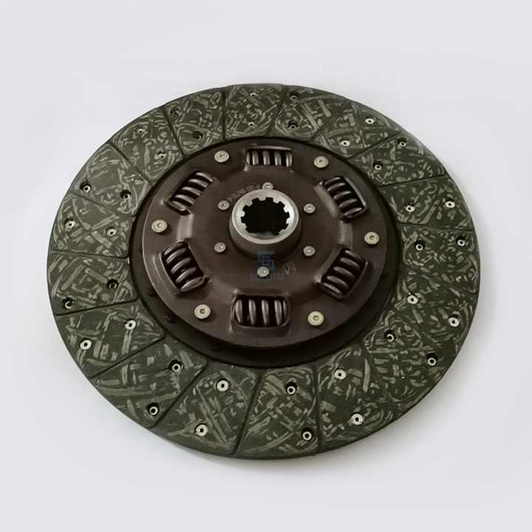
Planetary Gearset: The set of gears in automatic transmissions that allows for the seamless shifting between different gear ratios.
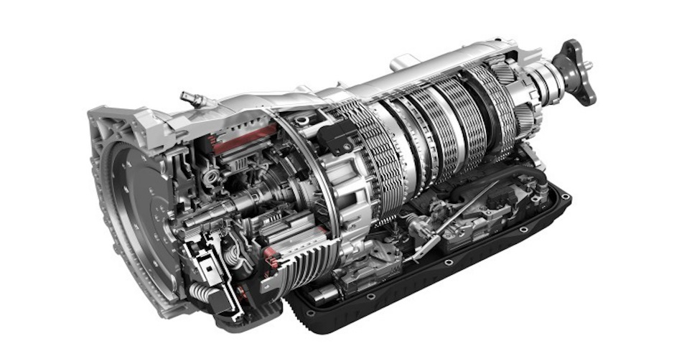
Differential: This component distributes the engine's power to the wheels, allowing them to rotate at different speeds during turns and cornering.
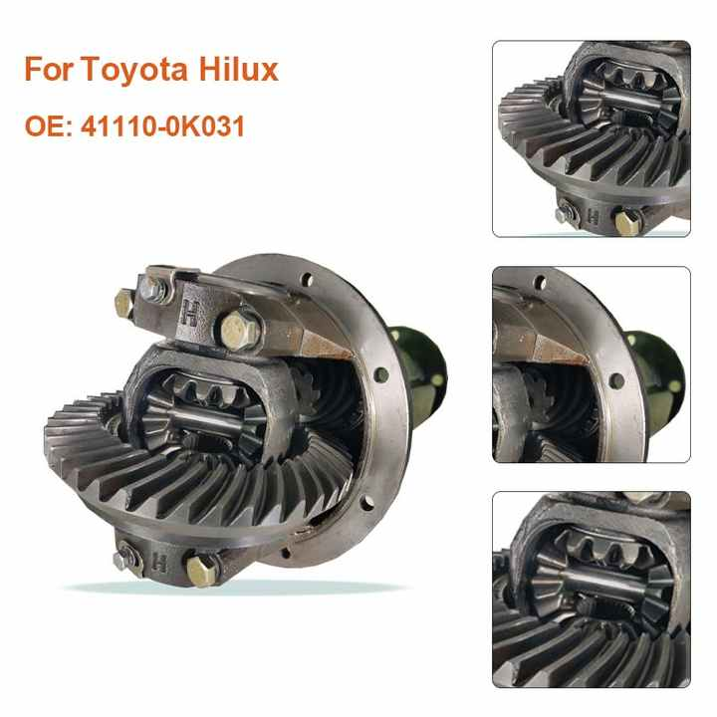
Transmission Fluid: The specialized fluid that lubricates and cools the internal components of the transmission system.
The transmission system in Japanese automobiles is renowned for its durability, efficiency, and smooth operation, contributing to the overall driving experience.

2.5 ENGINE SYSTEM
The engine system in Japanese automobiles is the heart of the vehicle, providing the power and performance that drivers have come to expect from these vehicles. types of engine systems found in Japanese vehicles include:
- Internal Combustion Engines: These engines convert the chemical energy stored in fuel into mechanical energy, driving the vehicle's wheels.
- Hybrid Engines: These engines combine an internal combustion engine with an electric motor, offering improved fuel efficiency and reduced emissions.

- COMPONENTS OF THE ENGINE SYSTEM
- Cylinder Block: The main structural component of the engine, housing the cylinders where the combustion process takes place.
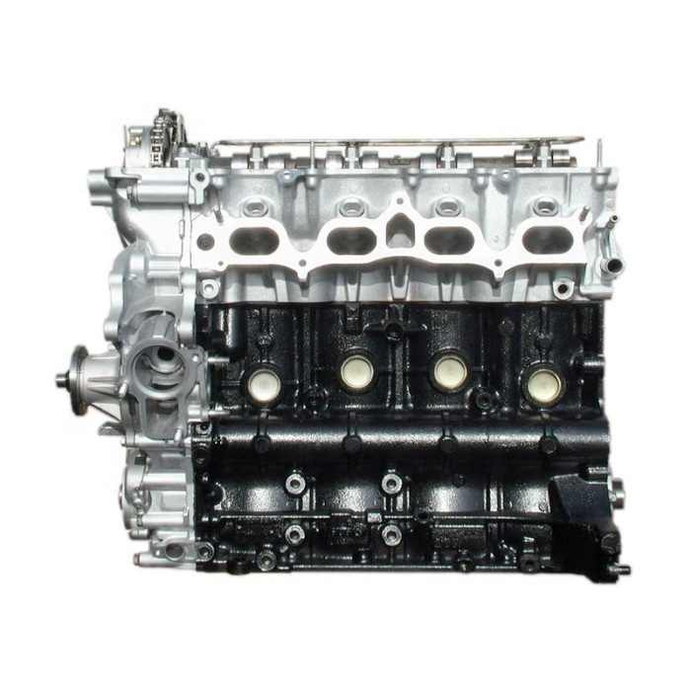
- Piston: The component that moves up and down within the cylinder, converting the energy from the combustion process into rotational force.
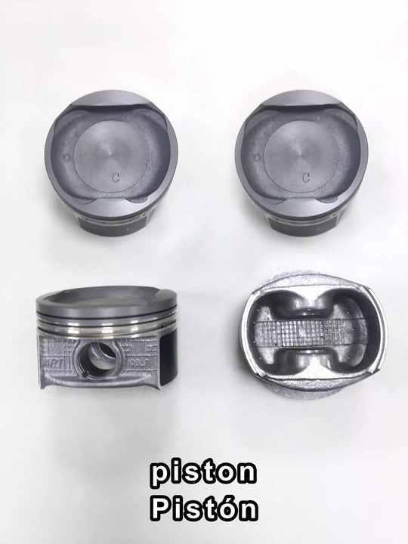
- Crankshaft: The component that converts the reciprocating motion of the pistons into rotational motion, which is then transmitted to the transmission.
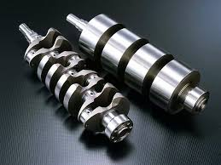
- Camshaft: The component that controls the opening and closing of the engine's valves, regulating the flow of air and fuel into and out of the cylinders.
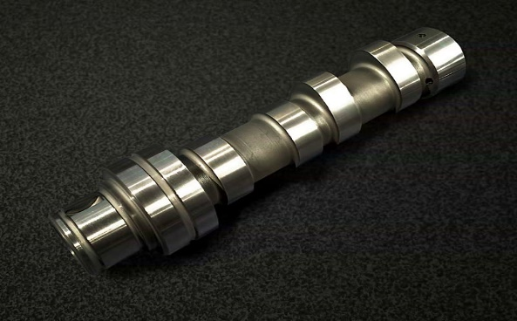
- Spark Plug: The component that ignites the air-fuel mixture within the cylinder, initiating the combustion process.
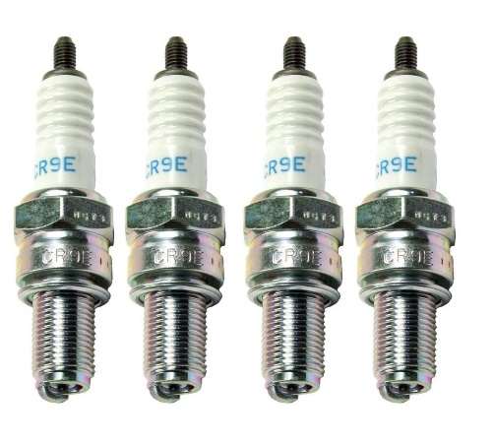
- Fuel Injection System: The system responsible for delivering the precise amount of fuel into the engine's cylinders, ensuring efficient combustion.
The engine system in Japanese automobiles is renowned for its reliability, fuel efficiency, and performance, thanks to advanced engineering and strict quality control measures.

2.6 IGNITION SYSTEM
The ignition system in Japanese automobiles is responsible for providing the spark that ignites the air-fuel mixture in the engine's cylinders, allowing the combustion process to occur. types of ignition systems found in Japanese vehicles include:
Conventional Ignition System: This system uses a distributor to route the high-voltage spark to the appropriate spark plugs.
Electronic Ignition System: This more advanced system uses electronic components, such as an ignition coil and electronic control unit, to generate and distribute the spark, providing improved reliability and performance.

COMPONENTS OF THE IGNITION SYSTEM
Ignition Coil: This component transforms the low-voltage current from the battery into the high-voltage spark needed to ignite the air-fuel mixture.
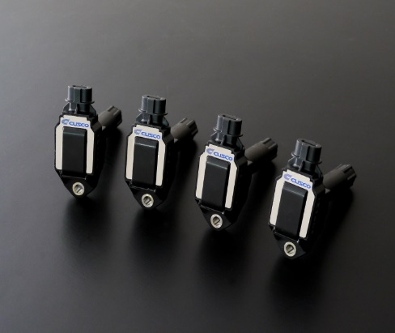
Spark plugs: The components that generate the spark within the engine's cylinders, initiating the combustion process.
Ignition Control Module: The electronic component that controls the timing and distribution of the spark, ensuring optimal engine performance.
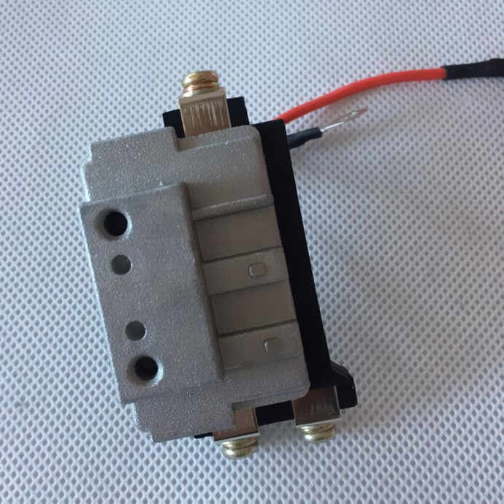

2.7 EXHAUST SYSTEM
The exhaust system in Japanese automobiles is responsible for removing the spent gases from the engine's combustion process, while also reducing noise and emissions.

Components of the exhaust system include:
Catalytic Converter: This component uses a chemical reaction to convert harmful exhaust emissions into less toxic substances, reducing the vehicle's environmental impact.
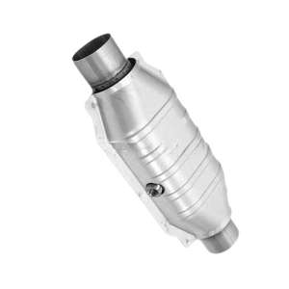
Muffler: The component that reduces the noise generated by the engine's exhaust, providing a quieter driving experience.
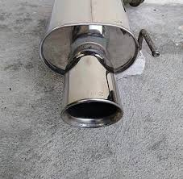

Exhaust Manifold: The component that collects the exhaust gases from the engine's cylinders and directs them towards the catalytic converter.
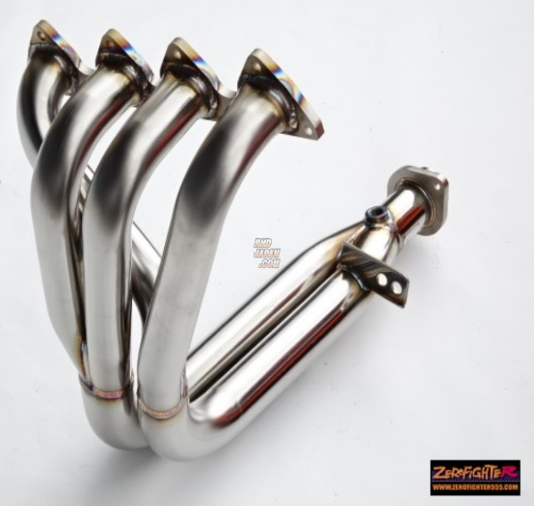
Exhaust Pipes: The components that transport the exhaust gases from the manifold to the muffler and out of the vehicle.
The exhaust system in Japanese automobiles is designed to be efficient, durable, and environmentally friendly, contributing to the overall driving experience and compliance with emission regulations.

CHAPTER THREE
OPERATIONS CARRIED OUT DURING THE INTERNSHIP AT SUNNY AUTOMECH WORKSHOP
During the five-month student industrial work experience program at Sunny Automech Workshop, I was able to gain valuable hands-on experience in the maintenance and repair of Japanese automobiles.
The various operations I was involved in included:
DISASSEMBLY AND REASSEMBLY OF COMPONENTS
I was trained in the proper techniques for disassembling and reassembling various automotive components, such as the engine, transmission, and suspension systems. This allowed me to develop a deep understanding of the inner workings of these systems and how they function together.

MAINTENANCE AND REPAIR PROCEDURES
I actively participated in routine maintenance tasks, such as oil changes, tire rotations, and brake inspections. I also assisted with more complex repair procedures, such as engine overhauls, transmission rebuilds, and electrical system diagnostics.
QUALITY CONTROL AND CUSTOMER SERVICE
I was also involved in the quality control process, ensuring that all repairs were completed to the highest standards. Additionally, I had the opportunity to interact with customers, providing them with updates on the status of their vehicles and addressing any concerns they had.
The hands-on experience gained during my internship at Sunny Automech Workshop was invaluable, as it allowed me to apply the theoretical knowledge I had acquired in the classroom to real-world situations.

3.1 ENGINE SERVICE (CHANGE OF OIL) AND REPAIR
During my internship, I was involved in various engine service and repair procedures, including:
Engine disassembly and reassembly: I learned how to properly disassemble and reassemble the engine, including the removal and installation of components such as the cylinder head, crankshaft, and pistons.
Engine overhaul: I assisted in the complete overhaul of several engines, including the replacement of worn or damaged components and the proper adjustment of critical systems such as the timing belt and valve train.
Ignition system service: I was trained in the diagnosis and repair of ignition system components, such as spark plugs, ignition coils, and the ignition control module.
PROCEDURES
The engine service and maintenance procedures followed at Sunny Automech Workshop were in strict accordance with the manufacturer's recommendations and industry best practices. The workshop had developed a comprehensive preventive maintenance program that ensured the optimal performance and longevity of the engines.

- Lift the vehicle securely and remove the engine cover or access panels to gain access to the engine components.
- slack the sump bolt with the necessary spanner
- and drain the engine oil completely.
- Replace the oil filter and refill the engine with the recommended grade and quantity of engine oil.
- Inspect the engine components, such as the timing belt, hoses, and belts, for wear or damage and replace as necessary.

- 3.2 CHANGING OF BRAKE PAD:
- I was involved in the process of changing brake pads on various Japanese vehicles.

- PROCEDURES
Loosen the wheel lugs and remove the wheel.
Inspect the brake pads and measure the thickness to determine if replacement is necessary.
Disconnect the brake calliper from the mounting bracket and swing it out of the way.
Remove the old brake pads and clean the calliper and mounting bracket.
Install the new brake pads, making sure they are properly seated and secured. 7.
Reconnect the brake calliper and reinstall the wheel.
Repeat the process for all four wheels.
- The workshop ensured that only genuine OEM parts were used in all brake repairs to maintain the vehicle's safety and performance.

- 3.3 CHANGING OF GEARBOX
- One of the more complex tasks I was involved in during my internship was the changing of a gearbox.

PROCEDURES
Drain the transmission fluid and remove the transmission from the vehicle.
Disassemble the transmission, inspect all components, and replace any worn or damaged parts.
Reassemble the transmission, ensuring all components are properly aligned and lubricated.

3.4 DIAGNOSTIC TESTING AND TROUBLESHOOTING
I was trained in the use of specialized diagnostic equipment, such as scan tools and multimeters to identify and diagnose issues with the vehicles. This enabled me to develop my problem-solving skills and my ability to quickly identify and address the root causes of problems.

3.5 CHANGING OF SHOCK ARSORBERS
Procedure
After securing and lifting the vehicle, remove the wheels after which you’ll find the shock absorber. It is typically mounted between the vehicle’s chassis and the wheel hub.
Depending on the model, you may need to remove components like the sway bar links or other components that obstruct access to the shock.

Remove the upper mounting bolts of the shock absorber. Next, remove the lower mounting bolts. Carefully pull the old shock absorber out afterwards.

Position the new shock absorber in place, ensuring it aligns with both the upper and lower mountings.

3.6 CHANGING OF BRAKE DISC
The replacement of brake discs follows similar procedure to the replacement of brake pads with the addition of the removal of the brake disc after taking out the brake calliper and the brake pads. The new brake disc will also be installed before reinstalling the brake pads and the brake calliper.

CHAPTER FOUR
4.1 CHALLENGES ENCOUNTERED DURING THE INTERNSHIP

ADHERENCE TO SAFETY PROTOCOLS: One of the primary challenges I faced during my internship was the strict adherence to safety protocols. The workshop placed a strong emphasis on workplace safety, and I had to be diligent in following all the safety procedures, such as using personal protective equipment, properly securing the vehicle during maintenance, and following the correct lifting and handling techniques.

TECHNICAL KNOWLEDGE REQUIREMENTS: The repair and maintenance of Japanese vehicles required a deep understanding of their technical specifications and engineering principles. I had to continuously expand my knowledge and skills to keep up with the latest advancements in automotive technology.

CUSTOMER COMMUNICATION: Interacting with customers and effectively communicating the status of their vehicle repairs was another challenge I faced. I had to develop strong communication skills to explain technical issues in a way that was easily understandable to non-technical individuals.

4.2 SUMMARY OF ATTACHMENT ACTIVITIES
In summary, my five-month internship at the Sunny Automech Workshop provided me with a comprehensive understanding of the repair and maintenance of Japanese vehicles. I was exposed to a wide range of tasks, including engine service and repair, brake system maintenance, and gearbox replacement. The hands-on experience I gained, combined with the technical knowledge I acquired, have greatly enhanced my ability to work in the automotive industry. Throughout the internship, I was able to apply the theoretical knowledge I had acquired in the classroom to real-world situations, which allowed me to develop a deeper understanding of the practical aspects of automotive repair and maintenance.

4.3 RECOMMENDATIONS
Based on my experience during the internship, I would recommend the following:
Enhancing the internship program by incorporating more structured training modules and providing more opportunities for hands-on practice in a wider range of vehicle repair and maintenance tasks.
Improving the communication between the workshop and the academic institution to ensure that the internship program aligns with the curriculum and provides the most relevant and up-to-date practical experience for students.
Investigating the possibility of incorporating more advanced diagnostic and repair equipment, such as computerized diagnostic tools, to expose students to the latest technologies used in the industry.

4.4 CONCLUSION:
The Student Industrial Work Experience Scheme has been invaluable in bridging the gap between theoretical knowledge and practical skills in the automotive industry. My internship at the Sunny Automech Workshop has equipped me with the necessary technical expertise and hands-on experience to work effectively in the repair and maintenance of Japanese vehicles. The knowledge and skills I have acquired will be instrumental in my future career as an automotive engineer and technician.

s4.5 REFERENCES
(Morimoto & YAMANAKA, 2012) Sustainable Industry-Academia-Government Collaborative Education Focusing on Advantages of Industry
Perceptions of Workplace, Principal, and Productive Teachers on Students' Work Readiness in SMK Negeri 1 Purworejo (Subijanto, 2019), Indonesia (Subijanto, 2019)
EVALUASI PROGRAM PEMBELAJARAN PEKERJAAN DASAR TEKNIK OTOMOTIF KELAS X TKRO DI SMK NEGERI 1 SEDAYU
Towards the Qualified Human Resource: Internship Program at Leading Ex-LPTK Universities in Indonesia
Morimoto, E., & YAMANAKA, H. (2012). Sustainable Industry-Academia-Government Collaborative Education Focusing on Advantages of Industry: Long-term Internship after 5years Practice. In Journal of Engineering Education Research (Vol. 15, Issue 5, p. 47). https://doi.org/10.18108/jeer.2012.15.5.47
Subijanto, S. (2019). Perceptions of Workplace, Principal, and Productive Teachers on Students’ Work Readiness in SMK Negeri 5 Surabaya Indonesia. In Jurnal Pendidikan Teknologi Kejuruan (Vol. 2, Issue 4, p. 125). https://doi.org/10.24036/jptk.v2i4.21123

