
TECHNICAL REPORT ON
STUDENT INDUSTRIAL WORKS EXPERIENCE SCHEME (SIWES)
HELD AT
KWARA STATE POLYTECHNIC
PRESENTED BY
BEYIOKU TAIWO MICHAEL
ND/23/MEC/PT/0087
SUBMITTED TO:
DEPARTMENT OF MECHANICAL ENGINEERING, INSTITUTE OF TECHNOLOGY (IOT)
KWARA STATE POLYTECHNIC, P.M.B 1375, ILORIN
KWARA STATE
IN PARTIAL FULFILMENT OF THE REQUIREMENT FOR THE AWARD OF NATIONAL DIPLOMA (ND) IN MECHANICAL ENGINEERING DEPARTMENT
KWARA STATE POLYTECHNIC, ILORIN, KWARA STATE.

AUGUST – DECEMBER, 2024

DEDICATION
I am delighted to dedicate this report to the Almighty God for the grace and opportunity given to me to complete this program.

ACKNOWLEDGEMENT
I give thanks to Almighty God for his grace and mercy over my life and privilege given for the start and completion of my SIWES program.
Special thanks to my parents Mr. and Mrs. BEYIOKU for their undying love and support morally, spiritually and financially over my life, and their words of encouragement and prayer which has been the driving force behind my successful SIWES program.
I also give thanks to my lovely siblings; Maria Beyioku, Olayemi Beyioku, Serah Beyioku, Moses Beyioku, Kehinde Beyioku, Oluwatosin Beyioku for their love, support, and words of advice and encouragement during my SIWES program, you are most appreciated. May the Lord bless you all.
I express my profound gratitude to my department lecturers and my SIWES supervisor Engr. Adeshina Dayo for the support towards the successful completion of my program, and to all my friends for their contributions in one way or the other. God bless you all.

PREFACE
The Student Industrial Work Experience Scheme (SIWES) helps in exposing students to the practical application of their course and to get used to equipment and machines used in the factory. The SIWES was established to promote student skill in industrial practice and pre-expose them to working experience in industrial setting.
The SIWES programme covered a period of four months from August to December 2024 and it is a partial fulfilment of a two year academic programme to obtain an OND certificate in Engineering. The report explains the description of work done.

Table of Contents
Title Page i
Dedication ii
Acknowledgement iii
Preface iv
Table of Contents v
CHAPTER 1: INTRODUCTION
1.1: Background 1
1.2: Objectives of SIWES 2

CHAPTER 2: DESCRIPTION OF THE ESTABLISHMENT OF ATTACHMENT
2.1: Location and Brief History of Establishment 3
2.2: Objectives of Establishment 3
2.3: Organization Structure (Including Organogram) 5
2.4: The Various Departments/Units in the Establishment and their Functions 5

CHAPTER 3: WORKDONE
3.1: Various Machines, Tools, and Equipments and their Functions in the Engineering Workshop 7
3.2: Machine Tools and Equipments and their Functions in the Workshop 10
3.3: Metal Casting in the Fabrication Workshop 16

CHAPTER 4: EXPERIENCE GAINED
4.0: Summary of experience gained 21

CHAPTER 5: SUMMARY, CONCLUSION AND RECOMMENDATION
5.1: Summary of Attachment Activities 22
5.2: Problems Encountered during the Program 22
5.3: Suggestions for the Improvement of the Scheme 23

CHAPTER 1
1.0. INTRODUCTION
1.1. Background
SIWES stands for Students Industrial Work Experience Scheme. It is a mandatory internship program for students in Nigerian universities and polytechnics, particularly those in engineering, technology and other related fields.
The SIWES program was established by the Federal Government through the Industrial Training Fund (ITF) under the National Board of Technical Education (N.B.T.E.) in 1973, with the primary objective of bridging the gap between theoretical knowledge acquired in the classroom and practical experience in the industry.
1.1. Objectives of SIWES
The Students Industrial Work Experience Scheme is designed to achieve the following specific, measurable, achievable, relevant, and time-bound objectives:
- Primary Objectives
- Practical Skill Acquisition: To provide students with hands-on experience in their chosen field, enabling them to apply theoretical knowledge by equipping them with practical skills and competencies required in the industry in real-world setting.
- Industry-Academia Collaboration: To foster collaboration between educational institutions and industries, and facilitating the exchange of knowledge, expertise, and resources between academia and industry promoting mutual understanding and benefit.
- Career Preparation: To prepare students for the workforce by exposing them to industry practices, ethics, and expectations thereby enhancing students' employability and career prospects.

- Secondary Objectives
- Skill Development: To enhance students' skills, particularly in areas such as problem-solving, communication and teamwork while developing their critical thinking, creativity and innovation skills.
- Exposure to Industry Practices: To provide students with firsthand experience of industry practices, procedures, and standards.
- Entrepreneurial Skill Development: To encourage students to develop entrepreneurial skills and consider starting their own business.
- Expected Outcomes.
- Improved Employability: To improve the employability of graduates by providing them with relevant work experience and skills thereby enhancing their career prospects and opportunities.
- Enhanced Skill Competencies: To enhance student’s ability to apply theoretical knowledge and practical skills in real-world setting.

CHAPTER 2
2.0. DESCRIPTION OF THE ESTABLISHMENT OF ATTACHMENT
2.1. Location and Brief History of Establishment
KWARA STATE POLYTECHNIC (KWARAPOLY) P. M. B 1375 ILORIN, KWARA STATE was established in 1972 as Kwara State College of Technology. The institution was renamed Kwara State Polytechnic in 1985. Since its inception, the polytechnic has undergone significant development and expansion, with a focus on providing high-quality technical and vocational education.
2.2. Objectives of Establishment
- Primary Objectives
- To provide high-quality technical and vocational education that meets the needs of the economy and society.
- To equip students with practical skills and competencies required in the industry
- To promote research and innovation in various fields, leading to the development of new technologies and products.

- Secondary Objectives
- To foster collaboration between academia and industry, leading to the exchange of knowledge, expertise, and resources.
- To provide a conducive learning environment that supports academic excellence and personal growth.
- To provide opportunities for lifelong learning and professional development.
- To promote entrepreneurship and self-employment among graduates.

2.3. Organization Structure.
RECTOR

DEAN SCHOOL OF ENGINEERING

MECHANICAL ENGINEERING WORKSHOP MANAGER

QUALITY CONTROL INSPECTOR
SAFETY OFFICER
FITTING SECTION SUPERVISOR
MACHINING SECTION SUPERVISOR
WELDING SECTION SUPERVISOR

WELDING TECHNICIANS
FITTINGS TECHNICIANS
MACHINING TECHNICIANS

STUDENT TRAINEES (MACHINING)
STUDENT TRAINEES (WELDING)

STUDENT TRAINEES (FITTINGS)

2.4. The Various Departments or Units in the Establishment and their Functions.
- Mechanical Engineering Department
- Functions:
- Design and development of mechanical systems
- Thermodynamics and heat transfer
- Fluid mechanics and dynamics
- Materials science and metallurgy
- Welding and Fabrication Engineering Department
- Functions:
- Design welding processes
- Fabricate metal products
- Conduct quality control
- Develop new welding techniques
- Testing of welding equipments
- Inspect welded products
- Train welding personnel

- Automotive Engineering Unit
- Functions:
- Design vehicle systems
- Develop engine performance
- Test transmission systems
- Improve braking systems
- Develop safety features
- Validate vehicle performance
- Research new automotive technologies

CHAPTER 3
3.0. WORKDONE
3.1. Various Machines, Tools, and Equipments and their Functions in the Engineering Workshop.
Tools and equipment can be any items or apparatus that is used to achieve a goal or a specific objective either mechanical or non-mechanical. Also tools are most component in engineering workshops.
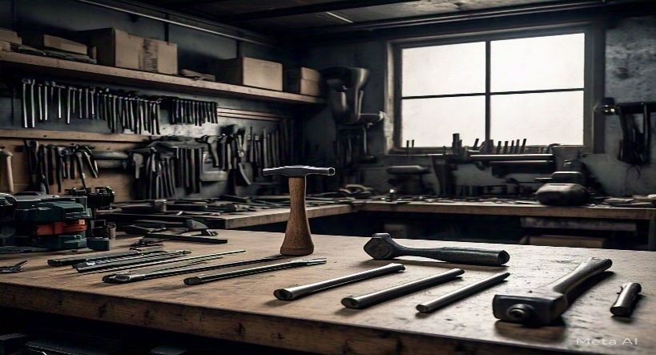

- Different Hand Tools in the Engineering Workshop
- Cutting Tools
- Hacksaw: A hacksaw is a handheld saw used to cut metal pipes, rods, and other metal objects. It consists of a frame, a blade, and a handle.
- Bolt cutters: Bolt cutters are used to cut chains, bolts, and wires. They consist of two handles and a cutting jaw.
- Pliers: Pliers are handheld tools used to grip, bend, and cut objects. There are various types of pliers, including needle-nose pliers, slip-joint pliers, and locking pliers.
- Utility knife: A utility knife is a handheld tool used to cut various materials like wood, plastic, and drywall. It consists of a blade and a handle.
- Scissors: Scissors are handheld tools used to cut paper, fabric, and other lightweight materials.
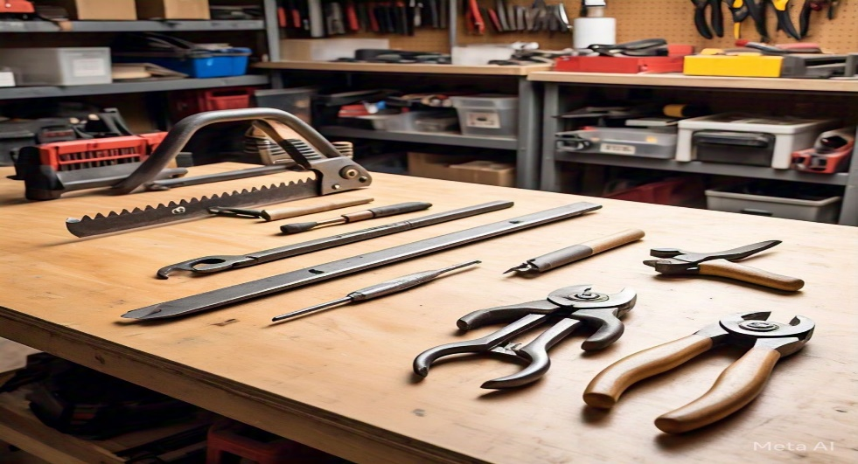

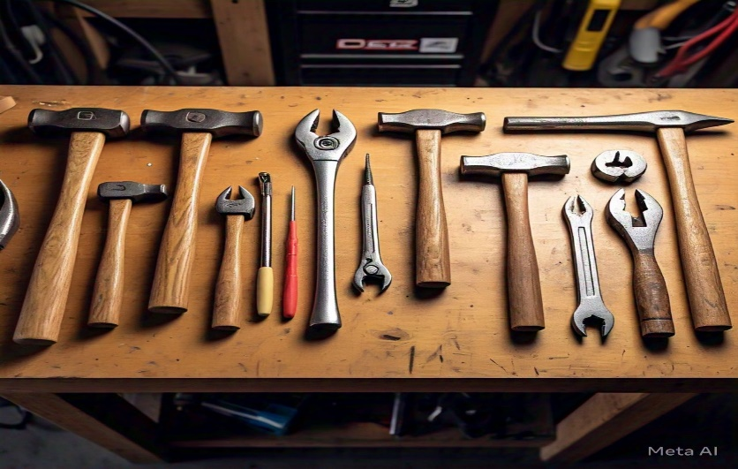

- Fastening Tools
- Hammer: A hammer is a handheld tool used to drive nails, fit parts together, and break apart objects. There are various types of hammers, including claw hammers, ball-peen hammers, and sledgehammers.
- Screwdrivers: Screwdrivers are handheld tools used to drive screws and other fasteners. There are various types of screwdrivers, including flathead screwdrivers, Phillips-head screwdrivers, and Torx screwdrivers.
- Pliers: Pliers are also used as fastening tools to grip and twist objects.
- Wrenches: Wrenches are handheld tools used to tighten and loosen bolts and nuts. There are various types of wrenches, including adjustable wrenches, socket wrenches, and box-end wrenches.
- Tape measure: A tape measure is a handheld tool used to measure distances and sizes.



- Measuring Tools
- Calipers: Calipers are handheld tools used to measure internal and external dimensions. There are various types of calipers, including digital calipers and dial calipers.
- Micrometer: A micrometer is a handheld tool used to measure precise dimensions. There are various types of micrometers, including digital micrometers and analog micrometers.
- Level: a level is a handheld tool used to ensure surfaces are level and plumb.
- Square: A square is a handheld tool used to ensure accurate right angles.
- Protractor: A protractor is a handheld tool used to measure angles.

- Holding Tools
- Clamps: Clamps are handheld tools used to hold objects in place. There are various types of clamps, including bar clamps, pipe clamps, and C-clamps.
- Vises: Vises are handheld tools used to hold objects firmly in place. There are various types of vises, including bench vises and hand vises.
- Gripping pliers: Gripping pliers are handheld tools used to hold small objects.
- Magnetic bases: Magnetic bases are handheld tools used to hold metal objects.
- Bench stops: Bench stops are handheld tools used to hold objects against a bench.

3.2. Machine Tools and Equipment and their Functions in the Workshop
- Lathe Machine
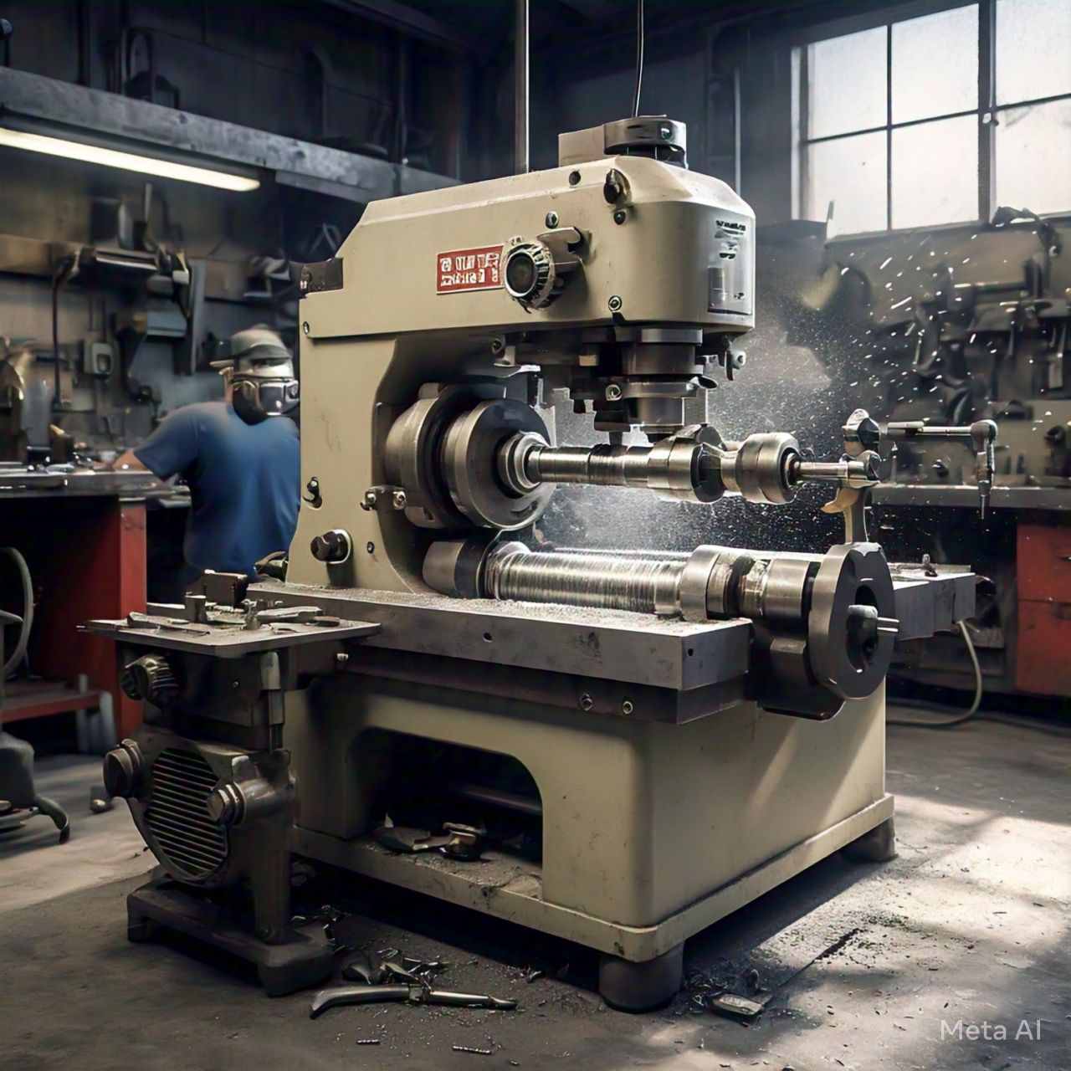
The lathe machine is a machine tool used to shape and form cylindrical work pieces by rotating them against a cutting tool. It consists of a bed, a headstock, a tailstock, and a carriage. The headstock holds the spindle, which rotates the work piece. The tailstock provides support for the work piece, while the carriage moves along the bed to position the cutting tool.

- Main Components of Lathe Machine
- Bed: The bed is the base of the lathe machine, providing support for the other components.
- Headstock: The headstock is located at one end of the bed and holds the spindle, which rotates the work piece.
- Tailstock: The tailstock is located at the other end of the bed and provides support for the work piece.
- Carriage: The carriage moves along the bed and holds the cutting tool.
- Cross-slide: The cross-slide moves perpendicular to the bed and holds the cutting tool.
- Compound rest: The compound rest is a swiveling table that holds the cutting tool.

- Functions of Lathe Machine
- Turning: The lathe machine is used to turn cylindrical work pieces to precise dimensions.
- Facing: The lathe machine is used to face cylindrical work pieces to create flat surfaces.
- Threading: The lathe machine is used to thread cylindrical work pieces to create screw threads.
- Knurling: The lathe machine is used to knurl cylindrical work pieces to create textured surfaces.
- Drilling: The lathe machine can be used to drill holes in cylindrical work pieces.
- Reaming: The lathe machine can be used to ream holes in cylindrical work pieces.
- Tapping: The lathe machine can be used to tap holes in cylindrical work pieces.
- Boring: The lathe machine can be used to bore holes in cylindrical work pieces.

- Work done or Operations Performed on Lathe Machine
- Rough turning: Rough turning involves turning a cylindrical work piece to remove excess material.
- Finish turning: Finish turning involves turning a cylindrical work piece to precise dimensions.
- Facing: Facing involves creating a flat surface on a cylindrical work piece.
- Threading: Threading involves creating screw threads on a cylindrical work piece.
- Knurling: Knurling involves creating a textured surface on a cylindrical work piece.

- Common Lathe Machine Problems and Solutions
- Vibration:
- Causes: Unbalanced work piece, worn bearings, misaligned spindle.
- Solutions: Balance the work piece, replace worn bearings, and align the spindle.
- Inaccurate Turning:
- Causes: Worn or damaged cutting tool, incorrect cutting tool geometry, insufficient cutting tool pressure.
- Solutions: Replace worn or damaged cutting tool, adjust cutting tool geometry, and adjust cutting tool pressure.
- Overheating:
- Causes: Insufficient coolant, clogged coolant lines, incorrect cutting tool material.
- Solutions: Ensure sufficient coolant, clean clogged coolant lines, select correct cutting tool material.
- Chuck or Work piece Damage:
- Causes: Excessive tightening or loosening, incorrect chuck or work piece alignment, insufficient cutting tool pressure.
- Solutions: Tighten or loosen the chuck correctly, align the chuck and work piece correctly, adjust cutting tool pressure.
- Preventative Maintenance
- Regular Cleaning: Clean the machine and its components regularly to prevent dirt and debris buildup.
- Lubrication: Apply lubricants to moving parts and components to reduce friction and wear.
- Inspections: Perform regular inspections to identify potential problems before they become major issues.
- Operator Training: Ensure operators are properly trained and follow correct operating procedures to prevent machine damage and optimize performance.

- CNC Machine
A CNC (Computer Numerical Control) machine is a computer-controlled machine tool that uses programmed instructions to execute precise movements and actions. The machine consists of a computer control system, machine tool, drive system, sensors, and feedback systems. The computer control system is the brain of the CNC machine, interpreting programmed instructions and controlling the machine's movements. The machine tool is the physical machine that performs the desired operation, such as cutting, drilling, or milling.
The drive system is the mechanism that moves the machine tool along the desired path, using motors, gears, and ball screws. Sensors and feedback systems monitor the machine's movements and provide feedback to the control system, ensuring accuracy and precision. CNC machines can perform various operations, including movement along multiple axes, cutting, drilling, milling, turning, grinding, and engraving.
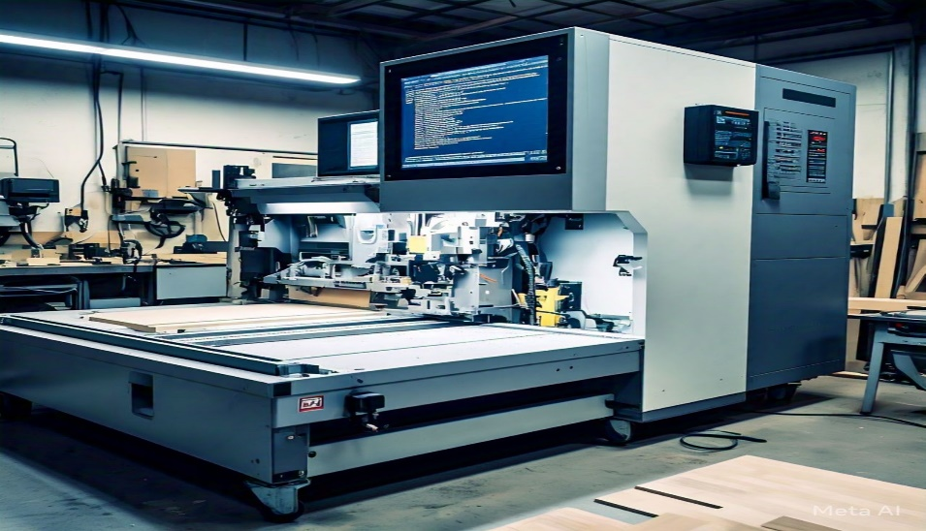

There are several types of CNC machines, including milling machines, lathes, grinding machines, drilling machines, and router machines. Milling machines are used for milling, drilling, and tapping operations. Lathes are used for turning, facing, and boring operations. Grinding machines are used for grinding and polishing operations. Drilling machines are used for drilling and tapping operations. Router machines are used for routing and engraving operations.

- Main Components of a CNC Machine
- Computer Numerical Control (CNC) System: The brain of the machine, responsible for interpreting programs and controlling machine movements.
- Machine Tool: The physical part of the machine that performs the desired operation, such as cutting, drilling, or milling.
- Spindle: The rotating shaft that holds the cutting tool in place.
- Axes: The mechanical components that move the spindle and cutting tool along specific paths.
- Drive System: The motors, gears, and ball screws that power the axes and spindle.
- Control Panel: The interface where operators input programs, monitor machine status, and adjust settings.

- Common CNC Machine Problems and Solutions
- Inaccurate Machining:
- Causes: Inaccurate machining can occur due to incorrect programming, worn-out cutting tools, or improper machine calibration.
- Solution: Verify programming accuracy, check machine calibration, and use precision cutting tools.

- Machine Vibration:
- Causes: Machine vibration can cause inaccurate machining, reduce tool life, and lead to machine damage.
- Solution: Check machine mounts and foundations, balance rotating components, and use vibration-dampening materials.
- Tool Breakage:
- Causes: Tool breakage can occur due to incorrect tool selection, improper tool setup, or excessive cutting forces.
- Solution: Select correct cutting tools, set up tools correctly, and monitor cutting forces.
- Spindle Overheating:
- Causes: Spindle overheating can occur due to excessive cutting forces, incorrect coolant usage, or malfunctioning spindle components.
- Solution: Monitor coolant usage, check spindle components, and reduce cutting forces.
- Program Errors:
- Causes: Program errors can occur due to incorrect programming, syntax errors, or incompatible program formats.
- Solution: Verify program syntax, check program compatibility, and use program simulation software.

- Axis Slippage:
- Causes: Axis slippage can occur due to worn-out bearings, incorrect axis alignment, or excessive cutting forces.
- Solution: Check axis alignment, replace worn-out bearings, and reduce cutting forces.
- Coolant Leaks:
- Causes: Coolant leaks can occur due to damaged hoses, loose connections, or clogged coolant nozzles.
- Solution: Inspect hoses and connections, replace damaged components, and clean coolant nozzles.
- Motor Overload:
- Causes: Motor overload can occur due to excessive cutting forces, incorrect motor sizing, or malfunctioning motor components.
- Solution: Reduce cutting forces, check motor sizing, and replace malfunctioning motor components.

3.3. Metal Casting in Fabrication Workshop
Metal casting is a fabrication process where molten metal is poured into a mold to create a desired shape or form. Metal used may be; aluminum, copper, iron, zinc, or alloys like stainless steel (chronium-nickel-iron).
The process also includes;
- Creating a replica of the desired shape or form
- Creating a mold around the pattern
- Heating metal to it's melting point
- Pouring molten metal into the mold and allowing it to cool and solidify
- Removing the casting from the mold and performing additional processing (e.g, grinding)

3.4. Description of step-by-step Metal Casting Fabrication Process using Sand Casting Technique in Mechanical Engineering Welding and Fabrication Workshop
- Mold Preparation
We prepare the molding material such as sand (silica) by sieving to ensure that it is free from debris and contaminants and has optimal density and permeability to ensure high quality casting with minimal defects.
After sieving, we spread the molding material to make a mold on which we lay our pattern (either wooden or metal pattern) and we apply a binder (clay or resin) to the material and ram the pattern into the mold.
Then we lay the mold box on the mold and position a runner pipe in the center of the pattern and 2 riser pipes at points on the pattern to create holes (mold cavity) within the molding material where molten metal will pass through, and we ensure the mold is dry and free of defects.
After the mold is dried, the mold box is to be raised in order to remove the pattern used before the mold is once again covered.

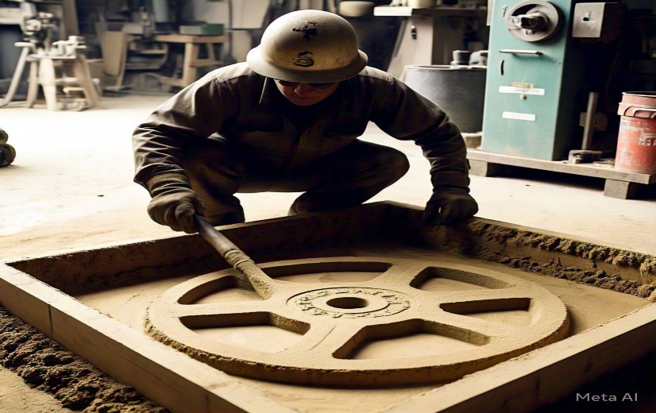

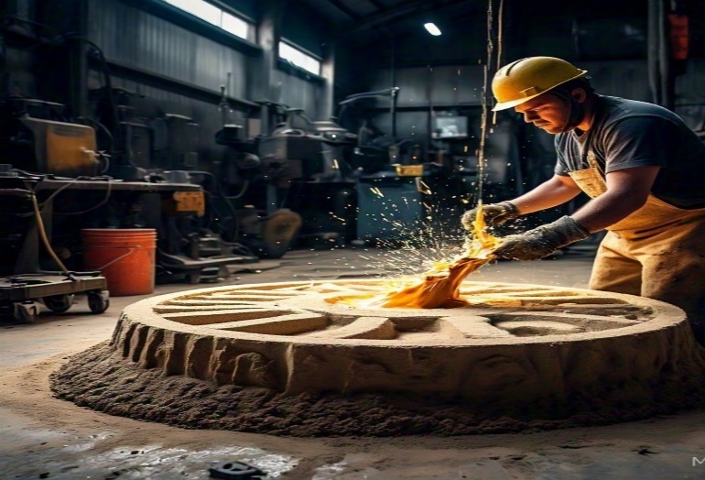

- Melting and Pouring of the Metal Heated
The metal to be used is then heated (i.e, the desired quantity of aluminum scraps) in a furnace or crucible to its melting point. Wearing personal protective equipment (PPE), such as safety glasses, gloves and leather boots, using a pair of tongs the molten metal is gently lifted and poured through the mold cavity ensuring the metal flows smoothly and fills it.

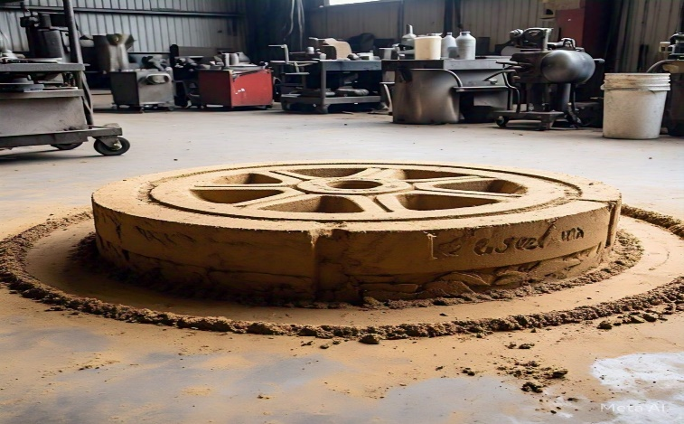

- Solidification and Removal of the Casting
After filling up the mold with the heated metal, it is then allowed to solidify by monitoring the cooling process to ensure it cools slowly and evenly in the mold. After which the mold box is raised for the removal of the casting using a pair of tong after solidification.
- Post-Casting Operations
Then next is to proceed to cleaning the casting to remove any mold material or debris, after which we inspect the casting for defects or irregularities and finding none other necessary post-casting operations are performed like, grinding or machining to achieve a smooth surface finish.

3.5. Materials and Equipment used in the Casting Process
- Silica sand
- Sieve
- Pattern (either wooden or metal)
- Binders (clay or resin)
- Runner and riser pipes (to form the mold cavity)
- Molding box
- Metal scraps
- Furnace machine or crucible
- Personal protective equipment (PPE)

CHAPTER 4
4.0. Experience Gained
The 4-months SIWES program has exposed me to technical skills as in, practical application of theoretical knowledge, familiarity with industry-standard equipment and software, and hands-on experience with projects and tasks in relation to my course of study and my view of knowledge is broadened through the experience gained at various units which involves the following:
- Familiarizing with the knowledge of different types of hand tools used in the workshop
- How to operate the lathe machine in regards to tasks given in the workshop
- Identification of different components of the lathe machine and common lathe machine problems and their solutions
- How to operate the CNC machine in regards to operations to be carried out
- Identification of different components, functions and common CNC machine problems and their solutions
- Practical application in metal casting using sand casting technique

CHPATER 5
5.0. Summary, Conclusion and Recommendation
5.1. Summary of Attachment Activities
- Familiarization and Training
- Familiarized with common hand tools used in workshops.
- Underwent training on safety protocols and best practices.
- Metal Casting Process
- Learned about the sand casting technique and its applications.
- Participated in the sand casting process using the sand casting technique.
- Gained hands-on experience with metal casting processes.
- Machine Operation
- Received training on operating the lathe machine.
- Learned about CNC machines and their programming.
- Practiced operating CNC machines and gained familiarity with their controls.
- Explored other machine tools and equipment used in workshops.

5.2. Problems Encountered during the Program
- Time constraints due to multiple ongoing projects
- Unlimited access due to electricity supply
- Occasional delays due to equipment malfunction

5.3. Suggestions for the Improvement of the Scheme
- Ensure that SIWES programs are aligned with the student’s academic curriculum to maximize learning outcomes
- Establish clear learning objectives for SIWES programs to help students understand what they need to achieve
- Ensure that students receive effective supervision and guidance during their SIWES program
- Provide regular feedback to students to help them improve and adjust to the work environment

