CHAPTER ONE
1.1 PURPOSE OF TRAINING
The Student Industrial Work Experience Scheme (SIWES) was initiated in 1973 by the Industrial Training Fund (ITF). This was to update practical knowledge of students in the Universities, Polytechnics and Colleges of Technology. It was aimed at bridging the gap between the theoretical knowledge acquired in classes and technical knowledge in the industry by providing students with the opportunities to apply their educational knowledge in real work situations.
Over the years, SIWES has contributed immensely to building the common pool of technical and allied skills available in the Nigeria economy which are needed for the nation’s industrial development.
Furthermore, the place and relevance of SIWES is underscored by the fact that the scheme contributes to improving the quality of technical skills generally available in the pool from which employers source technical manpower
Its gives student the opportunity to blend the theoretical knowledge acquired in the classroom and with practical hands on application of knowledge required to perform work in the industry. Also it prepares students for employment and makes the transition from school to the industry easier after graduation. I undertook my SIWES at MATAG TUGA ENGINEERING, Along NTA Junction Ajase Ipo, Kwara State
1.2 COMPANY’S PROFILE
MATAG TUGA ENGINEERING Automobile workshop, is located Along NTA Junction Ajase Ipo, Kwara State Kwara State Nigeria, the establishment deals with vehicles such as SUVs, wagon, van, sedan, coupe, truck, hybrid and pick-up of various brands and models. Though not equipped with the latest technology available in developed parts of the world, however with its equipment and tools it has been carrying out proper diagnosis, servicing and maintenance of customer’s vehicle.
1.3 ESTABLISMENT’S CORPORATE GOAL
Ministry of works and transportation Automobile workshop goals to our clients is to fix your vehicle to the proper working condition in a clean and professional environment, so that you are happy and satisfied with the service that was performed.
We also want you to have the trust and confidence in us that you are being treated honestly and fairly. Also to have the freedom to approach us at any time with any questions or concerns with the service that you are receiving.
The goal to employees is to provide them with the best working conditions possible with the proper tools and equipment to repair our client’s vehicles. This in turn gives them the privilege to associate with happy, satisfied and dedicated clients. Also, for the trainee to have the freedom to input on how to better improve the working conditions to offer better service to our clients.

1.4 ORGANIZATION CHART
Managing director

Apprentice/Trainee
Engineer
Stock keeper
Cashier
Secretary
Manager

Workshop
Store

CHAPTER TWO
2.1 HAND TOOLS AND EQUIPMENT WITH THEIR FUNCTIONS
There all different types of hand tool and equipment in mechanical engineering sector, but some of them can be mentioned below, as:
SPANNER: it is used for tightening and loosing of bolts and units we have various types of spanner; such as flat ring and plug, spanner adjustable spanner.
JACK: it is used for lifting more vehicles to remove wheel (tyre)
SOCKET: this tool used in tightening, loosing bolt and nut especially during the servicing of motor vehicle.
PLIER (engineering): it is used for cutting thing cable, turning, griping work piece.
SCREW Driver: it is used in driving in/tightening the screw; there are different types of shape, such as: flat, star, hexagonal.
HAMMER: it is used in pulling in/out some part of motor vehicle. It is in different forms/types such as straight, pane, ball, and sledge hammer.
WHEEL Spanner: it is used for loosing or tightening the bolt and nut.
2.2 SERVICING OF MOTOR VEHICLE
There are two way of servicing motor vehicle in the automobile aspect this includes normal servicing and comprehensive servicing. We shall take them one after the other.

2.2.1 NORMAL SERVICING
Step 1: Remove the protector of the vehicle and open the bonnet.
Step2: Dry the engine oil from the sump.
Step3: Loose the oil filter with chain filter sockets or replace it with new oil filter.
Step 4: Remove the fuel filter and replace with new one.
N.B: Make sure that it is fixed in a current place to avoid incomplete work of motor vehicle.
Steps: close the sump and make sure that it is well closed. N.B: Before the servicing motor vehicle you must have up to 10,000km/h fuel, if it is not up to that it is not advisable to service motor vehicle. Then the new OH must be checked whether it gauged or not.
2.2.2 COMPREHENSIVE SERVICING
This Servicing has 16 names which implore it more to be comprehensive than the normal servicing, although it also just like normal servicing but it has further steps in the process which is not involved in the normal servicing.
Comprehensive servicing also under goes the steps of that of normal servicing but the only Changes is listed below:
- Changing of timing belt.
- Changing of alternator belt.
- Change of sparking plug.
- Changing of the break pad.
- Changing of engine oil.
2.3 CYLINDER BLOCK
The designed of the cylinder block depends on the system of cooling the engine. The cylinder block for the basic frame work of the engine and it usually made from grey cast iron entraining granite carbon, because of the material capacity of being cast into intricate shapes, Aluminum Alloy could use in some case, the properties are;
- Light
- Good conductor of heat
- Good corrosive resistance
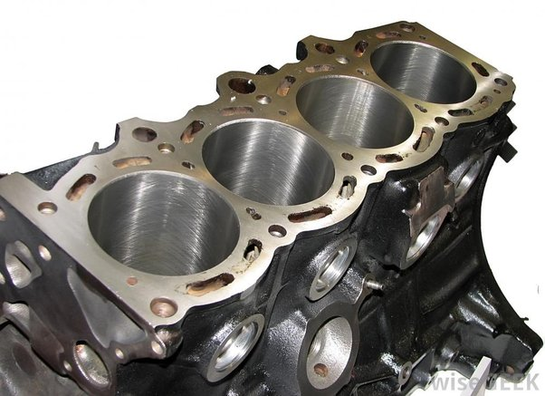
The cylinder block (Engine): which is known as the power unit is the means of converting the chemical energy into the heat and then into the mechanical energy for the purpose of transmitting motion. The cylinder block house, cylinder bore, piston and its rings, water pump, crankshaft, oil pump, taper, e.t. c

Cylinder piston and piston ring
Cylinder bore is the hole where the piston travels along. To ensure that a good seal is obtained; spring piston rings are fitted into grooves in the piston for the entire force by the burning gases. The piston must be a good sliding fit in the cylinder impression ring as the top piston prevents the gases from escaping so the oil controller with carper rings fitted regulates the oil supplied to the upper cylinder.
There are three types of piston ring
- Upper sealing ring (thickness 1, 2mm)
- Lower sealing ring (thickness 1, 5mm)
- Scraper ring (thickness 2,5mm)
2.4 REMOVER OF PISTON
Access to the piston may be obtained by removing the cylinder head, disconnecting the large and lifting the complete piston and connecting and assembling through the linear.
The following procedure should be followed
- Remove the required cylinder head.
- Remove the crane case door.
- Remove the large and set screws, tab wash and lower half of the large and bearing.
- Pull the connecting rod and piston upward through the linear until the gudgeon pin hole is cheer.
- Remove the hairclips and extract the gudgeon pin
- Remove the piston ring with care, because rough handling may damage it.
2.5 FUNCTIONS OF PISTON
1. To form the movable gas tight in the plunger of the cylinder
2. It serves as guide and protects the bearing at the small end of the connecting rod
3. It takes up the side thrust
4. It receives and transmits the expulsive of gases in the ambition chamber during the power stroller in the crankshafts via the connecting rod for the piston to be able to perform the above must:
Be rigid enough to withstand the high pressure and temperature
- Be high to reduce the engine weight to help in acceleration.
- Must be a good head conductor to prevent seizure.
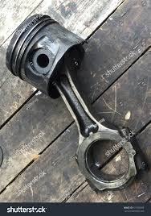
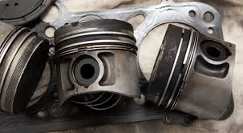
- Must have low expansion rate to avoid the piston slap.

CHAPTER THREE
3.1 CRANKSHAFT FOR FOUR CYLINDER ENGINE CAMSHAFT
The purpose of the camshaft is to operate the closing and opening of the valves (inlet and exhaust) it has many cams but two camshafts are usually foe each cylinder. The first one operates the inlet valve while the second one operates the exhaust valve.
Camshaft rotates its bearing and has a screw gear which drives the distribution shaft and oil pump and mechanical petrol fuel pump.
Mechanical petrol pump: It is also operated by the cam of the camshaft.
The camshaft is driven by the crankshaft, timing gear is twice the of the crankshaft timing gear. Therefore for every two of the crankshaft of for one revolution it is half revolution of the crankshaft. In a four cylinder engine, the inlet and exhaust valves in each cylinder operate in inch per cycle. It means each valve opens and closes once at every two revolution of the crankshaft.
Cam: the purpose of the cam is to produce a straight line motion or convert the rotary motion of the push rod.
Connecting rod: Connection rod is the rod in the engine part that links/connect the crankshaft to the piston. It has two end, small and big end bearing.
The small rod is connected to the piston of the crankpin inside the crankshaft.
3.2 FUNCTIONS OF THE CARBURETOR
- The purpose of a carburetor is to require mixture of petrol and air for combustion in the cylinder.
A simple carburetor of what needle valve, jet and two chambers cal/ed float.
Choke: it increases the speed of air flow passing to the missing chamber. Float chamber. It is made of hollow brass or plastic. It keeps the petrol as a camshaft level in the f/oat chamber, needle value: it is attached to the top of the float it opens and closes the entrance of the floating chamber, when the falls back' or rises (i.e. it controls the flow of petrol the flow of petrol from the tank into the float chamber).
- Throttle valve; it controls the speed of the engine by accelerating or decelerating.
- Mixing chamber; this is the area where petrol and air mix together before getting into the cylinder through the induction manifold
3.3 OPERATION OF THE SIMPLE CARBURETOR
When the piston moves down the depression will be created in the cylinder, there will be easy in pressure between the float chamber jet into the mixing chamber before fusing the inlet manifold.
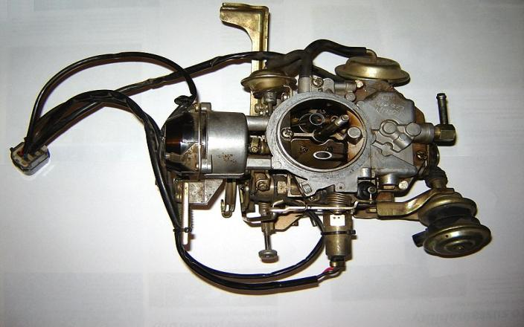
NOTE; It is the depression that is created by the downward movement of the piston in the cylinder that usually draws the mixing of the petrol and the air into the combustion chamber or the cylinder.
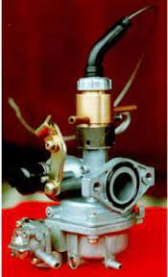

3.4 OVER HEATING
When we observed that an engine is doing over heating then the first thing to do is to check the radiator and the fan Gasket, if the radiator has burst it should be replaced, because if not it can cause over heating end it can knock the engine.

CHAPTER FOUR
4.1 REPLACEMENT OF GEAR BRAIN BOX AUTOMAIC
Before we can replace gear brain box, we must have observed firstly, may be the gear is not well selecting, if the gear is not well selecting, then we search the gear fuse and to make sure it is ok and then check the cable, if it we observed that its well connected then the gear brain box is ok.
Secondly, on the gear brain box panel, should be checked if there are some pins that are faulty and if some resistance and some capacitance are ok, the next thing is to change the whole panel of the brain box, before it can have normal function.
4.2 REPLACEMENT OF STEERING RACK
If the car not well controlled, it will search for the problem jse observant (i.e. steering rack that is not functioning we! The next thing is to replace it with another one, and after the replacement make sure that you put another power steering transmission oil to make it function well.
4.3 STARTER MOTOR
A starter motor is the electrical component which is found near the wheel, and provides the cranking effort in the engine.
4.4 IGNITION COLL
This ignition coil contains coil and it is found on the sparkplug, it purpose is step up the battery to a higher voltage that can jump a plug gap.
4.5 GEAR BOX
The purpose of gear box is to transmit the power developed by the engine to the road wheels, the higher the speed of the vehicle the more the speed becomes high whereby it need only little effort to propel it along. Also if the engine is at its maximum speed the power is develops fail or do not increase again.
If a vehicle want to climb along steep hill or mountain since at this moment the vehicle needs more power to move to vehicle the hill, how can it convert its maximum steep to the required torque, except the speed is reduced so as to increase the tongue. But this cannot be done by raising the foot from the accelerator pedal otherwise the engine will stall. A gear box is introduced to assist in this case.
4.6 TYPES OF GEAR BOX
There are two types of gear box namely:
1. SLIDING MESH GEAR BOX.
2. CONSTANT MESH GEAR BOX
4.6.1 CONSTANT MESH GEAR BOX
This is the modification of the sliding mesh gear box, all its gear are in constant mesh, but the main shaft is mounted on the shaft can rotate independent of it.
4.6.2 SLIDING MESH GEAR BOX (FOUR SPEED)
The gear box always in mesh and this is why it is called constant mesh, in a neutral position (no gear is engaged) the clutch shaft and lay shaft are always rotate together. The main shaft will not rotate so no drive can be transmitted to the engine to the road wheel at the rear. This gear box also has its oil which is commonly know as gear oil for lubricating all teeth and bearing in the gear.
SLIDING MESH GEAR BOX
GEAR ONE: is the biggest gear on the main output shaft slider that slides shaft forward the mesh with the big gear on the lay shaft.
GEAR THREE: the smallest gear on the main shaft slide, which slides backward by the selector fork into mesh with the biggest gear on the lay shaft.
GEAR FOUR: the dog teeth of the smaller gear in the main shaft slider, which slides forward more into the mesh with clutch shaft dag teeth the line transmission in this case is straight.
REVERSE GEAR
When vehicle is moving forward the main shaft and the clutch shaft rotate back) vehicle, the direction of rotation of the main shaft has to be reversed, for this reason idler gear is provided.
NOTE: before any gear could engage in the clutch the peal must be pressed down. The operation of the four gear box is the same with the inception of the reduction by one gear, the lay shaft always revolve in the opposite direction of the clutch shaft.

CHAPTER FIVE
5.0 CONCLUSION
The issue of SIWES in the various institutions should be compulsory to all under graduate student to have practical experience of what has been taught. It also enables be friendlier with an organization of the course of study.
My impression about the organization is that the company I fell happy with. Because of the way the director of the company treated me, just as if I should work there after my diploma course.
5.1 SUGGESTION AND RECOMMENDATION TO THE ORGANISATION
AND THE POLYTECHNIC CONCERNING THE SIWES PROGRAMME.
The deal of giving opportunity to do SIWES programme is a good idea because it aid the student to know practical aspect of the field of study.
Any organization likes is where he/she goes for the programme that he/she may be kindly employed, if it is relevant to the course of his/her study.

