

STUDENT INDUSTRIAL WORK EXPERIENCE SCHEME (SIWES)

HELD AT

BASH NIGERIA ELECTRICAL MANAGEMENT SERVICES AGENCY
20, Oke Andi, Sango Ilorin, Kwara State.

BY

POPOOLA JOSHUA
MATRIC NO: ND/23/EEE/PT/0221

DEPARTMENT OF ELECTRICAL/ELECTRONICS ENGINEERING, INSTITUTE OF TECHNOLOGY, KWARA STATE POLYTECHNIC, ILORIN.

IN PARTIAL FULFILLMENT FOR THE AWARD OF NATIONAL DIPLOMA IN ELECTRICAL ELECTRONICS ENGINEERING

AUGUST – NOVEMBER, 2024.
DEDICATION
This report is dedicated to GOD Almighty for His protection and guidance over me throughout the period of training.
It is also dedicated to my dearest parent MR and MRS POPOOLA and Oluwayomi’s Family for their support.
ACKNOWLEDGEMENT
My appreciation goes to ALMIGHTY GOD who in His mercy gave me the opportunity to complete the SIWES programme.
My gratitude also goes to my lovely parent and also to my lovely siblings for their prayers and well wishes during this programme.
PREFACE
This report covers the work done and experience gained by me during the SIWES programme at BASH NIGERIA ELECTRICAL MANAGEMENT SERVICES AGENCY 20, Oke Andi, Sango Ilorin, Kwara State.
The programme is part of the award of National Diploma (ND), it enables students to know and get used to the practical aspect of the theoretical work being thought in school. It also enable student to be exposed to their various field of study so that they will work harder.

TABLE OF CONTENTS

Title Page i
Dedication ii
Acknowledgment iii
Preface iv
Table of Contents v

CHAPTER ONE
1.0 Introduction 1
1.1 Definition of SIWES 1
1.2 Goals and Objective of SIWES 1

CHAPTER TWO
2.0 Brief History of the Company 3
2.1 Organization Structure Chart 3

CHAPTER THREE
3.0 Electrical/Electronic Tools and their Uses 5
3.1 Uses of the Above Tools 5
3.2 Pictures of the Tools Used

CHAPTER FOUR
4.0 Wiring System 7
4.1 Types of Wiring System 7
4.2 Electrical Accessories 8
4.3 System of Wiring for a Building 9
4.4 Electrical Components Used For a Conduit System Wiring
of a Two Bedroom Flat 9

CHAPTER FIVE
5.1 Recommendation 12
5.2 Conclusion 12

CHAPTER ONE

1.0 INTRODUCTION
The practical background of the engineering student industrial work is purposely set up in partial fulfillment of the requirements for the award of National Diploma (N.D) in electrical/electronic engineering. I fulfilled my compulsory four months industrial training at BASH NIGERIA ELECTRICAL MANAGEMENT SERVICES AGENCY
The report comprises of my experience, knowledge and my involvement in the job description during the course of my SIWES.

1.1 DEFINITION OF SIWES
SIWES means Student Industrial Work Experience Scheme. It is a course by which students are exposed to practical training in their respective field of study. SIWES is the acceptable skill training programme set up as the requirement for the award of National Diploma (ND) certificate for student studying engineering and applied science. Its effort is to bridge the gap existing between theory and practical aspect of engineering and some applied sciences.

1.2 GOALS AND OBJECTIVES OF SIWES
- To enable students to be practically oriented.
- To enable students to handle equipment and machines in their field of study.
- To expose students to challenges to be face in their course of study and their fields after graduation.

CHAPTER TWO

2.0 BRIEF HISTORY OF THE COMPANY
BASH Nigeria Electrical Management Services Agency is a privately owned company. The company deals with electrical installation and wiring of house both full conduit and half conduit.

2.1 ORGANIZATION STRUCTURE CHART

DIRECTOR
APPRENTICE
STAFF

CHAPTER THREE
3.0 ELECTRICAL/ELECTRONICS TOOLS AND THEIR USES
The company has an Electrical Technician that makes use of the following instruments in performing their operations:
- Fixing tape
- Pliers
- Screwdrivers
- Electrical insulator tape
- Hammer
- Torpedo level
- Measuring Tape
- Hack saw
- Insulator or rubber Glove
- Bending Spring
- Draw wire
- Tester
- Ladder

3.1 USES OF THE ABOVE TOOLS
- Fishing Tape: Is a tool used by electrical Technician to draw wire inside a pipe during conduit wiring
- Pliers: Is a hand tool used to hold objects firmly and at the same time use to peel and cut wire to desire length
- A screwdriver: is a tool for driving screw (to open electrical object like garden light, fence light when fixing.
- Electrical insulator tape: is a type of tape used to insulate electrical wires and other materials when during wiring installation.
- Hammer: in some aspect in an electrical field, hammer is use to nail some electrical equipment that cannot stand or hang on their own.
- Torpedo level: is used to make sure your work is level and plumb.
- Tape measure: is used to measure height and length of switch and outlet.
- Hack saw: is used to cut pipe and other strong electrical materials that needs to be cut.
- Insulator Gloves: it stand as hand resistor for workers i.e defend workers from electrifying
- Bending Spring: for bending pipe where it is needed.
- Tester: it is used to know if there is current in a particular place when wiring of a building

3.2 PICTURES OF THE TOOLS USED
FISH TAPE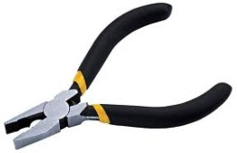PLIERS
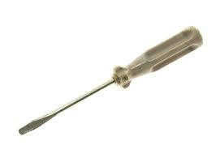Screwdriver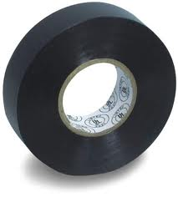Electrical Tape

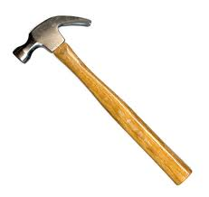Hammer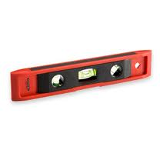 Torpedo level

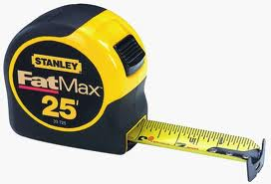Tape Measure 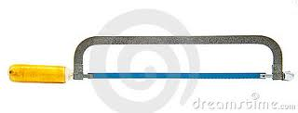Hack Saw
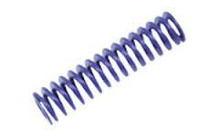Spring 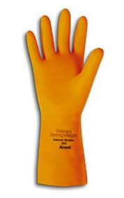Glove

CHAPTER FOUR
4.0 WIRING SYSTEM
Wiring system can be defined as the insulated conductors used to transfer electricity from a junction to another.
4.1 TYPES OF WIRING SYSTEM
- Surface wiring
- Conduit wiring
      - Surface Wiring: This is a type of wiring system that include running a wire on wall when doing the wiring.
      - Conduit system: This type of wiring is done by the use of tubes or pipes in which single core insulator conductors are run into the pipes or tubes.
Conduit wiring system is also divided into two parts namely:
- Half conduit
- Full conduit
In half conduit wiring system, the wire is been connects over the ceiling like that of surface wiring, but all the wire passes to the switch, lamp holder, socket, A.C socket and cooker unit are run inside the pipes which cannot be seen outside the wall.

In full conduit wiring system, is a very neat and has good appearance cable cannot expose outside the wall, and likewise over the ceiling cable is being passed through the pipes.

4.2 ELECTRICAL ACCESSORIES
These are electrical materials use in wiring installation work aside of bulbs and cables.
- Patress: - it serves as the box for switch and socket in surface wiring system.
- Junction Box: - it is a box or junction where the wire meets in surface wiring
- Switch:-it is a device used to switch ON/OFF bulb and some electric accessories
- Clips and nails: - it is used for holding the cable firmly on the wall.
- Lamp holder: - it is a devices used for holding the lamp or bulb.
- Socket outlet: - it is a device where the appliance is plug.
- Pipe: - it is a tube of different dimension (e.g. 20 or 25mm²) through which the cable is being passed.

4.4 ELECTRICAL COMPONENTS TO BE USED FOR A CONDUIT SYSTEM OF WIRING OF A TWO BEDROOM FLAT
1. Main sitting room
No of wall bracket 4
No of switch 2gangs
No of 13amps socket 6

2. Family sitting room
No of wall bracket 4
No of switch 3gangs
Switch 1gangs
No of 13amps socket 4
No of 15amps 2
No of 13amps double with TV 1
3. Dinning
No of wall bracket 2
No of 13amps double socket 1
No of switch 3gangs
4. Kitchen
No of 13amps socket double 1
No of 13amps single 1
No of switch 2gangs
Cooker control unit (13amps) 1
4. Master Bedroom
No of wall bracket 2
Dimmer switch 1
No of 13amps with TV 2
No of 15amps 1
No of 13amps single 2
5. Bedroom (2)
No of wall bracket 2
No of switch 3gangs
No of 13amps with TV 1
No of 15amps 1
8. Passage
No of switch 3gangs
No of 13amps 1
Distribution board 1
Energy Meter 1
Change over Switch 1
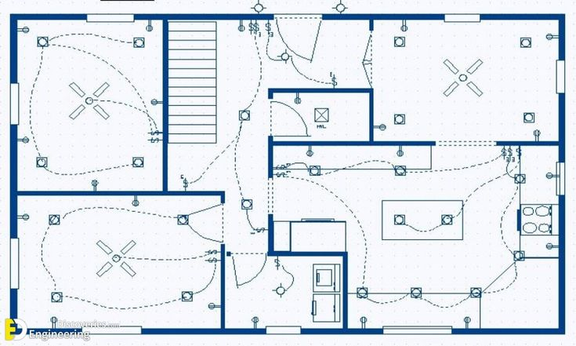
CHAPTER FIVE

5.0 CONCLUSION
The Student Industrial Work Experience Scheme (SIWES) has contributed to my exposure and training in the field of electrical electronic engineering.
The programme also enabled me to put into practice the knowledge gained in the classroom with the actual industrial experience and to develop a critical and realistic approach to problems and their solutions in the electrical field. Under the BASH Nigeria Electrical Management Services Agency, gave me good practical knowledge about my course of study. Also all their staff are so friendly and kind to the extent that one cannot distinguish one person from the others.

5.1 RECOMMENDATION
Under the BASH Nigeria Electrical Management Services Agency has a lot of experience for student that has interest in installation and wiring of houses both surface and conduit.
The following should be taken into consideration.
The ITF supervisor and the department supervisor should make it necessary and important to visit student at their various locations. This would enable them to know the problem and state of their students. IT placement is now becoming difficult due to an increase the number of students applying for placement, the school’s ITF unit should take it upon themselves to provide for the students who have not gotten placement.

