

TECHNICAL REPORT ON
STUDENTS INDUSTRIAL WORKS EXPERIENCE SCHEMES (SIWES)

HELD AT

Sultabs enterprises
doyin plaza, surulere, lagos nigeria

PRESENTED BY:

SULTON OPEYEMI
ND/23/BAM/PT/0361

SUBMITTED TO:

THE DEPARTMENT OF BUSINESS ADMINISTRATION, INSTITUTE OF FINANCE AND MANAGEMENT STUDIES, KWARA STATE POLYTECHNIC, ILORIN.

IN PARTIAL FULFILMENT OF THE REQUIREMENT FOR THE
AWARD OF NATIONAL DIPLOMA (ND) IN BUSINESS ADMINISTRATION .

AUGUST - NOVERMBER 2024

DEDICATION
I am delight to dedicate this report to Almighty God who gave me the grace and opportunity to complete this program

ACKNOWLEDGEMENT
I thank God Almighty for his mercy and grace that kept me all through my SIWES period.
I am greatly indebted to my parents, Mr. & Mrs. SULTON for their morally, spiritually and financially, word of encouragement and prayer given to me, who make my SIWES programme successful and also my relatives and siblings.
I also want to thank my friend and everyone that contributed to the success of my SIWES program my Industrial supervisors, my colleagues and co-workers for the tremendous moral assistance throughout the period of my attachment.

REPORT OVERVIEW
The report comprises the background of SIWES, the description of the organization, its aims and objectives, the experiences gained as an industrial training student and the summary, conclusions and recommendations.
It has a total of 9 chapters with sub-chapters. It also has the preliminary pages, such as the title page, report overview and table of contents and recommendations on the improvement of scheme.

TABLE OF CONTENT
Title Page
Dedication
Acknowledgement
Report Overview
Table of Contents
CHAPTER ONE
- Background of Siwes
1.2 Objectives of SIWES
1.3 Objectives of the Training at SULABS ENTERPRISES
CHAPTER TWO
- History of SULABS ENTERPRISES
2.1 Organizational Structure
2.2 Major Products and Services
CHAPTER THREE
3.0 Description of Work Done
3.1 Production Department
3.2 Quality Control Department

3.3 Sales and Marketing Department
3.4 Logistics and Distribution
CHAPTER FOUR
4.0 Safety Precautions at SULABS ENTERPRISES
4.1 Challenges Encountered During the Training
4,2 Solutions and Recommendations
CHAPTER FIVE
5.0 Conclusion
5.1 Recommendation

CHAPTER ONE : INTRODUCTION
1.1 Background of SIWES
SIWES program was established in year 1973 by the federal Government of Nigeria through the industrial Training Fund (ITF) under the National Board of Technical Education (N.B.T.E) and it has its head quarters in Jos, plateau state.
There are other reasons behind the establishment of SIWES program, but the major reason is to learn the practical aspect of their field of study while still in course of study, which will help to face the future challenges in their respective field of study.
.
1.2 Objectives of SIWES
• To expose students to industrial operations in their field of study.
• To develop technical and practical skills.
• To familiarize students with safety regulations and industry standards.
• To improve students’ employability after graduation.

1.3 Objectives of the Training at SULABS ENTERPRISES
• To understand the production processes of building materials such as cement, tiles, and concrete blocks.
• To gain practical experience in quality control and material testing.
• To learn about the distribution and marketing of construction materials.
• To understand workplace safety measures in the industry.

CHAPTER TWO
DESCRIPTION OF THE COMPANY
2.0 History of SULABS ENTERPRISES
SULABS ENTERPRISES was established in 2002 and has grown to become a major supplier of high-quality building materials. The company specializes in [list the materials such as cement, blocks, tiles, roofing sheets, etc.].
2.1 Organizational Structure
The company is structured into different departments, including:
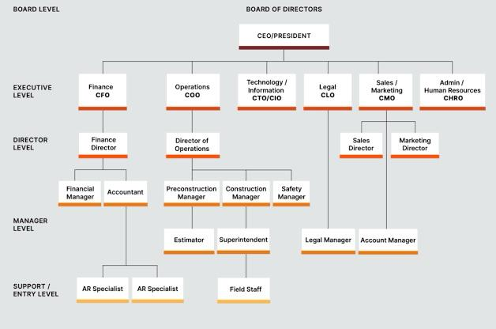

2.2 Major Products and Services
The company produces and distributes:
• Cement and concrete blocks
• Roofing sheets and tiles
• Paints and coatings
• Plumbing and electrical fittings• Construction chemicals

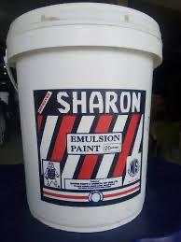
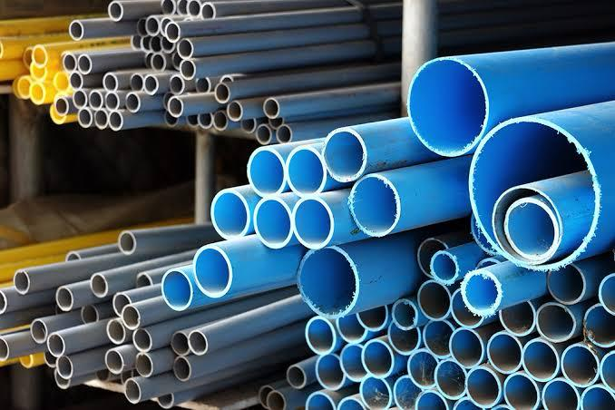



CHAPTER THREE
TRAINING PROGRAM AND EXPERIENCES
3.0 Description of Work Done
During my industrial training, I was assigned to different departments to gain experience in various aspects of the business.
3.1 Production Department
• Observed the mixing process of concrete and mortar.
• Assisted in operating machines used for block and tile production.
• Monitored raw material usage and waste management.
3.2 Quality Control Department
• Conducted material tests for strength, durability, and moisture content.
• Learned about industry standards (e.g., SON, ISO certifications).
• Assisted in maintaining quality control records.

3.3 Sales and Marketing Department
• Assisted in customer service and order processing.
• Learned about pricing strategies and market trends.
• Conducted field surveys to understand customer preferences.
3.4 Logistics and Distribution
• Observed warehouse operations and inventory management.
• Assisted in coordinating deliveries to customers.
• Learned about supply chain challenges and solutions.

CHAPTER FOUR
SAFETY MEASURES AND INDUSTRIAL CHALLENGES
4.0 Safety Precautions at SULABS ENTERPRISES
• Use of personal protective equipment (PPE).
• Regular safety training sessions for workers.
• Proper handling and storage of raw materials.
• Emergency response procedures in case of accidents.
4.1 Challenges Encountered During the Training
• Limited access to some high-tech machinery due to safety concerns.
• Occasional shortage of raw materials affecting production.
• Harsh working conditions in some departments.
4.2 Solutions and Recommendations
• Improve student involvement in hands-on machine operations.
• Ensure consistent supply of raw materials.
• Provide better ventilation and working conditions for staff.
CHAPTER FIVE
CONCLUSION AND RECOMMENDATIONS
5.0 Conclusion
My SIWES experience at SULABS ENTERPRISES was highly beneficial as it provided practical knowledge and hands-on experience in the building materials industry. The training improved my technical skills, teamwork, and understanding of industrial operations.
5.2 Recommendations
• More companies should partner with universities to enhance industrial training opportunities.
• Safety training should be a priority for all industrial trainees.
• Companies should allow trainees more involvement in core production activities.

