

STUDENT INDUSTRIAL WORK EXPERIENCE SCHEME (SIWES) REPORT

HELD AT
LOWER NIGER RIVER BASIN DEVELOPMENT AUTHORITY (LNRBDA)

BY
TAOFEEQ IBRAHIM OLAMIDE
ND/23/AGT/PT/0096

SUBMITED TO
DEPARTMENT OF AGRICULTURAL TECHNOLOGY, INSTITUTE OF APPLIED SCIENCE, KWARA STATE POLYTECHNIC, ILORIN

IN PARTIAL FULFILMENT OF THE REQUIREMENT FOR THE AWARD OF NATIONAL DIPLOMA (ND) IN AGRICULTURAL TECHNOLOGY.
DEDICATION
This report is dedicated to almighty God, the Supreme Being, the beneficent, the merciful, and the foundation of wisdom, knowledge and understanding to the prudent.

TABLE OF CONTENT
Title Pages
Dedication
Acknowledgment
Table of Content
CHAPTER ONE
1.1 Introduction
1.2 Definition of SIWES
1.3 Aim and Objectives of SIWES
1.4 Brief History of SIWES
1.5 The organizational chart of the company
CHAPTER TWO
2.1 Introduction to LNRBDA
2.2 Basic functions of LNRBDA
CHAPTER THREE
3.1 Student specific involvement at various section/unit
CHAPTER FOUR
4.0 Discussion
4.1 Relevance of experience gained to estate management.
4.2 Interpersonal relations within the organization
CHAPTER FIVE
5.0 Conclusion
5.1 Personal impression about the organization
5.2 Recommendation, suggestion and observation and the polytechnic.
CHAPTER ONE
1.1 INTRODUCTION
With the instruction given by the school authority to proceed on Industrial Training scheme on the 20th of august 2023 at any place which can accept us to perform the industrial attachment of which I attached to Lower Niger River Basin Development Authority (LNRBDA). It’s a parastatal of the Federal Ministry of Water Resources established to embark on the development of surface and groundwater resources for multipurpose use and provision of related infrastructure and service for socio-economic development for the period of four month as part of the requirement for the fulfillment of the award of National Diploma in Agricultural Technology.
Definition of SIWES, highlight aims, goal& objective:
1.2 DEFINITION OF SIWES.
Student industrial work experience which is a program established by I.T.F (Industrial Training Fund) in 1976 to bridge the gap between theory and practical aspect of learning in a tertiary institution in Nigeria.
SIWES was established in Nigeria to help student develop on their practical aspect of learning expose them to various techniques in the industry and also help them to know the ways of handling equipment and machineries.
The program was established with various coordinating agencies respect to each tertiary institution in the country. These agencies are:
1. NBTE (National Broad for Technical Education)
2. NUC (National University Commission) for university
3. NCCE (National Commission of College of Education) for colleges of education.

1.3 AIM AND OBJECTIVES OF SIWES
i. Provide an avenue for students in institution of higher learning to acquire industrial skills and experience in their approved courses of study
ii. Prepare students for the industrial work situation which they are likely to meet after graduation
iii. Expose students to work methods and techniques in handling equipment and machinery not available in their institution
iv. Provide students which they are likely to meet after graduation
v. Expose students to work methods and techniques in handling equipment and machinery not available in their various institutions.
1.4 BRIEF HISTORY OF SIWES
Student industrial work experience scheme (SIWES) was established by Industrial Training Fund (ITF) in 1973/1974 to solve the problem of lack of adequate practical skills preparatory for employment in industries by Nigerian graduate of tertiary institution.
Prior to the establishment of the schemes, there was a concern among our institution of higher learning lacked practical background studies preparation for employment in the industries.
The student industrial work experience scheme (SIWES) is a skill training program designed to expose and prepare student of agriculture technology, environmental science, medical science and pure & applied science for the industrial work situation one is likely to meet after graduation.

1.5 THE ORGANIZATIONAL CHART OF THE COMPANY
Principal Officer
Senior Officer
Land clearing and development
Flood and Erosion Control

Admin
Sales of Agricultural Produce

Officer
IT and SIWES students
Secretary

CHAPTER TWO
2.1 INTRODUCTION TO LNRBDA
The Lower Niger River Basin Development Authority (LNRBDA) is a Nigerian federal agency operating under the Federal Ministry of Water Resources. Established to manage and develop water resources, LNRBDA focuses on enhancing agricultural productivity and providing related infrastructure to foster socio-economic development.
2.2 BASIC FUNCTIONS OF LNRBDA
The basic functions of LNRBDA are;
i. Water Resource Development
ii. Agricultural Support
iii. Infrastructure Provision
2.3 WATER RESOURCE DEVELOPMENT
The Lower Niger River Basin Development Authority (LNRBDA) is responsible for the sustainable management and development of water resources within its jurisdiction. This effort is essential for agriculture, domestic water supply, hydroelectricity, flood control, and environmental sustainability.
KEY AREAS OF WATER RESOURCE DEVELOPMENT
1. Surface and Groundwater Utilization
- LNRBDA harnesses rivers, lakes, and groundwater to ensure a reliable water supply for different sectors.
- It constructs boreholes, reservoirs, and pumping stations to facilitate water distribution.
2. Irrigation Development
- The authority supports dry-season farming by developing irrigation schemes to provide water to farmlands.
- It manages large-scale irrigation projects such as dam-fed irrigation systems and small-scale farmer-managed irrigation.
3. Dam Construction and Management
- Multi-purpose dams are built to store and regulate water for irrigation, hydropower, and municipal use.
- Some notable dams within LNRBDA’s jurisdiction include:
Asa Dam (Kwara State) – provides water supply and irrigation support.
Oyun Dam (Kwara State) – used for irrigation and rural water supply.
4. Water Supply for Rural and Urban Areas
- LNRBDA develops rural and urban water supply schemes by drilling boreholes and setting up water treatment plants.
- It supports communities and local governments in accessing clean water for drinking and sanitation.
5. Flood Control and Erosion Management
- The authority engages in flood control projects to prevent destruction caused by excessive rainfall and overflowing rivers.
- It constructs embankments, drainage systems, and reservoirs to manage excess water.
6. Hydropower Development
- Some of LNRBDA’s dams have the potential for small-scale hydroelectric power generation to support rural electrification.
7. Environmental and Climate Adaptation Measures
- The agency promotes sustainable water management by adopting measures such as:
Afforestation programs to prevent desertification.
Efficient water uses techniques to reduce waste.
Wetland conservation to protect biodiversity.
CHAPTER THREE
3.1 STUDENTS SPECIFIC INVOLVEMENT AT THE ORGANIZATION
Being SIWES Student, I was not just treated as a student in the organization but also assigned some tasks. Most of time, I was selected to field operation where we trained on the pen and picking of eggs, harvesting of maize, feeding of layer in the pens, e.t.c
As a SIWES student, I participated in removing of unwanted wed or plants from the bed, storing of livestock and dived maize in the Wherehouse which can be use for feed mills and other materials useful around agricultural sectors. Also participating in wetting of pepper on the farm land, using the sprayer to fumigate farming land for pest control and many other activities that took place in the organization were carried out together as SIWES student.
3.2 PLANT REARING (PROPAGATION & CULTIVATION)
Plant rearing involves nurturing plants from seeds, cuttings, or saplings until they reach maturity. It requires careful attention to soil quality, water availability, temperature, and light conditions. The most common method of growing plants is through seeds, which germinate under favorable conditions, including adequate moisture, oxygen, and warmth. However, not all plants grow efficiently from seeds, and some are better propagated through vegetative means.
Vegetative propagation methods include cuttings, grafting, layering, and tissue culture. Cuttings involve taking a portion of the stem or leaves and allowing them to develop roots before planting them in the soil. Grafting is widely used in fruit tree cultivation, where two plant parts are joined to form a single plant with improved characteristics. Layering is a technique where a branch is bent and covered with soil until roots form, after which it is separated from the parent plant. Tissue culture, a modern approach, enables mass production of disease-free plants in a laboratory setting, ensuring genetic uniformity and higher yields.
The success of plant growth depends on various environmental factors. Soil must be rich in nutrients like nitrogen, phosphorus, and potassium to support strong roots and healthy foliage. Watering should be well-regulated, as excessive moisture can lead to root rot, while insufficient water may stunt growth. Sunlight plays a crucial role in photosynthesis, and different plants have varying light requirements. Temperature also influences plant growth, with tropical plants thriving in warmer climates and temperate plants requiring cooler conditions. Fertilization, whether organic or synthetic, enhances soil fertility and promotes vigorous plant development.
Pest and disease control is essential in plant rearing. Farmers and gardeners often use chemical pesticides, biological controls, or organic methods such as neem oil and companion planting to protect crops from harmful insects and diseases. Proper spacing between plants ensures good air circulation, reducing the risk of fungal infections. Regular pruning helps remove dead or diseased plant parts, improving overall plant health.
3.3 LAYERS REARING (POULTRY FARMING FOR EGG PRODUCTION)
Layers rearing involves raising chickens specifically for egg production. These birds, known as layers, require special care from the early stages of life to maintain high productivity. The rearing process begins with brooding, where newly hatched chicks are kept in a controlled environment with adequate warmth, light, and feed. The temperature during the first few weeks is maintained at around 32-35°C and gradually reduced as the chicks grow. A balanced diet rich in proteins, vitamins, and minerals is essential for proper development during this phase.
As the birds mature into the grower stage, their diet is adjusted to support muscle and bone development without excessive weight gain. This stage typically lasts until they reach 18 weeks of age. At this point, the layers transition to the production stage, where they start laying eggs. Proper nutrition is crucial during this period, with special attention given to calcium intake to ensure strong eggshells. Layer feed formulations contain essential nutrients that support continuous egg production while maintaining the health of the hens.
The housing system used in layers rearing varies depending on farm size, resources, and management style. The deep litter system is a traditional method where birds are raised on the floor with bedding material such as sawdust or straw. This system requires frequent cleaning to prevent disease outbreaks. The cage system, a more modern approach, confines hens in individual or group cages, making egg collection easier and improving hygiene. Free-range systems allow birds to roam in open spaces, leading to better welfare and egg quality, though they require more land and careful management.
Proper lighting plays a significant role in maintaining egg production. Layers need around 16 hours of light per day to stimulate laying cycles. Artificial lighting is often used in poultry houses to supplement natural daylight, especially during shorter days. Regular egg collection, at least two to three times a day, helps maintain egg quality and prevents breakage. Storage conditions should be cool and dry to extend the shelf life of eggs before they reach the market.
Disease prevention is a critical aspect of layers rearing. Common poultry diseases such as Newcastle disease, infectious bronchitis, and avian influenza can cause severe losses if not controlled. Vaccination programs, biosecurity measures, and proper hygiene practices help minimize the risk of infections. Providing clean drinking water and maintaining a well-ventilated environment further enhances the health and productivity of the flock.
In summary, both plant rearing and layers rearing require careful planning and management. Plant rearing focuses on proper propagation methods, environmental conditions, and pest control, while layers rearing emphasizes nutrition, housing, disease prevention, and optimal egg production conditions. By following best practices, both processes can yield high-quality crops and eggs, benefiting farmers and consumers alike.

CHAPTER FOUR
EXPERIENCE GAIN DURING SIWES IN LNRBDA
4.1 FEEDING OF LAYERS
Feeding plays a crucial role in layers rearing, directly impacting their health, egg production, and quality. Layers require a nutritionally balanced diet at different stages of their growth to ensure high productivity. The feed should contain essential nutrients such as proteins, carbohydrates, fats, vitamins, minerals, and water in the right proportions.
Key Nutrients in Layer Feed
- Protein – Essential for body maintenance, egg production, and feather health. Sources include soybean meal, fish meal, and sunflower meal.
- Carbohydrates – Provide energy for daily activities and egg production. Common sources include maize, wheat, and sorghum.
- Fats & Oils – Help in energy storage and absorption of fat-soluble vitamins. Vegetable oils and fish oil are commonly used.
- Calcium & Phosphorus – Required for eggshell formation and bone strength. Sources include limestone, oyster shells, and bone meal.
- Vitamins & Minerals – Maintain immune function, egg quality, and overall health. Vitamins A, D, E, and B-complex are essential, along with minerals like iron, zinc, and magnesium.
- Water – The most important nutrient, making up 65-75% of the hen’s body and egg composition. Clean drinking water must be available at all times.
Feeding Management Practices
- Feed should be provided regularly and in the right quantity to prevent wastage or underfeeding.
- Crushed oyster shells or limestone can be added separately to ensure hens get enough calcium.
- Avoid feeding moldy or contaminated feed as it can cause health problems like mycotoxicosis.
- Feed should be stored properly in a dry and cool place to prevent spoilage.
- Feeding should be done at consistent times daily to maintain a stable laying cycle.
- Provide fresh water at all times, as dehydration can reduce egg production
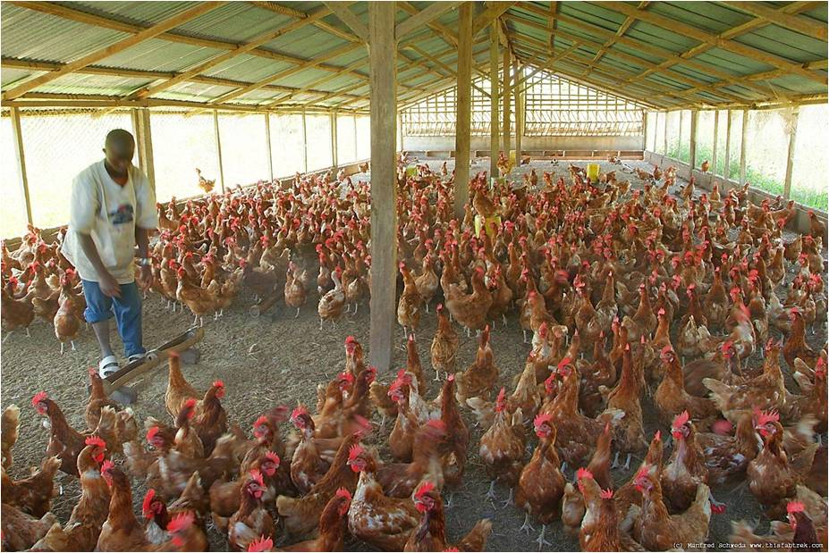
Fig 1: layers breed feeding, source: google.com

4.2 PICKING (COLLECTING) EGGS IN LAYERS REARING
Egg collection is a crucial part of layers rearing as it ensures high-quality eggs, reduces breakage, and maintains hygiene. Proper handling and storage of eggs help in preserving their freshness and maximizing farm productivity.
Best Practices for Picking Eggs
- Collect Eggs Frequently
Eggs should be collected at least 2-3 times a day to prevent breakage and contamination. The best times for collection are:
Morning (6 AM - 8 AM) – Most hens lay their eggs in the early morning.
Midday (12 PM - 1 PM) – A second round ensures no eggs are left too long.
Afternoon (4 PM - 5 PM) – The final collection reduces the risk of cracked or dirty eggs.
- Handle Eggs Gently
Eggs have a delicate shell and can break easily. Use clean, dry hands or soft gloves while collecting to avoid cracks. Never squeeze or drop eggs as this can lead to internal damage.
- Use Clean Baskets or Trays
Eggs should be placed in clean, well-ventilated collection baskets, trays, or crates with cushioned bottoms to prevent breakage. Avoid stacking eggs too high to prevent pressure cracks.
- Avoid Collecting Wet or Dirty Eggs
Eggs should not be collected with wet or dirty hands, as moisture can allow bacteria to penetrate the shell. If an egg is dirty, it should be cleaned properly (see cleaning methods below).
5. Egg Cleaning and Sorting
- Cleaning Dirty Eggs
- If eggs have dirt or feces, dry brushing is the best method to avoid washing away the protective cuticle.
- Avoid washing eggs with cold water, as it can force bacteria into the pores of the shell.
- If necessary, use warm water (slightly warmer than the egg) with a mild sanitizer.
- After cleaning, allow eggs to dry completely before storage.
- Sorting Eggs by Size and Quality
After collection, eggs should be graded and sorted based on size, weight, and shell condition.
Grade A – Clean, smooth, and uniform in size.
Grade B – Slightly rough or minor blemishes.
Rejected – Cracked, extremely dirty, or misshapen eggs should not be sold.

4.3 HARVESTING
1. Harvesting Maize (Corn)
The right time to harvest maize depends on its intended use:
- Green maize (fresh consumption) – Harvested when the kernels are soft and milky, about 70-80 days after planting.
- Mature dry maize (for grains/storage) – Harvested when kernels are hard, and moisture content is 20-25%, usually 3-4 months after planting.
Signs that maize is ready for harvest include:
- The leaves turn yellow and dry.
- The husk (outer covering) dries and shrinks.
- The silks turn brown and dry up.
- Kernels become hard and dented when pressed.
Methods of Harvesting Maize
- Manual Harvesting: Done by hand, where farmers pull off cobs from the stalks.
- Mechanical Harvesting: Large farms use combines harvesters, which cut, thresh, and clean the maize at once.
Post-Harvest Handling
- Drying: Maize grains should be dried to 12-14% moisture before storage to prevent mold and pests.
- Shelling: Removing grains from the cob using manual or mechanical shellers.
- Storage: Keep dried maize in well-ventilated stores, silos, or airtight bags to prevent weevil and mold damage.
- Processing: Maize can be milled into flour, used for animal feed, or sold as whole grains.
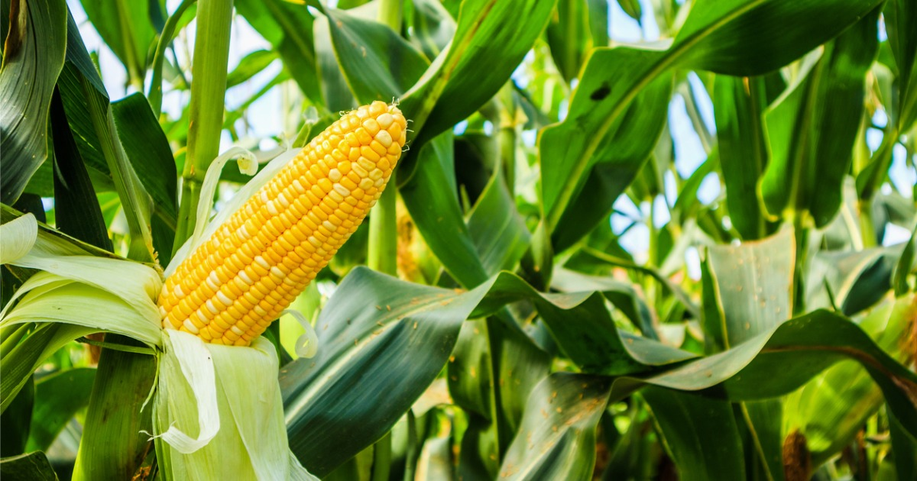
Fig 2: ready to harvest maize, source: google.com

2. Harvesting Cassava
Cassava is usually ready for harvesting 8-12 months after planting, depending on the variety and growing conditions. Some early-maturing varieties can be harvested as early as 6-8 months, while others may take up to 18 months.
Signs that cassava is ready for harvest include:
- Leaves begin to yellow and drop.
- The stem hardens and thickens.
- The roots are large and firm when dug up.
Methods of Harvesting Cassava
- Manual Harvesting: Farmers use hoes or dig around the base of the plant to expose the tubers. The stems are cut, and the roots are pulled out carefully to avoid breaking them.
- Mechanical Harvesting: Large farms use cassava harvesters, which lift the roots from the soil with minimal damage.

Post-Harvest Handling
- Peeling and Cleaning: Cassava roots are washed and peeled to remove dirt and outer skin.
- Processing: Fresh cassava must be processed quickly as it deteriorates within 2-3 days after harvest. It can be:
- Dried and ground into flour (garri, fufu, tapioca, starch).
- Boiled, roasted, or fried for direct consumption.
- Fermented for local delicacies.
iii. Storage: Fresh cassava can be stored in soil pits or wrapped in moist materials to extend shelf life. Processed cassava (flour, starch) can be stored for several months.
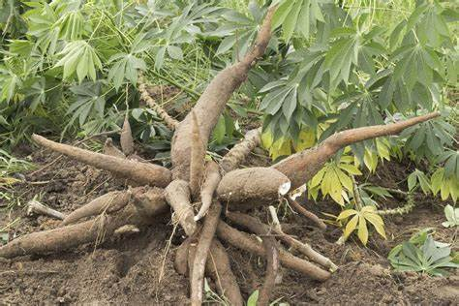
Fig 3: harvested cassava tube, source: google.com

CHAPTER FIVE
5.0 CONCLUSION AND ACHIEVEMENT
The experience and knowledge required could be possible if not for student industrial working experience scheme. I therefore explore the departments’ management board to allow my fellow students to their training in both public and private firms where their knowledge will be exposed to field work and these will bring great opportunities and benefit to the country at large.
I want to express my profound gratitude to Industrial Training Fund office and the school authority for the opportunity given to me to undergo this programme which has been helpful in boarding my talent towards practical aspect of the profession and exposed me into the limelight of Agricultural Technology. I also want to thank the management and staff of Lower Niger River Basin Development Authority (LNRBDA), for the opportunity given to me to undergo my Training in their firm, also to the Head of Department (HOD) of Agricultural Technology, my SIWES Coordinator for their supervision. I sincerely thank the Government and ITF for introduction of the Scheme to Higher Leaning Schools. More grease to your elbow.
5.1 RECOMMENDATION
SUGGESTION TO THE ORGANIZATION (LNRBDA)
i. The organization should organize seminar at least once in a month on practical training in which students have learned from various department so that there will be an opportunity of asking question and answer.
ii. Organization should draw the attention of all students so that they will be able to contribute to the progress of the organization by their suggestion.
iii. The organization should give more room to student in the field of operation i.e cultivation of land, breeding and harvesting, egg hatching and incubation and many other activities in the organization in order to proclaim the idea of Students industrial scheme
SUGGESTION TO THE KWARA STATE POLYTECHNIC
i. The polytechnic should base and specialized on how and where to be attached in relevant to their course are professional job.
ii. The polytechnic should choose supervisor from each department lecture or lecturers from other polytechnic that relevant to the field of student for supervisor in order to put students through in their training.

