

A TECHNICAL REPORT
STUDENT INDUSTRIAL WORKING EXPERIENCE SCHEME
(SIWES)

HELD AT:
WARAFANAHU MAKAIYA ALIYAH OPTIMAL BIZ LIMITED, ESTATE JUNCTION BEHIND RAILWAY KULENDE ILORIN KWARA STATE

PREPARED BY:
OYEWO RUKAYAT ADENIKE
ND/23/BAM/PT/0539

SUBMITTED TO:

DEPARTMENT OF BUSINESS ADMINISTRATION AND MANAGEMENT
KWARA STATE POLYTECHNIC, ILORIN

IN PARTIAL FULFILLMENT OF THE REQUIREMENTS FOR THE AWARD OF NATIONAL DIPLOMA (ND) IN BUSINESS ADMINISTRATION AND MANAGEMENT

Sept., – Nov., 2024
DEDICATION
I dedicate this technical report to the Almighty GOD, the giver of knowledge, wisdom and who is rich in mercy.

ACKNOWLEDGEMENT
I take this opportunity to express my profound gratitude and deep regards to the creator of heaven and earth, the one who knows the beginning and the end, the alpha and the omega. my sincere gratitude also goes to my guidance MR. & MRS. OYEWO for their financial support and word of encouragement during my SIWES Programme and also to those who stood by me during my SIWES programme, thank you all. I also take this opportunity to express a deep sense of gratitude to compliment my supervisor at my place of attachment for taking her time for my practical knowledge and for her cordially support, valuable information and guidance which helped me in completing my SIWES through various stages may Almighty God bless you abundantly.
TABLE OF CONTENT
Dedication
Acknowledgement
CHAPTER ONE
  - Introduction to SIWES
  - History of SIWES
  - Objectives of the Programme
  - Objectives of Establishment
CHAPTER TWO
2.1 Activities of place of Attachment
2.2. Precaution Taken in the Place of Attachment
2.3 Organizational Product and Benefits
CHAPTER THREE
Reporting on Work Carried Out
3.1 Reporting on Daily Work Carried Out
CHAPTER FOUR
Challenges Encounter In Place of Attachment
CHAPTER FIVE
Summary, Conclusion and Recommendations
5.1 Summary
5.2 Conclusion
5.3 Recommendations
CHAPTER ONE
  - INTRODUCTION TO SIWES
Students Industrial Work Experience Scheme (SIWES) is a Skills Training Program designed to prepare and expose Students of Universities, Polytechnics, Colleges of Technology, Colleges of Agriculture and Colleges of Education for the Industrial Work situation they are likely to meet after graduation. The Scheme affords Students the opportunity of familiarizing and exposing themselves handling equipment and machinery that are usually not available in their institutions.

1.2 HISTORY OF SIWES
The Students’ Industrial Work Experience Scheme (SIWES) was initiated in 1973 by the Federal Government of Nigeria under the Industrial Training Fund (ITF) to bridge the gap between theory and practice among products of our tertiary Institutions. It was designed to provide practical training that will expose and prepare students of Universities, Polytechnics, and Colleges of Education for work situation they are likely to meet after graduation.
Before the establishment of the scheme, there was a growing concern among the industrialists that graduates of institutions of higher learning lacked adequate practical background studies preparatory for employment in industries. Thus the employers were of the opinion that the theoretical education going on in higher institutions was not responsive to the needs of the employers of labour.
As a result of the increasing number of students’ enrolment in higher institutions of learning, the administration of this function of funding the scheme became enormous, hence ITF withdrew from the scheme in 1978 and was taken over by the Federal Government and handed to National Universities commission (NUC), National Board for Technical Education (NBTE) and National Commission for Colleges of Education (NCCE). In 1984, the Federal Government reverted back to ITF which took over the scheme officially in 1985 with funding provided by the Federal Government.
1.3 OBJECTIVES OF THE PROGRAMME
The specific objectives of SIWES are to:
- Provide placements in industries for students of higher institutions of learning approved by relevant regulatory authorities (NUC, NBTE, NCCE) to acquire work experience and skills relevant to their course of study
- Prepare students for real work situation they will meet after graduation.
- Expose students to work methods and techniques in the handling of equipment and machinery that may not be available in schools.
- Make transition from school to the labour market smooth and enhance students’ conduct for later job placement
- Provide students with the opportunity to apply their knowledge in real life work situation thereby bridging the gap between theory and practice
- Strengthen employer involvement in the entire educational process and prepare students for employment in industry
- Promote the desired technological knowhow required for the advancement of the nation.
1.4 OBJECTIVES OF ESTABLISHMENT
The specific objectives of establishment are to:
- Increase market share by attracting new customers and retaining existing ones through effective marketing strategies.
- Develop new flavors, healthier options, or unique packaging to meet changing consumer preferences.
- Foster brand loyalty by engaging with customers through promotions, sponsorships, and social media interaction.
- Implement environmentally friendly practices, such as reducing plastic usage, improving recycling efforts, and sourcing ingredients sustainably.
- Optimize production and distribution processes to reduce costs while maintaining product quality.
- Explore new markets, both geographically and demographically, to broaden the customer base.
- Focus on increasing profitability through strategic pricing, cost management, and enhancing sales volume.
- Respond to the growing trend towards health consciousness by offering low-calorie or sugar-free alternatives.

CHAPTER TWO
2.1 ACTIVITIES OF PLACE OF ATTACHMENT
The experience, knowledge, skills and exposure acquired during the period of attachment in the industrial exercise cannot be over emphasized. I was exposed to certain areas in my course of study, such as:
- Palate of Bottle Water
- Crate of malta gold
- Pack of bigi water
- Crate of malta Guinness
- Crate of Sprite
- Pack of Bigi orange
- Pack of Fearless
- Pack of coca cola
- Pack of nutria milk
- Pack of bigi apple
- Pack of chivita
- Pack of limca
- Crate of fanta
2.2. PRECAUTION TAKEN IN THE PLACE OF ATTACHMENT
- Implement rigorous quality control measures at every stage of production to ensure that ingredients and final products meet safety and quality standards.
- Maintain high levels of cleanliness in production facilities, including regular sanitation of equipment and surfaces to prevent contamination.
- Carefully select and monitor suppliers for raw materials to ensure they meet safety and quality requirements.
- Use food-grade packaging materials that are free from harmful substances and ensure proper sealing to maintain product integrity.
- Provide comprehensive training for employees on food safety practices, hygiene, and handling procedures to minimize risks during production.
- Adhere to local and international regulations governing food and beverage production, including labeling, ingredient disclosure, and health regulations.
- Conduct regular internal and external audits to assess compliance with safety and quality standards.
- Establish clear protocols for product recalls in case of safety issues, ensuring swift action to protect consumers.
- Implement practices to minimize environmental impact, such as waste management and sustainable sourcing of ingredients.

2.3 ORGANIZATIONAL PRODUCT AND BENEFIT

Computers and Laptops

Use: For data entry, processing loan applications, managing customer information, and running financial software.

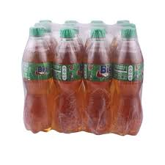
Bigi Apple

Flavor: Offers a refreshing apple taste, appealing to fruit-flavored beverage lovers.
Hydration: Provides a sweet, enjoyable way to stay hydrated.
Variety: Adds diversity to beverage options, especially for those looking for non-cola flavors.

Bigi Water
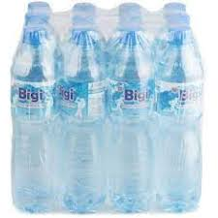

- Hydration: Primarily designed for hydration, providing essential water intake.
- Purity: Usually purified and free from contaminants, ensuring safe drinking.
- Calorie-Free: Contains no calories, making it a great option for those managing weight.

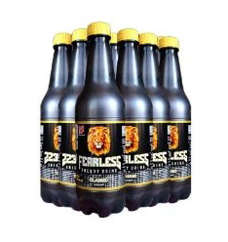
Fearless Drink

- Energy Boost: Often contains caffeine and other energy-boosting ingredients, making it suitable for quick energy replenishment.
- Focus and Alertness: Designed to enhance concentration and alertness, ideal for active lifestyles.
- Variety of Flavors: Offers different flavors to appeal to a wide audience.

Fanta
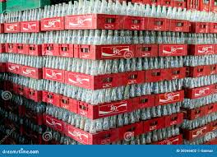

- Variety of Flavors: Available in multiple flavors (orange, grape, etc.), catering to diverse taste preferences.
- Fun and Playful Branding: Appeals to younger audiences and promotes a sense of enjoyment.
- Refreshing: Provides a sweet, bubbly experience that can be refreshing on hot days.

Chivita Drink
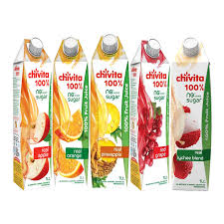

- Nutritional Benefits: Often made from real fruit juice, providing vitamins and minerals.
- Natural Ingredients: Usually marketed as containing natural ingredients, appealing to health-conscious consumers.
- Variety: Available in different flavors, catering to various tastes.

Coca-Cola

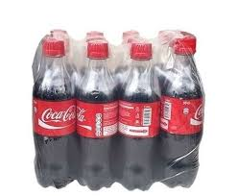
- Iconic Taste: Known for its unique flavor, loved by many around the world.
- Versatile Use: Can be enjoyed on its own or used as a mixer in various cocktails and beverages.
- Cultural Significance: Holds a significant place in popular culture and brand recognition.

Malta Gold


- Nutritional Value: Often enriched with vitamins and minerals, providing some nutritional benefits.
- Non-Alcoholic: A malt beverage that offers a rich, sweet flavor without alcohol, suitable for all ages.
- Cultural Appeal: Popular in various cultures, especially in West Africa, often associated with traditional celebrations.

ORGANIZATION STRUCTURE/ORGANOGRAM
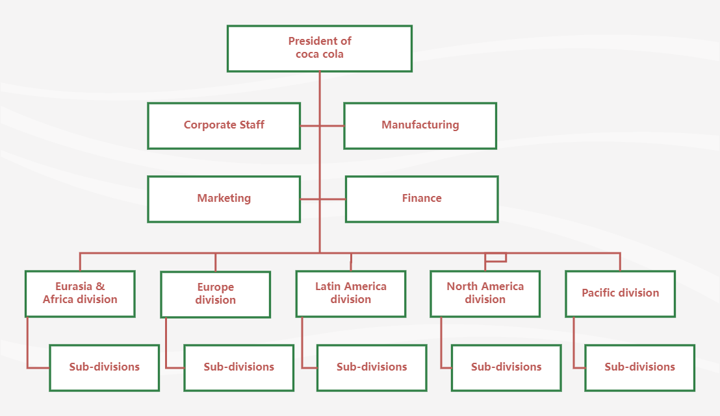
Board of Director

CHAPTER THREE
REPORTING ON WORK CARRIED OUT
3.1 Reporting on Daily Work Carried Out
WEEK 1: I was introduced to all member in the organization and I was given rules and regulation of the organization
WEEK 2: I learnt on how to arrange goods and how to take stocks of goods in the warehouse
WEEK 3: I was taught on how to pack 5 crates of coca cola and how to store bigi water into warehouse
WEEK 4: I learnt on how to sell 100 pack of fearless and how to sell 2 pack of coca cola
WEEK 5: I learnt about 2 pet of fearless, 6 pet of bigi apple and 2 pet of viju milk
WEEK 6: I learnt on how to stock goods that was brought from the company to warehouse
WEEK 7: I learnt on how to aquavie bottle water was sold
WEEK 8 I learnt on how to pack fanta for sales and how to receive transaction for each product.
CHAPTER FOUR
CHALLENGES AND GAIN ENCOUNTER IN PLACE OF ATTACHMENT

GAINS
- The soft drink market continues to grow, providing opportunities for sales and expansion and also, a wide range of products appeals to various tastes and demographics.
- Opportunities to create new flavors and healthier options can attract health-conscious consumers.
- Working with well-known brands can provide job security and professional growth.
- Brands often engage in creative marketing campaigns that can enhance visibility and engagement.
- Opportunities to connect with other professionals and businesses in the beverage industry.
- Potential for partnerships with retailers, suppliers, and distributors.
- Soft drinks often play a role in social gatherings and celebrations, contributing to community and cultural experiences.
CHALLENGES
- I face a steep learning curve and a heavy workload, which can be stressful and demanding.
- Dealing with difficult customers or resolving complaints as been intimidating me to customer service roles.
- I was assigned to menial tasks and limited responsibilities, which can be frustrating for those seeking more substantial contributions.
- Balancing internship responsibilities with academic commitments can be difficult, requiring effective time management skills.
- Experience receiving insufficient mentorship or guidance, making it challenging to navigate roles effectively.
- The financial industry is heavily regulated, and grasping all relevant laws and compliance requirements as been overwhelmed.
- The soft drink market is highly competitive, making it challenging to stand out.
- Rising costs of ingredients, packaging, and transportation can affect profitability.
CHAPTER FIVE
SUMMARY, CONCLUSION AND RECOMMENDATIONS
5.1 SUMMARY
Working in a soft drink company offers numerous opportunities, including access to a growing market, potential for innovation, and the chance to engage with well-established brands. Employees can benefit from networking opportunities and the cultural significance of soft drinks. However, challenges such as health concerns, intense competition, sustainability issues, and operational costs must be carefully navigated. Additionally, changing consumer preferences necessitate continuous adaptation and market research.
5.2 CONCLUSION
The soft drink industry is dynamic and multifaceted, presenting both significant opportunities and formidable challenges. Success in this field requires a proactive approach, a willingness to adapt, and a commitment to quality and sustainability. Understanding market trends and consumer behavior is essential for anyone looking to thrive in this competitive sector.
5.3 RECOMMENDATIONS
- SIWES supervisors should make sure they visit the students in their place of attachment for proper monitoring, improvement and progress for the benefit of the societies as a whole.
- Employees should seek ongoing training and education to stay updated on industry trends and technological advancements.
- Regularly update your knowledge of industry trends, consumer preferences, and regulatory changes to stay ahead of the competition.
- Focusing on eco-friendly practices and sustainable materials can enhance the company’s brand image and appeal to environmentally conscious consumers.
- Be open to new ideas and product development, especially in response to health trends and sustainability initiatives.
- Engage in and promote sustainable practices within the company to address environmental concerns and appeal to socially conscious consumers.

