
A TECHNICAL REPORT
STUDENT INDUSTRIAL WORKING EXPERIENCE SCHEME
(SIWES)

HELD AT:
CONNER STONE NIG, ENTREPRISES, 64 OGBA ROAD GUINESS AGEGE LAGOS STATE

PREPARED BY:
FOLARANMI MARIAM MOTUNRAYO
ND/23/BAM/PT/0427

SUBMITTED TO:

DEPARTMENT OF BUSINESS ADMINISTRATION AND MANAGEMENT
KWARA STATE POLYTECHNIC, ILORIN

IN PARTIAL FULFILLMENT OF THE REQUIREMENTS FOR THE AWARD OF NATIONAL DIPLOMA (ND) IN BUSINESS ADMINISTRATION AND MANAGEMENT

Sept., – Dec., 2024
DEDICATION
I dedicate this technical report to the Almighty GOD, the giver of knowledge, wisdom and who is rich in mercy.

ACKNOWLEDGEMENT
I take this opportunity to express my profound gratitude and deep regards to the creator of heaven and earth, the one who knows the beginning and the end, the alpha and the omega. my sincere gratitude also goes to my guidance MR. & MRS. FOLARANMI for their financial support and word of encouragement during my SIWES Programme and also to those who stood by me during my SIWES programme, thank you all. I also take this opportunity to express a deep sense of gratitude to compliment my supervisor at my place of attachment for taking her time for my practical knowledge and for her cordially support, valuable information and guidance which helped me in completing my SIWES through various stages may Almighty God bless you abundantly.
TABLE OF CONTENT
Dedication
Acknowledgement
CHAPTER ONE
  - Introduction to SIWES
  - History of SIWES
  - Objectives of the Programme
  - Objectives of Establishment
CHAPTER TWO
2.1 Benefit Derived from SIWES Training Programme
2.2 Precaution taken in the Place of Attachment
2.3 Uses of Bakery Equipment
Organization Structure/Organogram
CHAPTER THREE
Reporting on Work Carried Out
3.1 Reporting on Daily Work Carried Out
CHAPTER FOUR
Challenges Encounter in Place of Attachment
CHAPTER FIVE
Summary, Conclusion and Recommendations
5.1 Summary
5.2 Conclusion
5.3 Recommendations
CHAPTER ONE
  - INTRODUCTION TO SIWES
Students Industrial Work Experience Scheme (SIWES) is a Skills Training Program designed to prepare and expose Students of Universities, Polytechnics, Colleges of Technology, Colleges of Agriculture and Colleges of Education for the Industrial Work situation they are likely to meet after graduation. The Scheme affords Students the opportunity of familiarizing and exposing themselves handling equipment and machinery that are usually not available in their institutions.

1.2 HISTORY OF SIWES
The Students’ Industrial Work Experience Scheme (SIWES) was initiated in 1973 by the Federal Government of Nigeria under the Industrial Training Fund (ITF) to bridge the gap between theory and practice among products of our tertiary Institutions. It was designed to provide practical training that will expose and prepare students of Universities, Polytechnics, and Colleges of Education for work situation they are likely to meet after graduation.
Before the establishment of the scheme, there was a growing concern among the industrialists that graduates of institutions of higher learning lacked adequate practical background studies preparatory for employment in industries. Thus the employers were of the opinion that the theoretical education going on in higher institutions was not responsive to the needs of the employers of labour.
As a result of the increasing number of students’ enrolment in higher institutions of learning, the administration of this function of funding the scheme became enormous, hence ITF withdrew from the scheme in 1978 and was taken over by the Federal Government and handed to National Universities commission (NUC), National Board for Technical Education (NBTE) and National Commission for Colleges of Education (NCCE). In 1984, the Federal Government reverted back to ITF which took over the scheme officially in 1985 with funding provided by the Federal Government.
1.3 OBJECTIVES OF THE PROGRAMME
The specific objectives of SIWES are to:
- Provide placements in industries for students of higher institutions of learning approved by relevant regulatory authorities (NUC, NBTE, NCCE) to acquire work experience and skills relevant to their course of study
- Prepare students for real work situation they will meet after graduation.
- Expose students to work methods and techniques in the handling of equipment and machinery that may not be available in schools.
- Make transition from school to the labour market smooth and enhance students’ conduct for later job placement
- Provide students with the opportunity to apply their knowledge in real life work situation thereby bridging the gap between theory and practice
- Strengthen employer involvement in the entire educational process and prepare students for employment in industry
- Promote the desired technological knowhow required for the advancement of the nation.
1.4 OBJECTIVES OF ESTABLISHMENT
The specific objectives of establishment are to:
- Provide hands-on experience in baking techniques, food safety, and sanitation practices.
- Enhance technical skills related to equipment operation, maintenance, and troubleshooting.
- Familiarize students with day-to-day operations, including inventory management, customer service, and production planning.
- Teach the importance of quality control in baking processes.
- Present real-world challenges in the bakery environment for students to analyze and propose solutions.
- Foster critical thinking and adaptability in various situations.
- Encourage collaboration with other staff members to complete tasks efficiently.
- Develop communication skills through interactions with customers and team members.
CHAPTER TWO
2.1 BENEFIT DERIVED FROM SIWES TRAINING PROGRAMME
The experience, knowledge, skills and exposure acquired during the period of attachment in the industrial exercise cannot be over emphasized. I was exposed to certain areas in my course of study, such as:
- Baking
- Packaging Goods
- Customer Relation
- Sanitation
- Coconut Bread
- Slice Bread
- Act as administrative management
- Use of POS for Purchasing Goods
- Small Chop Business
- Oven
- Mixer
2.2 PRECAUTION TAKEN IN THE PLACE OF ATTACHMENT
1. Personal Hygiene
- Regular handwashing with soap and water, especially after handling raw ingredients.
- Wearing clean uniforms, aprons, and hairnets to prevent contamination.
2. Food Safety
- Ensuring all ingredients are fresh and stored at appropriate temperatures.
- Regularly checking expiration dates on products.
3. Equipment Safety
- Proper training on the use of ovens, mixers, and other machinery to prevent accidents.
- Regular maintenance and inspection of equipment to ensure safe operation.
4. Sanitation Practices
- Cleaning and sanitizing surfaces, utensils, and equipment before and after use.
- Implementing a cleaning schedule to maintain a hygienic environment.
5. Safe Handling of Ingredients
- Avoiding cross-contamination by using separate utensils for raw and cooked products.
- Storing raw ingredients, especially allergens, in designated areas.
6. Fire Safety
- Keeping fire extinguishers accessible and ensuring staff are trained in their use.
- Regularly checking electrical equipment and ensuring proper ventilation.
7. Ergonomics
- Using proper lifting techniques to prevent injuries when handling heavy bags of flour or other materials.
- Providing anti-fatigue mats for standing areas to reduce strain.
8. Emergency Procedures
- Establishing clear protocols for emergencies, including injury, fire, or equipment failure.
- Conducting regular safety drills to prepare staff for potential emergencies.
9. Pest Control
- Implementing measures to prevent pest infestations, such as sealing entry points and regular inspections.
- Using safe pest control methods in compliance with health regulations.
10. Training and Awareness
- Providing ongoing training for staff on food safety, hygiene, and workplace safety.
- Encouraging a culture of safety and vigilance among all employees.
2.3 USES OF BAKERY EQUIPMENT
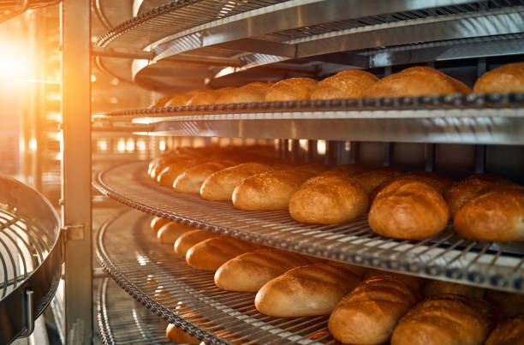
OVEN

Use: The primary equipment for baking bread, pastries, cakes, and cookies. Types include deck ovens, convection ovens, and rotary ovens.

MIXER
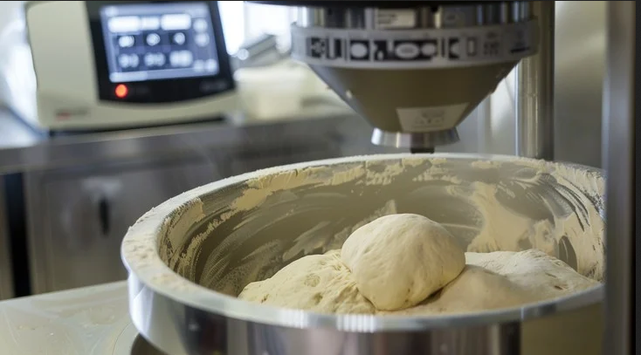

Use: Used to mix ingredients for dough and batter. Stand mixers and spiral mixers are common types, each suitable for different dough consistencies and flour.
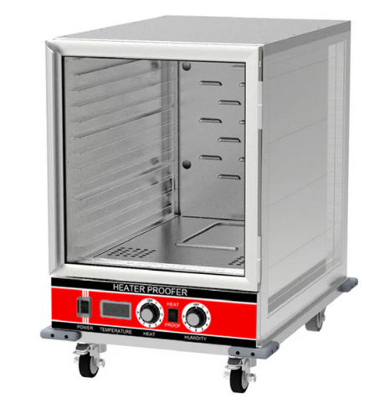
PROOFING CABINET

Use: Provides a controlled environment for dough to rise (proof) before baking, maintaining optimal temperature and humidity.
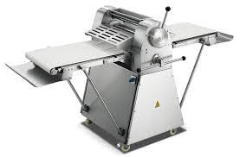
DOUGH SHEETER

Use: Rolls out dough to a uniform thickness, ideal for pastries, croissants, and other layered products.

BAKING PANS AND TRAYS

Use: Various shapes and sizes are used to hold dough during baking. Common types include loaf pans, muffin trays, and sheet pans.
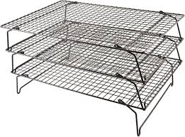
COOLING RACK

Use: Allows baked goods to cool evenly after baking, preventing sogginess and maintaining texture.

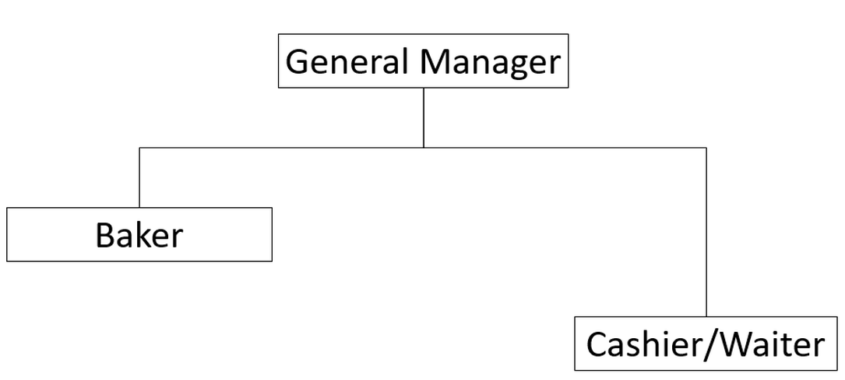
ORGANIZATION STRUCTURE/ORGANOGRAM

FUNCTIONS
GENERAL MANAGER
- Operations Management: Oversee daily operations, ensuring efficiency and quality.
- Staff Management: Hire, train, and supervise staff; manage schedules and performance.
- Financial Oversight: Handle budgeting, financial reporting, and cost control.
- Customer Service: Ensure high levels of customer satisfaction and address complaints.
- Inventory Control: Manage inventory levels and order supplies as needed.
- Marketing and Sales: Develop promotional strategies to increase sales and attract customers.
WAITER
- Customer Service: Greet customers, take orders, and provide menu recommendations.
- Order Management: Relay orders to the kitchen and ensure timely delivery.
- Table Maintenance: Set up and clean tables, refill drinks, and address customer needs.
- Payment Processing: Present bills and process payments.
- Product Knowledge: Stay informed about menu items, specials, and ingredients.
BAKER
- Baking: Prepare and bake a variety of bread, pastries, and other baked goods.
- Recipe Development: Create and modify recipes for new products.
- Quality Control: Ensure consistency and quality in baked products.
- Equipment Maintenance: Maintain and clean baking equipment and work areas.
- Inventory Management: Monitor ingredient supplies and assist in ordering when necessary.

CHAPTER THREE
REPORTING ON WORK CARRIED OUT
3.1 Reporting on Daily Work Carried Out
WEEK 1: I was introduced to all member in the organization and I was given rules and regulation of the organization
WEEK 2: Orientation was given to me as to maintain good behavior and abide by the rules ad regulation that guide the organization and also I attend to customer that want to our product and I confirm his/her payment that was already approved by the supervisor
WEEK 3: I practicalized on how to packaged goods for effective delivery and I also learn how to manage time effectively to ensure all products are baked and ready for sale.
WEEK 4: Goods was booked by our immediate customers and I ensure that it was delivery safely to them
WEEK 5: Sanitation was done and I attend to customer after we are done with the sanitation
WEEK 6: I sold out goods for our immediate customers and invoice was given to them
WEEK 7: I learnt how to packaged nylon and label the bread
WEEK 8: I learnt how to do slice bread and labeling
WEEK 9: I worked with other members in the organization to deliver bread
WEEK 10: I learnt how to mix flour, and I produced bread out

CHAPTER FOUR
CHALLENGES ENCOUNTER IN PLACE OF ATTACHMENT
1. Consistency in Quality
- Ingredient Variability: Differences in ingredient quality can affect the final product.
- Baking Techniques: Inconsistent baking methods can lead to variations in taste and texture.
2. Staffing Issues
- High Turnover: The bakery industry often experiences high turnover rates, leading to staffing shortages.
- Training: Continuous training is necessary to maintain quality and efficiency, which can be time-consuming.
3. Time Management
- Production Schedules: Balancing production schedules to meet customer demand without overproducing can be challenging.
- Seasonal Variations: Fluctuations in demand during holidays or seasons can disrupt schedules.
4. Equipment Maintenance
- Breakdowns: Equipment failures can halt production and lead to financial losses.
- Upkeep Costs: Regular maintenance can be costly and time-consuming.
5. Food Safety Regulations
- Compliance: Adhering to strict food safety regulations requires constant vigilance and documentation.
- Training Staff: Ensuring all staff are trained in food safety practices is essential but can be challenging.
6. Inventory Management
- Spoilage: Perishable ingredients may spoil if not managed properly, leading to waste.
- Supply Chain Issues: Disruptions in the supply chain can result in ingredient shortages.
7. Customer Preferences
- Changing Trends: Keeping up with consumer trends (gluten-free, vegan options) requires flexibility and innovation.
- Feedback Management: Handling customer complaints and feedback effectively is crucial for maintaining satisfaction.
8. Financial Management
- Cost Control: Managing costs, especially with fluctuating ingredient prices, is essential for profitability.
- Pricing Strategies: Setting competitive yet profitable pricing can be challenging.
9. Marketing and Competition
- Brand Awareness: Building a strong brand in a competitive market requires effective marketing strategies.
- Social Media: Staying active and engaging on social media to attract customers can be demanding.
CHAPTER FIVE
SUMMARY, CONCLUSION AND RECOMMENDATIONS
5.1 SUMMARY
Working in a bakery offers a unique blend of creativity, skill development, and community engagement that can be both personally and professionally rewarding. The bakery environment fosters a hands-on experience where individuals can explore the art and science of baking, from mastering traditional recipes to experimenting with innovative flavors. Employees gain valuable skills, such as time management, teamwork, and customer service, all of which are essential in a fast-paced setting. Additionally, the sense of accomplishment that comes from creating delicious products and receiving positive feedback from customers enhances job satisfaction. Overall, working in a bakery not only nourishes one's passion for baking but also provides opportunities for personal growth and career advancement in the culinary arts.
5.2 CONCLUSION
The student industrial work experience scheme (SIWES) helps students to expand their knowledge and experience in their field of study. It will also help student whenever they come across it in future career.
5.3 RECOMMENDATIONS
- Siwes supervisors should make sure they visit the students in their place of attachment for proper monitoring, improvement and progress for the benefit of the societies as a whole.
- Regularly train staff on food safety practices and conduct audits to ensure compliance with regulations.
- Monitor market trends and customer preferences to adapt product offerings accordingly, including healthier or specialty options.
- Develop a robust marketing plan that includes social media engagement and community outreach to build brand awareness.

