
KWARA STATE POLYTECHNIC, ILORIN, KWARA STATE

STUDENT INDUSTRIAL WORK EXPERIENCE SCHEME(SIWES)
A TECHNICAL REPORT OF FOUR (4) MONTHS INDUSTRIAL WORK EXPERIENCE

AT

KWARA STATE MINISTRY OF ENVIRONMENT

PERPARED BY
NAME: AJAO MARIAM ADEBIMPE
MATRIC NO: ND/23/BAM/PT/0815
DEPARTMENT: BUSINESS ADMINISTRATION AND MANGEMENT

IN PARTIAL FULFILMENT TO THE REQUIREMENTS FOR THE AWARD OF NATIONAL DIPLOMA IN BUSINESS ADMINISTRATION AND MANGEMENT

DURATION: AUGUST TO NOVEMBER 2024

CERTIFICATION
This is to certify that these was written by Ajao Mariam Adebimpe with the matriculation number ND/23/BAM/PT/0815 as part of the requirement for the three-months Students Industrial Work Experience Scheme (SIWES) in the Department of Business Administration and Management, Kwara State Polytechnic, Ilorin, Kwara State.

_________________________ _______________
SIWES COORDINATOR Date
Name/Signature

_________________________ _______________
Head of Department Date
Name/Signature

DEDICATION
Firstly, I thank Almighty Allah for giving me the strength to accomplish my training at Kwara State Ministry of Environment, Ilorin.

DECLARATION
I declare that this report is the outcome of my three-months Students Industrial Work Experience Scheme (SIWES) at Kwara State Ministry of Environment, Ilorin from the month of August to November 2024. The concepts and perspectives expressed in this report are mine and I have duly acknowledged the input of other relevant authors where applicable.

______________________________ ________________________
Ajao Mariam Adebimpe Signature & Date
ND/23/PSM/FT/0815

ABSTRACT
This technical report was written based on my experience during Student’s Industrial Work Experience Scheme undertaken at Kwara State Ministry of Environment. During my training period, I spent the four months at the Business Administration and Management department of the organization, where I learnt series of steps required for business and management processes and procedures, among which are organization management, poultry feed management, types of poultry birds, operation of solar pumping machine.
There are five chapters in this technical report. Chapter one comprises of history of SIWES, its objective and objectives of this report, chapter two talks about different departments in the organization, chapter three is mainly on activities of the organization especially the business administration and management department which is the backbone of the organizational management, whereas chapter four talks about challenges during the SIWES and proffered solutions, the last chapter was for conclusion and recommendations.

TABLE OF CONTENT
- Certification
- Dedication
- Declaration
- Abstract
- Table of content
CHAPTER ONE
- Introduction to SIWES
- Objective of SIWES
- Objective of SIWES Report
CHAPTER TWO
- Brief History Of The Organization and Organogram
- Roles of Each Department in the Organization
- Office Equipment and their uses
CHAPTER THREE
- Organizational Management
- Office Management
CHAPTER FOUR
- Challenges Faced During the Training and Possible Solution
CHAPTER FIVE
- Summary
- Conclusion
- Recommendation

CHAPTER ONE

INTRODUCTION TO SIWES
The Student Industrial Work Experience Scheme (SIWES) is a program in Nigeria that gives University, Polytechnic, and Technical College students the opportunity to gain more work experience in their chosen field. The program is run by the Industrial Training Fund (ITF) and aims to improve the quality and standards of education in Nigeria. SIWES was established in 1971 to help the country achieve technological advancement, and has been shown to have a positive impact on the country’s economy and work force.
Over the years, SIWES has contributed immensely to building the common pool of technical and allied skills available in Nigeria economy which are needed for the nation’s industrial development. Furthermore, the place and relevance of SIWES is under scored by the fact that the scheme contributes improving the quality of technical skills.
Operators: The ITF, the coordinating agency (NUC, NCCE, NBTE) Employers of labors and the institutions.
Funding: It is funded by the federal government of Nigeria.
Beneficiaries: Undergraduate students of the following institutions/faculties: Agriculture, Engineering, Technology, Environmental, Sciences and Education etc.
Duration: Four months for the polytechnics and colleges of education and six months for the universities.

OBJECTIVES OF THE SIWES
The objectives of the Student Industrial Work Experience Scheme (SIWES) are:
- To provide students with the opportunity to gain practical experience in their study field.
- To prepare students for the transition from education to the workplace.
- To bridge the gap between theory and practice by exposing students to real-world work situations.
- To provide students with opportunities to develop their skills and knowledge.
- To create a stronger connection between education and the world of work.

OBJECTIVES OF SIWES REPORT
The objectives of this report are:
- Demonstrate Practical Learning: Showcase the practical skills and knowledge acquired during the SIWES program.
- Bridge Theory and Practice: Illustrate the application of academic concepts in real-world scenarios.
- Highlight Experience: Present a comprehensive overview of the tasks, activities, and responsibilities undertaken.
- Reflect on Insights: Share personal insights gained from observing procurement practice and supply chain management.
- Showcase Skill Development: Exhibit the growth of skills like communication, teamwork, and problem-solving.
- Provide Recommendations: Offer suggestions to enhance departmental activities and SIWES programs.
- Contribute to Academic Growth: Integrate practical experience to enrich academic learning.
- Acknowledge Mentors and Colleagues: Express gratitude to those who guided and supported during the program.
- Prepare for Professional Roles: Equip for future careers in procurement and supply chain management as well as relate fields.
- Conclude SIWES Journey: Summarize the entire experience and its impact on personal and professional development.

CHAPTER TWO
Brief History of Kwara State Ministry of Environment
The Kwara State Ministry of Environment was established to address environmental issues and promote sustainable development within the state. Its formation aligns with Nigeria’s broader commitment to environmental management and conservation, particularly in response to challenges such as deforestation, waste management, pollution, and climate change. Over the years, the ministry has evolved to incorporate various programs aimed at enhancing environmental awareness among citizens and ensuring compliance with environmental regulations.
Initially focused on basic environmental protection measures, the ministry has expanded its scope to include comprehensive policies that address urban planning, land use management, and biodiversity conservation. The ministry collaborates with other governmental agencies, non-governmental organizations (NGOs), and international bodies to implement projects that improve the state’s ecological health. This collaborative approach has led to initiatives aimed at reforestation, waste recycling, and public education campaigns on environmental sustainability.
Organogram of Kwara State Ministry of Environment
The organogram of the Kwara State Ministry of Environment typically outlines the hierarchical structure and relationships within the ministry. While specific details may vary, a general structure can be described as follows:
1. Minister of Environment
- The Minister is the head of the ministry and is responsible for overall policy direction, administration, and coordination of environmental matters in Kwara State.
2. Permanent Secretary
- The Permanent Secretary acts as the chief administrative officer of the ministry, overseeing daily operations and ensuring that policies set by the Minister are implemented effectively.
3. Departments/Units under the Ministry
- Environmental Protection Department: Focuses on enforcing environmental laws and regulations, managing waste disposal, and promoting sustainable practices.
- Pollution Control Unit: Responsible for monitoring pollution levels, implementing control measures, and ensuring compliance with environmental standards.
- Biodiversity Conservation Unit: Works on protecting natural habitats, wildlife conservation efforts, and promoting biodiversity.
- Climate Change Unit: Engages in initiatives related to climate change adaptation and mitigation strategies.
4. Special Advisers/Assistants
- These individuals provide specialized advice to the Minister or Permanent Secretary on various environmental issues.
5. Support Staff
- This includes administrative staff, technical officers, and field workers who assist in executing projects and programs related to environmental management.
This organogram reflects a structured approach to managing environmental affairs in Kwara State, ensuring that all aspects from policy-making to implementation are covered efficiently.
ORGANOGRAME OF THE ORGANIZATION
KWARA STATE MINISTRY OF ENVIRONMENT

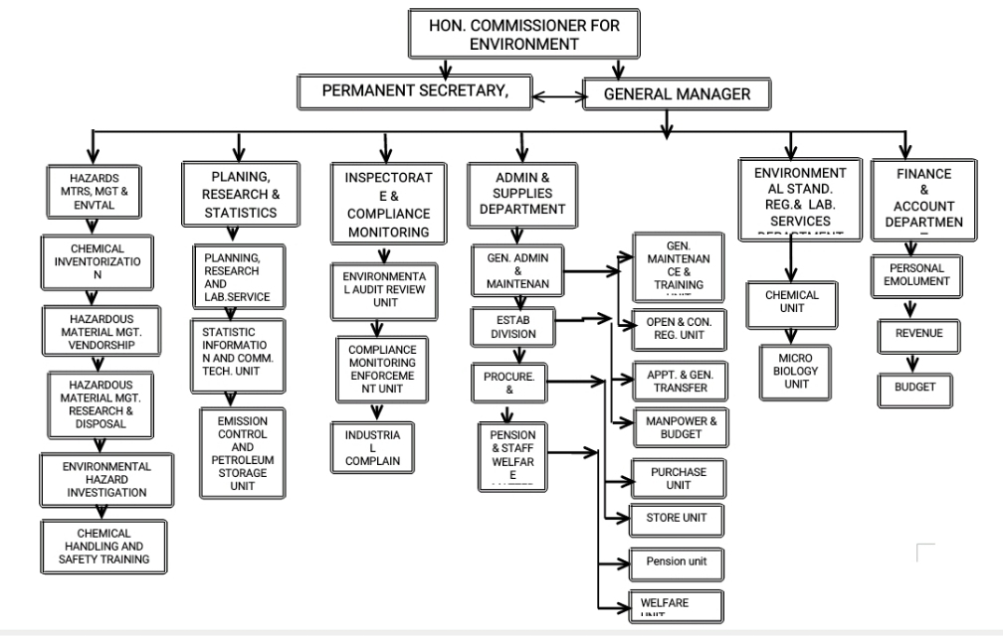

Office Equipment and Their Uses
In a modern office environment, various types of equipment are essential for ensuring productivity, efficiency, and effective communication. Below is a detailed list of common office equipment along with their specific uses:
1. Computers: Computers are fundamental tools in any office setting. They facilitate data processing, storage, and retrieval. Employees use computers for tasks such as word processing, spreadsheet management, email communication, and accessing the internet for research or collaboration.
2. Telephones: Telephones remain vital for direct communication within and outside the office. They allow employees to make calls quickly without relying solely on digital communication methods. Modern telephones often come equipped with features like voicemail, call forwarding, and conference calling.
3. Printers: Printers are necessary for producing hard copies of documents that may be required for meetings, presentations, or record-keeping. They can print text documents as well as images and graphics depending on the type of printer used (e.g., inkjet or laser).
4. Document Scanners: Document scanners convert physical documents into digital formats (such as PDFs), making it easier to store and share information electronically. This is particularly useful for archiving important records or sharing documents via email.
5. Copiers: Copiers allow users to create duplicates of documents quickly and efficiently. Many modern copiers also function as printers and scanners, providing multifunctional capabilities that save space and resources.
6. Shredders: Shredders are essential for maintaining confidentiality by securely disposing of sensitive documents that are no longer needed.
8. Office Stationery: Stationery supplies such as pens, paper, notebooks, sticky notes, and folders are crucial for daily operations in an office setting.

CHAPTER THREE
Organizational Management
Organizational management is the practice of planning, coordinating, and overseeing the resources, processes, and people within an organization to achieve specific objectives. It encompasses a range of functions that include strategic planning, decision-making, leadership, and resource allocation. The primary goal of organizational management is to optimize efficiency, productivity, and overall performance by effectively utilizing both human and material resources.
Why is Organizational Management Important?
- Goal Alignment: Organizational management ensures that every employee understands the common business objectives. This alignment helps in directing individual and team efforts towards achieving the overarching company mission.
- Resource Optimization: Effective organizational management facilitates the efficient allocation of resources—be it labor, finances, time, or technology—thereby preventing wastage and maximizing productivity.
- Enhanced Productivity: A well-structured management system provides a clear framework for work processes. This clarity results in increased productivity at all levels of the organization.
- Strategic Planning: Organizational management involves strategic planning that helps companies adapt to changes in the business environment while remaining competitive over the long term.
- Decision-Making: It offers a structured approach to decision-making that ensures choices align with the organization’s goals and values. This applies to decisions made by frontline employees as well as senior leadership.
- Leadership Development: Management practices identify and nurture leadership talent within an organization. This development is crucial at all levels from team leaders to executives—ensuring growth and success.
- Quality Control: Organizational management implements and monitors quality control measures to ensure consistency and excellence in products or services offered by the organization.
- Employee Engagement: It promotes a culture of involvement where employees feel valued and engaged in their work regardless of their position within the organization.

Office Management
Office management is a multifaceted role that focuses on enhancing productivity, efficiency, and collaboration within an office environment. It encompasses a wide range of responsibilities that can vary significantly depending on the industry, size of the company, and specific departmental needs. The primary goal of office management is to create an organized and effective workplace that supports both employees and organizational objectives.
Key Responsibilities of Office Management
- Handling Office Equipment: Office managers are responsible for ensuring that all office equipment is functioning properly. This includes managing maintenance schedules, troubleshooting issues, and coordinating repairs or replacements when necessary.
- Creating a Positive Work Environment: A significant part of office management involves fostering a welcoming atmosphere for employees and visitors alike. This can include everything from the aesthetic arrangement of furniture to the overall ambiance of the workspace.
- Budget Management: Office managers often oversee the office budget, which includes tracking expenses related to supplies, equipment, and other operational costs. They must ensure that spending aligns with company policies while also seeking cost-saving opportunities.
- Welcoming Visitors and New Employees: A key aspect of office management is being the first point of contact for guests and new hires. This includes greeting them warmly, providing necessary information about the office layout, policies, and procedures.
- Organizing Activities: Office managers are typically tasked with planning both in-office activities (like team-building exercises) and off-site events (such as retreats or conferences) to enhance employee engagement.
- Travel Coordination: Managing travel arrangements for staff members is another critical responsibility. This includes booking flights, accommodations, and transportation while adhering to budget constraints.
- Internal Communications Management: Effective communication within an organization is vital for success. Office managers facilitate this by managing internal communications through emails, newsletters, or meetings to keep everyone informed about important updates.
- Acquiring Office Supplies: Ensuring that the office is stocked with necessary supplies falls under the purview of office management. This involves maintaining inventory levels and placing orders as needed.
- Safety and Security Oversight: Office managers also play a role in maintaining safety protocols within the workplace to protect employees’ well-being.
Types of Office Managers
There are various types of office managers based on their specific roles within different industries:
- Corporate Office Managers: Focus on improving departmental performance in corporate settings.
- Legal Office Managers: Oversee operations in law firms.
- Medical and Dental Office Managers: Manage healthcare facilities with an emphasis on patient care.
- Virtual Office Managers: Handle remote operations for companies without a physical office space.
Evolution of Office Management
The role of office management has evolved significantly over recent years from traditional clerical tasks to more strategic positions within organizations. Modern office managers are now involved in high-level decision-making processes regarding productivity improvements, workspace design, and employee engagement strategies.
Skills Required for Modern Office Managers
To be successful in today’s dynamic work environment, modern office managers need a diverse skill set:
- Proficiency in various software tools used for communication and project management.
- Strong project management skills to handle multiple tasks simultaneously.
- Up-to-date knowledge about industry trends and regulations.
- Flexibility to adapt to changing workplace needs.
- Problem-solving abilities to address challenges creatively.

CHAPER FOUR

CHALLENGES FACED AND PROFFERED SOLUTIONS
The challenges represented here is based on my personal encounter during the period of my training at Kwara State Ministry of Environment, Ilorin. Various challenges were faced during the period of the SIWES training which are:
Challenge: Heavy Workload and Time Constraints
Solution: Time management technical, prioritize tasks and create schedules were adopted.
Challenge: Communication Barriers
Solution: Maintain clear communication channels, ask for clarifications, and follow up.
Challenge: Balancing confidentiality and transparency
Solution: Adhere to ethical guidelines, be transparent in all ramification and seek guidance.
Challenge: allowances
Solution: they should encourage the trainee by given them token which will in turn encourage the student to learn.
Challenge: Limited Resources.
Solution: optimize available Resources brainstorm creative solutions with colleagues.
Challenge: Working with Diverse Stakeholders.
Solution: Practice active listening, find common ground, and be flexible.
Challenge: Personal and Professional Growth Pressure.
Solution: Prioritize self-care and continuous learning to manage stress and grow professionally.

CHAPTER FIVE

SUMMARY

In summary, effective organizational management serves as a compass guiding entities toward their goals through structured approaches to resource allocation, decision-making, problem-solving, and fostering a productive work environment. Effective office management plays a crucial role in creating productive workplaces where employees feel empowered to perform their best work while contributing positively to organizational goals.

CONCLUSION
The period of my industrial training at Kwara State Ministry of Environment, Ilorin was mind blowing. I was given the chances to think and act like a Business management Officer, which I will soon become. I was exposed to working experience at various sections such as management process, Organizational management, poultry management etc, and I ensured I gained the best I could from all the activities.
Finally, I can comfortably conclude by saying a very big thanks to ITF for offering students the opportunity to experience the practical aspect of their profession while in school. The whole training at Kwara State Ministry of Environment, Ilorin taught me how to apply all what we were taught in class.

RECOMMENDATION
Despite the challenges of transportation and cost of commuting, we students who participated in the SIWES program did our best to be punctual and focused. It was difficult but worthwhile experience. I would like to suggest that the Federal Government of Nigeria should establish a system of funding for students participating in the SIWES program. This funding would help to cover the cost of transportation, encourage punctuality, and support the overall success of the program. It would also be beneficial to have a mandatory payment structure in place for organization that host SIWES students, to provide them with financial support and incentivize them to participate. This would ultimately lead to greater student engagement and better outcomes.
The following are the recommendations I am making based on my experienced and challenges during the period of my industrial training at Public Procurement Agency.
- Proper orientation should be organized for students before they are sent out for industrial training. The orientation should go wide enough to cover the best way of filling log books.
- Each department should endeavour to check the relevance of student’s choice of workplace to their carrier and possibly guide them if need be.
- Student should be helped get placement and also monitored to ensure they are really serious in their place of work and how punctual they are because some students are willing to be committed but sometimes unable to get good place.
In view of this, I strongly implore the Polytechnic Authority to put into consideration some of these recommendations.

