

A REPORT ON STUDENT INDUSTRIAL WORK EXPERIENCE SCHEME (SIWES) CARRIED OUT AT LAGOS STATE UNIVERSITY OF EDUCATION OTO/IJANIKIN

BY
LAWAL SUMMAYAH OLAJUMOKE
(ND/23/LIS/FT/0012)

A SIWES REPORT SUBMITTED TO THE DEPARTMENT OF LIBRARY AND INFORMATION SCIENCE,
FACULTY OF INFORMATION AND COMMUNICATION SCIENCES, KWARA STATE POLYTECHNIC, ILORIN

ACKNOWLEDGEMENT
All thanks to almighty God for the completion of this report. I also want to acknowledge my parents for their total support, I pray God in his infinite bless you and you shall reap the fruit of your labor. Also, my profound gratitude goes to whole department of library and information science lecturers and also all the staffs of Lagos state university of education library for their guidance and continuous help, may almighty God bless you all and my sincere gratitude goes to my colleague.

REPORT OVERVIEW
Student Industrial Work Experience Scheme (SIWES) is an industrial training program that assist students to gather practical experience in their various disciplines. It is designed to expose and prepare students of universities, Polytechnics and Colleges of education in order to enhance their skills and prepare for their future careers in their various course of study. This report is about the experience I gained during my Four months SIWES Program at Lagos State University of Education (LASUED) which started on the 5th of August ,2024 and ended on the 22nd of November,2024. A period of 16weeks.
This report also includes the organizational structure, the various sections/units in the establishment and their functions, the work I did and the experience I gained during my stay in the above-mentioned establishment.
More so, I also discuss some challenges I encountered during the period of my training and soe recommendations that could help improve the organization and the scheme at large.

Title page
Acknowledgement
Report Overview
TABLE OF CONTENTS
CHAPTER ONE - INTRODUCTION PAGES
- Introduction………………………………………………………………………………………………………………………..1
  - Brief history of Siwes………………………………………………………………………………………………1
  - Objectives of Siwes……………………………………………………………………………………………………………..2
CHAPTER TWO – DESCRIPTION OF THE ESTABLISHMENT OF INDUSTRIAL ATTACHMENT
2.1 Location and brief history of attachment………………………………………………………………………………………….3
2.2 Objectives of establishment………………………………………………………………………………………………………………4
2.3 Organizational Structure (including organogram)………………………………………………………………………………5
2.4 Various units in the establishment and their functions………………………………………………………………………6
CHAPTER THREE – DESCIPTION OF WORK DONE AND EXPERIENCE GAINED
3.1 Work Done
3.2 Experience gained statement
CHAPTER FOUR – DESCRIPTION OF THE EQUIPMENT USED, THEIR FUNCTIONS AND DETAILED USAGE
4.1 Outline the equipment used during the attachment
4.2 Detailed description of their usages
CHAPTER FIVE – SUMMARY, CONCLUSION AND RECOMMENDATIONS
5.1 Summary
5.2 Conclusions
5.3 Problems encountered during program
5.4 Recommendations

CHAPTER ONE
INTRODUCTION
The student industrial work experience scheme (SIWES) is an accepted skill program done in other to prepare students for the world beyond the classrooms. It is a program to acquire the necessary skills and technical competence.
Library and information science (LIS) is an academic and professional study of how information and information carriers are produced, acquired, organized, evaluated, selected, maintained, disseminated, managed and eventually used. This report is the full documentation of my student industrial work experience scheme (SIWES) as a student of library and information science (LIS) within a period of four months in an academic library – Lagos state university of education; which started on the 5th of August,2024 to 22nd of November,2024.

  - BRIEF HISTORY OF SIWES
Report writing is important in the completion of the SIWES program. It is compulsory for students that undergo the SIWES program to write a report to show that they successfully completed and gained from the program. This brings us to a brief background study of SIWES.
SIWES is an acronym for Students Industrial Work Experience Scheme program that was established in 1973 by the ITF to serve the problem of lack of adequate practical skills preparatory for employment in industries by Nigeria tertiary institutions graduates. The scheme educates students on industrial based skills essential for a smooth transition from the classroom theories to the actual practice the real world of work. Students of tertiary institution are given the opportunity of being familiarized and exposed to the needed experience in handling machineries and equipment which are usually not available in the educational institutions. Partaking in SIWES industrial training has become a crucial pre-condition for the award of diploma and degree certificates in specific disciplines in most institutions of higher learning in Nigeria in line with the government education policies. The operators are; the ITF, the coordinating agencies (NUC, NCCE, NBTE), employers of labor and various institutions. It is funded by the Federal Government of Nigeria.

1.2 OBJECTIVES OF SIWES
- To provide avenues for students to acquire industrial skills for experience during their course of study.
- To expose student to work methods and techniques in handling equipment and machineries that may not be readily available in the University.
- To enlist and strengthen employer’s involvement in the entire educational process and prepare students for employment in industry and commerce.
- To prepare students for industrial work situation they are likely to meet after graduation.
- To provide students with the opportunities to apply their educational knowledge in real work situation, thereby bridging the gap between theories and practice.

CHAPTER 2
DESCRIPTION OF THE ESTABLISHMENT OF INDUSTRIAL ATTACHMENT
2.1 LOCATION OF THE ESTABLISHMENT
My institution of attachment was Lagos state university of education Library (LASUED). It is situated in Lagos and it is of dual campus. The main campus is located in Oto/Ijanikin with a campus at Noforija, Epe. The main campus library which is described as the center of the college where knowledge and other research breakthrough is domicile
The library was established along the college in 1958, it is on record that the library has changed site twice since its movement into the college, the former library was earlier housed at AOCOED international school (AIS), Ijanikin.
On Monday 22nd October 2002, the library moved from its old building to the new college library complex of 750m with a sitting capacity of 305 built by educational trust fund (ETF) in the heart of the college

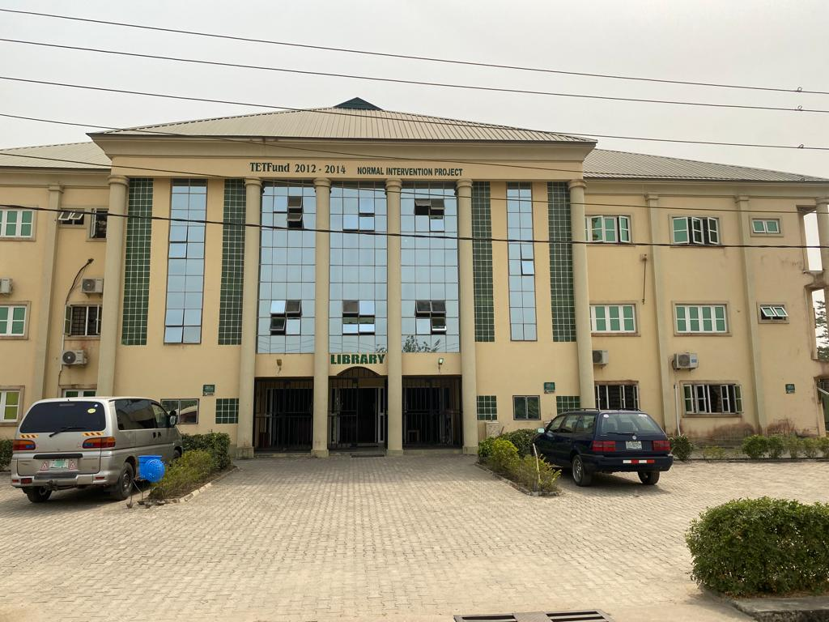

2.2 BRIEF HISTORY OF THE ESTABLISHMENT
Lagos state university of education which was formerly known as Adeniran Ogunsanya college of education (AOCOED) evolved as one of the products of missionary education and the implementation of series of recommendations from different educational commissions between 1900 and 1960. Within this period, Lagos as the capital of Nigeria the base of the British colonial masters and the hub of viable economic activities, witnessed unprecedented population growth. The unexpected population increase was responded to by the number of mission schools as well as government schools that sprang up in Lagos during that period, the emergence of those competing schools called for the recruitment of qualified teachers, unfortunately, there was a large chunk of untrained teachers working in Lagos during that particular period.
Adeniran Ogunsanya college of education formerly known as Lagos state college of education moved to its permanent site at 0tto/Ijanikin in 1982. This establishment has a rich history in teacher education and training, it is also known for providing programs in various fields of education, producing qualified educators who contribute to the educational landscape in Nigeria
The library was established along the college in 1958, it is on record that the library has changed site twice since its movement into the college, the former library was earlier housed at AOCOED international school (AIS), Ijanikin. The university library has a collection of 39,828 volumes of books and 287 titles in 1161 volumes of journal.
The library has been headed by the following officers either as college librarian or as University Librarian (UL).
- Mrs Olaide Amole 1986-1999
- Late miss Adunola O. Tella 1999-2006
- Mrs Oluwole. O 2006-2019
- Dr. Ilasu Jinadu 2019-2020 (coordinator)
- Dr. Towolawi, Kuburat Oluwakemi 2020-2021
- Mrs Aiyegunle 2021-2022 (acting university librarian)
- Dr. Abayomi Imam 2022-Till date (University librarian)

2.3 AIMS AND OBJECTIVES OF THE ESTABLISHMENT
- To provide special training courses in education or related subjects
- To conduct research with particular reference in the field of education
- To arrange conferences, seminars, courses, study groups and like activities for the purpose of improving instructions and learning in the Lagos state school’s system
- To develop and propagate a professional code and inculcate in its student’s ethics of the education profession

2.4 ORGANISATIONAL STRUCTURE
LAGOS STATE UNIVERSITY OF EDUCATION ORGANOGRAM
VICE CHANCELLOR
UNIVERSITY LIBRARIAN

UNIVERSITY DEVELOPMENT COMMITEE
HEAD E-LIBRARY
HEAD READER SERVICE
HEAD ADMIN
HEAD TECHNICAL SERVICE
SECURITY UNIT
COMMITTEE UNIT
CLEANING UNIT
ACQUISITION UNIT
REPROGRAPHIC UNIT
CATALOGUING UNIT
CLASSIFICATION UNIT

CIRCULATION UNIT
REFERENCE UNIT
SERIALS UNIT
PROJECT UNIT
RESEARCH UNIT

MAINTENANCE UNIT

Location of Collections, Divisions, Sections in the Main Library
GROUND FLOOR
READER’S SERVICES UNIT
LEFT WING | RIGHT WING
Security unit | Technical services unit
Circulation section | Second reading room
Directorate library service office | Reprographic unit
First reading room | Restrooms

1st FLOOR
LEFT WING | RIGHT WING
Viewing room | Reference section
Staff reading room | Serials section
Restrooms | Reading room (Third)
Audiovisual room

^{2nd} FLOOR

LEFT WING | RIGHT WING
Administrative section(University Librarian’s Office) | Relaxation area
E-Library unit | Seminar room
Conference room | Restrooms

4.5 VARIOUS DEPARTMENTS AND UNITS IN THE ESTABLISHEMNT
There are various department/unit in Lagos state university of Education library which include:
- Technical service unit
- Reader service unit
- E-library unit
- Admin unit

TECHNICAL SERVICE UNIT: The technical service unit is the engine room of the library where the technicalities involved in cataloguing and classification of library materials are been done. (it is the behind the scene) the technical service department is headed by the Head of technical service. In the technical service department different services are been carried out such as
- Acquisition
- Checking and rechecking
- Sorting
- Stamping
- Accessioning
- Cataloguing
- Classification

- ACQUISITION: This is the process of acquiring materials into the library, the main process of acquisition in Lagos state university of education is either through TETFUND or PURCHASE. Sometimes, they acquire through gifts and donation

- CHECKING AND RECHECKING: This is the stage after acquisition of library materials into the library and it is done by librarians in the technical section. These are things that are checked in the acquired materials:
- Checking the acquired materials against the invoice
- Checking the originality of the materials
- Checking the quality of the acquired materials (Hardback/Paperback)

- SORTING: After checking and rechecking has been done thoroughly and confirmed, then sorting comes in. sorting is the act of arranging books of the same subject or disciplines together for easy retrieval for the next process,

- STAMPING: This is the process of engraving the institution stamp on all the materials that are newly acquired, this process is done in other for the institution to claim the acquired materials through using ownership stamp. In Lagos state university of education, they have mainly three stamp which are ownership stamp, accession or Block stamp and Donation stamp

- OWNERSHIP STAMP: This type of stamp carries the name of the institution on it, it is used to claim the acquired materials in other to avoid misconceptions.
- ACCESSION STAMP: This is also known as block stamp, this is the stamp that entails the accession number, call number.
- DONATION STAMP: This type of stamp is used for donated material

- ACCESSIONING: This is the process of giving a unique number to every newly acquired books in order to differentiate a copy of book from other book even if they carry same title, same author and so on. This number is always registered into a book called “Accession register”
ACCESSION REGISTER: The accession register is a crucial document in a library use to keep track of the books and other materials added to their collection over time, it is a permanent record of every item the library acquires, the accession register entails the accession number, the acquired year, title, authors name, publisher, source of acquisition, copies, price.

- CATALOGUING: This is the physical description of a particular book to point out the bibliographical features of the materials such as author, title, place of publication, publisher, edition, year of publication, pagination, ISBN, volumes, series, editors etc.
- Author: this is the person responsible for the work, it can be either corporate author/bodies {UNICEF, WHO, UNESCO) or individual entity. The surname of the author must be in capital letters follow by comma, identify the other names in full. E.g MOSES, Peter Okwobi. When you have 3 authors you are to write all but when you have more than 3 author’s, you only indicate the first author name and put ET AL (among others).

- Title: We have different types of title which are: the main title, sub title, parallel title

- Place of publication: The place of publication is known as the location where the work was done, and we are only expected to use the town eg. Abeokuta, Ibadan, New-York etc.

- Publisher (publishing house): They are in charge of the proper preparation and handling of the intellectual work that an author presents, Eg Routledge, CRC Press etc

- Edition: This is where addition or subtraction comes in a work, for every edited work the title remains the same.

- Year of Publication: This Is the year where the work was published, it is usually found in the verso or copyright page.

- ISBN: International standard book number, it is usually 13 digits it is a unique number given to every books published, it is usually issued by the national library

- CLASSIFICATION: Is the grouping together of books of the same subject or discipline before they are been arranged on the shelf. This is the process of assigning class number to library materials or holdings

READER SERVICE UNIT: This is a prominent section in the library that ensures the direct contact of the users with the library staffs, this section is in charge of the materials that have been processed in the technical service and makes them available to the users in an organized and controlled system. It is usually headed by a librarian. The subsections include:
- Circulation section
- Reference section
- Serial section
- Reprographic section

- Circulation section: This section is headed by a senior librarian, he/she supervises the activities of this section, He/she is directly responsible to the university librarian. The following are the services rendered in the circulation section.
- Registration of users
- Organization of orientation for the users
- Issuing library cards to users
- Renewal of issued material
- Charging/discharging of resources
- Clearance
- Provision of statistics for users/staffs
- Provision of statistics for books borrowed/consulted
- Books shelving.

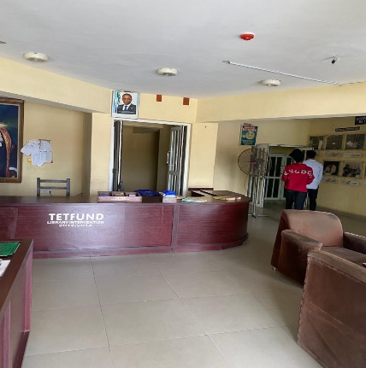
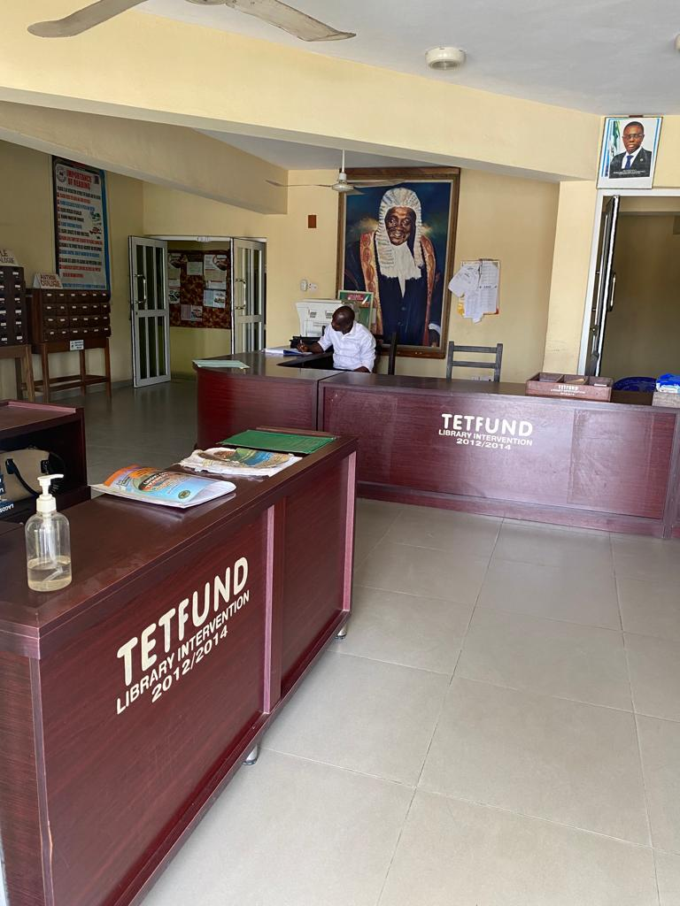

- Reference section: This reference unit is under the supervision of the circulation librarian, this section contains materials such as dictionary, encyclopedias, directories, gazetteers, almanac, year book, thesaurus and many more. Reference books cannot be checked out or leave the library, they are only meant for consultation, generally people only use a section of information from a reference book not the entire book. This section offers readers advisory service, the following are questions that are been asked by the users
- Readymade questions
- General studies questions
- Research questions
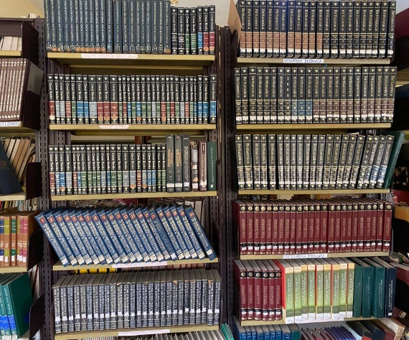

- Serials section: The serials document are house in the serials room, this section is headed by a librarian, this section contains daily, weekly, monthly, quarterly, and annual publication, after processing they are shelved alphabetically by title. However, the materials in this section are under closed access, the materials are newspapers, magazines, journals etc.

- Reprographic section: this section is also known as document reproduction or copy service; the primary purpose of reprographic section is to provide convenient access to information and preserve valuable document. This section allows users to obtain copies of books, articles, research paper, and other resources for personal use, research, or study purpose. Reprographic sections are especially beneficial for researcher, students, and professionals who need to access and work with printed materials without handling the original items directly. This are some services rendered in this section:

- Photocopying
- Scanning
- Printing
- Microfilming
- digitization etc.
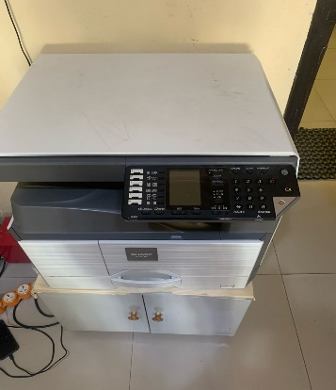

E-LIBRARY UNIT: This section directly assists the students and staff to use the computer facilities, to access the internet, it provides wireless internet services and provide access to the subscribed and free data bases of the library for their research. The section is headed by an E-librarian. The section develops and implement training programs for users on the search for qualitative academic E-journal and E-books from the E-library.
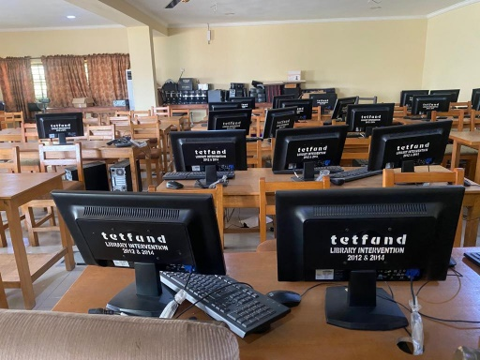

ADMINISTRATIVE DEPARTMENT: This is where the administrative activities of the library are been carried out. This section is headed by the university librarian , some of the functions rendered in the admin section are:
- Filling of documents
- Receiving mails
- Dispatching mails
- Paging of document
- Reference document

CHAPTER 3
DESCIPTION OF WORK DONE AND EXPERIENCE GAINED
3.1 WORK DONE
During my Siwes programme I was posted to work in 7 sections in Lagos state university of education library with different time duration in each section. The section Are:
Circulation section 4 weeks
Technical section 6 weeks
Serials section &Reference section 2 weeks
Reprographic section 1 week
E-library section 2 weeks
Admin section 1 week
Making a total of 16 weeks spent in the library. My description of work done and experience gained will be reported for each of the section In the order below:

Circulation Section:
On the 5th of August 2024 I was given proper orientation on the activities, functions and operations of circulation section by MRS Aiyegunle who is the head of Readers service. I was taught how to shelf and shelf read i.e the proper arrangement of books on the shelf according to their class mark on a daily basis throughout my stay in the library, Afterwards I was assigned to a shelf (600-699) which is technology under the supervision of MRS ALAGBE who selflessly guided me all through stay my stays in regards shelfing.
I was taught on how to take statistics of users which must be done on a daily basis and also how to take statistics on book consulted which must be done twice a day, btw 9am-2pm and 2pm-6pm as well as book borrowed statistics which is done on a weekly basis.
I learnt how to charge and discharge library materials and also how to attend to library users as well as registering new library users, I also help library users on how to locate material using access point for ease retrieval on the shelf which is either through the title, author, or subject catalogue cards, I was also opportuned to witness the library orientations for new library users

EXPERIENCE GAINED STATEMENT
- I have a better understanding on why the circulation have to be in the centre of the library because it has direct contact with the users
- I was able to attend to library users
- I helped library users in using the access point in retrieving their needed materials
- I can differentiate between shelving and shelf reading
- I learnt how to take users, book borrowed, and book consulted statistics

TECHNICAL SECTION:
I was introduced to the technical department on the 2nd of September , 2024 by MRS Awotola who is the head of technical service and she gave me a brief explanation on what technical section is all about. While MR Raymond gave me a brief explanation on how they acquire library materials, I was taught several methods of acquiring information materials in the library and they are: Through purchase, gift or donation, legal deposit, bequeath and so on. But for Lagos state university of education library, the most common method of acquiring materials is through direct purchase which is through TETFUND. As regards this section, some of the activities performed by me includes: inspecting of newly acquired materials against the acquisition list to ensure that the materials are in good condition and they are the one requested for by the library users
In the technical section sorting of newly acquired material must be done for easy retrieval before stamping and accession so as not to mis-place materials that are of the same title, i was given proper training on how to stamp the materials that is, the first compulsory page to stamp is the title page, and also the library security pages which is every 15th page of the material using ownership stamp, then I moved on to stamping using accession stamp on the verso page which is also known as the copyright page. I was also opportuned to give accession number to the newly acquired materials with the help of a librarian (MR Raymond) who also trained me on how to use the accession register.
In Lagos state university of Education which was formerly known as (Adeniran Ogunsanya college of education), they were initially making use of Dewey decimal classification scheme whereby cataloguing is being done on 3 by 5 cards, I was trained on how to catalog and I was opportuned to do some cataloguing on the cards. After cataloguing has been done and checked by the librarian in charge, if there’s any mistake, I will be corrected by them, after making use of the Dewey decimal classification scheme, I was also exposed to Library of congress classification scheme which was done on a work sheet, I made use of worksheet to enter the entries which where transferred to 3by5 inches card by the typist.
Hence, after cataloguing has been done, I was trained on how to classify using both Dewey decimal classification scheme and Library of congress classification scheme, the Dewey decimal classification scheme entails 10 numerals while LC entails 21 alphabets which exclude 5 letters which are I,O,W,X,Y.
The Dewey decimal classification scheme includes the following:
1. 000-099 computer science, information, general works
2. 100-199 philosophy, psychology
3. 200-299 religion
4. 300-399 social science
5. 400-499 language
6. 500-599 science
7. 600-699 technology
8. 700-799 arts & recreation
9. 800-899 literature
10. 900-999 history & Geography

The following are the procedures of how to classify materials using Dewey decimal classification scheme:
To classify a material, we first consider to:
* check the abstract to give us a clue on the subject map of the material;
* we also go through the table of contents in order to affirm the subject of the material;
* after the subject have been decided, we proceed to check the subject in the index
* The index would lead us to the schedules of Dewey decimal classification where would get the class number
* After getting the class number it will be written on the top left corner of the 3 by 5 inches catalogue card

While the library of congress classification scheme includes the following:
A General works
B Philosophy, psychology, Religion
C Auxiliary sciences of history
D History: General and old world
E History: Americas
F History: Americas
G Geography
H Social Sciences
J Political Sciences
K Law
L Education
M Music
N Fine Arts
P Literature and Language
Q Sciences
R Medicine
S Agriculture
T Technology
U Military Science
V Naval Science
Z Biography and Library science

The following are the procedures of how to classify materials using Library of congress classification scheme:
To classify a material, we first consider to:
* check the abstract to give us a clue on the subject map of the material;
* we also go through the table of contents in order to affirm the subject of the material;
* after the subject have been decided, we proceed to check in the Library of Congress subject heading list;
* the subject heading list will direct us to the schedule to decide the precise Class Mark for the subject treated by the material;
* After getting the class mark it will be written on the top left corner of the 3 by 5inches catalogue card

EXPERIENCE GAINED STATEMENT
- I learnt that the technical section is the engine room and it is out of bound to non-staffs
- I learnt that it is very essential to stamp all newly acquired materials especially with the ownership stamp.
- I learnt that there is a security page that must be stamped which is every 15th pages of every materials
- I learnt that accession stamp should be on the copyright page and not other pages
- I learnt how to catalogue using 3 by 5 cards and also using worksheet.
- I learnt how to file the call cards (this card is known as the card that is been referred to whenever a card can’t be found in the access point) it can only be found in the technical room
- I gained little knowledge on how to classify using Both DDC and LC classification scheme.
- I also learnt that TETFUND is a major financer in the purchase of library materials.
- I learnt that any book funded by TETFUND must carry a TETFUND stamp. Also, any book donated must carry a donation stamp.

SERIAL & REFERENCE SECTION
I resumed to this section on the 11th of October 2024, In Lagos state university of education library, these two sections are combined and it is headed by MR Ojo-Are Muse who gave me proper orientation about the functions and activities of these 2 sections.
In Reference section I was taught how to attend to the questions of the users such as the ready- made questions, general studies questions and research questions. I was trained on how to guide users on how to use the reference materials which includes encyclopedias, Dictionaries, Atlas, Gazetteers etc. I was also taught that the reference materials are only meant for consultation, and not to be taken out of the reference room and not to be borrowed.
In Serial section I was taught the forms and types of materials found in these sections, they are published on regular or irregular intervals that is daily, weekly, monthly, quarterly, annually, and bi-annually. I recorded and did indexing of newspapers which means the extraction of key information from the newspapers ranging from politics, education, finance, economy, health, sport, entertainment, security etc. I was taught how to stamp and how newspapers are displayed for users.
In the serial section I documented newspaper prices and types of newspapers for the purpose of auditing, and I was opportuned to witness how Auditing of newspapers are done. I was taught how to stamp and record newly acquired serial collections such as Journals.

EXPERIENCE GAINED STATEMENT

- I learnt that the serial materials have international standard serial number which are only 8 digits
- I know how to index newspaper according to headlines
- I learnt how to assist users in the reference library
- I learnt that journals are arranged alphabetically and the used-less ones are kept in the pamphlets
- I learnt that serial materials are not written or published by one author but by group of people or corporate body or organization dealing with various topics in different fields
- I learnt that reference materials can’t be read from cover to cover but you can only pinpoint the information you need from it

REPROGRAPHIC SECTION:
I was introduced to this section on the 25th of October 2024 by MR Ojo who taught me how to use the photocopy machine, I was trained on how to assist users who needs to make a duplicate or digitize materials for personal use.
EXPERIENCE GAINED STATEMENT
- I learnt how to use the photocopy machine
- I assisted the users in making copies of materials needed

ELECTRONIC LIBRARY:
I was introduced to the Electronic library on the 1st of November 2024 by MR Adeogun who is the E-librarian in partner with MRS Shittu, they taught and enlightened me on the what it takes and the resources needed to setup an electronic library, I was enlightened on how to booth and shut down the system on a daily basis. I attended to users in electronic library and I also monitor the users attendance. I was taught on how to use different online databases ( RESEARCH 4 LIFE, AJOL, and PROQUEST). I also assisted in downloading free books for offline consumption by users. I was also taught on how to use Online Computer Library Centre(OCLC) and Library of Congress databases to catalogue and classify library materials.

EXPERIENCE GAINED STATEMENT
- I also know the important of shutting down systems every closing hours
- I learnt how to make use of AJOL for research
- I learnt how to use OCLC for cataloguing and classification
- I learnt how to download free books for offline consumption
- I learnt how to attend to users in electronic library
- I can differentiate between closed and open databases
ADMINISTRATIVE SECTION:
On the 15th of November 2024, I was introduced to the administrative section in the library by MRS Alagbe under the supervision of the university librarian (Dr. Abayomi Imam). During my stay at the administrative section, I learnt some of the administrative activities, which includes: Filing of documents, receiving of incoming files, Dispatching of outgoing mails. In this section, I was taught on how to use file index, I was taught on how to stamp received mails, I was also taught on how to file documents on the file cabinet.

EXPERIENCE GAINED STATEMENT
- I learnt how to use the file index
- I learnt about correspondence register (inward and outward register)
- I learnt that things in the administrative section must be done administratively
- I learnt that any mail that is coming in or going out has to be referenced
- I learnt that you must always have your own copy of file incase there is a case of missing file.

CHAPTER 4
DESCRIPTION OF THE EQUIPMENT USED, THEIR FUNCTIONS AND DETAILED USAGE
4.1 OUTLINE THE EQUIPMENT USED DURING THE ATTACHMENT
- Stamp
- Accession Register
- 3 by 5 card
- Photocopy machine
- Desktop
- Trolley
- Subject heading

  - DETAILED DESCRIPTION OF THEIR USAGES

- STAMP: It is use to engrave a sign/mark on all the materials that are newly acquired, this process is done in other for the institution to claim the acquired materials through using ownership stamp. In Lagos state university of education, they have mainly three stamp which are ownership stamp, accession or Block stamp and Donation stamp

- OWNERSHIP STAMP: This type of stamp carries the name of the institution on it, it is used to claim the acquired materials in other to avoid misconceptions.
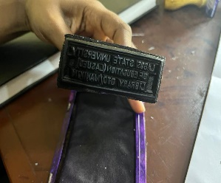
- ACCESSION STAMP: This is also known as block stamp, this is the stamp that entails the accession number, call number.
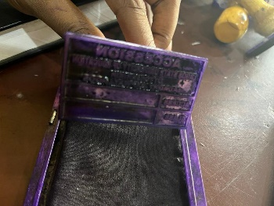
- DONATION STAMP: This type of stamp is used for donated material

- ACCESSION REGISTER: This is a crucial document in a library use to keep track of the books and other materials added to their collection over time, it is a permanent record of every item the library acquires, the accession register entails the accession number, the acquired year, title, authors name, publisher, source of acquisition, copies, price.
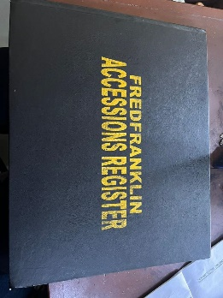

- 3 BY 5 CARD: This is a card use to catalogue and it is used in technical section to give the physical description of that book which includes Author, title, place of publication, publisher, ISBN, etc after been used for cataloguing the material they are kept in the drawer for record.

- PHOTOCOPY MACHINE: This machine used for making copies of required items from books, journal, newspapers or pamphlets and the like, it is known as a copier used in making duplicate documents and other visual images onto paper or other materials.
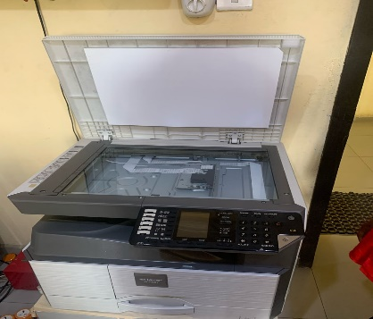

- DESKTOP: is a computer designed to be used at a desk or table, it typically consists of a case that houses the Central processing unit (CPU), memory, storage, and other essential components. The monitor, keyboard, and mouse are separate peripherals connected to the main units.
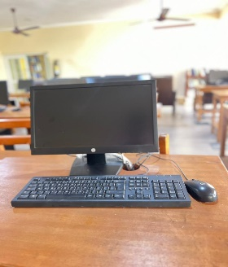

- TROLLEY: It serves as a mobile storage and transport for books, librarians and patrons use it to move multiple books around the library efficiently, The trolley usually has shelves or compartments where books can be neatly arranged, making it easier to organize and transport them from one section to another.
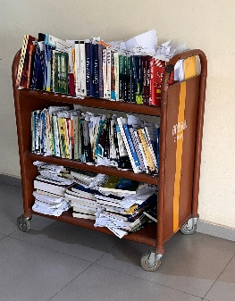

- SUBJECT HEADING: They are standardized terms assigned to library materials to represent their main topics, these headings are part of controlled vocabulary system such as library of congress subject headings (LCSH) and are used to organize and classify information in library catalogue. It helps users locate relevant materials by providing a consistent and efficient way to search for information on a specific subject
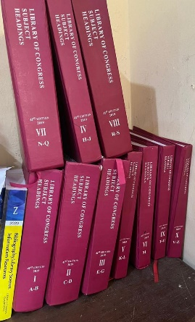
CHAPTER FIVE

SUMMARY, CONCLUSION AND RECOMMENDATION
  - SUMMARY
The students’ Industrial Work Experience Scheme is a programme for developing students’ through industrial attachment. The scheme educates students on industrial based skills essential for a smooth transition from the classroom theories to the actual practice the real world of work and students who participate in it are intended to gain practical knowledge of the theories and ideas they have learned during the teaching-learning process. During my training, I realized that education in the classroom is just an introduction or a way of learning the basics of a field of study.

5.2 CONCLUSION
The student industrial work experience scheme helped me to explore more on the theoretical work done in school, I was able to explore wide range of resources and materials. I had access to variety of books, journals, online databases and reference materials

  - PROBLEMS ENCOUNTERED DURING PROGRAM
Some of the problems I encountered during my training was:
- Lack of standby generator whenever there is power failure, hence the reading is sometimes dark
- There is no adequate user education to direct users on how to use or explore the library when in search of information. For instance, it is usually difficult for a user coming into the library for the first time to find his/her way around the library without consulting someone. Self-service is to be considered to correct such issue
- High cost of transportation fare
- Inadequate man power
- The internet service is reasonably good but needs to be improved for better services.

  - RECOMMENDATION
Based on my experience in this library I recommend that:
- The internet facility in the library should be worked on
- There should be adequate power supply
- There should be proper orientation for users of the library
- The library needs more hands-on desk.

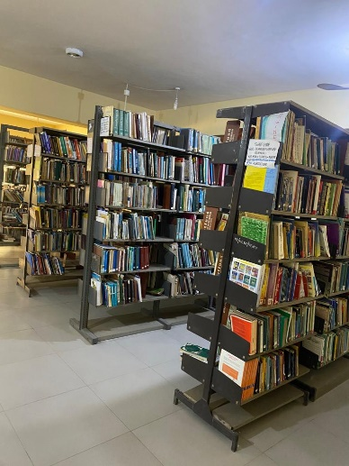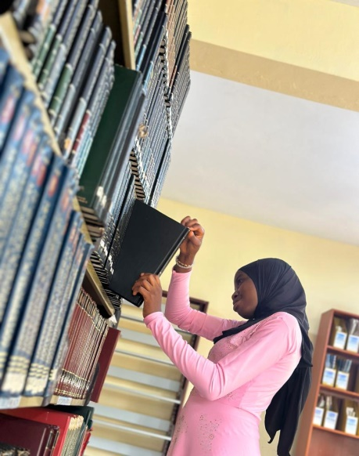
Reading room Shelving
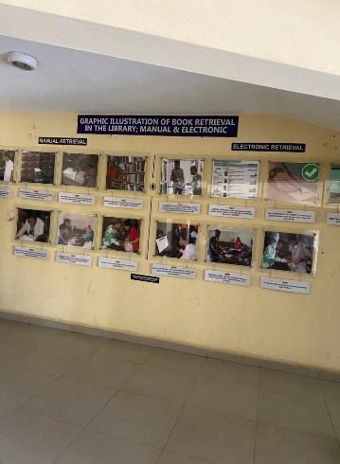
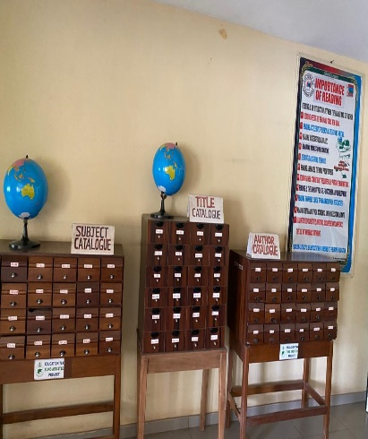
Graphic illustration of book Retrieval in the library Access point

