
A TECHNICAL REPORT
ON

STUDENT INDUSTRIAL WORK EXPERIENCE SCHEME (SIWES)
UNDERTAKEN AT
ADEBAYO LAMIKAY AUTOMOBILE WORKSHOP, OMU-ARAN
BY

OLOYEDE SAMUEL IDOWU
ND/23/MEC/FT/0002

SUBMITTED TO THE DEPARTMENT OF MECHANICAL ENGINEERING
INSTITUTE OF TECHNOLOGY
KWARA STATE POLYTECHNIC, ILORIN
IN PARTIAL FULFILLMENT OF THE REQUIREMENTS FOR THE AWARD OF NATIONAL DIPLOMA IN MECHANICAL ENGINEERING

PREFACE
This technical report covers experience acquired during the period of four (4) months of student training work experience scheme (SIWES) held at ADEBAYO LAMIKAY AUTOMOBILE WORKSHOP OMU-ARAN which is an essential part of preparing the student for their diploma in engineering course to satisfy the accredited requirement.

DEDICATION
The report is whole heartedly dedicated to God Almighty (ALPHA AND OMEGA) which has made these four (4) months of the (SIWES) appreciate the fatherly kindness of my industrial fathers, brothers, sisters; Engr. Jubril, Engr. Samad, and Engr. Yakub whom had contributed through thick and thin to the upliftment of my career, the Lord is your strength.
O God, graciously have mercy upon my parents for all they have done for me right from my childhood to where I am today.

ACKNOWLEDGEMENT
Firstly, my profound gratitude goes to Almighty God the owner of the whole universe, the sustainers of the world who gave me the privilege and knowledge to witness in the industrial training exercise, and to my able parents Mr. & Mrs. Oloyede for their full financial and parental support on my life before, during and after the SIWES programme. Also to my uncle FASORO AZEEZ BODE, my able aunty ODUNAYO and her husband brother Micheal for their moral & spiritual support towards my life.
Finally, I bless God for my other course mates whom also went for the said programme, may we never lack in Jesus name. Amen.

TABLE OF CONTENT
Title page 1
Preface 2
Dedication 3
Acknowledgement 4

Chapter One
1.0 Introduction 6
1.1 SIWES 6
1.2 Aims and Objectives of SIWES 6
1.3 Historical background of the company 6
1.4 Place of attachment 7
1.5 Automobile 7
Chapter Two
2.0 Introduction to tool 8
2.1 Safety 8
2.2 Causes of accident in mechanical workshop 8
2.3 Vehicle maintenance 8
2.4 The engine and how it works 9
2.5 Types of engine 10
2.6 The firing order 11
Chapter Three
3.0 Diagram of the parts of the engine 12
3.1 The fuel system 14
3.2 The fuel pump 14
3.3 The carburetor 15
Chapter Four
4.0 Brake system 16
4.1 Vehicle name and logo 16
4.2 The steering 16
4.3 The suspension parts 16
4.4 The drive shaft and propellers shaft 17
4.5 Causes of an engine overheating 17
4.6 Common signs of engine overheating 18
4.7 Terminologies in automobile 18
Chapter Five
5.0 Experience gained 20
5.1 Recommendations 20
5.2 Conclusion 20
Appendix 21

CHAPTER ONE
1.0 INTRODUCTION
The student industrial work experience scheme (SIWES) is organized by the industrial training fund (ITF) whose primary aim is to expose students to the relevant areas of experience of his/her course of study. This programme is made mandatory to especially students if science and technology courses to fulfill the requirements in his/her academic pursuit, and by so doing full participation of student is been accessed.
1.1 SIWES
The student industrial work experience scheme was promulgated through decree 149 of 1977 by the Federal government under the head of state Gen. Yakubu Gowon. It was introduced to give the Bsc and National Diploma (ND) students the work experience needed during their studies.
1.2 AIMS AND OBJECTIVES OF SIWES
- Acquisition of industrial skills.
- Its aim to prepare students for the working situation ahead.
- its aim is also to expose student to the method and techniques in handling available equipment in their various institutions.
- It gives students technological know-how on their course(s).
1.3 HISTORICAL BACKGROUND OF THE COMPANY
ADEBAYO LAMIDI KAREEM popularly known as ADEBAYO LAMIKAY AUTOMOBILE WORKSHOP was established on the 3rd of October, 1978 in the ancient city of Omu-Aran along Ilorin-Kabba highway. The owner of the said workshop, Mr. Adebayo Lamidi Kareem is from Oro Irepodun local government of Kwara state. Since the establishment of this workshop, Lamikay Auto-workshop deals only with gasoline engines vehicles of different categories: Honda, Toyota, Ford, Jeep, SUV, KIA, Infiniti, Nissan, Lexus etc.
1.4 PLACE OF ATTACHMENT
The field of attachment is automobile where we only deal with gasoline engines. Adebayo Lamika automobile workshop is a certified dealer in original spare parts and rendering of automobile services.
1.5 AUTOMOBILE
Automobile is from a Greek and Latin word which means; AUTO in Greek is Self while Mobile in Latin is Moving.
By definition automobile is a wheeled vehicle that carries its own motor and transport goods and passengers.
The history of automobile begins as early ad 1769 with the creation of steam-powered automobile.

CHAPTER TWO
2.0 INSTRODUCTION TO TOOLS
Example of these tools: wheel spanner, flat spanner (of different sizes), Ring spanner (of different sizes), Ring and flat spanner, Socket (19 mm, 16mm, 20mm etc.), Pliers, Screw drivers, Shifting spanner, Cramp, Plug spanners (16mm, 21mm), Allen key (5, 10, 15, 20mm) Chisel, Hammer, Jack (pumping and rolling), punch (5, 10, 15, 20mm).
2.1 SAFETY
Safeties are precautions taken in the workshop to avoid hazard or damage to life and properties.
2.2 CAUSES OF ACCIDENT IN MECHANICAL WORKSHOP
- IGNORANCE: Accident often occurs due to inexperience of workers or uliterace. Its often said that a difficult job shouldn't be attempted to unless under supervision.
- CARELESSNESS: We should learn to be careful enough in workshop to avoid accidents.
- LOW TECHNOLOGICAL KNOW-HOW: Incompetency of workers can lead to accident in workshop.
2.3 VEHICLE MAINTENANCE
To expand the life span of a vehicle, some certain procedures need to be considered:
- Make sure the four wheel tyres are of equal size & of the same pressure.
- Always check the water level inside the radiator which serves as coolant to the engine.
- Worn out brake pads and brake lamina should be replaced adequate braking system.
- Replace/ rebuilt the burnt clutch disc with another for absolute gear efficiency.
- Replaced engine oil with oil filter when certified kilometers are covered or merely every three (3) month interval.
- Always check the oil level through the use of dip stick for accuracy.
- Always check the brake fluid cylinder mounted on the master brake for the brake and clutch to function well.
Note: Some vehicle have the cylinder for brake & clutch fluid separately.
- Always check the vehicle alignment.
- Replace the unfunctioning engine parts e.g. Piston, Ring, Connecting rod, Bearing, Cylinder, Valves, Fly wheel immediately after detecting fault.
2.4 THE ENGINE AND HOW IT WORKS
"Engine" refers to an enclosed component where fuel and heat energy is converted into mechanical energy; the engine consists of four (4) main sections name;
- Top cylinder cover
- Cylinder head/ top cylinder
- Engine block
- Oil pan, (sump) or button tray
The internal combustion started in the carburetor where the fuel pump draw the petrol from the tank into the carburetor and mixed with the air and this air come from the jet, the mixed, petrol transfers into the combustion chamber so as to bring about combustions where piston is involve and the combustion chamber is at the rare side of cylinder and inside it, the petrol is converted into mechanical energy. Hence, the reaction is repeated. The up and down movement of the piston which is inside the engine block is transformed into rotary movement so as to drive the crankshaft which control the ink and also the exhaust valves at the top of the cylinder.
Initially, the engine does not start work without the air of starter motor; this is connected to motor fly wheel. The fly wheel is bolted disc to the end of the crankshaft which makes the piston and the connecting rod move up and down.
Due to the heat produced by the internal combustion of the engine, the metal part could seize without a cooling system, but there is a part called water jacket, through his jacket water is circulated and also passes through the radiator.
2.5 TYPES OF ENGINE
There are specific types of engine brand classified according to the number of cylinders present inside the engine block, but it mainly depends on the vehicle type and brand to be discussed on; these cylinder numbers are mechanically called strokes. Examples; 4 strokes engine, 6 strokes engine, 8 strokes engine and 12 strokes engine (common to diesel engine vehicles).
The particular types of engine piston number is very essential as to arrange the firing order.

2.6 THE FIRING ORDER
This strictly depends on the manufacturer's directive, some arrangement that present the strike vibration of engine are' like 4 cylinder engine may be 1234 or 1423 or 1342 respectively.

CHAPTER THREE
3.0 DIAGRAM OF THE PARTS OF THE ENGINE
There are several parts in vehicle engine but they vary by products. Some engine parts are still common but its location of constitute materials differs or they may vary in shape but the name still stands e.g. Top cylinder, crankshaft example are;
- Engine block or cylinder block
- Top cylinder cover/ cylinder head
- Camshaft
- Crankshaft
- Valves (inlet and exhaust)
- Piston ring (oil, compression & fire ring)
- Fly wheel
- Gudgeon pin
THE ENGINE BLOCK OR CYLINDER BLOCK
This is the part of an engine that carries virtually all parts in the engine e.g. Piston, crankshaft, cylinder, connecting rod etc. the engine blocks are of different types namely; engine with removable sleeve & non removable sleeve. The engine block is made up of some holes called water jacket which stores water coolant to the block.
THE TOP CYLINDER/ CYLINDER HEAD
This comprises of the combustion chamber, valves, spark plug etc. and it's made up of aluminum or cast iron.

CRANKSHAFT AND FLY WHEEL
As the shaft rotates by the connecting rod pushing on the crank pin a similar action to the used on a starting handle. It conveys this rotary motion to the transmission section of the vehicle.
Where the fly wheel is fitted onto register spigots and bolted concentric. The fly wheel has gear teeth on its circumference in order to provide a means of starting the engine with an electric starter motor also it provides friction face to the clutch.
CAMSHAFT
There are two cams for each cylinder, one to control inlet valve and the other for the exhaust valve.
The camshaft rotates in its own bearing and vary often.
PSITON RING
This parts helps to prevent the escape of expanding gases and access of oil into the upper part of the cylinder. Piston rings are fitted into grooves provided around the piston. The rings are oil ring, fire ring and compressor ring.
CONNECTING ROD
This is made of steel stampeding or light alley shaped in cross section. It function is to join the piston to the crankshaft & convert linear movement of piston to rotary motor of the crankshaft.
Gudgeon pin connects connecting rod to piston and connected to camshaft by bearing cap.
ENGINE VALVE
Valve open and close at predetermined time while vary with different engine design. There is inlet valve which controls the flowing of petrol from the manifold to the piston and exhaust valve to release the burnt or used gases as exhaust through the exhaust pipe.
3.1 THE FUEL SYSTEM
This system consists of:
Fuel tank - Fuel pump - Connected pipe (fuel pipe) - Carburetor/ injector
3.2 THE FUEL PUMP
There are basically two types of fuel pump in automobile;
- Mechanical fuel pump (manual)
- Electric fuel pump (automatic)
- Mechanical fuel pump is mounted outside the fuel tank just around the engine block where it operates manually.
- An electric fuel pump is a type of pump also place within the engine block, it is conrtolled by the elctric current supplied by Brain box also known as electronic control module (E.C.M). however, failure arises in the supply of fuel from the tank by the pumps a time where the filter of the pump contact dirt or corrosions.

3.3 THE CARBURATOR/ INJECTOR
The carburetor or the fuel injector system is responsible for mixing the correct amount of petrol with air as it passes through into the combustion chamber. Faults of carburetor and injection is mainly blockage in the fuel flow (the jest and filters) and also blockage in the air flow.

CHAPTER FOUR
4.0 BRAKE SYSTEM
Chart: Brake pedal - brake serve - master brake - brake hose - 3, 4 way junction - brake disc/ brake drum.
The brake system is majorly supported by the fluid, this is put into action by marching the pedal brake to pull the Sappho for softening then this will act with the master brake where the brake fluid will be distributed evenly to the four (4) wheel i.e. the brake disk and brake drum
4.1 VEHICLE NAMES AND LOGO
- Toyota
- Mazda
- Honda
- Suzuki
- Lexus
- Hyundai
- Mitsubishi
4.2 THE STEERING
The steering part of a vehicle allows it to be steer to any desire location. Faults of steering include excessive play in the steering pad or breakage in any steering colum.
4.3 THE SUSPENSION PARTS
The suspension parts include the shock absorbers, upper & lower arms, the stabilizer, stabilizer links and various bushes. Faults of these can be detected when there is excessive movement where they are located or odd noise. Breakage can also occur in them.
The remedy to all these faults is to be replaced the affected parts.
4.4 THE DRIVE SHAFT AND PROPELLER SHAFT
The drive shaft and propeller shaft are responsible for transmitting the vehicle in front wheel drive and rear wheel drive respectively. Faults include excessive noise, violation, slip rotation and even breakage.

4.5 CAUSES OF AN ENGINE OVERHEATING
Engine overheating can be caused by several factors, including:
- CODING SYSTEM FAILURES: A malfunctioning radiator, water pump, thermostat can prevent the engine from dissipating heat effectively, leading to overheating
- COOLANT ISSUES: Low coolant levels, incorrect coolant mixture, or using the wrong type of coolant can reduce the cooling systems efficiency.
- BLOCKED RADIATOR OR COOLANT PASSAGES: Dirt, debris or coccosion can block the radiator or coolant passages, hindering the cooling process.
- FAULTY THERMOSTAT: A thermostat stuck in the closed position will prevent coolant from circulating, causing the engine the overheat.
- DRIVING CONDITIONS: Towing heavy loads, driving in extreme heat or stop and go traffic can place additional stress on the engine, increasing the risk of overheating.
4.6 COMMON SIGNS OF ENGINE OVERHEATING
The common signs of engine overheating include:
- Rising temperature gauge: A dashboard temperature gauge moving into the real zone is a clear indicator of overheating.
- Steam or smoke: steam or smoke coming from under the hood suggests that the engine is overheating.
- Unusual smells: A sweet smell (often associated with coolant) or a burnt smell can indicate overheating.
- Warning lights: The 'check engine" or "temperature" warning lights may illuminate when the engine overheats.
- Loss of power: Overheating can cause the engine to lose power or shut down to prevent damage.
4.7 TERMINOLOGIES IN AUTOMOBILE
- ABS: Anti-lock breaking system
- FWD: Front wheel drive
- RWD: Rear wheel drive
- BMW: Bavarian motor works
- DTRL: Day time running light
- PMS: Premium motor spirit (petrol)
- SAE: society of automotive engineering
- A/T: Automotive transmission
- VIN: Vehicle identification number
- ATF: Automatic transmission fluid
- SRS: Supplement restraint system
- R & R: Remove & Replace
- AWD (QUATRO): All wheel drive
- LE: Limited edition
- XLE: Extra luxury edition
- CE: Classic edition
- GLX: Grand luxury edition
- EX: Executive edition
- SS: Speed sensor
- SES: Service engine soon

CHAPTER FIVE
5.0 EXPERIENCE GAINED
I was able to derive knowledge and skill on how to work on different gasoline engine vehicle of different model.
5.1 RECOMMENDATION
Dealing with automobile engineering, the following should be considered:
- Never give your engine to an amateur.
- Always take note of slight change in the engine sound.
- Always replace worn out or damage parts or simply repair it.
- Unknown skill shouldn't be applied on engine.
5.2 CONCLUSION
Conclusively, the industrial work experience scheme (SIWES) is a beneficial program for engineering and science student in tertiary institutions. In fact, it's an eye opener to me particularly.
I think it will be of good improvement if our institutions can be equipped in terms of engineering and sciences.

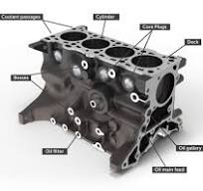
APPENDIX
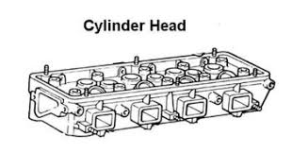

Fig. 3.0.1:Engine Block Fig. 3.0.2: Cylinder Head

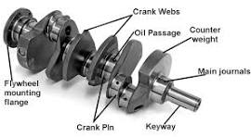
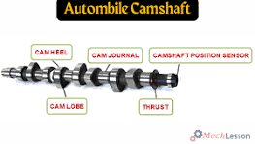

Fig. 3.0.3: Crankshaft Fig. 3.0.4: Camshaft
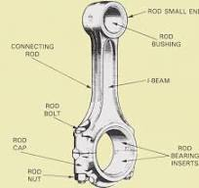
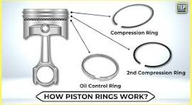

Fig. 3.0.5: Piston Ring Fig. 3.0.6: Connecting Rod

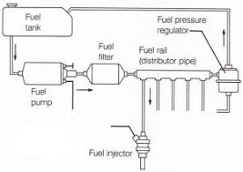
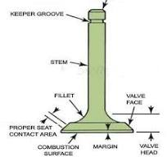

Fig. 3.0.7: Engine Valve Fig. 3.1:Fuel System
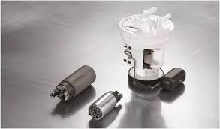
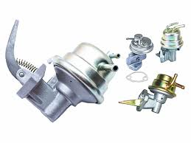

Fig. 3.2.1 Mechanical fuel pump Fig. 3.2.2 Electrical fuel pump
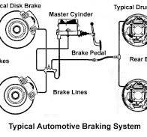
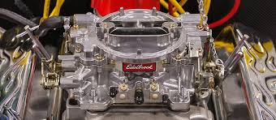

Fig. 3.3: Carburetor Fig. 4.0: Brake system

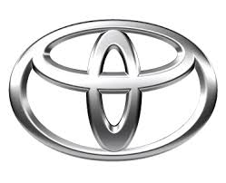

Fig. 4.1: Car brand logos
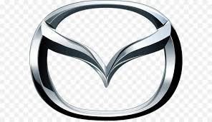

Toyota Mitsubishi Mazda
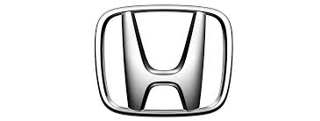
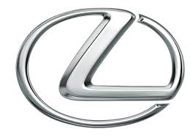

Suzuki Lexus Honda
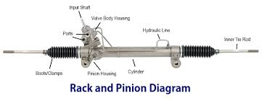


Hyundai
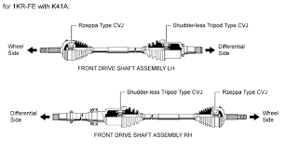
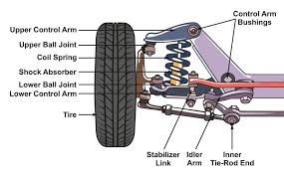
Fig. 4.2 Complete Steering rack

Fig. 4.3: Suspension Part Fig. 4.4: Drive shaft

