

A TECHNICAL REPORT
STUDENT INDUSTRIAL WORKING EXPERIENCE SCHEME
(SIWES)

HELD AT:
KELLYSON KELECHI NIG. ENT. SHOP NO 4 BESIDE RAMAT EVENT CENTER ALAGBADO SOBI ROAD, ILORIN, KWARA STATE

PREPARED BY:
SAHEED RASHEEDAT OYEYEMI
ND/23/BAM/PT/0636

SUBMITTED TO:

DEPARTMENT OF BUSINESS ADMINISTRATION AND MANAGEMENT
KWARA STATE POLYTECHNIC, ILORIN

IN PARTIAL FULFILLMENT OF THE REQUIREMENTS FOR THE AWARD OF NATIONAL DIPLOMA (ND) IN BUSINESS ADMINISTRATION AND MANAGEMENT

Sept., – Dec., 2024
DEDICATION
I dedicate this technical report to the Almighty GOD, the giver of knowledge, wisdom and who is rich in mercy.

ACKNOWLEDGEMENT
I take this opportunity to express my profound gratitude and deep regards to the creator of heaven and earth, the one who knows the beginning and the end, the alpha and the omega. my sincere gratitude also goes to my guidance MR. & MRS. SAHEED for their financial support and word of encouragement during my SIWES Programme and also to those who stood by me during my SIWES programme, thank you all. I also take this opportunity to express a deep sense of gratitude to compliment my supervisor at my place of attachment for taking her time for my practical knowledge and for her cordially support, valuable information and guidance which helped me in completing my SIWES through various stages may Almighty God bless you abundantly.
TABLE OF CONTENT
Dedication
Acknowledgement
CHAPTER ONE
  - Introduction to SIWES
  - History of SIWES
  - Objectives of the Programme
  - Objectives of Establishment
CHAPTER TWO
2.1 Activities of place of Attachment
2.2. Precaution Taken in the Place of Attachment
2.3 Uses of the Organization Equipment
CHAPTER THREE
Reporting on Work Carried Out
3.1 Reporting on Daily Work Carried Out
CHAPTER FOUR
Challenges Encounter In Place of Attachment
CHAPTER FIVE
Summary, Conclusion and Recommendations
5.1 Summary
5.2 Conclusion
5.3 Recommendations
CHAPTER ONE
  - INTRODUCTION TO SIWES
Students Industrial Work Experience Scheme (SIWES) is a Skills Training Program designed to prepare and expose Students of Universities, Polytechnics, Colleges of Technology, Colleges of Agriculture and Colleges of Education for the Industrial Work situation they are likely to meet after graduation. The Scheme affords Students the opportunity of familiarizing and exposing themselves handling equipment and machinery that are usually not available in their institutions.

1.2 HISTORY OF SIWES
The Students’ Industrial Work Experience Scheme (SIWES) was initiated in 1973 by the Federal Government of Nigeria under the Industrial Training Fund (ITF) to bridge the gap between theory and practice among products of our tertiary Institutions. It was designed to provide practical training that will expose and prepare students of Universities, Polytechnics, and Colleges of Education for work situation they are likely to meet after graduation.
Before the establishment of the scheme, there was a growing concern among the industrialists that graduates of institutions of higher learning lacked adequate practical background studies preparatory for employment in industries. Thus the employers were of the opinion that the theoretical education going on in higher institutions was not responsive to the needs of the employers of labour.
As a result of the increasing number of students’ enrolment in higher institutions of learning, the administration of this function of funding the scheme became enormous, hence ITF withdrew from the scheme in 1978 and was taken over by the Federal Government and handed to National Universities commission (NUC), National Board for Technical Education (NBTE) and National Commission for Colleges of Education (NCCE). In 1984, the Federal Government reverted back to ITF which took over the scheme officially in 1985 with funding provided by the Federal Government.
1.3 OBJECTIVES OF THE PROGRAMME
The specific objectives of SIWES are to:
- Provide placements in industries for students of higher institutions of learning approved by relevant regulatory authorities (NUC, NBTE, NCCE) to acquire work experience and skills relevant to their course of study
- Prepare students for real work situation they will meet after graduation.
- Expose students to work methods and techniques in the handling of equipment and machinery that may not be available in schools.
- Make transition from school to the labour market smooth and enhance students’ conduct for later job placement
- Provide students with the opportunity to apply their knowledge in real life work situation thereby bridging the gap between theory and practice
- Strengthen employer involvement in the entire educational process and prepare students for employment in industry
- Promote the desired technological knowhow required for the advancement of the nation.
1.4 OBJECTIVES OF ESTABLISHMENT
The specific objectives of establishment are to:
- Provide students with hands-on experience in tile manufacturing, design, and installation processes.
- Familiarize students with industry standards, practices, and the working environment in the tiles sector.
- Enhance technical skills related to tile production, including quality control and maintenance of machinery.
- Involve students in ongoing projects to help them apply theoretical knowledge in real-world scenarios.
- Connect students with professionals in the industry to foster relationships that may benefit their future careers.
- Educate students about current trends in tile designs, materials, and customer preferences.
- Instill knowledge of safety protocols and regulations relevant to the manufacturing and installation of tiles.
- Encourage students to participate in research initiatives aimed at improving product quality and sustainability in tile production.
- Provide a platform for students to give feedback on processes and suggest improvements based on their observations.
- Offer mentorship and career advice to help students transition smoothly from academic to professional settings.
CHAPTER TWO
2.1 ACTIVITIES OF PLACE OF ATTACHMENT
The experience, knowledge, skills and exposure acquired during the period of attachment in the industrial exercise cannot be over emphasized. I was exposed to certain areas in my course of study, such as:
- 40/40 Castle Black
- Inches Pipe
- Plastic Tiles
- Pipe
- 80 cur 40/40 wall floor
- 4 set of w/c
- Chemical 3
- Plug Tiger
- 13/4m/t socket
- 120 cur wall floor
- 20 cur 40/40 plain tiles
- 120 cur 25/40 wall tiles
- Plastic Elbow
- Black Glazod
- Capling
- Tap Plastic
- Elaptor
- Ball gage and tee tap
2.2. PRECAUTION TAKEN IN THE PLACE OF ATTACHMENT
- Adherence to industry safety standards (e.g., ISO, IEC) for both tiles and electrical components.
- Regular training sessions for employees on safety practices, handling materials, and proper use of machinery.
- Mandatory use of personal protective equipment (PPE) such as gloves, helmets, goggles, and ear protection in production areas.

- Proper insulation and grounding of electrical components to prevent shocks and short circuits. Regular inspection and maintenance of electrical systems and equipment.
- Rigorous testing of tiles and electrical components to ensure they meet quality standards and are free from defects.
- Installation of fire extinguishers and alarms, along with regular fire drills.
- Safe storage and handling of chemicals used in tile production and electrical components, including proper labeling and Material Safety Data Sheets (MSDS).
- Clearly marked emergency exits and evacuation plans, along with first aid kits readily available.
- Proper disposal of hazardous materials and waste products to prevent environmental contamination.
- Conducting regular safety audits and inspections to identify and mitigate potential hazards.
2.3 USES OF THE ORGANIZATION EQUIPMENT

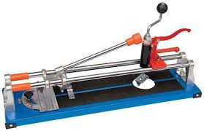
TILE CUTTING MACHINES

Use: Used to cut tiles to specific sizes and shapes, ensuring precise dimensions for installation.

TILE PRESSING MACHINES
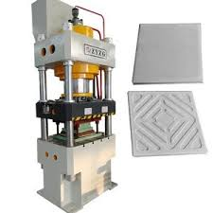

Use: Compresses raw materials to form tiles, ensuring uniform thickness and density.

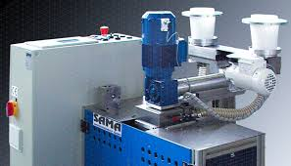
GLAZING MACHINES

Use: Applies a protective and decorative glaze to tiles, enhancing aesthetics and durability.

KILNS
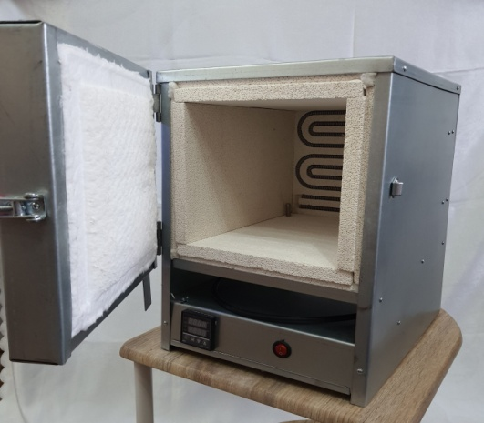

Use: Heats tiles at high temperatures to harden them and achieve the desired finish.

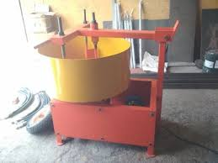
5. Mixers

Use: Combines raw materials (clay, sand, pigments) to create a consistent mixture for tile production.
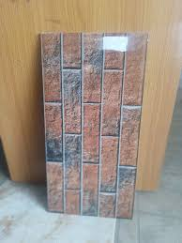
WALL TILE

Uses: Wall tiles add visual appeal and can transform the look of a space with various colors, patterns, and textures.

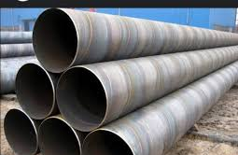
PIPE

Use: Transporting potable water from treatment plants to homes and businesses.
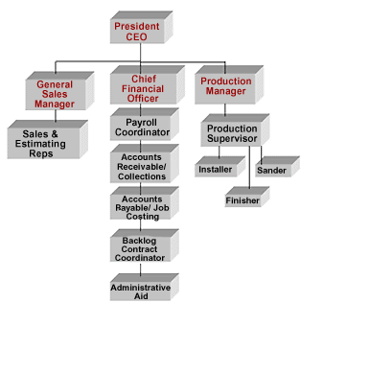
ORGANIZATION STRUCTURE/ORGANOGRAM

CHAPTER THREE
REPORTING ON WORK CARRIED OUT
3.1 Reporting on Daily Work Carried Out
WEEK 1: I was introduced to all member in the organization and I was given rules and regulation of the organization
WEEK 2: I learnt on how to fix 80 cur 40/40 castle black and also I practicalized on how to sold wall tiles 40/40 floor
WEEK 3: I learnt on how to produce tile through the mixer machine and glazing machine
WEEK 4: I sold 10 bags of cement which was approved by the supervisor
WEEK 5: I practicalized on how to fix wall socket and how to fix plain tile on the floor
WEEK 6: I practicalized on how to fix 120 cur 25/40 wall tiles
WEEK 7: I learnt how to make use of elaptor, black glazod and tee tap
WEEK 8: I was introduced on how 2 bond, 2 tee, 2 capling and shower rose was used
CHAPTER FOUR
CHALLENGES ENCOUNTER IN PLACE OF ATTACHMENT

1. Raw Material Supply
- Challenge: Fluctuations in the availability and cost of raw materials, such as clay, sand, and pigments, can affect production.

2. Quality Control
- Challenge: Maintaining consistent product quality can be difficult, leading to defects that may result in customer dissatisfaction and returns.

3. Technological Advancements
- Challenge: Keeping up with new technologies in tile production and design can require significant investment and training.

4. Environmental Regulations
- Challenge: Compliance with environmental laws regarding waste management, emissions, and sustainable practices can be complex and costly.

5. Market Competition
- Challenge: Intense competition from both local and international manufacturers can lead to pricing pressures and reduced market share.

6. Changing Consumer Preferences
- Challenge: Staying ahead of trends in design and consumer preferences can be challenging, requiring ongoing market research and innovation.

7. Economic Fluctuations
- Challenge: Economic downturns can reduce construction and renovation activities, impacting demand for tiles.

8. Labor Shortages
- Challenge: Finding skilled labor for production and installation can be difficult, affecting operational efficiency.
CHAPTER FIVE
SUMMARY, CONCLUSION AND RECOMMENDATIONS
5.1 SUMMARY
Working with various materials and technologies allows employees to acquire specialized skills in tile production, design, and installation. The industry offers opportunities for advancement, with pathways leading to supervisory roles, project management, and specialized technical positions. Employees often engage in creative processes, contributing to the design and aesthetics of tiles, which can be personally fulfilling.
The construction and renovation sectors consistently demand tiles, providing a level of job security in a growing industry. Working in a tile company fosters teamwork, allowing employees to collaborate with diverse professionals, enhancing communication and interpersonal skills.
5.2 CONCLUSION
Working in a tile company presents a unique opportunity for individuals to engage in a dynamic industry that combines artistry, craftsmanship, and technology. Employees can benefit from job stability, skill development, and the chance to contribute to innovative design and sustainable practices. The diverse roles within the company allow for career growth, collaboration, and the satisfaction of seeing tangible results from their efforts in creating beautiful spaces.
5.3 RECOMMENDATIONS
- Siwes supervisors should make sure they visit the students in their place of attachment for proper monitoring, improvement and progress for the benefit of the societies as a whole.
- Employees should seek ongoing training and education to stay updated on industry trends and technological advancements.
- Engaging with industry professionals through workshops, trade shows, and online platforms can provide valuable insights and opportunities for career advancement.
- Focusing on eco-friendly practices and sustainable materials can enhance the company’s brand image and appeal to environmentally conscious consumers.

