

A TECHNICAL REPORT
STUDENT INDUSTRIAL WORKING EXPERIENCE SCHEME
(SIWES)

HELD AT
ALIYU SISA FARM LIMITED
Off Old Ilorin-Jebba Road, Oyun Area, Ilorin, Ilorin East Local Government Kwara State

Prepared by:
ADELEYE VESSELS ADEDARA
ND/23/ABE/FT/0011

SUBMITTED TO

DEPARTMENT OF AGRICULTURAL AND BIO-ENVIRONMENTAL ENGINEERING TECHNOLOGY
INSTITUTE OF TECHNOLOGY, KWARA STATE POLYTECHNIC, ILORIN

INPARTIAL FULFILLMENT OF THE AWARD OF THE REQUIREMENT OF THE AWARD OF NATIONAL DIPLOMA IN AGRICULTURAL AND BIO-ENVIRONMENTAL ENGINEERING TECHNOLOGY

DEDICATION
I dedicate this report to Almighty God, who has been all in all from the beginning of my attachment to the end of the SIWES program all glory belongs to Him.
I also dedicate the SIWES report to my lovely family for their financial support and spiritual advice during the period of attachment.

ACKNOWLEDGEMENT
My sincere gratitude goes to Almighty God who has made things easy for me and for his unfailing love over my life, and my sincere gratitude goes to my parents Mr and Mrs Adeleye I pray May Almighty God continue to bless you and enrich your pocket.
Also my appreciation goes to the entire ALIYU SISA FARM LIMITED and the manager for his warm hand of love he has shown to us during the period.

PREFACE
The Students industrial Work Experience Scheme (SIWES) is a course which help the vocational technology students to become self employed in any aspect of their life.
The SIWES now serve as a big advantage to every student who participate in the program and also know how to make use of his/her time within the program.
As an Agricultural Engineering student, writing this report has become a personal experience in which what had been taught in school are put into practical aspect.
This SIWES program have positive influence in the growth and development of my field practical experience.

TABLE OF CONTENTS
Title page i
Dedication ii
Acknowledgement iii
Preface iv
Table Of Contents v
CHAPTER ONE
1.1 Introduction 1
1.2 Background of SIWES 1
1.1 Aim and Objective of SIWES 2
CHAPTER TWO
2.1 Brief History of Establishment 3
2.2 Objectives of Establishment 3
CHAPTER THREE
3.1 Fish Farming 4
3.2 Aquaculture Value Chain 6
3.3 Pond Preparation for fish Farming 6
CHAPTER FOUR
4.1 Poultry Production 10
4.2 Some Poultry Materials and their Uses 12
CHAPTER FIVE
5.1 Summary of Attachment Activities 14
5.2 Challenges encountered during the Programme 14
5.3 Conclusion 14
5.4 Recommendation 14

CHAPTER ONE
1.0. INTRODUCTION
The Students Industrial Work Experience Scheme (SIWES) was created in 1973 by Industrial Training Find (ITF) to help students studying in Nigeria Tertiary institutions in the country to acquire the necessary practical education experience in their respective field of study and other related professions. Students Industrial Work Experience Scheme (SIWES) was officially approved and presented by the Federal government of Nigeria in 1974. The scheme was entirely supported by ITF, but as the financial responsibility became too much for the fund, it withdrew in 1978. The National Universities Commission (NUC) and the National Board for Technical Education (NBTE) given control of the scheme by the Federal government in 1979. The Federal government headed over supervision to Industrial Training Fund in November 1984. It was taken over by the Industrial Training Fund (ITF) in July 1985, with the Federal government bearing entire duties for funding.
Students Industrial Work Experience Scheme (SIWES), which can so be referred to as Industrial Training was created in order to connect the existing gap between the theory taught in the classroom and the practical aspects of Sciences, Medicine, Agriculture, Education, Engineering and Technology and other professional programmes in the Nigerian tertiary institutions. The programme is aimed at exposing students to the various machines, equipments, professional work methods, the laws biding the profession, the safety precautions and the ways of safe guarding the work areas in the industries as well as other organizations and parastatals.
The programme was establishment primarily to impact an intense practical understanding on the Students in their various disciplines. It was also intended that the students undergo the process of training in relation to academic knowledge and practical in other to apply the training afterwards. Students Industrial Work Experience Scheme was initiated for students to understand the fundamental principles in other to become better, focused, equipped and to acquire the practical applications towards attaining great success in his/her discipline.
The Students Industrial Work Experience Scheme (SIWES) which can also be referred to as Industrial Training which involves the Students, the Universities and the Industries. The training is funded by the Federal Government of Nigeria and jointly by the Industrial Training Fund (ITF) and the National Universities Commission (NUC).
1.2. OBJECTIVES OF SIWES
- To connect the existing gap between theory and practical.
- To Find out the contribution of SIWES to human resources development through certification and accreditation of technology-based courses.
- To establish the correlation between the needs of employers of labour and the skill potentials of SIWES participants.
- To enable students to acquire technical skills and experience for the professional development in their study.
- To expose students to the necessary skills for smooth transition from classroom to the labour market.

CHAPTER TWO

2.1 BRIEF HISTORY OF ESTABLISHMENT
Aliyu Sisa Farm Limited was established in 2019 and is located off Old Ilorin-Jebba Road, Oyun Area, Ilorin, within Ilorin East Local Government, Kwara State. The farm was founded with the goal of contributing to the agricultural sector through sustainable fish and poultry farming. Since its inception, the farm has specialized in the breeding and production of catfish, as well as poultry farming, including the rearing of broilers and layers for meat and egg production. Through innovation and best farming practices, Aliyu Sisa Farm Limited has steadily grown to provide quality agricultural products to local markets and beyond.

2.2 AIM AND OBJECTIVES OF ESTABLISHMENT
- To produce high-quality catfish and poultry products to meet the growing demand for protein-rich food.
- To promote sustainable and modern fish and poultry farming techniques for increased productivity.
- To create employment opportunities and support local farmers through training and capacity building.
- To contribute to food security in Kwara State and Nigeria at large.
- To ensure efficient farm management and expansion through innovative agricultural practices.

CHAPTER THREE
VARIOUS EXPERIENCE GAINED
3.1 FISH FARMING
Fish farming, also known as aquaculture, is the practice of breeding, rearing, and harvesting fish under controlled conditions for commercial or subsistence purposes. It is an essential sector in agriculture that helps meet the growing demand for fish as a source of protein. Fish farming involves different methods, including pond farming, cage culture, and recirculating aquaculture systems.
One of the most common types of fish farming is catfish farming, which is widely practiced in Nigeria due to its high market demand, fast growth rate, and adaptability to various environmental conditions. Other commonly farmed fish species include tilapia and carp
Importance of Fish Farming
- Provides a sustainable source of protein and essential nutrients.
- Supports food security and reduces overfishing of natural water bodies.
- Creates employment and income opportunities for farmers and investors.
- Enhances economic growth by supplying fish to local and international markets.
- Allows for controlled breeding and efficient management of fish health and nutrition.
Catfish farming.
There are two important types of catfish farming, they are;
- Nursery ﬁsh farming
- Grow out ﬁsh farming

The Nursery Fish Farming
This involves the inducement of the female ﬁsh to lay eggs which are then fertilized artiﬁcially by the male sperm, incubated and hatched. Those little ﬁshes between a day and two weeks old are known as “fries”. These fries are then nurtured from between three and four weeks into ‘ﬁngerlings’ which is the size suitable for use in the “grow out farming”.
The Grow Out Fish Farming
This is dependent on the nursery ﬁsh farming without the nursery stage. But they can be operated separately by two diﬀerent farmers or the same farmer can operate both.
Stages In Catfish Farming
There are two stages in catfish farming and they include;
- PRIMARY STAGE (nursery ﬁsh farming stage) :=this is between the nursery and the grow out operation, it involves the nurturing of fries three or four weeks to grow into post ﬁngerlings, mini juvenile and juvenile respectively
- SECONDARY STAGE (grow out ﬁsh farming stage) := this is the period you nurtured the ﬁngerlings for four to ﬁve months into grow out size/ table ize ﬁsh suitable for consumption.
African Catfish
Scientiﬁc name: Clarias gariepinus
Family: clarridae
Species: clarias gariepinus

3.2 AQUACULTURE VALUE CHAIN
This is the diﬀerent stages of ﬁsh production in which they are being added value to before reaching or getting to the ﬁnal consumer ready for consumption or from the point of production to the point of marketing or consumption. The diﬀerent stages of aquaculture value chain includes; ﬁsh feed production, ﬁngerlings production, table ﬁsh production, post harvest processing, transportation, marketing.
FISH FEEDS
BROODSTOCKS
TABLE FISHS
FINGERLINGS
PROCESSED SMOKE-DRIED FISH
PACKAGED AND LABBELLED FISHS

The ﬁngerlings, table ﬁshes and broodstocks utilize the feed for their growth, then they are being processed into smoke-dried ﬁsh then the smoke-dried ﬁshes are packaged and labeled.

3.3 POND PREPARATION FOR FISH FARMING
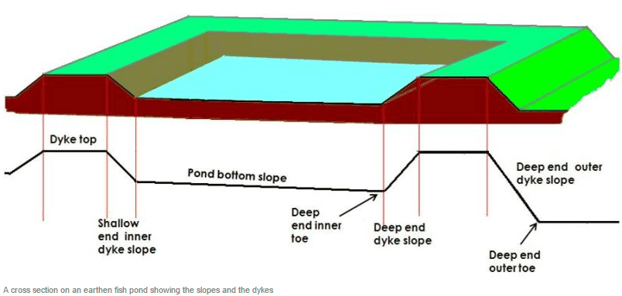

Pond preparation is a crucial step in setting up a successful fish farming operation. Properly prepared ponds create the ideal environment for fish growth, ensuring optimal water quality and minimizing risks of diseases. Here are the key steps involved in pond preparation:
- Site Selection:
  - Choose a location with access to clean water, preferably a natural water source or reliable water supply.
  - Ensure the area has good drainage and is away from pollution sources.
  - Consider the pond's size, depth, and access for feeding and harvesting.
- Pond Design and Excavation:
  - The pond should be designed with sloping sides and a deeper central area to allow for water circulation and prevent water stagnation.
  - Excavate the pond to the desired depth, typically between 1.5 to 2 meters, depending on the species of fish being farmed.
- Soil Testing:
  - Conduct soil testing to determine its permeability and suitability for holding water.
  - Use lime to correct the pH levels of the soil if necessary, ensuring it is within the ideal range for fish farming (6.5–8.0).
- Water Inlet and Outlet:
  - Set up an inlet to ensure a constant supply of clean water and an outlet for drainage and water exchange.
  - Install screens or mesh at the inlet to prevent the entry of unwanted organisms, debris, or predators.
- Pond Lining and Filling:
  - If necessary, line the pond with materials such as clay, polyethylene, or concrete to prevent water seepage.
  - Once the pond is lined, fill it with water, ensuring the water depth is adequate for the fish species being farmed.
- Fertilization and Water Conditioning:
  - Apply organic fertilizers such as manure or compost to promote the growth of algae, which serves as a natural food source for fish.
  - Test the water quality for oxygen levels, temperature, pH, and ammonia levels, and adjust as needed to create a suitable environment for the fish.
- Stocking the Pond:
  - Allow the pond to settle for a few days before introducing fish to ensure that water conditions are stable.
  - Stock the pond with healthy, disease-free fingerlings at the recommended stocking density for the fish species being farmed.
By following these steps, you can create a well-maintained and efficient fish farming pond, promoting healthy fish growth and a successful aquaculture operation.
Some Fish Farm Materials
- A fish bath tub is a device used in fish farming to manage and treat fish for various purposes, such as disease control, parasite treatment, and sometimes for temporary quarantine. The bath tub typically contains water in which fish are submerged for a short period, often with added medicinal solutions or chemicals, to treat or prevent infections.
- This process is known as "bath treatment" or "dipping."
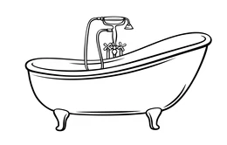

Figure 2 Fish Bath Tub

- A fishnet is a type of mesh material used in fishing and fish farming operations to capture, contain, and transport fish. It is made from various durable materials, such as nylon, polyethylene, or cotton, and is woven into a grid-like pattern with openings of different sizes depending on the intended use.

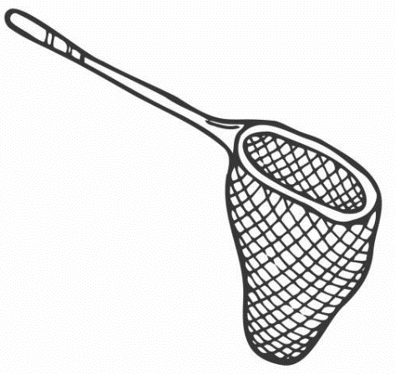

Figure 3 Fishnet
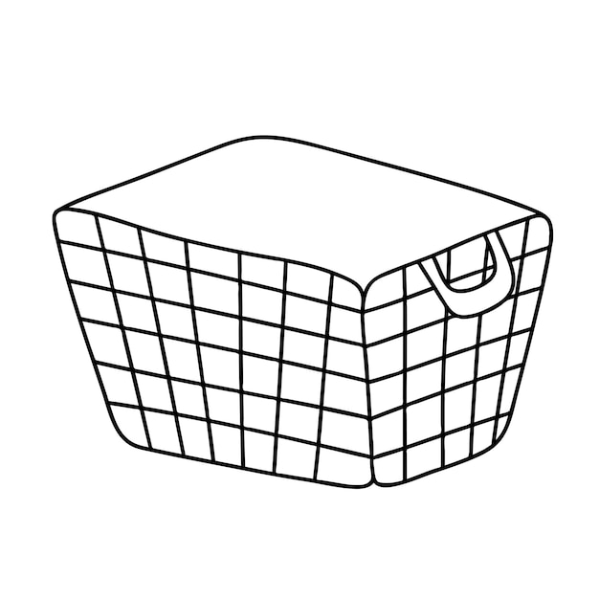
- A plastic basket is a lightweight, durable container made from plastic, commonly used in various industries, including farming and fish farming. In fish farming, plastic baskets are used to handle, transport, and store fish, especially during harvesting or sorting. They are designed with small holes or perforations to allow water drainage and air circulation, which helps maintain the health of the fish during transportation or temporary containment. These baskets are also used in crop farming for harvesting fruits, vegetables, or seeds. Their versatility, ease of cleaning, and resistance to corrosion make them an essential tool in many agricultural and aquaculture operations.

Figure 4 Plastic Basket

CHAPTER FOUR
4.1 POULTRY PRODUCTION
Poultry production refers to the breeding, raising, and management of domesticated birds, primarily chickens, turkeys, ducks, and geese, for the purpose of producing meat, eggs, or both. It is one of the most common forms of livestock farming globally due to its high efficiency and the demand for poultry products. Poultry farming can be categorized into two major types: broiler production (for meat) and layer production (for eggs).
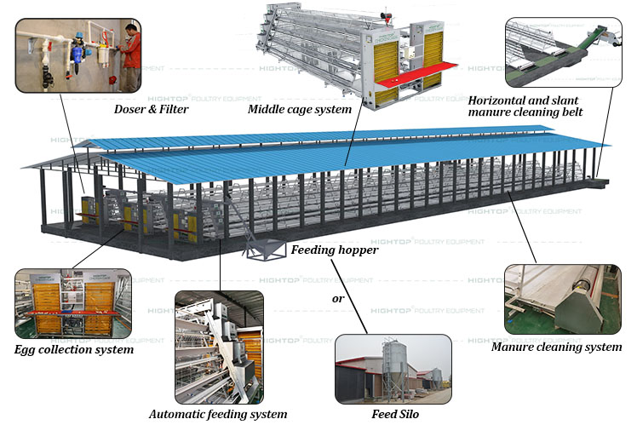

Key Aspects of Poultry Production
- Breeding and Selection:
  - The selection of high-quality breeds is essential for successful poultry production. Broilers are selected for rapid growth and high meat yield, while layers are chosen for high egg production and disease resistance.
- Housing and Environment:
  - Poultry houses, or chicken coops, should provide adequate space, ventilation, and protection from extreme weather and predators. Proper lighting and temperature control are important to maintain bird health and productivity.
- Feeding:
  - Poultry require a balanced diet rich in proteins, vitamins, minerals, and carbohydrates to promote growth and egg production. Special feeds are used for different stages of life—starter, grower, and finisher for broilers, and layers' mash or pellets for egg-laying hens.
- Health Management:
  - Disease prevention through vaccination, regular health checks, and maintaining a clean environment is crucial for ensuring healthy poultry. Common poultry diseases include avian influenza, coccidiosis, and Newcastle disease.
- Egg Collection and Meat Harvesting:
  - For egg production, eggs are collected regularly to prevent damage and contamination. For broilers, meat harvesting is done when birds reach the appropriate weight, typically around 6-8 weeks of age for broilers.
- Waste Management:
  - Proper disposal or composting of poultry manure is essential to maintain farm hygiene and prevent environmental pollution. Poultry litter is also an excellent fertilizer for crops.
Importance of Poultry Production
- Economic Contribution: Poultry farming provides a reliable source of income for farmers, especially in rural areas.
- Food Security: Poultry products (meat and eggs) are a vital source of protein for human consumption.
- Employment: Poultry farming creates numerous direct and indirect jobs in farming, processing, and distribution sectors.
- Sustainability: Poultry farming requires less land and water compared to other livestock farming, making it more sustainable and efficient in terms of resource usage.
Poultry production is a dynamic and profitable agricultural venture that contributes to the global food system and helps meet the dietary needs of a growing population.
4.2 SOME POULTRY MATERIALS AND THEIR BRIEF EXPLANATIONS
- Chicken Feed:
  - Poultry feed is the primary source of nutrition for chickens, typically made from a blend of grains, protein meals, vitamins, and minerals. The feed is formulated according to the chicken's age, whether for layers (egg production) or broilers (meat production). It ensures proper growth, egg production, and overall health.
- Waterer:
  - A waterer is a device used to provide clean water to poultry. It can come in various forms, such as automatic nipple waterers, open troughs, or bell drinkers. Adequate water supply is crucial for hydration, digestion, and optimal poultry health.
- Nesting Boxes:
  - Nesting boxes are small, private spaces provided for laying hens to lay their eggs. Proper nesting boxes reduce the likelihood of egg breakage, encourage hens to lay their eggs in one place, and help maintain cleanliness in the coop.
- Poultry Housing (Coop):
  - Poultry houses or coops are structures designed to house chickens, protect them from predators, and provide shelter from harsh weather conditions. They should be well-ventilated, dry, and spacious enough to allow the birds to move freely while ensuring biosecurity.
- Roosting Bars:
  - Roosting bars are horizontal bars or perches where chickens rest at night. Chickens naturally prefer to sleep off the ground, and roosting bars provide a comfortable, safe place for them to do so, minimizing stress and health issues.
- Incubators:
  - Incubators are machines used to artificially incubate eggs, controlling temperature and humidity levels to promote hatching. They are especially useful in hatcheries and for large-scale poultry operations where natural incubation may not be feasible.
Feeder:
  - Feeders are devices designed to provide chickens with their daily food. They come in different types, such as trough feeders, hanging feeders, and automatic feeders. Proper feeders ensure that chickens receive the right amount of feed without contamination or wastage.
- Litter:
  - Litter is the material placed on the floor of the poultry house to absorb moisture, manage odors, and provide a clean environment for the birds. Common types of litter include wood shavings, straw, and sawdust. Proper litter management is essential for controlling disease and promoting bird health.
- Lighting System:
  - Artificial lighting is used to regulate the day-night cycle for poultry, particularly for laying hens. Proper lighting can influence the birds' laying patterns, growth rate, and behavior. Lighting is typically controlled to simulate natural daylight conditions.
- Vaccines and Medications:
  - Vaccines and medications are essential tools in poultry farming to prevent diseases such as Newcastle disease, avian influenza, and coccidiosis. Regular vaccinations help maintain a healthy flock and reduce the risk of outbreaks.
These materials and equipment are fundamental for running a successful and efficient poultry farm, ensuring optimal production, health, and welfare of the birds.

CHAPTER FIVE
5.1 SUMMARY OF ATTACHMENT ACTIVITIES
The SIWES report conducted at Aliyu Sisa Farm Limited, located along Old Ilorin-Jebba Road, Oyun Area, Ilorin, focused primarily on poultry production and fish farming. During the attachment, I gained hands-on experience in managing both poultry and fish farming systems. In poultry production, I was involved in feeding, monitoring health, and egg collection, as well as managing the environment to optimize production. In fish farming, the focus was on catfish farming, where I participated in pond management, water quality monitoring, feeding, and harvesting. The experience also provided insights into the day-to-day operations of both sectors, enhancing my understanding of farm management, animal care, and efficient production practices, which are vital for the growth and sustainability of the farm.

5.2 CHALLENGES ENCOUNTERED DURING THE PROGRAMME
The main problem I encountered was getting placement and transportation.

5.3 CONCLUSION
In conclusion, the SIWES program at Aliyu Sisa Farm Limited provided invaluable practical experience in both poultry production and fish farming, allowing me to apply the theoretical knowledge acquired in the classroom to real-world farming operations. The hands-on experience in managing poultry and fish systems, understanding animal health, and improving production techniques has significantly broadened my understanding of agricultural practices. This exposure has not only sharpened my technical skills but has also prepared me for future challenges in the field of agricultural engineering, particularly in farm management. The experience has reinforced the importance of sustainable practices in farming and the vital role of efficient resource management in the success of agricultural ventures.
5.4 RECOMMENDATION
I suggest that all institutions or bodies involve in Student Industrial Working Experience Scheme, should provide places for industrial attachment for Student Industrial Training Fund and also pay some allowances to students and the company should provide more safety equipment to prevent further environmental and health hazards. Also, to students that are to undergo the training, I recommend that they should take it very seriously, because it is one of the most important parts of their studies which will help them build a very significant and effective meaning in their career.

