METHODOLOGY
This research employs an experimental approach to optimize the hybrid foam concrete mix design by incorporating palm kernel oil-based surfactants and lateritic soil. The methodology focuses on designing, testing, and analyzing mixed compositions to achieve an optimal balance between workability, strength, and durability.
The use of PKO-S aligns with the global emphasis on sustainable construction materials by reducing reliance on synthetic chemicals and introducing an eco-friendly alternative. Lateritic soil, being locally available and abundant in many tropical regions, offers a cost-effective solution for reducing cement consumption and its carbon footprint. This dual approach enhances the environmental sustainability of foam concrete while addressing critical performance parameters such as workability, strength and water absorption.

MATERIALS NEEDED
The materials needed for the experiment are Portland Limestone Cement (PLC), Laterite soil as partial replacement for fine aggregate, Stone dust as hybridized coarse aggregate, water, Foaming agent and Palm kernel oil-based surfactant.
    - Portland Limestone Cement: The primary binder in foam concrete is known as Portland Limestone Cement (PLC) typically Grade 42.5R, as specified in ASTM C150-20 and BS EN 197-1:2011. The cement is gotten from OMOLABI cement store, Agbo – Oba, Ilorin, Kwara State.
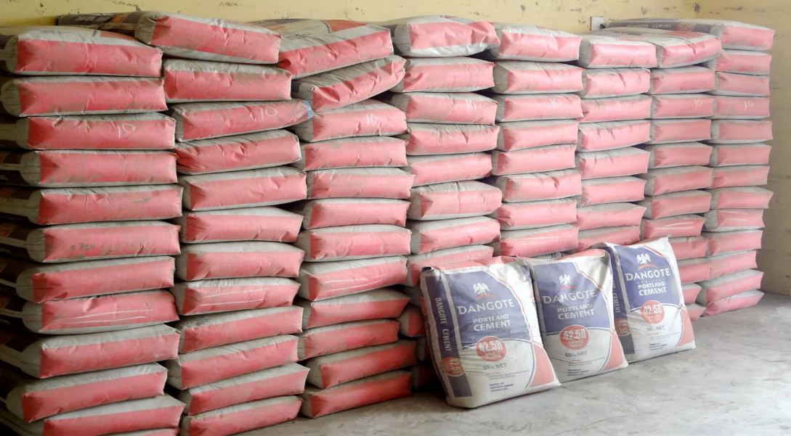

Fig 3.1. Dangote Cement in Store
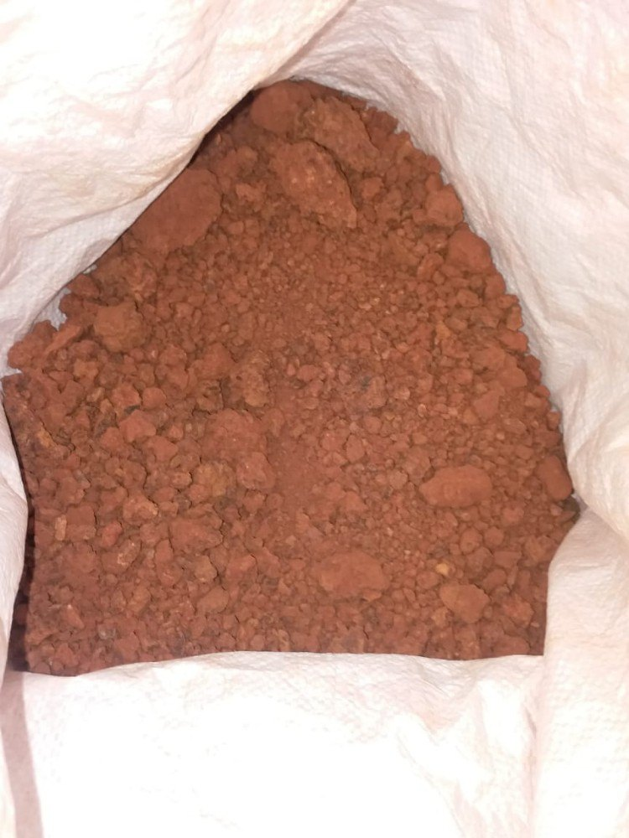
    - Lateritic Soil: Laterite soil is used as a partial replacement for fine aggregates in foam concrete and it provides strength and durability for concrete. Lateritic soil samples will be collected from nearby borrow pits. The soil will be air-dried, sieved through a 2 mm sieve as per BS 1377 standards.

Fig 3.2. Laterite Soil in Bag
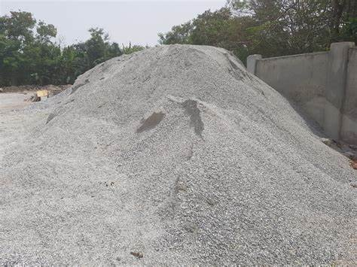
    - Hybridized Stone Dust (Coarse Aggregate): Stone dust is been introduced as a hybridized coarse aggregate in the mix. Since, there is no need for coarse aggregate in foam concrete to reduce its weight and density. Stone dust is collected from quarry sites and sieved to remove oversized particles. The gradation is verified as per ASTM C33/C33M.
Fig 3.3. Stone Dust from nearby quarry.
    - Palm kernel oil-based surfactants: Palm kernel oil-based surfactants are derived from the oil extracted from the seeds of the palm kernel through processes such as polyesterification or amidopropylation. PKO-S will be synthesized in the laboratory using palm kernel oil.
3.1.5. Water: Water is essential for hydration and foam generation. Potable water is been used for mixing and curing, conforming to ASTM C1602.
3.1.6. Foaming agent: Sodium Lauryl Sulfate (SLS) is a commonly used foaming agent in foamed concrete. The SLS is sourced for in OJA TUNTUN market, Ilorin.

METHODS
Two different samples of foamed concrete were produced for optimization. Optimization will be between a sample with PKO-S and LS and another without PKO-S. The mix ratio used for both samples is 1:1.5, where 1 is the ratio for the binder (PLC), 1.5 is the ratio divided between the aggregates (Laterite soil 60% and Stone dust 40%). The foaming agent varies in response to the water cement ratio.
Mixing Procedure:
- Weigh and mix the PLC, Laterite Soil, and Stone dust in a dry mixer until well combined
- In a separate container, mix the SLS in a small amount of water to create a foam solution.
- Add the Palm Kernel oil to stabilize the foam.
- Add Water to the dry mix and mix until a uniform paste is obtained.
- Mix the generated foam into the wet mix until well combined.
- Mix the hybridized foam concrete for an additional 2-3 minutes before pouring and curing for the specified amount of time.
Mix Proportioning:
- Mixes were prepared with varying lateritic soil content as a partial replacement for fine aggregate.
- PKO-S concentrations will vary from 0.5% upward.
- The water-to-binder ratio will vary following the required water-to-cement ratio.
- Adjust foaming agent concentrations to determine optimal levels for achieving desired density and strength.
- Specimens (150 mm cubes for compressive strength) were casted, compacted, and cured in water for 7, 14, and 28 days.
Various types of tests were carried out on the sample to check for the physical and mechanical properties of the Foam Concrete and to know the effect of Palm Kernel Oil Based Surfactant on the sample. The following tests were carried out by following the code of practice:
  - Workability: Workability is been assessed through the slump test, following ASTM C143/C143M. The slump cone is filled with foam concrete, tamped, and the subsidence measured to evaluate flow ability.
Procedure:
  - Sample Preparation:
Prepare fresh hybrid foam concrete mix according to specified proportions.
  - Slump Test Procedure:
Place the slump cone on a flat surface and fill it with fresh mix in three layers, compacting each layer with a tamping rod.
Level off the top surface and carefully lift off the cone vertically without disturbing the sample.
Measure the vertical distance between the top of the cone and the highest point of slumped concrete.
  - Interpretation and Data Analysis:
0–50 mm: Low workability (Total collapse)
50–100 mm: Medium workability (Half Slump)
100–250 mm: High workability (True Slump)
Record slump height as an indicator of workability; higher slump indicates better workability.
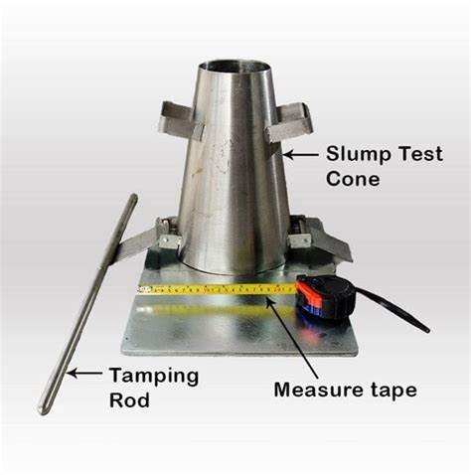
Fig 3.4. A Typical Example of Slump Test Apparatus.
  - Compressive Strength: The compressive strength test is a standard method for determining the strength of concrete. The compressive strength test can be conducted using the ASTM C39/C39M standard, which involves casting of the specimens, curing them, and then testing them using a universal testing machine. The test involves applying a compressive load to the specimen until it fails, and the maximum load is recorded. The compressive strength is then calculated using the formula:
$$Compressive Strength = \frac{Maximum Load}{Cross-sectional Area}$$
Where:
Maximum load (MPa) = The maximum load from the machine until failure
Cross – sectional Area (mm²) = The area of the cube

Procedure:
- Preparation of Mix Design:
Prepare the various mix designs of foam concrete by adding PKO-S and Laterite for optimization.
Ensure that the water-cement ratio is consistent across all samples to maintain uniformity.
- Casting Samples:
Pour the prepared foam concrete mix into cubic molds.
Use a vibrating table to eliminate air bubbles and ensure proper compaction.
Allow the samples to cure for 7, 14 and 28 days under controlled conditions (temperature and humidity).
- Testing Procedure:
After curing, samples were removed from the molds.
Each sample is been placed in a compression testing machine.
Load is gradually applied until failure occurs, recording the maximum load applied.
Results are recorded in MPa (Megapascals)
- Failure Mode Assessment:
The type of failure (brittle, ductile, or shear) should be noted as per BS EN 12390-3.
  - Water Absorption: It’s determined by submerging the specimens in water for 24 hours and calculating the percentage increase in mass, following (ASTM C642). This test provides the insight into the material’s porosity and permeability. Samples were oven-dried, submerged in water for 24 hours, and reweighed to calculate water absorption.
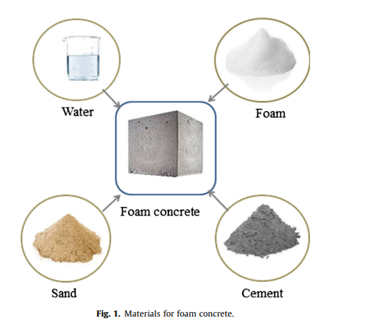
Fig 3.5. The components of Foamed concrete

