3. PROPOSED METHODOLOGY

3.1. Materials
The primary raw materials to be use in this study include Portland Limestone Cement (PLC), Fine Aggregate (Sand), Hybrid Stone dust, water, Palm Kernel Oil, and Sodium Lauryl Sulfate (SLS). PLC is a primary binder in foam concrete production. Fine aggregates, typically sand, will be used in foam concrete for its particulate properties and to assist in the cohesion of the mix. Water will be mixed with the cement in specified proportions to achieve a workable mix consistency. PKO will helps to stabilize foam in concrete mixtures. SLS will be used to create air bubbles, reduce the density of the material while maintaining the strength.
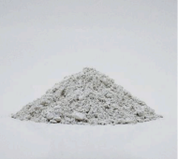
a.
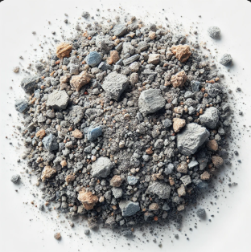
b.
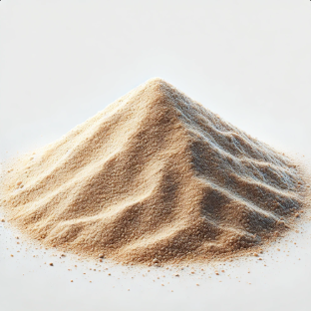
c.
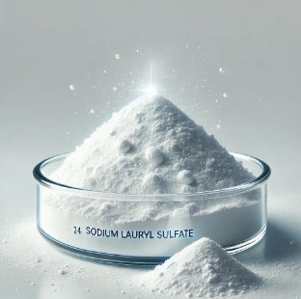
d.
Fig. 1. Material appearance. (a) Portland limestone cement, (b) hybrid stone dust, (c) fine aggregate, (d) sodium lauryl sulfate.

3.1.1. Cement
The cement will be sourced from a local supplier and will conform to the ASTM C150 standard for Portland limestone cement. The quality of cement will be checked for consistency in fineness, setting time, and compressive strength before use in the experiments. The physical and mechanical properties of cement are presented in Table 1.
Portland limestone cement is a blend of clinker, limestone, and gypsum. The main chemical reactions during hydration are:
C₃S + H₂O → C-S-H + Ca(OH)₂​
Where:
C₃S (Tricalcium silicate)
C-S-H (Calcium-silicate-hydrate, the binding gel)
Ca(OH)₂ (Calcium hydroxide, also called Portlandite)
Table 1. Physical and mechanical properties of cement.
Properties | Results | Limits of IQS: 5/1984
Initial setting time (minute) | 100 | > 45 minutes
Final setting time (minute) | 320 | < 600 minutes
Fineness (Blaine m² /kg) | 300 | > 230 (m² /kg)
Soundness by Autoclave Method (%) | 0.02 | Not more than 0.8
Compressive strength (MPa)
3 days | 21 | > 15
7 days | 27 | > 2

In addition, it is cheaper than other cement types such as high alumina cement, calcium sulfoaluminate cement and magnesium phosphate cement. Its chemical composition is given in Table 2.
Table 2. Chemical Composition.
Chemical composition of cement (%).
MgO 2.6
SiO₂ 18.7
Al₂O₃ 5.48
Fe₂O₃ 3.01
Na₂O 0.23
K₂O 1.22
SO₃ 3.25
CaO 62.3
Cl- 0.001
Loss on ignition 2.17
Insoluble residue 0.7

3.1.2. Fine Aggregates
A locally sourced river sand with particle sizes ranging from 0.075 mm to 4.75 mm will be used. The sand will be sieved and washed to remove impurities such as clay and organic matter to ensure quality. The grading will be confirmed to conform to the requirements of ASTM C33 for fine aggregates.

3.1.3. Palm Kernel Oil
Palm Kernel Oil will be used as a natural surfactant in foam concrete. PKO is derived from the seeds of the oil palm and is available from multiple suppliers in both raw and refined forms. The PKO used will be sourced from a reputable supplier that provides oil suitable for industrial applications. The oil will be filtered and stored in an airtight container to maintain its properties. The PKO will be incorporated into the foam mix at varying concentrations (e.g., 1%, 2%, and 3% by weight of cement) to assess its impact on foam stability and concrete properties.

3.1.4. Water
Water used in the mix will be potable and clean, sourced from a local supply, and in accordance with ASTM C94 standards for mixing concrete.

3.1.5. Sodium Lauryl Sulfate (foaming agent)
A commercial foaming agent SLS, depending on the standard mix will be used to generate foam. The foaming agent will be purchased from a supplier specializing in concrete additives and its properties will be verified according to ASTM C869 (Standard Specification for Foaming Agents). The foam produced by the agent will be used in varying volumes to create foam concrete.

3.1.6. Other Additives (optional)
Depending on the experimental requirements, other additives such as fibers (e.g., polypropylene or steel fibers) may be added to enhance the mechanical properties of foam concrete. These will be sourced from local suppliers, and their specifications will be checked for consistency and suitability according to ASTM C1116 (Standard Specification for Fiber-Reinforced Concrete).

3.2. Methods
The methodology will involve preparing foam concrete with varying concentrations of palm kernel oil and evaluating its properties. The experiments will focus on assessing the impact of PKO on the foam stability, mechanical properties and physical properties of foam concrete. The following outlines the key experimental procedures.

3.2.1. Mix Design Preparation
The first step in the experiment will be preparing the foam concrete mix design. The mixes will be prepared according to the following steps:
- The cement will be weighed and mixed with fine aggregates (sand) at a specified weight ratio, typically 1:1.5:3 by weight of cement to sand, depending on the target density.
- Water will be added in the amount necessary to achieve a suitable workability for the mix. A water-to-cement ratio of 0.8 to 1.5 will be used.
- The palm kernel oil will be incorporated into the foaming agent at concentrations of 1%, 2%, and 3% by weight of cement. The PKO will be mixed into the water phase of the foam concrete mix to ensure uniform distribution.
- The foam agent will be added in the correct amount to generate foam that will be mixed with the slurry. The amount of foam will be adjusted to achieve a target density (typically between 800 kg/m³ and 1,600 kg/m³) for the foam concrete.

3.2.2. Preparation of Foam
There are two primary techniques used in foam concreting: the pre-foaming method and the mix-foaming method. Both approaches regulate the mixing process and influence the quality of foamed concrete (Zulkarnain F. et al., 2011).
The pre-foaming method involves separately producing the base mix and stabilizing the preformed aqueous foam before thoroughly integrating the foam into the base mix. The pre-formed foam can be generated using either a dry or wet method. In the dry method, the foam agent solution is passed through a series of high-density constraints while compressed air is simultaneously introduced into a mixing chamber. This process creates a highly stable dry foam with bubble sizes smaller than 1 mm, allowing for uniform blending with the base material and producing pump-able foamed concrete (D. Aldridge et al., 2001). Conversely, the wet method generates foam by spraying the foam agent solution through a fine mesh, producing bubbles typically ranging from 2 to 5 mm in size. However, wet foam is comparatively less stable than dry foam (R.J. Pugh et al., 1996).
In the mix-foaming method, a surface-active agent is directly incorporated into the base mix, particularly into the cement slurry, during the mixing process. This results in the formation of a cellular structure within the foamed concrete (A. Short et al., 1978). For optimal results, the foam should be stable enough to withstand the pressure of the mortar until the cement begins to set. This stability is crucial in forming a strong concrete framework surrounding the air-filled voids.

3.2.3. Mixing and Casting
Once the foam is prepared, it will be carefully incorporated into the cement-sand-water mixture. The following procedure will be used for mixing and casting:
- The foam will be gently folded into the wet mix to avoid collapsing the air bubbles in the foam. This step is critical to maintain the desired air content and stability of the foam.
- The resulting foam concrete will be poured into molds of standard size (e.g., 150 mm x 150 mm x 150 mm for cube samples and 250 mm x 150 mm x 150 mm for beam samples) and vibrated to ensure uniform distribution and minimal air pockets.
- The foam concrete will be left to cure under standard conditions (ambient temperature of 20-25°C, with 60% humidity) for 24 hours before being demolded. The specimens will be further cured in water for up to 28 days.

3.2.4. Testing of Foam Concrete
Once the foam concrete has cured, it will be tested for various properties.

3.2.4.1. Compressive Strength Test
- Standard Code: ASTM C39 (Standard Test Method for Compressive Strength of Cylindrical Concrete Specimens)
- Procedure: Cube samples (150 mm x 150 mm x 150 mm) of foam concrete will be tested for compressive strength after 7, 14, and 28 days of curing.
- The specimen will be placed in a universal testing machine, and the load will be applied gradually at a rate of 0.25 MPa/s until failure occurs. The compressive strength will be calculated by dividing the maximum load by the cross-sectional area of the specimen.

3.2.4.2. Slump Test
- Standard Code: ASTM C143 – Standard Test Method for Slump of Hydraulic-Cement Concrete.
- Procedure:
- A slump cone (base diameter: 200 mm, top diameter: 100 mm, height: 300 mm) will be placed on a flat, non-absorbent surface.
- The cone will be filled with foam concrete in three layers, each tamped 25 times with a standard tamping rod.
- After filling, the cone will be carefully lifted vertically, allowing the concrete to slump under its own weight.
- The height difference between the original cone height and the highest point of the slumped concrete will be measured to determine the slump value.
S/N | Description Of Weeks | Duration | DEC | JAN | FEB | MAR | APR | MAY
1. | Proposal Defense | 1 week
2. | Literature review, Material Procurement | 2 weeks
3. | Mix trails, Characterization of Material | 2 weeks
4. | Fresh and Harden Property Test with Other Test | 6 weeks
5. | Statistical Analysis, Optimization | 4 weeks
6. | Result and Conclusion | 2 weeks
7. | Project Defense | 1 week
PROPOSED PROJECT TIMELINE

