A TECHNICAL REPORT ON
STUDENT INDUSTRIAL WORK EXPERIENCE SCHEME (S.I.W.E.S)

UNDERTAKEN AT:
GRACEFIELD HOTEL & SUITE
14/16 Benson Audu Avenue Off Isuti Road, Iganado Lagos State

BY:

OGUNBIYI TIMILEYIN DANIEL
ND/23/PAD/PT/431

THE DEPARTMENT OF PUBLIC ADMINISTRATION INSTITUTE OF FINANACE AND MANAGEMENT STUDIES, KWARA STATE POLYTECHNIC, ILORIN.

SEMINAR SUPERVISOR:
MR. ABDULKAREEM

October to November

CERTIFICATION
This is to certify that OGUNBIYI TIMILEYIN DANIEL of Matric Number; ND/23/PAD/PT/431 compiled this report based on his Eight Weeks (8) (two month) weeks Student Industrial Working Experience Scheme (S.I.W.E.S) carried out at Gracefield Hotel & Suite. 14/16 Benson Audu Avenue Off Isuti Road, Iganado Lagos State.

______________________ _______________________
Name of Academic Supervisor Signature and Date
Mr. Muhammed

DEDICATION
This report is dedicated foremost to God Almighty for his favor, mercy and grace upon my life especially during my 2 months SIWES program at Grace Field Hotel & Suite.
I would also like to dedicate it to my parents and siblings for their love and support and everyone else that contributed towards making my SIWES training a fun and successful one.

ACKNOWLEDGEMENT
My appreciation goes to the Industrial Training Fund (ITF) for their foresight in putting this program in place.
Many thanks to my supervisor, MR. ABDULKAREEM for taking time to supervise me during my training. I also express my profound gratitude to my (G.M) Ohiole Muhammed, the (HRM) Mrs. Patience Bassey and all members of staff of GRACEFIELD HOTEL & SUITE who gave me training and making my stay at GRACEFIELD HOTEL & SUITE an exciting and blissful one. Also to my parents and siblings thank you all for your moral and financial support.
I am deeply indebted to God Almighty, the giver of all wisdom, knowledge and understanding without whom I would have achieved nothing at all.

ABSTRACT
This Industrial Report presents the experience garnered during my Six months of Industrial Training undertaken at Grace Field Hotel & Suite. No 14/16, Benson Audu Avenue, Off Isuti Road, Igando, Lagos state.
My training was on Omega R.M.S (Point of Sale) which is designed for hotel and hospitality industry.
I acquired practical knowledge on how to install Omega POS, how to setup menu, how to punch order, how to void order and backup end of day.
This report discuses the technical skills gained during the training period and justifying the relevance of the scheme in equipping students with needed technical competence to thrive in the real world.

TABLE OF CONTENTS
Title page
Certification
Dedication
Acknowledgement
Abstract
Table of Content
CHAPTER ONE: INTRODUCTION TO TRAINING PROGRAMME
1.1 Purpose of Training
1.2 Objectives of the Program to Student
CHAPTER TWO: DESCRIPTION OF THE ESTABLISHMENT OFTHE ATTACHMENT
2.1 Brief History of the Establishment
2.2 Objectives of the Establishment
2.3 Organizational Structure Including the Organigram of the Establishment

CHAPTER THREE AND FOUR: REPORT CLEARLY ON WORK ACTUALLY
CARRIED OUT WITH CLEAR STATEMENT ON EXPERIENCE GAINED
3.1 Definition of Omega R.M.S (Point of Sale)
3.2 How to Setup menu
3.3 Sales Items
4.1 Main Reading

CHAPTER ONE
1.0 INTRODUCTION
1.1 Background
The Industrial Training fund established by decree 43 was introduced in 1971, vis-à-vis the birth of the Students Industrial Work Experience Scheme (SIWES) the same year by the Federal Government of Nigeria (FGN). It is against this background that the industrial training fund (ITF) initiated, designed and introduced SIWES Scheme in 1973 to acquaint students with the skills of handling employers’ equipment and machinery.
The Industrial Training Fund (ITF) solely funded the scheme during its formative years. However, due to financial constraints, the fund withdrew from the scheme in 1978. The Federal Government, noting the significance of the skills training, handed the management of the scheme to both the National Universities Commission (NUC), and the National Board for Technical Education (NBTE) in 1979. The management and implementation of the scheme was however, reverted to the ITF by the Federal Government in November, 1984 and the administration was effectively taken over by the industrial training fund in July 1985, with the funding solely boned by the Federal Government. It is an integral part of the requirements for the award of Certificates, Diplomas and Degrees in institutions of higher learning, e.g. Colleges of Education, Polytechnics, Universities, etc.
Student Industrial Work Experience Scheme (SIWES) exposes students to industry based skills necessary for a smooth transition from the classroom to work environments. It accords students of tertiary institutions the opportunity of being familiarized, exposed, and prepare students of universities, polytechnics, college of technology, college of agricultures and college of education for the industrial work situation they are likely to meet after graduation and to the needed experience in handling machinery and equipment which are not found in such an educational institution.
1.2 Objectives of SIWES
- To provide students with relevant practical experience.
- To satisfy accreditation requirements set by the Nigerian Universities Commission (NUC).
- To familiarize students with typical environments in which they are likely to function professionally after graduation.
- To provide student an opportunity to see the real world of their discipline and consequently bridge the gap between the University work and actual practice.
- To change the orientation of students towards labour market when seeking for job.
- To help students access area of interest and suitability for their chosen profession.
- To enhance students, contact for future employment
- To provide access to equipment and other facilities that would not normally be available in the University workshop
- To enlist and enhance industry involvement in university education.
- Summarily the objective of the Student Industrial Work Experience Scheme.
- To solve, the problem of inadequate practical skills, preparatory for employment in industries by Nigerian graduates of tertiary institution.
- To promote and encourage the acquisition of skills in industry and commerce, with a view of generating a pool of indigenous trained manpower sufficient to meet the needs of the economy.

CHAPTER TWO
2.0 DESCRIPTION OF THE ESTABLISHMENT OF ATTACHMENT
2.1 Location
Amuludun Radio 991.1 FM is located in Moniya Ibadan. Amuludun has emerged as the first internet digital radio in northern Nigeria and they are inclined to utilization wherever you are in the world, you can assess it, in terms of local capacity the transmission is from the heart of Ibadan, the political capital of Northern Nigeria, the entire Ibadan, Oyo, Ibarapa, Gangan, etc
2.2 Brief History of the Establishment
Amuludun 99.1 FM, located at Moniya Ibadan was established on 10th October, 2007 and commenced transmission in pure and undiluted Yoruba language on 22nd October, 2007 Amuludun FM. It has the appellation “O Tawonyo” meaning “Stand Out”. Amuludun FM Station has a bandwidth of 99.1MHz in the frequency modulated band.
2.3 Mission and Objectives of Establishment
- To encourage content and technology innovation
- To advance the interest of our members in local, state, national, International, industry and public affairs.
- To serve as an advisory body to the Federal and State Governments on broadcasting matters.
- To encourage and sustain greater co-operation and collaboration among the broadcasting organizations, and other industry players.
- To improve the quality and profitability of broadcasting
- To seek and utilize available resources for manpower development, research and set training standards.
- To set, regulate and monitor professional standards and ethics of its members.
- To encourage members to serve their communities.
- Amuludun radio serves lies in them up to day equipment and varieties of programmes such as issues and event, newspaper review, our Obodo Nigeria and the globe, guest of the week, eye witness news and democracy in practice. These entire programmes give viewers opportunity to call in and contribute to the programme. Presently, there are over fifty staff working directly with Amuludun radio
2.4 Departments/Units in the Establishment
- The Admin Unit: Administration department is backbone of an organization. An effective administrator is an asset to an organization. The Chairman, ATAR Communications Nigeria Limited, Dr Ahmed Tijjani Ramalan,
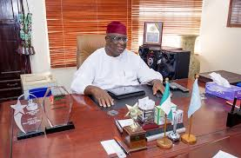
- Chief Presentation Officer: Mohammed Yusuf Suleiman
- Head of RADIO Studios: Mr. Rashid Oniyangi
- Producer: Aisha Musa Hassan
- Administration and Legislative Structure
- General Assembly: The General Assembly is the highest decision-making body and possesses the legislative and administrative authority to realize the organization’s objectives
- Central Working committee: Amuludun Radio is expected to have mass audience appeal, broadcasting 70 percent in Yoruba and 30 percent in English, while also relaying High Definition programming to diverse demographics across vast areas of Nigeria and West Africa.
- Zone: Amuludun Radio Channel 180 on StarTimes bouquet, which has been on test transmission for a couple of weeks, started live broadcasting recently.
- Control Unit: A control room or operations room is a room serving as a central space where a large physical facility or physically dispersed service can be monitored and controlled. A control room will often be part of a larger command center.

CHAPTER THREE
3.0 WORK EXPERIENCE
I carried out my Industrial Training in Control Room on Radio production with ATAR Communication (Amuludun FM)
3.1 Introduction
This to initiates, coordinates, supervise, and control matters such as funding, hiring key personnel, contracting and arranging for distributors. This also is involved throughout all phases of the process from the development to completion of the production. The also include how to set-up live shows on the studio.
3.1.1 Chains in RADIO production
1. Director: This person is responsible for overseeing the creative aspects in controlling the content and flow of the film's plot, and directing their performance.
2. Screen Writer: Are responsible for researching the story, developing the narrative, writing the screenplay, and delivering it, in the required format, to the Producers.
3. Executive producer This person is usually an investor in the project or someone who has facilitated the funding of the project. There may be multiple of these people on a project, depending on the financing arrangements.
4. Line producer Typically, this person manages the budget of the film production. Alternatively, or in addition, they may manage the day to day physical aspects of the film production.
5. Production Manager This person supervises the physical aspects of the production including personnel, technology, budget, and scheduling.
6. Production Coordinator This person is the information nexus of the production, responsible for organizing all the logistics from hiring crew, renting equipment, and booking talent. This person is an integral part of film production.
7. Production Secretary This person provides administration assistance in the production office to the production coordinator and production manager.
8. Production Accountant These people are responsible for managing finances and maintaining financial records during film production.
9. Post-Production Supervisor These people are responsible for the post production process, during which they maintain clarity of information and good channels of communication between the Producer, Editor, Supervising Sound Editor, the Facilities Companies (such as film labs, CGI studios and negative cutters) and the Production Accountant.
10. Camera Operator This person operates the camera under the direction of photography, or the film director, to capture the scenes on film.
11. Scripts Supervisor Also known as "continuity", keeps track of what parts of the script have been filmed and makes notes of any deviations between what was actually filmed and what appeared in the script.
12. Story Producer This person has overall responsibility for the story across episodes. In reality RADIO, this person is responsible for creating a story line via editing/producing the show's source footage.
13. Scripts Editor Provides a critical overview of the screenwriting process, using their analytical skills to help the screenwriter identify problems and thereby help to strengthen and develop the screenplay.
14. Production Sound Mixer This person is head of the sound department on set, responsible for recording all sound during filming.
15. Video Split/Assist Operator This is used by directors to watch a monitor during each take.
16. Digital Imaging Technician (DIT) On digital productions this person is responsible for the coordination of the internal workings of the digital camera.
17. Motion Control Technician/Operator This technician operates a motion control rig, which essentially is a 'camera robot' able to consistently repeat camera moves for special effects use.
18. Boom Operator (Boom Swinger) This person is responsible for microphone placement and movement during filming.
3.2 Equipment’s used at ATAR Communication
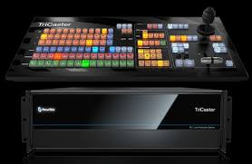
- Tricaster: Is also used to broadcast live program while the playout system is used for recorded programs. When there is no live show going on recorded program are being played through it.

- Video Camera: Is a camera used for electronic motion picture acquisition, initially developed for the Radio industry but now common in other applications as well. There are types of shots using the Zoom, the Close up Shot, Medium Close up (MC) and the Medium long shot (MLS).
Experiences using the camera
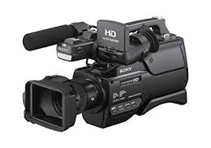
Colour adjustment, Cropping, framing and composition of picture including the layout, PAN, the movement of camera from right to left. Tilt movement which include the up and down tilt movement. Light and create visual image, there are different types of light which is the fill light, the back light, the hard light, and the spot light.

- Teleprompter: Is a display device that prompts the person speaking with an electronic visual text of a speech or script using a teleprompter is similar to using cue cards. I heard experiences on how weather forecast script to the teleprompter by highlighting all first then copy the document and clicking the teleprompter software, then add script and paste, then connect the teleprompter. A laptop was used to operate it to make it move fast and slow. Which was normally carried out by Mrs. Kemi Olorufemi.
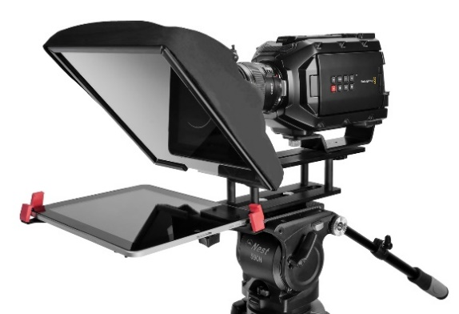

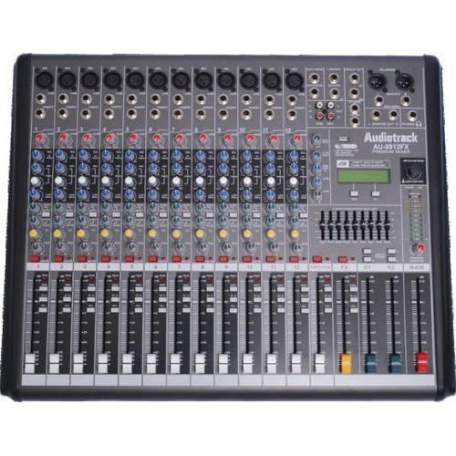
- Audio mixer: A mixer is an electronic device which is often used for changing the quality and the levels of audio signals. It is also known as a mixing console, an audio mixer, or a soundboard. Using a mixer is the most convenient way to route or combine various audio signals and even change the timbre and dynamics of the sound.

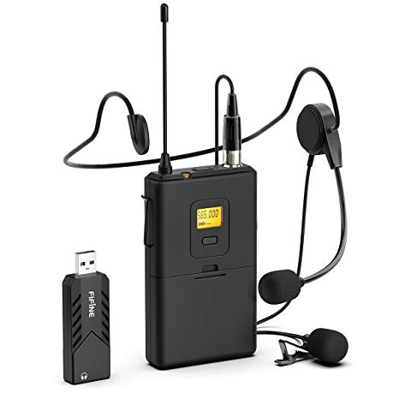
- Lapel microphone: Is a small microphone used for Radio, theatre, and public speaking, in order to allow for hands-free operation.

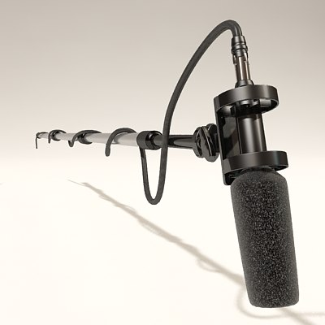
- Boom mic: is used to pick up sounds of the presenter and the guests, from ascending to descending order in all angels of the studio.

- Kenflo Lights: Is mainly used in the studio to clear shadows of an object, to also have a clear image of the subject or talent
Type of light
1. Fill Light is placed by the side of the subject to cast out shadow or to fill out shadows
2. Back lights are placed at the back of the subject to light him/her from behind.
3. Hard Light close to the natural light, source from the sun
4. Spot light is controlled narrowly focused beam of light
- Standing light is mainly used to have a clear picture or visual of the object behind the scene while a program or interview is being conducted

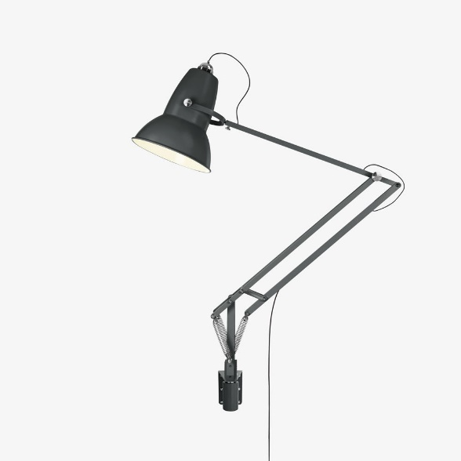
3.3 Live Programs at ATAR Communication
1. Live program on “Zaben 2019” in which the guest speaker was Hon. Mohammed Dan Lami Kurfi- Rep. member from Ibarapa
2. Live Program on “Likitan Amuludun”
3. “Ina Dalili” by Sargikano the presenter and the guest Amina Waziri, Mallam Yahaya Abdurrahaman and Abubakar Sadic Galadima
4. Live program Carried by me on Yoruba News “Labarun Duniya”
5. Live program on “SHANSHANI” in Yoruba Language
6. Review on News Paper “TAMBARI” in Yoruba Language
7. Live program on “Violence-Free 2019 elections and Vote not fight”
8. “The CJN Charges” dialect in English Language
9.Curbing election violence in Nigeria
10. 9:00am program on LABARUN AMULUDUN

3.4 Structural Representation of Studio Signs
Studio signs also refer to as using studio stickers with written words of instruction using to conduct the activities of a reporter in the studio. It is also used in order to avoid distortion while reporting news.
ADVERT
BREAK
STOP
ROUND-UP

STRETCH
OR
SLOW DOWN
SPEED-UP
STAND-BY
SLOW DOWN

COME
CLOSER
OK
30
SECONDS
15
SECONDS
CUT
ON
TIME

KEEP
TALKING
GO
BACK

STOP
DON’T
MOVE
A
MINUTES
COUNT
DOWN

CHAPTER FOUR
RECOMMENDATION AND CONCLUSION
4.1 Recommendation
The recommendations arising from the foregoing appraisal of the effectiveness of SIWES in the formation of competent and productive technical manpower for the economy are summarized as follows;
- The establishment of a National Commission for Student Industrial Training or a National Board for Cooperative Education was proposed to oversee the implementation of SIWES at the national level.
- Funds earmarked for SIWES should be appropriated directly by the National Assembly in the same way for the National Youth Service Corps Scheme in order to remove the bottlenecks associated with release of fund for the operation of the scheme.
- The Federal Government should make adequate provisions in the annual budget for proper funding for SIWES in view of the potentials of the scheme to contribute to enhancing the quality of pool of technical skills available to the economy.
- The stipulation that employers should accept students for SIWES should be strengthened with stiffer penalties put in place for defaulters.
- A review of the policies that guide and regulate SIWES is necessary to ensure that the scheme complies fully with the tenants of cooperative education or work-integrated learning.
4.2 Conclusion
The Student Industrial Work Experience Scheme (SIWES) plays a significant role in human resource development, it helps students develop new skills and enlightens them of what the present society holds for them after graduation and helps them adapt accordingly. As a result of the programme, I am now more confident to build my future My four (4) months industrial attachment with ATAR Communication (Amuludun FM RADIO) has been one of the most interesting, productive and instructive experience in my life. Through this training, I have gained new insight and more comprehensive understanding about the real industrial working condition and practice; it has also improved my soft and functional skills. All these valuable experience and knowledge that I have gained were not only acquired through the direct involvement in task but also through other aspect of training such as work observation, interaction with colleges, superior and other people related to the field.

